**Android Programming - Third Edition**

**Chapter 1 - Your First Android Application:**

An *activity* is an instance of Activity, a class in the Android SDK. An activity is responsible for managing user interaction with a screen of information.

You write subclasses of Activity to implement the functionality that your app requires. A simple application may need only one subclass; a complex application can have many.

A *layout* defines a set of UI objects and their position on the screen. A layout is made up of definitions written in XML. Each definition is used to create an object that appears on screen, like a button or some text.

*Widgets* are the building blocks you use to compose a user interface. A widget can show text or graphics, interact with the user, or arrange other widgets on the screen. Buttons, text input controls, and checkboxes are all types of widgets.

The Android SDK includes many widgets that you can configure to get the appearance and behavior you want. Each widget is an instance of the View class or one of its subclasses (such as TextView or Button).

Every widget has a corresponding XML element. The name of the element is the type of the widget (like TextView). Each element has a set of XML *attributes*. Each attribute is an instruction about how the widget should be configured.

Your widgets exist in a hierarchy of View objects called the *view hierarchy*. All view hierarchy’s have a root element, at the top of the hierarchy. All root elements must specify the Android resource XML namespace at http://schemas.android.com/apk/res/android.

LinearLayout inherits from a subclass of View named ViewGroup. A ViewGroup is a widget that contains and arranges other widgets. You use a LinearLayout when you want widgets arranged in a single column or row. Other ViewGroup subclasses are FrameLayout, TableLayout, and RelativeLayout.

When a widget is contained by a ViewGroup, that widget is said to be a *child* of the ViewGroup.

Let’s go over some widget attributes:

* android:layout_width and android:layout_height: These attributes are required for almost every type of widget. They are typically set to either match_parent or wrap_content:
  + match_parent: view will be as big as its parent
  + wrap_content: view will be as big as its contents require

For the root element, the value of both the height and width attributes are usually set to match_parent. The root element’s parent element is the view that Android provides for your app’s view hierarchy to live in.

* android:orientation: This determines whether the children of this widget appear vertically or horizontally. **The order in which children are defined determines the order in which they appear on screen.**

In a vertical layout, the first child will appear topmost. In a horizontal layout, the first child will be leftmost (unless the language is read right-to-left, in which case it’ll appear rightmost).

* android:text: This attribute tells the widget what text to display. The values of this attribute are not literal strings. They are references to *string resources*. A string resource is a string that lives in a separate XML file called a *strings file*.

You can give a widget a hard-coded string, like android:text=”True”, but this is not a good idea. Placing strings in to a separate file and then referencing them is better because it makes localization easy.

Let’s look at how to create a strings file. Every project includes a default strings file named strings.xml. It is in the app/res/values directory.

To add strings that are used in your program, create a string element, like so:

<string name="false_button">False</string>

Now, whenever you refer to @string/false_button in any XML file associated with your project, you will get the literal string “False” at runtime.

Although the default strings file is named strings.xml, you can name a strings file anything you want. You can also have multiple strings files in a project. **As long as the file is located in res/values, has a resources root element, and contains child string elements, your strings will be found and used appropriately.**

How do XML elements in your XML file become View objects? The answer starts in your Activity subclass (here it’s QuizActivity). If you look at QuizActivity, you’ll see three Activity methods.

Let’s look at onCreate(Bundle). This method is called when an instance of the activity subclass is created. When an activity is created, it needs a user interface to manage. To get the activity its user interface, you call the following Activity method:

public void setContentView(int layoutResID);

This method *inflates* a layout and puts it on the screen. When a layout is *inflated*, each widget is instantiated as defined by its attributes. You specify which layout to inflate by passing in the layout’s resource ID.

A layout is a *resource*. A resource is a piece of your application that’s not code - things like image files, audio files, and XML files. Resources for your project live in a subdirectory of the app/res directory.

To access a resource in code, you use its *resource ID*. For example, the resource ID for our layout in Chapter 1 is R.layout.activity_quiz.

These resource ID’s are generated automatically in the hidden R.java file included with your project.

Your strings also have resource IDs. You can refer to them in code like this:

setTitle(R.string.app_name);

Android generates a resource ID for the entire layout and for each string, but it doesn’t generate IDs for the individual widgets in your widget XML file. Not every widget needs a resource ID, only what you interact with.

To generate a resource ID for a widget, you include an android:id attribute in the widget’s definition, like so:

android:id="@+id/true_button"

Notice that there is a + sign in the values for android:id, but not in the values for android:text. This is because you are *creating* the IDs and only *referencing* the strings.

Wiring up your button widgets and other UI elements is a two-step process:

* Get references to the inflated View objects.
* Set listeners on those objects to respond to user actions.

In an activity, you can get a reference to an inflated widget by calling the following Activity method:

public View findViewById(int id);

This method accepts a resource ID of a widget and returns a View object.

For example:

mTrueButton = (Button) findViewById(R.id.true_button);

Note that you have to cast the returned View to the object that you need to get a reference to (in this case, Button).

Android applications are typically *event driven*. Unlike command-line programs or scripts, event-driven applications start and then wait for an event, such as the user pressing a button. Events can also be initiated by the OS or another application, but user-initiated events are the most obvious.

When your application is waiting for a specific event, it’s “listening for” the event. The object that you create to respond to an event is called a *listener*, and the listener implements a *listener interface* for that event.

The Android SDK comes with listener interfaces for various events, so you don’t need to write your own. For buttons, the event you want to listen for is a button being pressed (or “clicked”), so your listener will implement the View.OnClickListener interface.

Here’s an example of how that’s done:

mTrueButton.setOnClickListener(

new View.OnClickListener(){

@Override

public void onClick(View v){

//does nothing yet, but soon!

}

});

Here, we set a listener to inform us when the Button known as mTrueButton was pressed (clicked). The setOnClickListener(OnClickListener) method takes a listener as its argument. In particular, it takes an object that implements OnClickListener.

Here we implemented the listener as an *anonymous inner class*. Because this anonymous class implements OnClickListener, it must implement that interface’s sole method, onClick(View).

We are going to have each button trigger a pop-up message called a *toast*. A toast is a short message that informs the user of something but does not require any input or action.

To make toasts work, we first have to define the strings they display in strings.xml:

<string name="correct_toast">Correct!</string>

<string name="incorrect_toast">Incorrect!</string>

To create a toast, you call the following method from the Toast class:

public static Toast makeText(Context context,

int resId, int duration);

The Context parameter is typically an instance of Activity (Activity is a subclass of Context). The second parameter is the resource ID of the string that the toast should display. The Context is needed by the Toast class to be able to find and use the string’s resource ID. The third parameter is one of two Toast constants that specify how long the toast should be visible.

After you’ve created a toast, you call Toast.show() on it to get it on screen.

Here’s an example of all this doing a toast:

public void onClick(View v){

Toast.makeText(QuizActivity.this,

R.string.incorrect_toast,

Toast.LENGTH_SHORT).show();

}

**Chapter 2 - Android and Model-View-Controller:**

Android applications are designed around an architecture called Model-View-Controller, or MVC for short. In MVC, all objects in your application must be a model object, a view object, or a controller object.

A *model object* holds the application’s data and “business logic.” Model classes are typically designed to *model* things your app is concerned with, such as a user, a product in a store, or a photo in your phone’s camera roll. Model objects have no knowledge of the UI; their sole purpose is holding and managing data.

In Android applications, model classes are generally custom classes you create. All of the model objects in your application compose its *model layer*.

*View objects* know how to draw themselves on the screen and how to respond to user input, like touches. A simple rule of thumb is that if you can see it on screen, then it’s a view.

Android provides a wealth of configurable view classes. You can also create custom view classes. An application’s view objects make up its *view layer*.

*Controller objects* tie the view and model objects together. They contain “application logic.” Controllers are designed to respond to various events triggered by view objects and to manage the flow of data to and from model objects and the view layer.

In Android, a controller is typically a subclass of Activity, Fragment, or Service.

Model and view objects do not talk to each other directly; controllers sit squarely in the middle of everything, receiving messages from some objects and dispatching instructions to others.

MVC makes designing and understanding an application easier, because you can think in terms of layers instead of individual classes. MVC also makes classes easier to reuse. A class with restricted responsibilities is more reusable than one with its fingers in every pie.

To set up the app on a device, check out pages 46-48 in the book.

The book next shows you how to add icons to the resources of your app. This is shown on pages 48-52. Any .png, .jpg, or .gif file you add to a res/drawable folder will automatically be assigned a resource ID. **Filenames must be lowercase and not have any spaces.**

These resource IDs are not qualified by screen density. So you don’t need to determine the device’s screen density at runtime. All you have to do is use the resource ID in your code. When the app is run, the OS will determine the appropriate image to display on that particular device.

Now, you use reference IDs to reference resources in code. But you want to configure a button to display an icon in the layout definition. How do you reference a resource from XML?

With a slightly different syntax, like so:

android:drawableRight="@drawable/arrow_right"

android:drawablePadding="4dp"

In an XML resource, you refer to another resource by its resource type and name. A reference to a string resource begins with @string/. A reference to a drawable resource begins with @drawable/.

We still have a problem though. When we rotate the device, our project GeoQuiz will reset and show the first question again. This has to do with the activity lifecycle, which we cover next.

**Chapter 3 - The Activity Lifecycle:**

Every instance of Activity has a lifecycle. During this lifecycle, an activity transitions between three states: running, paused, and stopped. For each transition, there is an Activity method that notifies the activity of the change in its state. The figure below shows the activity lifecycle, states, and methods:

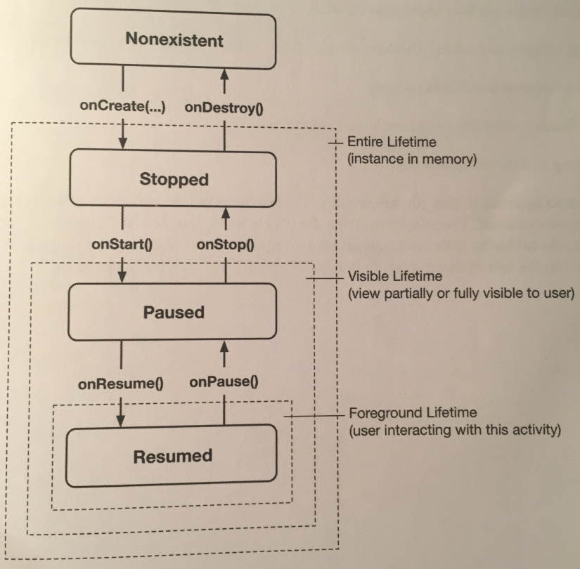

The figure below shows, for each state, whether the activity has an instance in memory, is visible to the user, or is active in the foreground (accepting user input):

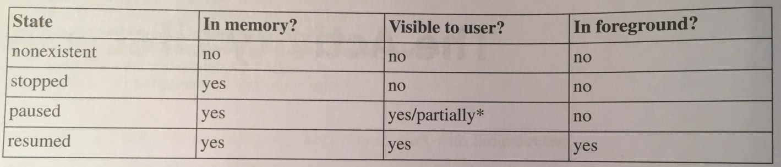

The resumed state represents the activity the user is currently interacting with. **Only one activity across all the apps on the device can be in the resumed state at any given time.**

Subclasses of Activity can take advantage of the methods in the above figure to get work done at critical transitions in the activity’s lifecycle. The methods are called the *lifecycle callbacks*.

We have already acquainted ourselves with one of these methods - onCreate(Bundle). The OS calls this method after the activity instance is created but before it’s put on screen.

Typically, an activity overrides onCreate(…) to prepare the specifics of its UI:

* Inflating widgets and putting them on screen (in the call to setContentView(int)).
* Getting references to inflated widgets.
* Setting listeners on widgets to handle user interaction.
* Connecting to external model data.

It’s important to understand that you never call onCreate(…) or any of the other Activity lifecycle methods yourself. You override them in your activity subclasses, and Android calls them at the appropriate time.

In Android, the android.util.Log class sends log messages to a shared system-level log. Log has several methods for logging messages. Here is the one that you will use most often:

public static int d(String tag, String msg);

The d stands for “debug” and refers to the level of the log message. The first parameter identifies the source of the message, and the second is the contents of the message.

The first string is typically a TAG constant with the class name as its value. This makes it easy to determine the source of a particular message. For example, in the controller file, we can add:

private static final String TAG = "QuizActivity";

We can use the Log.d(…) method in the transition functions like so:

@Override

public void onDestroy(){

super.onDestroy();

Log.d(TAG, "onDestroy() called");

}

Notice that you call the superclass implementation before you log your message. **This superclass call is required.** Calling the superclass implementation before you do anything else should be the first line of each callback method override implementation.

The @Override annotation asks the compiler to ensure that the class actually has the method that you’re attempting to override. So, if you misspell the method name, the compiler will bitch and you can fix your code.

When your application is launched initially, onCreate(Bundle), onStart(), and onResume() are called, in that order.

If you press the Back button on your device, it calls onPause(), onStop(), and onDestroy(), in that order.

When you press the Back button, you tell Android, “I’m done with this activity, and I won’t need it anymore.” Android then destroys your activity. This is Android’s way of being frugal with your device’s limited resources.

If you press the Home button, your activity received calls to onPause() and onStop(), but **not** onDestroy(). If you press the Recents button and then reopen your app, the activity was started and resumed, but it did not need to be created.

Pressing the Home button tells Android, “I’m going to go look at something else, but I might come back.” Android pauses and stops your activity, but tries not to destroy it in case you come back.

However, a stopped activity’s survival isn’t guaranteed. When the system needs to reclaim memory, it’ll destroy stopped activities.

Another situation that pauses an activity is when it’s obscured from the user, such as by a pop-up window. Even if the window only partially covers the activity, the activity is paused and cannot be interacted with. The activity resumes when the pop-up window is dismissed.

In Android 6.0 Nougat and higher, your activity can be in the paused state while still being fully visible because 6.0 and above has multi-window mode, and the user can interact with a window that doesn’t contain your activity, and yet your activity will still be visible in the other window.

Now, let’s talk about the bug we mentioned at the end of Chapter 2, that of the app resetting when we change the device’s orientation. When you change the device’s orientation, the instance of QuizActivity that you were looking at is destroyed, and a new one is created.

Rotating the device changes the *device configuration*. The device configuration is a set of characteristics that describe the current state of an individual device. The characteristics that make up the configuration include screen orientation, screen density, screen size, keyboard type, dock mode, language, and more.

Typically, applications provide alternative resources to match different device configurations. You saw an example of this when you added multiple arrow icons to your project for different screen densities.

Screen density is a fixed component of the device configuration; it cannot change at runtime. On the other hand, some components, like screen orientation, *can* change at runtime.

When a *runtime configuration change* occurs, there may be resources that are a better match for the new configuration. So, Android destroys the activity, looks for resources that are the best fit for the new configuration, and then rebuilds a new instance of the activity with those resources.

To set-up these resources, you need to create a directory where they are defined. The book shows you how to do this with Android Studio on pages 64-66.

When you create a new resource directory, you need to keep the filenames they reference the same as the other configurations so that they can be referenced with the same resource ID.

What the book does is define a landscape XML file that uses a FrameLayout. FrameLayout is the simplest ViewGroup and does not arrange its children in any particular manner. In this layout, child views will be arranged according to their android:layout_gravity attributes.

Here’s an example:

<Button

…

android:layout_gravity="bottom|right"

…/>

This puts the Button on the lower-right of the window.

Android does the work of determining the best resource for you, but it has to create a new activity from scratch to do it. For a QuizActivity to display a different layout, setContentView(…) must be called again. And this will not happen unless onCreate(…) is called again. Thus, Android destroys the current QuizActivity on rotation and starts fresh to ensure that it has the resources that best match the new configuration.

Note that Android destroys the current activity and creates a new one whenever any runtime configuration change occurs. A change in keyboard availability or language could also occur at runtime, but a change in screen orientation is the runtime change that occurs most frequently.

Android does a great job of providing alternative resources at the right time. However, destroying and re-creating activities on rotation can cause headaches, too, because you lose information when the activity is destroyed.

To fix the bug we have right now on rotation losing everything, the post-rotation QuizActivity needs to know the old value of mCurrentIndex. You need a way to save this data across a runtime configuration change, like rotation. One way to do this is to override the Activity method:

protected void onSaveInstanceState(Bundle outState);

This method is called before onStop(), except when the user presses the Back button, in which case the activity will be destroyed.

The default implementation of onSaveInstanceState(…) directs all of the activity’s views to save their state as data in the Bundle object. A Bundle is a structure that maps string keys to values of certain limited types.

This Bundle is passed to onCreate(Bundle).

When you override onCreate(…), you call onCreate(…) on the activity’s superclass and pass in the bundle you just received. In the superclass implementation, the saved state of the views is retrieved and used to re-create the activity’s view hierarchy.

You can override onSaveInstanceState(…) to save additional data to the bundle and then read that data back in onCreate(…). This is how you’re going to save the value of mCurrentIndex across rotation.

First, we need to add a constant that’ll be our key for the key-value pair that will be stored in the bundle for what we want to save:

private static final String KEY_INDEX = "index";

Next, we override onSaveInstanceState(…) to write the value of mCurrentIndex to the bundle with the constant as its key:

@Override

public void onSaveInstanceState(

Bundle savedInstanceState){

super.onSaveInstanceState(savedInstanceState);

Log.i(TAG, "onSaveInstanceState");

**savedInstanceState.putInt(KEY_INDEX,**

**mCurrentIndex);**

}

Finally, in onCreate(…), check for this value. If it exists, assign it to mCurrentIndex:

if(savedInstanceState != null){

mCurrentIndex =

**savedInstanceState.getInt(KEY_INDEX, 0);**

}

The second argument here is the default value, which we’re not really using because we first check that there is a bundle in the first place.

Now no matter how many times you rotate, shit is saved and restored properly.

Note that the types that you can save to and restore from a Bundle are primitive types and classes that implement the Serializable or Parcelable interfaces.

It’s usually a bad idea to put objects of custom types into a Bundle, however, because the data might be stale when you get it back out. It’s a better choice to use some other kind of storage for the data and put a primitive identifier into the Bundle instead.

Overriding onSaveInstanceState(…) is not just for handling rotation. An activity can also be destroyed if the user navigates away for a while and Android needs to reclaim memory. Android will never destroy a running activity to reclaim memory - the activity must be in the paused or stopped state (**usually stopped**) to be destroyed. If an activity is paused or stopped, then its onSaveInstanceState(…) method is called.

How does the activity you stash in onSaveInstanceState(…) survive the activity’s death? When onSaveInstanceState(…) is called, the data is saved to the Bundle object. That Bundle object is then stuffed into your activity’s *activity record* by the OS.

To understand the activity record, we add a *stashed* state to the activity lifecycle:

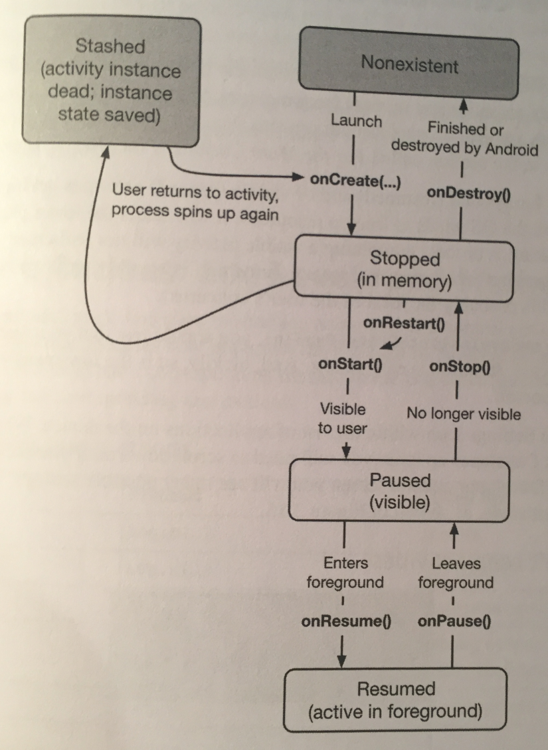

When your activity is stashed, an Activity object does not exist, but the activity record object lives on in the OS. The OS can reanimate the activity using the activity record when it needs to.

Note that your activity can pass into the stashed state without onDestroy() being called. However, you can always rely on onStop() and onSaveInstanceState(…) to be called.

Typically, you override onSaveInstanceState(…) to stash small, transient states that belong to the current activity in your Bundle and onStop() to save any permanent data, such as shit the user is editing, because your activity can be killed at any time after this method returns.

The activity record gets destroyed when the user presses the Back button. At that point, your activity record is discarded. Activity records are also typically discarded on reboot and may also be discarded of they’re not used for a long time.

Under some situations, Android will not only kill your activity but also completely shut down your entire application’s process. This will happen if the user is not currently looking at your application, but it can (and does) happen. Even in this case, the activity record will live on and enable a quick restart of your activity if the user returns.

The book gives some suggestions for testing that your state is being saved and restored properly on pages 72-73. It shows you how to turn on a setting that will always destroy activities if you’re not using them.

When you use the Log class to send log messages, you control not only the content of a message, but also a *level* that specifies how important the message is. Android supports five log levels, and each level has a corresponding method in the Log class. Sending output to the log is as simple as calling the corresponding Log method.

Here are the five log levels:

* ERROR, which uses Log.e(…) and is for errors.
* WARNING, which uses Log.w(…) and is for warnings.
* INFO, which uses Log.i(…) and is for informational messages.
* DEBUG, which uses Log.d(…) and is for debug output, which may be filtered out.
* VERBOSE, which uses Log.v(…) and is for development only, as release builds will be too slow if using it.

In addition, each of the logging methods has two signatures: one which takes a *tag* string and a message string and a second that takes those two arguments plus an instance of Throwable, which makes it easy to log information about a particular exception that your application might throw.

Here are some examples:

Log.d(TAG, “Current question index: “ + mCurrentIndex);

catch(ArrayIndexOutOfBoundsException ex){

//log a message at “error” log level, along with an //exception stack trace

Log.e(TAG, “Index was out of bounds”, ex);

}

**Chapter 4 - Debugging Android Apps:**

When you encounter runtime exceptions, **look for the last exception in LogCat and the first line in its stack trace that refers to code that you’ve written**. That’s where the problem occurs, and it’s the best place to start looking for answers.

If a crash occurs when the device is not plugged in, you can just connect the device and select it in Android Studio and LogCat will fill itself with the stored log. Devices typically keep logs for the last 10 minutes.

The book also shows you how to set breakpoints that occur when specific types of exceptions are thrown in your program, **right where they are thrown!** To use this feature, check out pages 83-84, where they show you how to do this in Android Studio.

In addition to Java problems, you’ll also have Android-specific problems that the Java compiler knows nothing about. This is where Android Lint comes in.

Android Lint is a static analyzer for Android code. A static analyzer is a program that examines your code to find defects without running it. Android Lint uses its knowledge of the Android frameworks to look deeper into your code and find problems that the compiler cannot. In most cases, Android Lint’s advice is worth taking.

You can manually run Lint to see all of the potential issues in your project. The book shows you how on page 85.

**Chapter 5 - Your Second Activity:**

An activity controls a screen of information.

*Starting* an activity means asking the OS to create an activity instance and call its onCreate(Bundle) method.

Creating an activity typically involves touching at least three files: the Java class file, an XML layout, and the application manifest. If you touch those files in the wrong ways, Android can get mad. To ensure that you do it right, you should use Android Studio’s New Activity Wizard.

When creating the XML for your activity, there is a special XML namespace for tools. This namespace allows you to override any attribute on a widget for the purpose of displaying it differently in the Android Studio preview.

For example, TextView has a text attribute, and you can provide a literal dummy value for it to help you see what it will look like at runtime from within the preview window. You do this like so:

tools:text="Answer"

The value “Answer” will never show up in the real app.

The *manifest* is an XML file containing metadata that describes your application to the Android OS. The file is **always** named AndroidManifest.xml, and it lives in the app/manifests directory of your project.

Every activity in an application **must** be declared in the manifest so that the OS can access it.

Now let’s talk about starting an activity from another activity. The simplest way one activity can start another is with the Activity method:

public void startActivity(Intent intent);

When this method is called, the call is sent to the OS. In particular, it’s sent to a part of the OS called the ActivityManager. The ActivityManager then creates the Activity instance and calls its onCreate(…) method.

How does the ActivityManager know which Activity to start? That information is in the Intent parameter.

An *intent* is an object that a *component* uses to communicate with the OS. The only components we have seen so far are activities, but there are also services, broadcast receivers, and content providers.

Intents are multi-purpose communication tools, and the Intent class provides different constructors depending on what you’re using the intent to do.

In our case, we are using the intent to tell the ActivityManager which activity to start, so you will use this constructor:

public Intent(Context packageContext, Class<?> cls);

The Class argument specifies the activity class that the ActivityManager should start. The Context argument tells the ActivityManager which application package the activity class can be found in.

Here is how shit would look:

mCheatButton = (Button) findViewById(R.id.cheat_button);

mCheatButton.setOnClickListener(

new View.OnClickListener() {

@Override

public void onClick(View v){

**//start CheatActivity**

**Intent i = new Intent(QuizActivity.this,**

**CheatActivity.class);**

**startActivity(i);**

}

});

Before starting the activity, the ActivityManager checks the package’s manifest for a declaration with the same name as the specified Class. If it finds the declaration, it starts the activity, and all is well. If it doesn’t, you get a nasty ActivityNotFoundException, which crashes your app. This is why all activities must be declared in the manifest.

When you create an Intent with a Context and a Class object, you are creating an *explicit intent*. You use **explicit intents** to start activities **within your application**.

It may seem strange that two activities within your application must communicate via the ActivityManager, which is outside your application. However, this pattern makes it easy for an activity in one application to work with an activity in another application.

When an activity in your application wants to **start an activity in another application**, you create an ***implicit intent***. You will see implicit intents in Chapter 15.

Now let’s talk about passing data between activities. To send data between activities, you will send this value as an *extra* on the Intent that’s passed into startActivity(Intent).

Extras are arbitrary data that the calling activity can include with an intent. You can think of them like constructor arguments, even though you cannot use a custom constructor with an activity subclass (Android creates activity instances and is responsible for their lifecycle). The OS forwards the intent to the recipient activity, which can then access the extras and retrieve the data.

An extra is structured as a key-value pair. To add an extra to an intent, you use Intent.putExtra(…). For our case, we will call:

public Intent putExtra(String name, boolean value);

Intent.putExtra(…) comes in many flavors, but it always has two arguments. The first argument is always a String key, and the second argument is the value, whose type will vary. It returns the Intent itself, **so you can chain multiple calls if you need to.**

Here’s how you would create the String key. **In the child activity**, make the String key like so:

private static final String EXTRA_ANSWER_IS_TRUE =

"com.bignerdranch.android.geoquiz.answer_is_true";

An activity may be started from several different places, **so you should define keys for extras on the activities that retrieve and use them**. Using your package name as a qualifier for your extra prevents name collisions with extras from other apps.

Now, the great way to place an extra into an intent is to encapsulate the input into a method. We will create a static newIntent(…) method to do this encapsulation, **in the child activity**:

public static Intent newIntent(Context packageContext,

boolean answerIsTrue){

Intent i = new Intent(packageContext,

CheatActivity.class);

i.putExtra(EXTRA_ANSWER_IS_TRUE, answerIsTrue);

return i;

}

This static method allows us to create an Intent properly configured with the extras CheatActivity will need. Using a newIntent(…) method like this for your activity subclasses will make it easy for other code to properly configure their launching intents.

We will create the intent and start the activity **in the parent activity** like so:

mCheatButton = (Button)

findViewById(R.id.cheat_button);

mCheatButton.setOnClickListener(

new View.OnClickListener() {

@Override

public void onClick(View v){

//start CheatActivity

**boolean answerIsTrue =**

**mQuestionBank[mCurrentIndex].isAnswerTrue();**

**Intent i =**

**CheatActivity.newIntent(QuizActivity.this,**

**answerIsTrue);**

startActivity(i);

}

});

You only need one extra, but you can put multiple extras on an Intent if you need to. To do this, add more arguments to your newIntent(…) method to stay consistent with the pattern.

To retrieve the Boolean value from the extra, you use:

public boolean getBooleanExtra(String name,

boolean defaultValue);

The first argument is the name of the extra. The second argument is the default answer if the key is not found.

**In the child activity**, retrieve the value sent:

…

private boolean mAnswerIsTrue;

…

mAnswerIsTrue = getIntent().getBooleanExtra(EXTRA_ANSWER_IS_TRUE,

false);

…

Note that Activity.getIntent() always returns the Intent that started the activity. This is what you sent when calling startActivity(Intent) from **the parent activity**.

When you want to hear back from a child activity, you call the following Activity method from the parent activity:

public void startActivityForResult(Intent intent,

int requestCode);

The first parameter is the same intent as before. The second parameter is the *request code*. The request code is a user-defined integer that’s sent to the child activity and then received back by the parent. It is used when an activity starts more than one type of child activity and needs to know who is reporting back.

Now our example will only ever start one type of child activity, but using a constant for the request code is best practice that will set you up well for future changes.

The first thing we do is define this request code and use it with startActivityForResult(…) **in the parent activity calling the child**:

…

**private static final int REQUEST_CODE_CHEAT = 0;**

…

mCheatButton.setOnClickListener(

new View.OnClickListener() {

@Override

public void onClick(View v){

//start CheatActivity

boolean answerIsTrue =

mQuestionBank[mCurrentIndex].isAnswerTrue();

Intent i =

CheatActivity.newIntent(QuizActivity.this,

answerIsTrue);

**startActivityForResult(i, REQUEST_CODE_CHEAT);**

}

});

Now, there are two methods you can call in the child activity to send data back to the parent:

public final void setResult(int resultCode);

public final void setResult(int resultCode,

Intent data);

Typically, the *result code* is one of two predefined constants: Activity.RESULT_OK or Activity.RESULT_CANCELED. You can also use another constant, RESULT_FIRST_USER, as an offset when defining your own result codes.

Setting result codes is useful when the parent needs to take different action depending on how the child activity finished.

Calling setResult(…) is not required of the child activity. If you don’t need to distinguish between results or receive arbitrary data on an intent, then you can let the OS send a default result code.

A result code is always returned to the parent if the child activity was started with startActivityForResult(…). If setResult(…) was not called, then when the user presses the Back button the parent will receive Activity.RESULT_CANCELED.

In our implementation, we are interested in passing some specific data back to the parent activity. So we create an Intent, put an extra into it, and then call Activity.setResult(int, Intent) to get that data into the parent activity’s hands.

**In the child activity**, we add a constant for the extra’s key and a private method that does this work:

…

private static final String EXTRA_ANSWER_SHOWN =

"com.bignerdranch.android.geoquiz.answer_shown";

…

mShowAnswer.setOnClickListener(

new View.OnClickListener() {

…

setAnswerShownResult(true);

}

…

private void setAnswerShownResult(

boolean isAnswerShown){

Intent data = new Intent();

data.putExtra(EXTRA_ANSWER_SHOWN,

isAnswerShown);

**setResult(RESULT_OK, data);**

}

…

When the user presses the Show Answer button, the CheatActivity packages up the result code and the intent in the call to setResult(int, Intent).

Then, when the user presses the back button to return to the QuizActivity, the ActivityManager calls the following method on the parent activity:

protected void onActivityResult(int requestCode,

int resultCode, Intent data);

The parameters are the original request code from the parent activity and the result code and intent passed into setResult(…) in the child activity.

The final step is to override onActivityResult(…) in the parent activity to handle the result. However, in our case, because the contents of the result Intent are also an implementation detail of CheatActivity (the constant EXTRA_ANSWER_SHOWN), add another method **in the child activity** to help decode the extra into something QuizActivity can use:

public static boolean wasAnswerShown(Intent result){

return result.getBooleanExtra(EXTRA_ANSWER_SHOWN,

false);

}

Now, lastly, in the parent activity, add a new member variable to hold the value that the child activity is passing back. Then override onActivityResult(…) to retrieve it, checking the request code and result code to be sure they’re what you expect. This is a best practice to make future maintenance easier.

@Override

protected void onActivityResult(int requestCode,

int resultCode, Intent data){

if(resultCode != Activity.RESULT_OK){

return;

}

if(requestCode == REQUEST_CODE_CHEAT){

if(data == null){

return;

}

**mIsCheater =**

**CheatActivity.wasAnswerShown(data);**

}

}

Finally, modify the checkAnswer(boolean) method in QuizActivity to check whether the user cheated and to respond accordingly. This code in on page 108.

This is how the Android OS sees your activities:

* When you click on an app to launch it, the OS does not start the app; it starts an activity in the application. More specifically, it starts the application’s *launcher activity*.
  + In our case, QuizActivity is the launcher activity. This is stated in the manifest.
* After you start an app, and you go to a separate screen, a new child activity is started, right on top of its parent activity. These activities exist in a stack.
* Pressing the back button on the child causes its activity to be popped off the stack, and the parent activity resumes its position on the top.
  + A call to Activity.finish() would also pop an activity off the stack.
* If you’re in the launcher activity and press back, the app will be popped off the stack and you will return to the last screen you were at before launching the app.

What we’re seeing here is that the ActivityManager maintains a *back stack* and that this back stack is not just for your application’s activities. Activities for **all** applications share the back stack, which is one reason the ActivityManager is involved in starting your activities and lives with the OS and not your application. The stack represents the use of the OS and device **as a whole** rather than the use of a single application.

**Chapter 6 - Android SDK Versions and Compatibility:**

The properties of supported versions of Android your app can run on appear in the build.gradle file.

In this file you can see three important values: the minimum SDK, the target SDK, and the compile SDK.

The minimum SDK value is a hard floor below which the OS should refuse to install the app.

The target SDK value tells Android which API level your app was *designed* to run on. Most often this will be the latest Android release. **If you don’t update this value when newer versions of Android come out, subsequent changes in those APIs are ignored.**

The compile SDK version is private information that states what SDK and API features you can use in your code. When Android Studio is looking to find classes and methods you refer to in your imports, the build target (compile SDK version) determines which SDK version it checks against.

You can modify the minimum SDK version, target SDK version, and compile SDK version in your build.gradle file, but note that modification of this file requires that you sync your project with the gradle changes before they will be reflected. You can select Tools🡪Android🡪Sync Project with Gradle Files. This will trigger a fresh build of your project with the updated values.

Let’s talk about an issue. What happens if your minimum SDK version is lower than your build SDK version, and you want to run code that exists on the newer build SDK version? Well, Android has gotten much better at dealing with this. **If you use code from a higher version than your minimum SDK, Android Lint will report build errors.**

How can you write conditional code that runs on newer devices and old code that runs on older devices? Use Build.VERSION.SDK_INT and the version code constant of the device, like so:

if(Build.VERSION.SDK_INT >=

Build.VERSION_CODES.LOLLIPOP){

…

}

The Build.VERSION.SDK_INT constant is the device’s version of Android.

**Chapter 7 - UI Fragments and the Fragment Manager:**

In this chapter we will make an application that has a list of items that you can tap to get a detailed description of. You might think that this would be easy and just take two activities. However, imagine this:

* Your user is running your app on a tablet. Tablets and larger phones have screens large enough to show the list and detail at the same time - at least in landscape orientation:

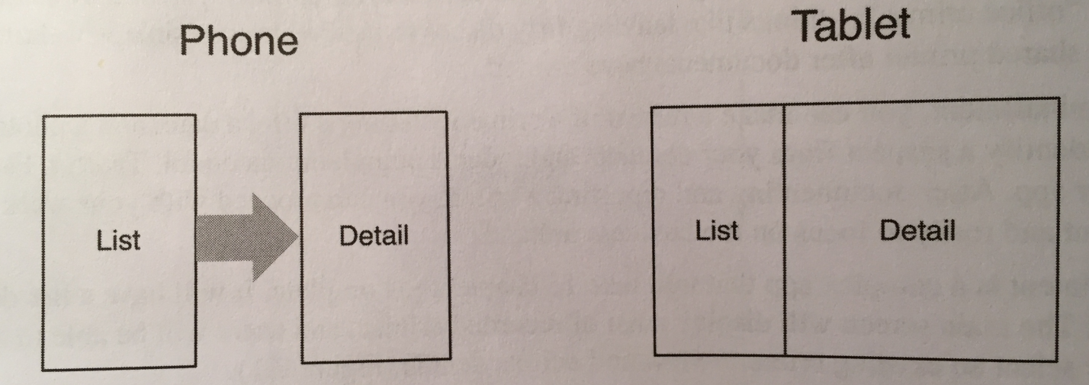

* Your user is viewing a detail on their phone and wants to see the next item in the list. It would be better if the user could swipe to see the next item without having to return to the list. Each swipe would update the detail view with information for the next item.

What these scenarios have in common is UI flexibility: the ability to compose and recompose an activity’s view at runtime depending on what the user or the device requires.

Activities were not built to provide this flexibility. An activity’s views may change at runtime, but the code to control those views must live inside the activity. As a result, activities are tightly coupled to a particular screen used by the user.

You can get around this by moving the app’s UI management from the activity to one or more *fragments*.

A *fragment* is a controller object that an activity can deputize to perform tasks. Most commonly, the task is managing a user interface. The user interface can be an entire screen or just one part of the screen.

A fragment managing a user interface is known as a *UI fragment*. A UI fragment has a view of its own that is inflated from a layout file. The fragment’s view contains the interesting UI elements that the user wants to see and interact with.

The activity’s view contains a spot where the fragment’s view will be inserted. Or it might have several spots for the views of several fragments.

You can use the fragment(s) associated with the activity to compose and re-compose the screen as your app and users require. The activity’s view technically stays the same throughout its lifetime, and no laws of Android are violated.

This is how it would work:

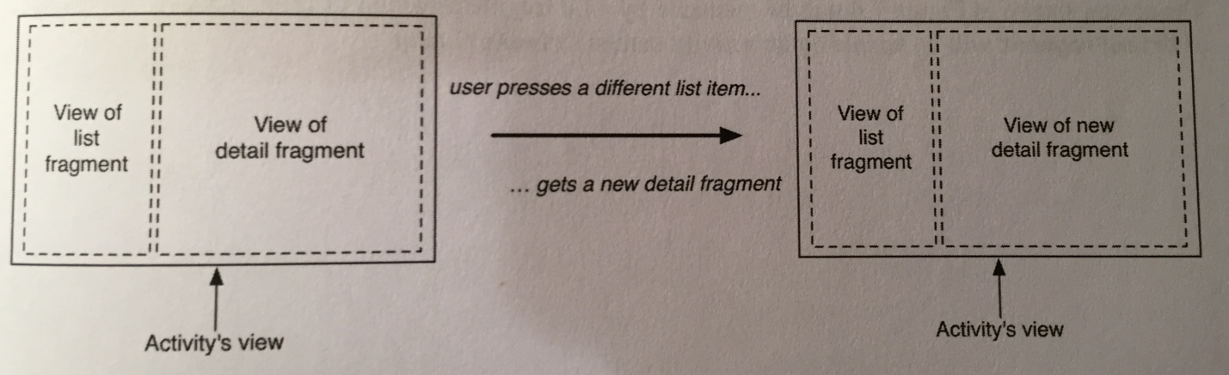

Using UI fragments separates the UI into building blocks, which is useful for more than just list-detail applications. Working with individual blocks, it’s easy to build tab interfaces, tack on animated sidebars, and more.

A fragment is incapable of getting a view on screen itself. Only when it’s placed in an activity’s hierarchy will its view appear. The activity will need to provide a spot for the fragment to be placed.

A fragment is *hosted* by an activity, in which the activity provides a spot in its view hierarchy where the fragment can place its view. A fragment is incapable of getting a view on screen itself. Only when it’s placed in an activity’s hierarchy will its view appear.

Fragments were introduced in API 11 along with the first Android tablets and the sudden need for UI flexibility. There are two implementations of fragments that we can use: native fragments or support fragments.

Native fragments are built into the device the user runs your app on. If you support many different versions of Android, each of those Android versions could have a slightly different implementation of fragments (for example, a bug could be fixed in one version and not in the version prior to it).

Support fragments are built into a library that you include in your application. This means that each device you run your app on will depend on the same implementation of fragments no matter the Android version. Because of this, we’ll use support fragments.

If you will use the implementation of support fragments, you need to include and use the *AppCompat* library, which is one of Google’s many compatibility libraries that you will use regularly. You need to make sure this AppCompat library is included in your list of dependencies.

Your project comes with two build.gradle files, one for the project as a whole and one for your app module. In the build.gradle of your app module you should see the AppCompat library there. If it isn’t, you need to add it in. The book shows you how on pages 131-133.

UUID is a Java utility class included in the Android framework. It provides an easy way to generate universally unique ID values. You generate a random unique ID by calling UUID.randomUUID().

To host a UI fragment, an activity must:

* define a spot in its layout for the fragment’s view
* manage the lifecycle of the fragment instance

The figure below shows the fragment lifecycle:

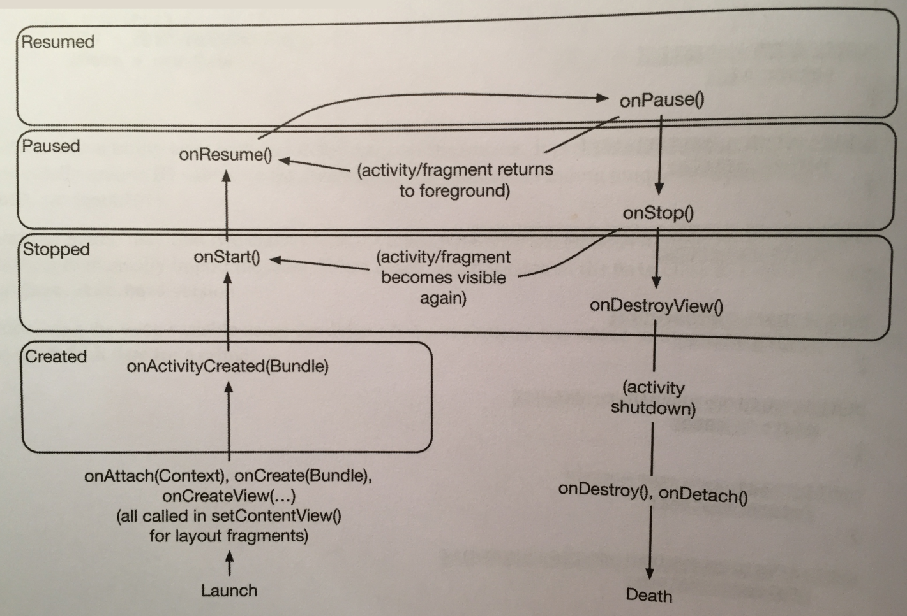

It is similar to the activity lifecycle: it has stopped, paused, and running states, and it has methods you can override to get things done at critical points - many of which correspond to activity lifecycle methods.

This correspondence is important. Because a fragment works on behalf of an activity, its state should reflect the activity’s state. Thus, it needs corresponding lifecycle methods to handle the activity’s work.

One critical difference between the fragment lifecycle and the activity lifecycle is that fragment lifecycle methods are called by the hosting activity, not the OS. The OS knows nothing about the fragments that an activity is using to manage things. **Fragments are the activity’s internal business.**

You have two options when it comes to hosting a UI fragment in an activity:

* add the fragment to the activity *layout*
* add the fragment in the activity’s *code*

The first approach is known as using a *layout fragment*. It’s simple but inflexible. If you add the fragment to the activity’s layout, you hardwire the fragment and its view to the activity’s view and cannot swap out that fragment during the activity’s lifetime.

The second approach, adding the fragment to the activity’s code, is more complex but flexible. It’s the only way to have control at runtime over your fragments. You determine when the fragment is added to the activity and what happens to it after that. You can remove the fragment, replace it with another, and then add the first fragment back again.

Thus, to achieve real UI flexibility, you must add your fragment in code. This is what we will do.

Even though you are adding the UI fragment in the hosting activity’s code, you still need to make a spot for the fragment’s view in the activity’s view hierarchy. The book does so on page 137 by adding a FrameLayout.

This FrameLayout will be the *container view* for a UI fragment. It does not name any fragment class and we will use this same layout to host other fragments.

Now that we have our container view to hold our fragment, we need to create a fragment.

The steps to creating a UI fragment are the same as those we followed to create an activity:

* compose a user interface by defining widgets in a layout file
* create the class and set its view to be the layout that we defined
* wire up the widgets defined from the layout in code

The book creates the layout by adding an XML file to the res/layout folder and adding shit to the layout file. This is done on pages 139-140.

The book then creates the fragment class. You need to make sure your fragment class extends Fragment, but **NOT** the Fragment from android.app, the Fragment from android.support.v4.app.Fragment.

Fragment lifecycle methods like onCreate(Bundle) **must be public** because they will be called by whatever activity is hosting the fragment.

Also, a fragment has a bundle to which it saves and retrieves its state. You can override Fragment.onSaveInstaceState(Bundle) for your own purposes just as you can override Activity.onSaveInstaceState(Bundle).

Note that you do **not** inflate the fragment’s view in onCreate(…). You configure the fragment instance in onCreate(…), but you create and configure the fragment’s view in another fragment lifecycle method:

public View onCreateView(LayoutInflater inflater,

ViewGroup container, Bundle savedInstanceState);

This method is where you inflate the layout for the fragment’s view and return the inflated View to the hosting activity. The LayoutInflater and ViewGroup parameters are necessary to inflate the layout. The Bundle will contain data that this method can use to retrieve the view from a saved state.

Here’s an example:

@Override

public View onCreateView(LayoutInflater inflater,

ViewGroup container, Bundle savedInstanceState){

**View v = inflater.inflate(R.layout.fragment_crime,**

**container, false);**

//wire widgets in fragment

…

return v;

}

Within onCreateView(…), you explicitly inflate the fragment’s view by calling inflate(…) and passing in the layout resource ID. The second parameter is your view’s parent, which is usually needed to configure the widgets properly. The third parameter tells the layout inflater whether to add the inflated view to the view’s parent. We pass in false because we will add the view in the activity’s code.

Next, we wire the widgets in the fragment. This is done in onCreateView(…), after the view gets inflated. Pages 145-147 shows what’s done. The one difference we need to take into account is that we must call View.findViewById(int) instead of Activity.findViewById(int). This is because the activity class has this method as a convenience method that calls view’s findViewById(int) behind the scenes. The Fragment class does not have a corresponding convenience method, so you have to call the real thing, like so:

v.findViewById(R.id.crime_title);

Now, the last thing you must do is add a fragment to an activity so it can be viewed onscreen.

When the Fragment class was introduced, the Activity class was changed to include a piece called the FragmentManager. The FragmentManager is responsible for managing your fragments and adding their views to the activity’s view hierarchy:

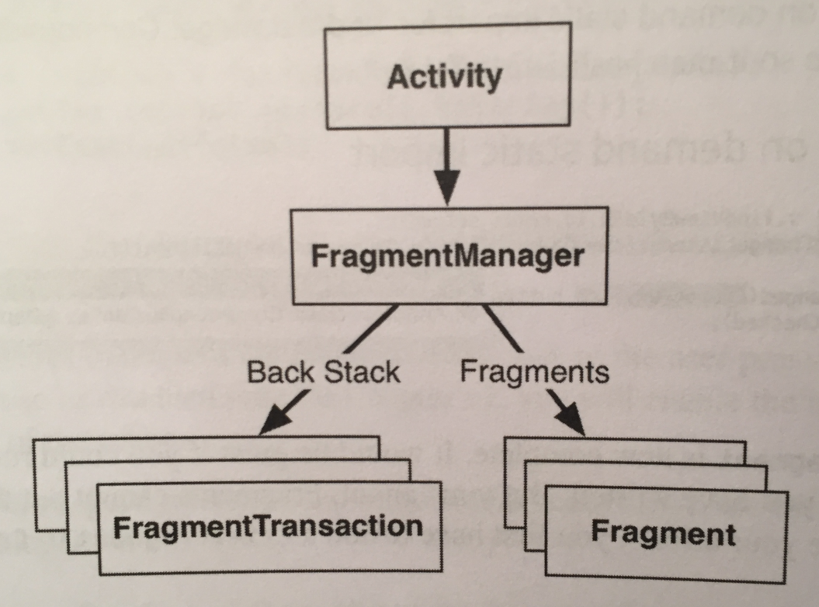

The FragmentManager handles two things: a list of fragments and a back stack of fragment transactions (which we will discuss shortly).

To add a fragment to an activity in code, you make explicit calls to the activity’s FragmentManager. The first step is to get the FragmentManager itself, like so:

FragmentManager fm = getSupportFragmentManager();

Now that you have the FragmentManager, add this code to give it a fragment to manage:

Fragment fragment =

fm.findFragmentById(R.id.fragment_container);

if(fragment == null){

fragment = new CrimeFragment();

fm.beginTransaction()

.add(R.id.fragment_container, fragment)

.commit();

}

Let’s look at the add(…) operation and the code around it. This code creates and commits a *fragment transaction*.

Fragment transactions are used to add, remove, attach, detach, or replace fragments in the fragment list. They are the heart of how you use fragments to compose and recompose screens at runtime. The FragmentMnager maintains a stack of fragment transactions that you can navigate.

The FragmentManager.beginTransaction() method creates and returns an instance of FragmentTransation. The FragmentTransaction class uses a *fluent interface* - methods that configure FragmentTransaction return a FragmentTransaction instead of void, so you can chain them together. So, the code above says, “Create a new fragment transaction, include one add operation in it, and then commit it.”

The add(…) method itself is the meat of the transaction. It has two parameters: a container view ID and the newly created fragment. The container view ID should look familiar. It’s the resource ID of the FrameLayout that we defined earlier.

A container view ID serves two purposes:

* It tells the FragmentManager where in the activity’s view the fragment’s view should appear.
* It’s used as a unique identifier for a fragment in the FragmentManager’s list.

When you need to retrieve the fragment from the FragmentManager, you ask for it by its container view ID:

Fragment fragment =

fm.findFragmentById(R.id.fragment_container);

Identifying a UI fragment by the resource ID of its container view is built into how the FragmentManager operates. If you are adding multiple fragments to an activity, you would typically create separate containers with separate IDs for each of those fragments.

Therefore, what the code above is doing is first asking the FragmentManager for the fragment with a container view ID of R.id.fragment_container. If this fragment is already in the list, the FragmentManager will return it.

Why would a fragment already be in the list? The call to the activity’s onCreate(…) method could be in response to the activity being *re-created* after being destroyed on rotation or to reclaim memory. When an activity is destroyed, its FragmentManager **saves out** its list of fragments. When the activity is re-created, the new FragmentManager retrieves the list and re-creates the listed fragments to make everything as it was before.

On the other hand, if there is no fragment with the given container view ID, then fragment will be null. In this case, you create a new fragment and a new fragment transaction that adds the fragment to the list.

The FragmentManager of an activity is responsible for calling the lifecycle methods of the fragments in its list. The onAttach(Context), onCreate(Bundle), and onCreateView(…) methods are called when you add the fragment to the FragmentManager.

The onActivityCreated(Bundle) method in the “Created” stage of the fragment lifecycle gets called after the hosting activity’s onCreate(Bundle) method has executed. When you add a fragment in an activity’s onCreate(Bundle) method, onActivityCreated(Bundle) will be called after the fragment has been added.

It’s important to note that the fragment’s lifecycle will mirror its containing activity lifecycle as closely as possible. If you add a fragment while the activity is already running, then the FragmentManager immediately walks the fragment thru whatever steps are necessary to get it caught up to the activity’s state.

Once the fragment’s state is caught up to the activity’s state, the hosting activity’s FragmentManager will call further lifecycle methods around the same time it receives the corresponding calls from the OS to keep the fragment’s state aligned with that of the activity.

**Don’t use fragments for every reusable component. Only for major components.**

Fragments are intended to encapsulate major components in a reusable way. A major component in one case would be on the level of an entire screen of your application.

If you have a significant number of fragments on screen at once, your code will be littered with fragment transactions and unclear responsibility. A better architectural solution for reuse with smaller components is to extract them into a custom view (a class that subclasses View or one of its subclasses).

**A good rule of thumb is to have no more than two to three fragments on the screen at a time.**

**Chapter 8 - Displaying Lists with RecyclerView:**

The book does something very interesting. First it creates a singleton store to hold Crime objects. The code for this is on page 159-161.

Then, the book creates a generic activity XML that can be used for multiple tasks. This is done on pages 161-162.

Next, the book creates an abstract activity that gets a different fragment depending on what fragment uses the abstract activity. What the book does is define a protected method to create a fragment:

protected abstract Fragment createFragment();

Then, we override this method in subclasses so that the correct fragment gets created when this abstract activity is used. We use this method when we create a fragment:

if(fragment == null){

fragment = **createFragment()**;

fm.beginTransaction()

.add(R.id.fragment_container, fragment)

.commit();

}

Then, to use this abstract class, we simply override the createFragment() method like so:

@Override

protected Fragment createFragment(){

return new CrimeFragment();

}

Remember, if you create an activity, **you must declare it in the manifest!** Also, if your new activity is the launch activity, the manifest needs to know.

Here’s how that’s done in the manifest file:

…

<activity android:name=".CrimeListActivity">

<intent-filter>

**<action android:name=**

**"android.intent.action.MAIN"/>**

**<category android:name=**

**"android.intent.category.LAUNCHER"/>**

</intent-filter>

</activity>

<activity android:name=".CrimeActivity">

</activity>

…

We will use a RecyclerView to list model objects. RecyclerView is a subclass of ViewGroup. It displays a list of child View objects, one for each item in your list of items. Depending on the complexity of what you need to display, these child Views can be complex or very simple.

If you have hundreds of model objects to display, RecyclerView will **NOT** make hundreds of child views. You only need child views that are on the screen; therefore it would make sense to create child view objects only as you need them.

RecyclerView does just that. Instead of creating all views, it creates just enough views to fill the screen. When a view is scrolled off the screen, RecyclerView reuses it rather than throwing it away. It recycles views over and over.

The RecyclerView’s only responsibilities are recycling TextViews and positioning them on the screen. To get the TextViews in the first place, it works with two classes: an Adapter subclass and a ViewHolder subclass.

The ViewHolder does one thing, it holds onto a View:

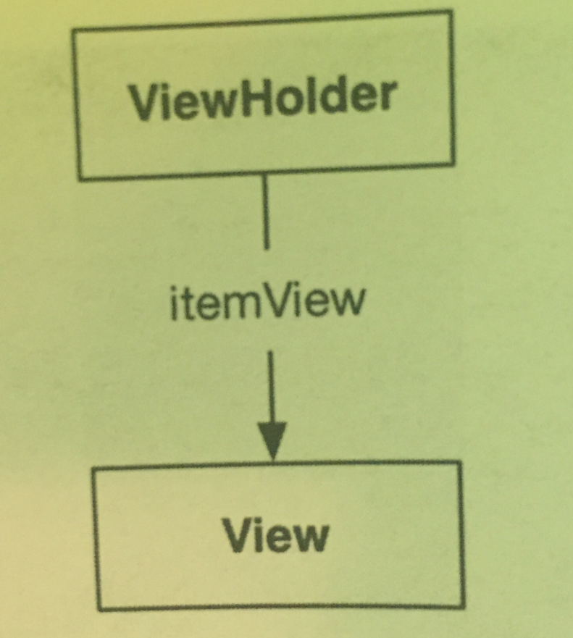

A small job, but it makes shit easier when views are very complicated. A typical ViewHolder subclass looks like this:

public class ListRow **extends RecyclerView.ViewHolder**{

public ImageView mThumbnail;

public ListRow(View view){

super(view);

mThumbnail =   
 (ImageView)view.findViewById(R.id.thumbnail);

}

}

You can then create a ListRow and access both mThumbnail, which you created yourself, and itemView, a field your superclass RecyclerView.ViewHolder assigns for you. The itemView field is your ViewHolder’s reason for existing: it holds a reference to the entire View you passed into super(view).

A RecyclerView never creates Views by themselves. It always creates ViewHolders, which bring their itemViews along for the ride:

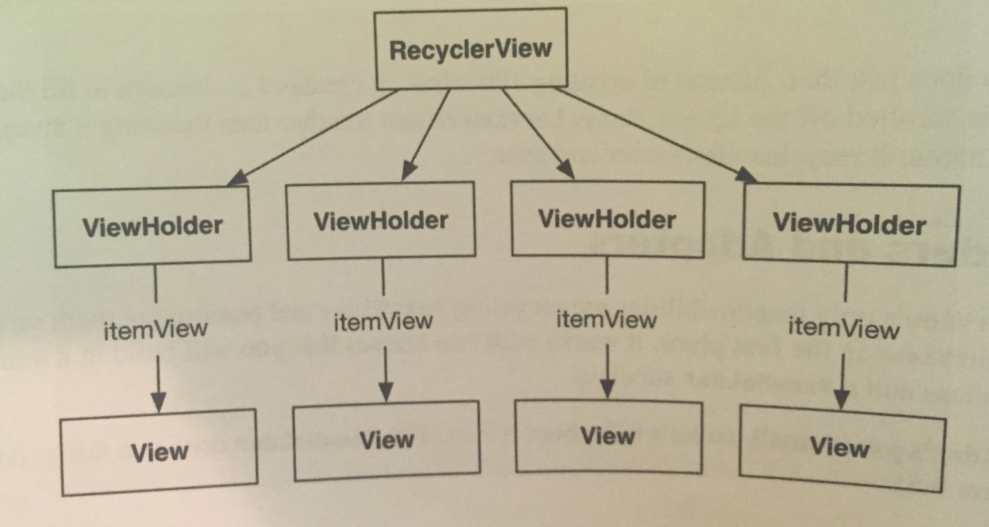

When the View is simple, ViewHolder has few responsibilities. For more complicated Views, the ViewHolder makes wiring up the different parts of itemView to a model object simpler and more efficient.

The picture above is somewhat simplified. RecyclerView does not create ViewHolders itself. Instead, it asks an *adapter*. An adapter is a controller object that sits between the RecyclerView and the data set that the RecyclerView should display.

The adapter is responsible for:

* Creating the necessary ViewHolders
* Binding ViewHolders to data from the model layer

To build an adapter, you must first define a subclass of RecyclerView.Adapter. Your adapter subclass will wrap the list of model objects you get from your store.

When the RecyclerView needs a view object to display, it will have a conversation with its adapter, like so:

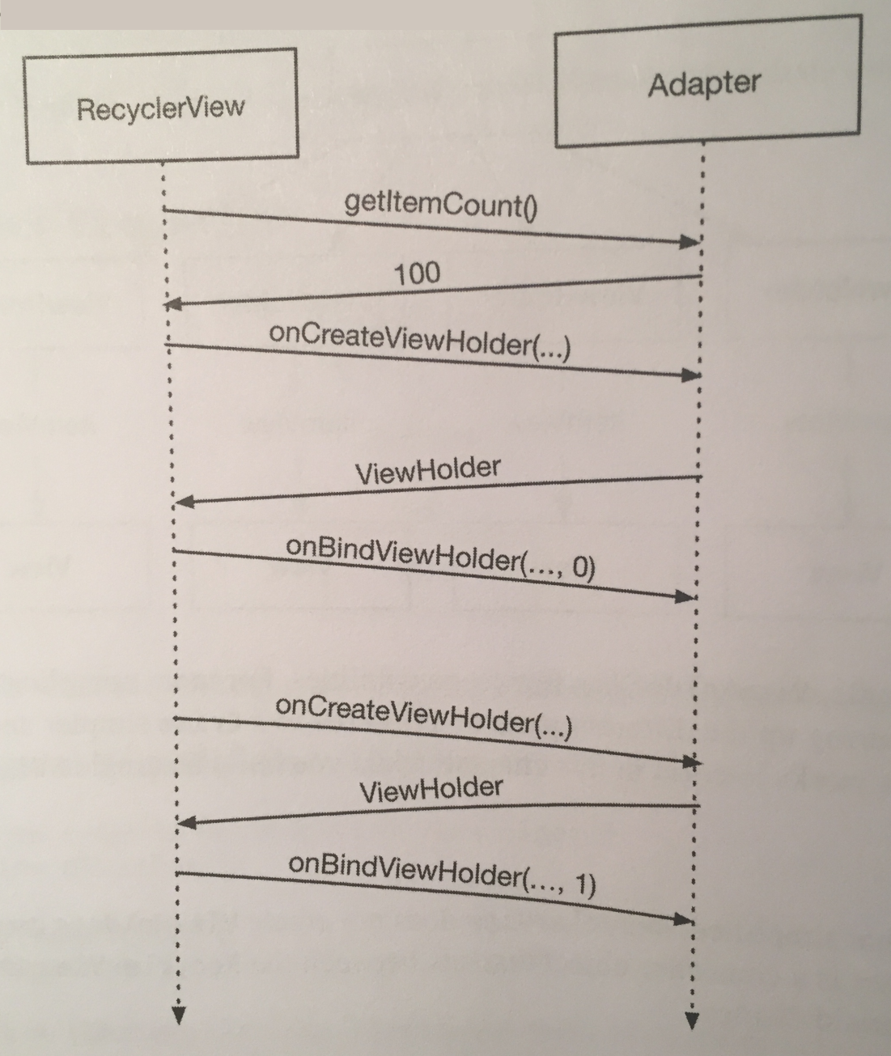

First, RecyclerView asks how many objects are in the list by calling the adapter’s getItemCount() method.

Then the RecyclerView calls the adapter’s onCreateViewHolder(ViewGroup, int) method to create a new ViewHolder, along with its juicy payload: a View to display.

Finally, the RecyclerView calls

onBindViewHolder(ViewHolder, int). The RecyclerView will pass a ViewHolder into this method along with the position. The adapter will look up the model data for that position and *bind* it to the ViewHolder’s View. To bind it, the adapter fills in the View to reflect the data in the model object.

After this process is complete, RecyclerView will place a list item on the screen. Note that onCreateViewHolder(ViewGroup, int) will happen a lot **less** often than onBindViewHolder(ViewHolder, int). Once a sufficient number of ViewHolders have been created, RecyclerView stops calling OnCreateViewHolder(…). Instead, it saves time and memory by recycling old ViewHolders.

To set up a RecyclerView, we need to import its dependency into the project (which is gone over on page 171), make a layout file for it, and then set it up in our fragment class file that will use it, like so:

private RecyclerView mCrimeRecyclerView;

@Override

public View onCreateView(LayoutInflater inflater, ViewGroup container, Bundle savedInstanceState){

View view =

inflater.inflate(R.layout.fragment_crime_list,

container, false);

**mCrimeRecyclerView =**

**(RecyclerView)view.findViewById(**

**R.id.crime_recycler_view);**

**mCrimeRecyclerView.setLayoutManager(**

**new LinearLayoutManager(getActivity()));**

return view;

}

Note that as soon as you create your RecyclerView, you give it another object called a LayoutManager. RecyclerView requires a LayoutManager to work.

We said earlier that RecyclerView’s only responsibilities are recycling Views and positioning them on the screen. But RecyclerView does not do the job of positioning items on the screen itself. It delegates that out to the LayoutManager. The LayoutManager handles the positioning of items and also defines the scrolling behavior. So if the LayoutManager is not there, RecyclerView will just fall over.

There are a few built-in LayoutManagers to choose from, and you can find more as third-party libraries. The code above uses LinearLayoutManager, which will position the items in the list vertically.

Each item displayed on the RecyclerView will have its own view hierarchy, exactly the way a fragment has a view hierarchy for an entire screen. You create a new layout for a list item view the same way you do for an activity or a fragment.

The book has the adapter and ViewHolder living as inner classes in the fragment class. The ViewHolder code is easy to understand:

private class CrimeHolder

extends RecyclerView.ViewHolder{

public CrimeHolder(LayoutInflater inflater,

ViewGroup parent){

super(inflater.inflate(

R.layout.list_item_crime, parent, false));

}

}

Here we inflate our list item view and pass it into ViewHolder’s super(…) constructor. The base ViewHolder class will then hold on to the RecyclerView view hierarchy. If you need that view hierarchy, you can find it in ViewHolder’s itemView field.

With the ViewHolder defined, we now create the adapter (remember it’s an inner class in the list fragment class):

private class CrimeAdapter

extends RecyclerView.Adapter<CrimeHolder>{

private List<Crime> mCrimes;

public CrimeAdapter(List<Crime> crimes){

mCrimes = crimes;

}

}

When the RecyclerView needs to display a new ViewHolder or connect a model object to an existing ViewHolder, it’ll ask this adapter for help by calling a method on it. The RecyclerView itself will **not** know anything about the model object, but the Adapter will know all of the model object’s intimate details.

We now need to implement three methods on the adapter.

onCreateViewHolder(…) is called by the RecyclerView when it needs a new View to display an item. In this method, you create a LayoutInflater and use it to construct a new ViewHolder:

@Override

public CrimeHolder onCreateViewHolder(

ViewGroup parent, int viewType) {

LayoutInflater layoutInflater =

LayoutInflater.from(getActivity());

return new CrimeHolder(layoutInflater, parent);

}

Now that you have an adapter, you can connect it to your RecyclerView. We make a method called updateUI() that sets up a fragment’s UI:

…

**private CrimeAdapter mAdapter;**

…

@Override

public View onCreateView(LayoutInflater inflater, ViewGroup container, Bundle savedInstanceState){

…

**updateUI();**

return view;

}

**private void updateUI(){**

**CrimeLab crimeLab = CrimeLab.get(getActivity());**

**List<Crime> crimes = crimeLab.getCrimes();**

**mAdapter = new CrimeAdapter(crimes);**

**mCrimeRecyclerView.setAdapter(mAdapter);**

**}**

Now we need to create code that binds our model data to each of the view cells in the RecyclerView. What we do is split the work to have inflation of a view and binding of that inflated view in separate places.

All the code that will do the binding will go inside of our ViewHolder class. That work starts with pulling out the widgets we’re interested in. This only needs to happen one time, so we write this code in our ViewHolder constructor:

private class CrimeHolder

extends RecyclerView.ViewHolder{

**private TextView mTitleTextView;**

**private TextView mDateTextView;**

public CrimeHolder(LayoutInflater inflater,

ViewGroup parent){

super(inflater.inflate(

R.layout.list_item_crime,

parent, false));

**mTitleTextView =**

**(TextView)itemView.findViewById(**

**R.id.crime_title);**

**mDateTextView =**

**(TextView)itemView.findViewById(**

**R.id.crime_date);**

}

}

We also need to create a bind(Crime) method, which will be called each time a new Crime should be displayed in our ViewHolder:

private class CrimeHolder

extends RecyclerView.ViewHolder{

**private Crime mCrime;**

…

**public void bind(Crime crime){**

**mCrime = crime;**

**mTitleTextView.setText(mCrime.getTitle());**

**mDateTextView.setText(**

**mCrime.getDate().toString());**

**}**

}

Now when given a model object, our ViewHolder can update its TextView’s to reflect the state of that model object.

Next, we call our bind(Crime) method in our adapter class’ onBindViewHolder(…) method (the second method we must override on adapter), which is called each time the RecyclerView requests that a given ViewHolder be bound to a particular model object:

@Override

public void onBindViewHolder(CrimeHolder holder,

int position) {

Crime crime = mCrimes.get(position);

holder.bind(crime);

}

**Always be efficient in your onBindViewHolder(…)! Otherwise, your scrolling will be slow!!**

The last method on adapter we need to implement is getItemCount(), which stores how many items are in our RecyclerView:

@Override

public int getItemCount() {

return mCrimes.size();

}

You can also make the RecyclerView respond to touches of its rows. There are many ways to do this. You can make RecyclerView forward along raw touch events, but the thing you’d normally do is to have an OnClickListener associated with the ViewHolder inner class of the RecyclerView to handle touch events whenever a row is clicked on the RecyclerView. This would all look like so:

private class CrimeHolder

extends RecyclerView.ViewHolder

**implements View.OnClickListener**{

…

public CrimeHolder(LayoutInflater inflater,

ViewGroup parent){

super(inflater.inflate(

R.layout.list_item_crime, parent, false));

**itemView.setOnClickListener(this);**

…

}

…

**@Override**

**public void onClick(View view){**

**Toast.makeText(getActivity(),**

**mCrime.getTitle() + " clicked!",**

**Toast.LENGTH_SHORT).show();**

**}**

}

Here we’re just making a toast, but later we will load in the detail view fragment to show the model object’s details.

**Chapter 9 - Creating User Interfaces with Layouts and Widgets:**

So far, we’ve been creating layouts by typing XML. Now, we’ll use ConstraintLayouts. With ConstraintLayout, instead of using nested layouts we add a series of *constraints* to our layout.

A constraint is like a rubber band, it pulls two things towards each other. So, for example, we can attach a constraint from the right edge of an ImageView to the right edge of its parent (the ConstraintLayout itself) as shown below:

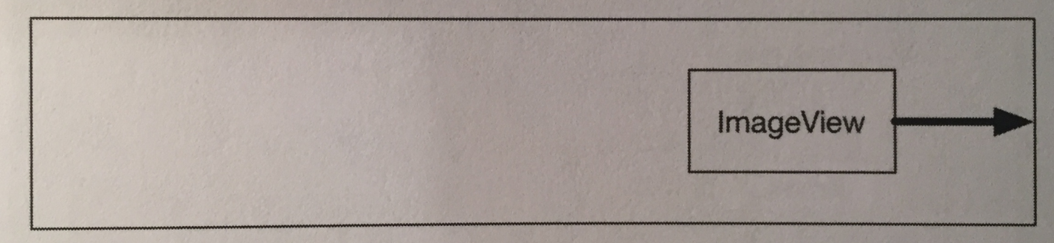

The constraint will hold the ImageView to the right.

We can create a constraint from all four edges of our ImageView (left, top, right, bottom). If we have opposing constraints, they’ll equal out and our ImageView will be right in the center of the two constraints:

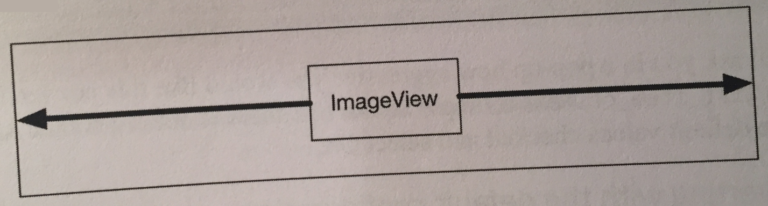

So to place views where you want them to go in a ConstraintLayout, you give them constraints instead of dragging them around the screen.

What about sizing widgets? For that we have three options:

* Let the widget decide (for instance, with wrap_content).
* Decide for yourself.
* Let your widget expand to fit your constraints.

To convert your layout to use a constraint layout, use the instructions on pages 184-185.

The book then goes over the GUI for adding constraints and shows you how to add constraints using the GUI. This is shown on pages 186-193.

When you add layout parameters using the GUI, in the XML they look like this:

app:layout_constraintTop_toTopOf="parent"

This attribute begins with layout_. All attributes that begin with layout_ are known as *layout parameters*. Unlike other attributes, layout parameters are directions to that widget’s *parent*, not the widget itself. They tell the parent layout how to arrange the child element within itself. We’ve seen a few layout parameters so far, like layout_width and layout_height.

The book then shows you how to add constraints to TextView’s on pages 195-198.

Now, we can use our views in the constraint layout to update attributes on them. First, we need to change our ID in the constraint layout GUI. This is easy and the book shows us how to do this on the top of page 199.

With the proper ID in place, we can now update our code to, for instance, show or hide the visibility of an ImageView, like so:

private class CrimeHolder

extends RecyclerView.ViewHolder

implements View.OnClickListener{

…

private ImageView mSolvedImageView;

public CrimeHolder(LayoutInflater inflater,

ViewGroup parent){

…

mSolvedImageView =

(ImageView)itemView.findViewById(

R.id.crime_solved);

}

public void bind(Crime crime){

…

mSolvedImageView.setVisibility(

mCrime.isSolved() ? View.VISIBLE : View.GONE);

}

…

}

Let’s talk about attribute units. Sometimes you need to specify values for view attributes in terms of specific sizes (usually in pixels, but sometimes in points, millimeters, or inches). You see this most commonly with attributes for text size, margins, and padding.

Android automatically scales images to different screen pixel densities using density drawable folders (such as drawable-xhdpi). But what happens when your images scale, but your margins don’t? Shit fucks up is what.

To solve this and other problems, Android provides density-independent dimension units that you can use to get the same size on different screen densities. Android translates these units into pixels at runtime, so there’s no tricky math for you to do.

Here are the units and their descriptions:

* dp: Short for *density-independent pixel* and usually pronounced “dip.” You typically use this for margins, padding, or anything else for which you would otherwise specify size with a pixel value.

When your display is a higher density, density-independent pixels will expand to fill a larger number of screen pixels. One dp is always 1/160th of an inch on a device’s screen. You get the same size regardless of screen density.

* sp: Short for *scale-independent pixel*. Scale-independent pixels are density-independent pixels that also take into account the user’s font size preference. You will almost always use sp to set display text size.
* pt, mm, and in: These are scaled units like dp that allow you to specify interface sizes in points (1/72 of an inch), millimeters, or inches. **However, don’t use them; not all devices are correctly configured for these units to scale correctly.**

Now that we know what layout parameters are, we can go into the difference between margins and padding. Margin attributes are layout parameters. They determine the distance between widgets. Given that a widget can only know about itself, margins must be the responsibility of the widget’s parents.

Padding, on the other hand, is **not** a layout parameter. The android:padding attribute tells the widget how much bigger than its contents it should draw itself. So, if, for example, you wanted a big button with the same size text in the button, make its padding large.

A *style* is an XML resource that contains attributes that describe how a widget should look and behave. For example, the following is a style resource that configures a widget with a larger-than-normal text size:

<style name=”BigTextStyle”>

<item name=”android:textSize”>20sp</item>

<item name=”android:padding”>3dp</item>

</style>

You can create your own styles and add them to a styles file in res/values/ and refer to them in layouts like this: @style/my_own_style.

You can also use styles that are created by Android. Here is an example:

style="?android:listSeparatorTextViewStyle"

This particular style makes the TextView look like a list separator and comes from the app’s *theme*. A *theme* is a collection of styles. Structurally, a theme itself is a style resource whose attributes point to other style resources.

Android provides platform themes that your apps can use. When you create a project, the wizard sets up a theme for your app that is referenced on the application tag in the manifest.

You can apply a style from the app’s theme to a widget using a *theme attribute reference*. This is what you did in the code above.

In the theme attribute reference, you tell Android’s runtime resource manager, “Go to the app’s theme and find the attribute named listSeparatorTextViewStyle. This attribute points to another style resource. Put the value of that resource here.”

Every Android theme will include an attribute named listSeparatorTextViewStyle, but its definition will be different depending on the overall look and feel of the particular theme. Using a theme attribute reference ensures that the TextViews will have the correct look and feel for your app.

**Chapter 10 - Using Fragment Arguments:**

This chapter will bring a list and detailed info from that list together. To get this to work, we will start an activity from a fragment.

Starting an activity from a fragment works nearly the same as starting an activity from another activity. You call the Fragment.startActivity(Intent) method, which calls the corresponding Activity method behind the scenes. We do this **in the fragment that contains our list**:

public void onClick(View v){

Intent intent = new Intent(getActivity(),

CrimeActivity.class);

startActivity(intent);

}

Here our fragment creates an explicit intent that names the CrimeActivity class. The fragment uses the getActivity() method to pass its hosting activity as the Context object that the Intent constructor requires.

However, we are not done. We need to tell the Activity we called which model object to display.

We do this by giving the fragment the model object ID as an Intent extra when the activity is started.

We first create a newIntent(…) method in CrimeActivity:

public static final String EXTRA_CRIME_ID = "com.bignerdranch.anroid.criminalIntent.crime_id";

public static Intent newIntent(Context packageContext,

UUID crimeID) {

Intent intent = new Intent(packageContext,

CrimeActivity.class);

intent.putExtra(EXTRA_CRIME_ID, crimeID);

return intent;

}

Now update the ViewHolder **in the fragment that contains our list** to use the newIntent(…) method while passing the crime ID:

public void onClick(View v){

Intent intent =

CrimeActivity.newIntent(getActivity(),

mCrime.getId());

startActivity(intent);

}

The crime ID is now safely stashed in the intent that belongs to CrimeActivity. However, it’s the CrimeFragment class, **the fragment that’s hosted by CrimeActivity, NOT the CrimeListFragment that contains the list of data**, that needs to retrieve and use that data.

There are two ways a fragment can access data in its activity’s intent: an easy, direct shortcut and a complex, flexible implementation. First, we’re going to do the shortcut.

In the shortcut, CrimeFragment will simply use getActivity() to access the CrimeActivity’s intent directly:

//this code is in the CrimeFragment class

@Override

public void onCreate(Bundle savedInstanceState){

super.onCreate(savedInstanceState);

UUID crimeID = (UUID)

getActivity().getIntent()

.getSerializableExtra(

CrimeActivity.EXTRA_CRIME_ID);

mCrime =

CrimeLab.get(getActivity())

.getCrime(crimeID);

}

Here, the getIntent() method returns the Intent that was used to start the activity. We call getSerializableExtra(String) on the Intent to pull the UUID out into a variable.

After we have retrieved the ID, we use it to fetch the model Crime object from the singleton CrimeLab store.

Now that CrimeFragment fetches a Crime, its view can display the Crime’s data. We update onCreateView(…) to display the Crime’s data, the code of which is on page 208.

The downside of this direct retrieval is that having the fragment access the intent that belongs to the hosting activity makes for simple code, but costs you the encapsulation of your fragment. The fragment is no longer a reusable building block because it expects that it will always be hosted by an activity who’s Intent defines the extra it needs.

This means that the fragment cannot be used with just any activity. A better solution is to stash the ID someplace that belongs to the fragment rather than keeping it in the activity’s personal space. The fragment could then retrieve this data without relying on the presence of a particular extra in the activity’s intent. That “someplace” that belongs to a fragment is known as its *arguments bundle*.

Every fragment instance can have a Bundle object attached to it. This bundle contains key-value pairs that work just like the intent extras of an Activity. Each pair is known as an *argument*.

To create fragment arguments, you first create a Bundle object. Next, you use type-specific “put” methods of Bundle to add arguments to the bundle:

Bundle args = new Bundle();

args.putInt(EXTRA_MY_INT, myInt);

To attach the arguments bundle to a fragment, you call Fragment.setArguments(Bundle). Attaching arguments to a fragment must be done **after** the fragment is created but **before** it’s added to an activity.

To hit this window, Android programmers follow a convention of adding a static method named newInstance(…) to the Fragment class. This method creates the fragment instance and bundles up and sets its arguments.

When the hosting activity needs an instance of that fragment, you have it call the newInstance(…) method rather than calling the constructor directly. The activity can pass in any required parameters to newInstance(…) that the fragment needs to create its arguments.

Here’s an example of a newInstance(…) method:

public class CrimeFragment extends Fragment{

private static final String ARG_CRIME_ID =

"crime_id";

…

public static CrimeFragment newInstance(

UUID crimeID){

Bundle args = new Bundle();

args.putSerializable(ARG_CRIME_ID, crimeID);

CrimeFragment fragment = new CrimeFragment();

fragment.setArguments(args);

return fragment;

}

…

}

This newInstance(UUID) method accepts a UUID, creates an arguments bundle, creates a fragment instance, and then attaches the arguments to the fragment.

Now CrimeActivity should call CrimeFragment.newInstance(UUID) when it needs to create a CrimeFragment. It will pass in the UUID it retrieved from its extra. We need to go into CrimeActivity and, in createFragment(), retrieve the extra from CrimeActivity’s intent and pass it into CrimeFragment.newInstance(UUID). We can also make EXTRA_CRIME_ID private since no other class will access that extra:

@Override

protected Fragment createFragment(){

UUID crimeId =

(UUID)getIntent().getSerializableExtra(

EXTRA_CRIME_ID);

return CrimeFragment.newInstance(crimeId);

}

So, what we have basically done here is **separate the activity specific extra from what the fragment** will take in, because now we have a newInstance(UUID) method in the fragment that we can change to satisfy whatever needs we want, **outside of what the activity provides**.

Notice that this independence does not go both ways. CrimeActivity needs to know plenty about CrimeFragment, including that it has a newInstance(UUID) method. This is fine. **Hosting activities should know the specifics of how to host their fragments, but fragments should not have to know specifics about their activities.** At least, not if you wanna maintain the flexibility of independent fragments.

Now, when a fragment needs to access its arguments, it calls the Fragment method getArguments() and then one of the type-specific “get” methods of Bundle:

@Override

public void onCreate(Bundle savedInstanceState){

super.onCreate(savedInstanceState);

**UUID crimeID = (UUID)**

**getArguments().getSerializable(ARG_CRIME_ID);**

mCrime =

CrimeLab.get(getActivity()).getCrime(crimeID);

}

We have one more snag to take care of. When we modify the details of a Crime, these changes are saved to the model, but when you return to the list, the RecyclerView is unchanged.

The RecyclerView’s Adapter needs to be informed that the data has changed (or may have changed) so that it can re-fetch the data and reload the list. You can work with the ActivityManager’s back stack to reload the list at the right moment.

When CrimeListFragment starts an instance of CrimeActivity, the CrimeActivity is put on top of the stack. This pauses and stops the instance of CrimeListActivity that was initially on top.

When the user presses the Back button to return to the list, the CrimeActivity is popped off the stack and destroyed. At that point, the CrimeListActivity is started and resumed.

When the CrimeListActivity is resumed, it receives a call to onResume() from the OS. When CrimeListActivity receives this call, its FragmentManager calls onResume() on the fragments that the activity is currently hosting. In this case, the only fragment is CrimeListFragment.

In CrimeListFragment, we override onResume() and trigger a call to updateUI() to reload the list. We modify updateUI() to call notifyDataSetChanged() if the CrimeAdapter is already set up.

Here’s how it all works in code:

**@Override**

**public void onResume(){**

**super.onResume();**

**updateUI();**

**}**

private void updateUI(){

CrimeLab crimeLab = CrimeLab.get(getActivity());

List<Crime> crimes = crimeLab.getCrimes();

**if(mAdapter == null)** {

mAdapter = new CrimeAdapter(crimes);

mCrimeRecyclerView.setAdapter(mAdapter);

}

**else{**

**mAdapter.notifyDataSetChanged();**

**}**

}

Why override onResume() to update the RecyclerView and not onStart()? You can’t assume that your activity will be stopped when another activity is in front of it. If the other activity is transparent, your activity may just be paused. If your activity is paused and your update code is in onStart(), then the list will **not** be reloaded. **In general, onResume() is the safest place to take action to update a fragment’s view.**

Now, what if you wanted to get a result from a started activity to a fragment that started it? Instead of using Activity’s startActivityForResult(…) method, you’d use Fragment.startActivityForResult(…) and instead of overriding Activity.onActivityResult(…), you would override Fragment.onActivityResult(…), like so:

public class CrimeListFragment extends Fragment{

private static final int REQUEST_CRIME = 1;

…

private class CrimeHolder extends

RecyclerView.ViewHolder implements

View.OnClickListener{

…

@Override

public void onClick(View v){

Intent intent = CrimeActivity.newIntent(

getActivity(), mCrime.getId());

startActivityForResult(intent,

REQUEST_CRIME);

}

}

@Override

public void onActivityResult(int requestCode,

int resultCode, Intent data){

if(requestCode == REQUEST_CRIME){

//handle result

}

}

…

}

Fragment.startActivityForResult(Intent, int) is similar to the Activity method with the same name. It includes some additional code to route the result to your fragment from its host activity.

Now, returning results from a fragment is a bit different. A fragment can receive a result from an activity, but it cannot have its own result. **Only activities have results.** So while Fragment has its own startActivityForResult(…) and onActivityResult(…) methods, it doesn’t have any setResult(…) methods.

Instead, you tell the *host activity* to return a value, like so (this returns from the detail fragment to the activity hosting the list fragment):

public class CrimeFragment extends Fragment{

…

public void returnResult(){

**getActivity().setResult(Activity.RESULT_OK,**

**null);**

}

}

Using fragment arguments in a bundle is much better than storing the model ID in onSaveInstanceState(Bundle) and getting it back from the Bundle in onCreate(Bundle), and creating a fragment from that ID, even though this solution will work.

The reason it’s better to use fragment arguments is because it’s extremely explicit, and easy to maintain. You know that you need to call newInstance(…) when you create a new fragment and pass in exactly what you need to create the fragment.

In the onSaveInstanceState(Bundle) solution, if you add another argument to the fragment, you may forget to place it in the Bundle in onSaveInstanceState(Bundle), but if you add it into newInstance(…) as a separate argument with another static string to pair it with, well then that’s bulletproof, because if you don’t create the fragment EXACTLY as you state, everything crashes. If you add another argument, you will know to stash it in the arguments bundle.

**Chapter 11 - Using ViewPager:**

Adding a ViewPager to your UI lets users navigate between list items by swiping across the screen to “page” forward and backward through views.

A ViewPager needs a layout file to be defined. It also requires an adapter, more specifically a PagerAdapter.

However, the conversation between ViewPager and PagerAdapter is much more involved than the conversation between RecyclerView and Adapter. Luckily, you can use FragmentStatePagerAdapter, a subclass of PagerAdapter, to take care of many of the details.

FragmentStatePagerAdapter will boil down the conversation to two simple methods: getCount() and getItem(int). When your getItem(int) method is called for a position in your array of crimes, it will return a CrimeFragment configured to display the crime at that position.

Here are the implementations of getCount() and getItem(int):

FragmentManager fragmentManager =

getSupportFragmentManager();

mViewPager.setAdapter(

new FragmentStatePagerAdapter(fragmentManager) {

@Override

public Fragment getItem(int position) {

Crime crime = mCrimes.get(position);

return

CrimeFragment.newInstance(crime.getId());

}

@Override

public int getCount() {

return mCrimes.size();

}

});

As you can see, you set the adapter to an unnamed instance of FragmentStatePagerAdapter. Creating a FragmentStatePagerAdapter requires the FragmentManager. Remember that FragmentStatePagerAdapter is your agent managing the conversation with ViewPager. For your agent to do its job with the fragments that getItem(int) returns, it needs to be able to add them to your activity. That’s why it needs your FragmentManager.

What exactly is FragmentStatePagerAdapter doing? The short story is that it’s adding the fragments you return to your activity and helping ViewPager identify the fragments’ views so that they can be placed correctly.

Now, in order to put the ViewPager into commission, we first need to move the newIntent method and EXTRA_CRIME_ID string into CrimePagerActivity, then get the ID from the intent. The top of page 221 shows how to do this.

Next, we modify CrimeHolder, our ViewHolder, to start a CrimePagerActivity instead of a CrimeActivity. The bottom of page 221 shows how to do this.

Now, we need to add CrimePagerActivity to the manifest so the OS can see it, as well as delete CrimeActivity. To accomplish this, just change CrimeActivity to CrimePagerActivity in the manifest.

Finally, delete the CrimeActivity class we were using.

And that should be it. By default, ViewPager loads the item currently onscreen plus one neighboring page in each direction so that the response to a swipe is immediate. You can tweak how many neighboring pages are loaded by calling setOffscreenPageLimit(int).

However, there’s still one issue. We need to set shit up so that when you press a specific item in your list, it shows up correctly in the ViewPager. By default, ViewPager shows the first item in its PagerAdapter. You can have it show what you selected by setting the ViewPager’s current item to the index of the selected crime.

To do this, at the end of CrimePagerActivity’s onCreate(…), we find the index of the selected crime by looping thru and checking each crime’s ID. When we find the Crime instance whose mId matches the crimeId in the intent extra, we set the current item to the index of that Crime:

//looping through so we set the ViewPager to the crime //we selected

for(int i=0; i < mCrimes.size(); i++){

if(mCrimes.get(i).getId().equals(crimeId)){

**mViewPager.setCurrentItem(i);**

break;

}

}

Now we’re really done!

There is another PagerAdapter type that you can use called FragmentPagerAdapter. FragmentPagerAdapter is used exactly like FragmentStatePagerAdapter. It only differs in how it unloads your fragments when they’re no longer needed.

With FragmentStatePagerAdapter, your unneeded fragment is destroyed. A transaction is committed to completely remove the fragment from your activity’s FragmentManager. The “state” in FragmentStatePagerAdapter comes from the fact that it will save out your fragment’s Bundle from onSaveInstanceState(Bundle) when it’s destroyed. When the user navigates back, the new fragment will be restored using that instance state.

FragmentPagerAdapter handles things differently. When your fragment is no longer needed, FragmentPagerAdapter calls detatch(Fragment) on the transaction, instead of remove(Fragment). This destroys the fragment’s view, but leaves the fragment instance alive in the FragmentManager. So fragments created by FragmentPagerAdapter are never destroyed.

Which kind of adapter you should use depends on your application. If you have a long list of shit to display, use FragmentStatePagerAdapter as it’s more frugal with memory.

On the other hand, if your interface has a small, fixed number of fragments, FragmentPagerAdapter is safe and appropriate. The most common example of this scenario is a tabbed interface. Some detail views have enough details to require two screens, so the details are split across multiple tabs. Adding a swipeable ViewPager to this interface makes the app tactile. Keeping these fragments in memory can make your controller code easier to manage, and because this style of interface has only two or three fragments per activity there is little danger of running low on memory.

**Chapter 12 - Dialogs:**

Dialogs demand attention and input from the user. They are useful for presenting a choice or important information. We will be working with an AlertDialog, an all-purpose Dialog subclass that you use most often.

When Lollipop was released, dialogs were given a visual makeover. It would be nice to use this new style in any Android release (4.1 and above). We can do this using the AppCompat library’s AlertDialog class. The AppCompat library is a compatibility library provided by Google that backports some features of recent versions of Android to older devices.

To use the AppCompat library, you must add it as a dependency.

When using an AlertDialog, it’s a good idea to wrap it in an instance of DialogFragment, a subclass of Fragment. It’s possible to display an AlertDialog without a DialogFragment, but it’s not recommended. Having the dialog managed by the FragmentManager gives you more options for presenting the dialog.

In addition, a bare AlertDialog will vanish if the device is rotated. On the other hand, if the AlertDialog is wrapped in a fragment, then the dialog will be re-created and put on screen after rotation.

What we’re going to do is create a DialogFragment subclass called DatePickerFragment. Within DatePickerFragment, we will create and configure an instance of AlertDialog that displays a DatePicker widget.

DialogFragment includes the following method:

public Dialog onCreateDialog( Bundle savedInstanceState);

The FragmentManager of the hosting activity calls this method as part of putting the DialogFragment on screen.

Here’s an example of an implementation of onCreateDialog(…) that builds an AlertDialog with a title and an OK button:

@Override

public Dialog onCreateDialog(Bundle savedInstance){

return new AlertDialog.Builder(getActivity())

.setTitle(R.string.date_picker_title)

.setPositiveButton(android.R.string.ok, null)

.create();

}

First, you pass a Context into the AlertDialog.Builder() constructor, which returns an instance of AlertDialog.Builder. Next, we call two methods to configure the dialog, setTitle(…) and setPositiveButton(…).

The setPositiveButton(…) method accepts a string resource and an object that implements DialogInterface.OnClickListener. For now leave the listener as null, we will implement a listener later.

A *positive* button is what the user should press to accept what the dialog presents or to take the dialog’s primary action. There are two other buttons that you can add to an AlertDialog: a *negative* button and a *neutral* button. These designations determine the positions of the buttons in the dialog.

Finally, we finish building the dialog with a call to AlertDialog.Builder.create(), which returns the configured AlertDialog instance.

Like all fragments, instances of DialogFragment are managed by the FragmentManager of the hosting activity. To get a DialogFragment added to the FragmentManager and put on screen, you can call the following methods on the fragment instance:

public void show(FragmentManager manager, String tag);

public void show(FragmentTransaction transaction, String tag);

The string parameter uniquely identifies the DialogFragment in the FragmentManager’s list. Whether you use the FragmentManager or FragmentTransaction version is up to you. If you pass in a FragmentTransaction, you are responsible for creating and committing that transaction. If you pass in a FragmentManager, a transaction will automatically be created and committed for you. Let’s do the latter.

What we need to do is add a constant for the DatePickerFormat’s tag. Then, in onCreateView(…), put in code to set a View.OnClickListener that shows a DatePickerFragment when the date button is pressed:

public class CrimeFragment extends Fragment{

…

private static final String DIALOG_DATE =

"DialogDate";

…

mDateButton.setOnClickListener(

new View.OnClickListener() {

@Override

public void onClick(View v){

FragmentManager manager =

getFragmentManager();

DatePickerFragment dialog =

new DatePickerFragment();

dialog.show(manager, DIALOG_DATE);

}

});

…

}

To add a DatePicker widget, or any other type of widget or view, to our AlertDialog, we use the following AlertDialog.Builder method:

public AlertDialog.Builder setView(View view);

This method configures the dialog to display the passed-in View object between the dialog’s title and its buttons.

What we need to do is create a new layout resource file and make its root element DatePicker. Next, in DatePickerFragment’s onCreateDialog(…), we inflate this view and set it on the dialog:

@Override

public Dialog onCreateDialog(Bundle savedInstance){

**View v =**

**LayoutInflater.from(getActivity())**

**.inflate(R.layout.dialog_date, null);**

return new AlertDialog.Builder(getActivity())

**.setView(v)**

.setTitle(R.string.date_picker_title)

.setPositiveButton(android.R.string.ok,

null)

.create();

}

Later versions of the DatePicker widget ignore the calendarViewShown attribute we specified in our layout file.

Using a layout instead of defining a DatePicker in code makes modifications easy if we change our mind about what the dialog should present. For instance, say if we wanted a TimePicker next to the DatePicker in this dialog. If we are already inflating a layout, we can simply update the layout file, and the new view will appear.

Also, notice that the selected date in the DatePicker is automatically preserved across rotation. This happens because Views can save their state across configuration changes, but only if they have an ID attribute. When we created the DatePicker in our layout file, we also asked the build tools to generate a unique ID for that DatePicker.

If we would’ve created the DatePicker in code, we would have to programmatically set an ID on the DatePicker for its saving to work.

Now, we need to wire up this DatePicker to present the Crime’s date and allow the user to change it.

We have passed data between two activities, and we have passed data between two fragment-based activities. Now we need to pass data between two fragments that are hosted by the same activity:

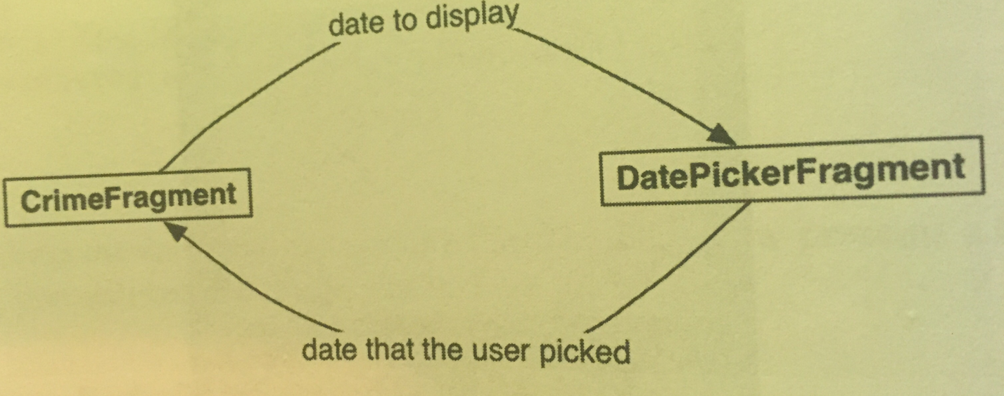

To get the Crime’s date into DatePickerFragment, we’re going to write a newInstance(Date) method in the DatePickerFragment class and make the Date an argument on the date picker fragment.

To get the new date back to the CrimeFragment so that it can update the model layer and its own view, we’ll package up the date as an extra on an Intent and pass this Intent in a call to CrimeFragment.onActivityResult(…):

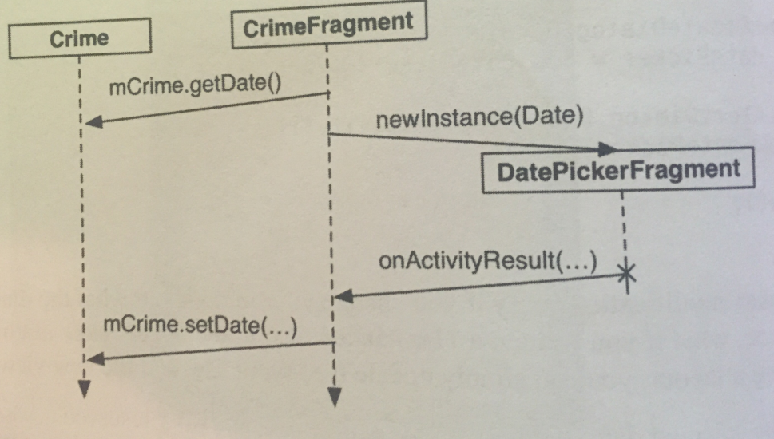

It may seem strange to call Fragment.onActivityResult(…), given that the hosting activity receives no call to Activity.onActivityResult(…) in this interaction. However, using onActivityResult(…) to pass data back from one fragment to another not only works, but it also offers some flexibility in how you present a dialog fragment, as we’ll see later.

To get our data into our DataPickerFragment, we stash the date in DatePickerFragment’s arguments bundle, where the DatePickerFragment can access it.

Creating and setting fragment arguments is typically done in a newInstance(…) method that replaces the fragment constructor:

private static final String ARG_DATE = "date";

private DatePicker mDatePicker;

public static DatePickerFragment newInstance(

Date date){

Bundle args = new Bundle();

args.putSerializable(ARG_DATE, date);

DatePickerFragment fragment =

new DatePickerFragment();

fragment.setArguments(args);

return fragment;

}

Now we can use this function in CrimeFragment’s onClick(…) method to create our DatePicker:

mDateButton.setOnClickListener(

new View.OnClickListener() {

@Override

public void onClick(View v){

FragmentManager manager =

getFragmentManager();

**DatePickerFragment dialog =**

**DatePickerFragment.newInstance(**

**mCrime.getDate());**

dialog.show(manager, DIALOG_DATE);

}

});

DatePickerFragment needs to initialize the DatePicker using the information held in the Date. However, initializing the DatePicker requires integers for the month, day, and year. Date is more of a timestamp and cannot provide integers like this directly.

To get the integers you need, you must create a Calendar object and use the Date to configure the Calendar. Then you can retrieve the required information from the Calendar:

public Dialog onCreateDialog(Bundle savedInstance){

Date date =

(Date)getArguments().getSerializable(ARG_DATE);

Calendar calendar = Calendar.getInstance();

calendar.setTime(date);

int year = calendar.get(Calendar.YEAR);

int month = calendar.get(Calendar.MONTH);

int day = calendar.get(Calendar.DAY_OF_MONTH);

…

mDatePicker =

(DatePicker)v.findViewById(

R.id.dialog_date_picker);

mDatePicker.init(year, month, day, null);

…

}

To have CrimeFragment receive the date back from DatePickerFragment, we need a way to keep track of the relationship between the two fragments.

With activities, you call startActivityForResult(…), and the ActivityManager keeps track of the parent-child activity relationship. When the child activity dies, the ActivityManager knows which activity should receive the result.

You can create a similar connection by making CrimeFragment the *target fragment* of DatePickerFragment. This connection is automatically reestablished after both CrimeFragment and DatePickerFragment are destroyed and re-created by the OS. To create this relationship, you call the following Fragment method:

public void setTargetFragment(Fragment fragment,

int requestCode);

This method accepts the fragment that will be the target and a request code just like the one you send in startActivityForResult(…). The target fragment can use the request code later to identify which fragment is reporting back.

The FragmentManager keeps track of the target fragment and request code. You can retrieve them by calling getTargetFragment() and getTargetRequestCode() on the fragment that has set the target.

In our CrimeFragment class, we create a constant for the request code and then make CrimeFragment the target fragment of the DatePickerFragment instance:

dialog.setTargetFragment(CrimeFragment.this,

REQUEST_DATE);

Now that we have a connection between CrimeFragment and DatePickerFragment, we need to send the date back to CrimeFragment. We are going to put the date in an Intent as an extra.

The method we use to send this intent to the target fragment is CrimeFragment.onActivityResult(int, int, Intent).

Activity.onActivityResult(…) is the method that the ActivityManager calls on the parent activity after the child activity dies. When dealing with activities, you don’t call this method yourself; that is the ActivityManager’s job. After the activity has received the call, the activity’s FragmentManager then calls Fragment.onActivityResult(…) on the appropriate fragment.

When dealing with two fragments hosted by the same activity, you can borrow Fragment.onActivityResult(…) and call it directly on the target fragment to pass back data.

In DatePickerFragment, we create a private method that creates an Intent, puts the date on it as an extra, and then calls CrimeFragment.onActivityResult(…):

public static final String EXTRA_DATE = "com.bignerdranch.android.criminalintent.date";

…

private void sendResult(int resultCode, Date date){

if(getTargetFragment() == null){

return;

}

Intent intent = new Intent();

intent.putExtra(EXTRA_DATE, date);

getTargetFragment().onActivityResult(

getTargetRequestCode(), resultCode,

intent);

}

Now it’s time to make use of this new sendResult(…) method. When the user presses the positive button in the dialog, you want to retrieve the date from the DatePicker and send the result back to CrimeFragment. In onCreateDialog(…) in the DatePickerFragment class, replace the null parameter of setPositiveButton(…) with an implementation of DialogInterface.OnClickListener that retrieves the selected date and calls sendResult(…):

.setPositiveButton(android.R.string.ok,

new DialogInterface.OnClickListener() {

@Override

public void onClick(DialogInterface dialog,

int which) {

int year = mDatePicker.getYear();

int month = mDatePicker.getMonth();

int day = mDatePicker.getDayOfMonth();

Date date = new GregorianCalendar(

year, month, day).getTime();

sendResult(Activity.RESULT_OK, date);

}

})

In CrimeFragment, override onActivityResult(…), which we called earlier in DatePickerFragment, to retrieve the extra, set the date on the Crime, and refresh the text of the date button:

@Override

public void onActivityResult(int requestCode,

int resultCode, Intent data){

if(resultCode != Activity.RESULT_OK){

return;

}

if(requestCode == REQUEST_DATE){

Date date = (Date)

data.getSerializableExtra(

DatePickerFragment.EXTRA_DATE);

mCrime.setDate(date);

mDateButton.setText(

mCrime.getDate().toString());

}

}

The code that sets the button’s text is identical to the code we call in onCreateView(…). To avoid setting the text in two places, we refactor to encapsulate this code in a private updateDate() method and then call it in onCreateView(…) and onActivityResult(…).

We use Android Studio to refactor. Pages 241-242 show how to do this.

Using onActivityResult(…) to send data back to a target fragment is especially nice when you’re writing an app that needs lots of input from the user and more room to ask for it - and you want the app working well on phones and tablets.

On a phone, you don’t have much screen real estate, so you would likely use an activity with a full-screen fragment to ask the user for input. This child activity would be started by a fragment of the parent activity calling startActivityForResult(…).

On the death of the child activity, the parent activity would receive a call to onActivityResult(…), which would be forwarded to the fragment that started the child activity.

Here is what this looks like:

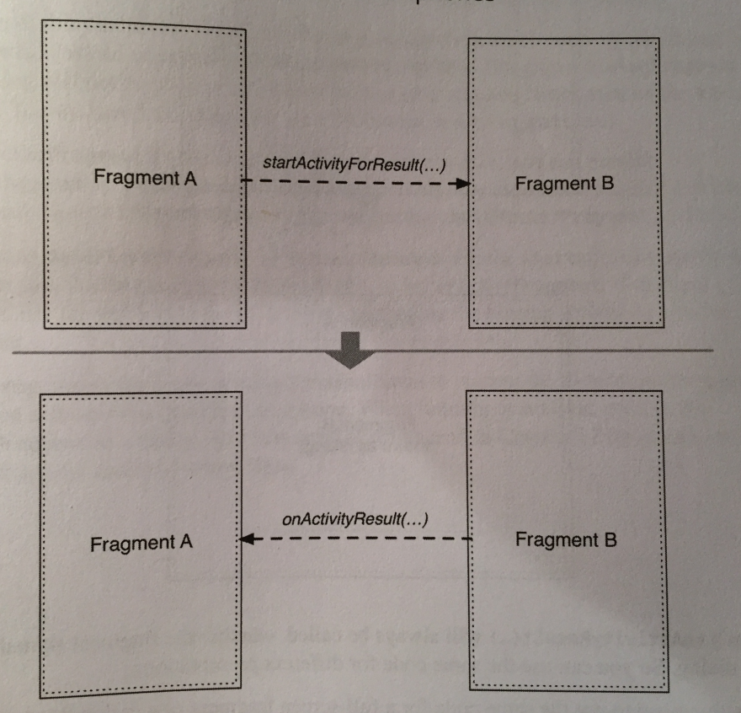

Now, on a tablet you have plenty of room. Therefore, it’s often better to present a DialogFragment covering most the screen to the user to get the same input. In this case, you set the target fragment and call show(…) on the dialog fragment. When dismissed, the dialog fragment calls onActivityResult(…) on its target.

Here’s what this looks like:

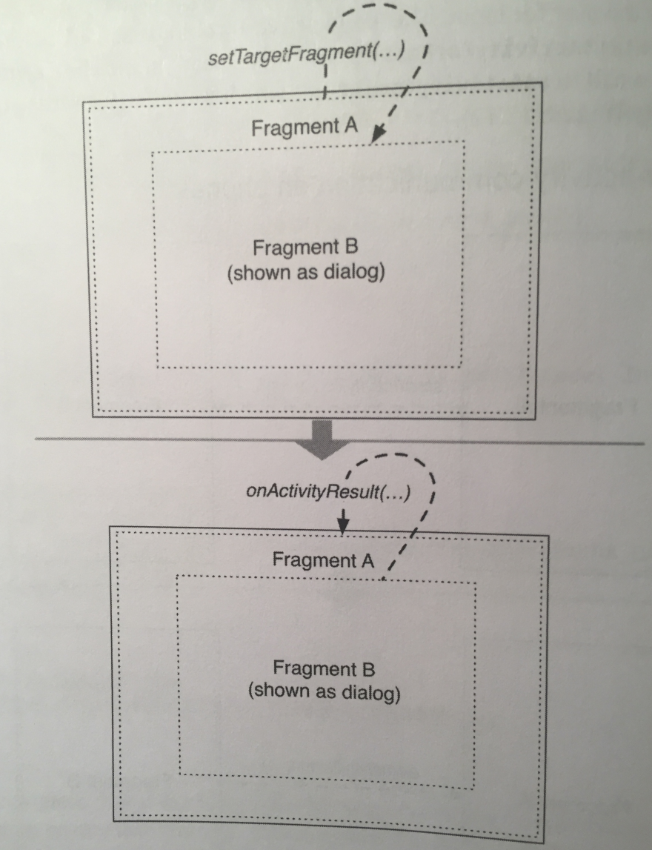

The fragment’s onActivityResult(…) will always be called, whether the fragment started an activity or showed a dialog. So you can use the same code for different presentations.

**When setting things up to use the same code for a full-screen fragment or a dialog fragment, you can override DialogFragment.onCreateView(…) instead of onCreateDialog(…) to prepare for both presentations.**

**Chapter 13 - The Toolbar:**

A key component of any well-designed Android app is the toolbar. The toolbar includes actions that the user can take, a new mechanism for navigation, and also provides design consistency and branding.

You can create a menu that will be displayed in the toolbar. The menu can have *action items* that lets users do shit. You can also configure something called the Up button, which lets the users go back.

The toolbar component is a new addition to Android as of Android 5.0 (Lollipop). Prior to Lollipop, the *action bar* was the recommended component for navigation and actions within an app.

The action bar and toolbar are very similar components. The toolbar builds on top of the action bar. It has a tweaked UI and is more flexible in the ways that you can use it.

You can get this new toolbar working with older versions of the Android API by using the AppCompat library.

To use the AppCompat library:

* add the AppCompat dependency
* use one of the AppCompat themes
* ensure that all activities are a subclass of AppCompatActivity

The book shows you how to accomplish these steps on pages 248-249.

The top-right area of the toolbar is reserved for the toolbar’s menu. The menu consists of *action items* (sometimes also referred to as *menu items*), which can perform an action on the current screen or to the app as a whole.

You define a menu in XML. You create an XML description and place the XML file in the res/menu directory of your project. Android generates a resource ID for the menu file that you then use to inflate the menu in code.

When you define action items in the XML, you use the showAsAction attribute. For example:

app:showAsAction="ifRoom|withText"

The showAsAction attribute refers to whether the item will appear in the toolbar itself or in the *overflow menu*. We have combined two values here, ifRoom and withText, so the item’s icon and text will appear if there is room. If there is room for the icon but not the text, then only the icon will be visible. If there is no room for either, then the item will be relegated to the overflow menu.

The overflow menu is accessed by the three dots on the far-right side of the toolbar.

Other options for showAsAction include always and never. Using always is not recommended; it’s better to use ifRoom and let the OS decide. Using never is a good choice for less-common actions that go in the overflow menu.

In general, you should only put action items that users will use frequently in the toolbar to avoid cluttering the screen.

Android studio contains *system icons* that you can use in your apps. They are found on the device rather than in your project’s resources. These system icons are cool to use in a prototype, but will look different across devices and OS versions, giving your app an inconsistent look.

A better option is to use Android Asset Studio, which is included in Android Studio and lets you create and customize an image to use in the Toolbar. The book shows you how to use Android Asset Studio on pages 253-255.

In code, menus are managed by callbacks from the Activity class. When the menu is needed, Android calls the Activity method onCreateOptionsMenu(Menu).

However, your design calls for code to be implemented in a fragment, not an activity. Fragment comes with its own set of menu callbacks. The methods for creating the menu and responding to the selection of an action item are:

public void onCreateOptionsMenu(Menu menu,

MenuInflater inflater);

public Boolean onOptionsItemSelected(MenuItem item);

In our CrimeListFragment, we need to override onCreateOptionsMenu(…) to inflate the menu we defined in XML eariler:

@Override

public void onCreateOptionsMenu(Menu menu,

MenuInflater inflater){

super.onCreateOptionsMenu(menu, inflater);

inflater.inflate(R.menu.fragment_crime_list, menu);

}

Within this method, you call MenuInflater.inflate(int, Menu) and pass in the resource ID of your menu file. This populates the Menu instance with the items defined in your file.

The FragmentManager is responsible for calling Fragment.onCreateOptionsMenu(…) when the activity receives its onCreateOptionsMenu(…) callback from the OS.

You must explicitly tell the FragmentManager that your fragment should receive a call to onCreateOptionsMenu(…). You do this by calling the following method:

public void setHasOptionsMenu(boolean hasMenu);

We override CrimeListFragment.onCreate(…) and let the FragmentManager know that CrimeListFragment needs to receive menu callbacks:

@Override

public void onCreate(Bundle savedInstanceState){

super.onCreate(savedInstanceState);

**setHasOptionsMenu(true);**

}

You should now be able to see your menu in the toolbar.

Now we need to respond to menu selections (like when you press the + button to add a new Crime). To respond to the user pressing the New Crime action item, we need a way to add a new Crime to our list of crimes. In our CrimeLab store, we add a method that adds a Crime to the list of crimes:

public void addCrime(Crime c){

mCrimes.add(c);

}

Now, when the user presses an action item, your fragment receives a callback to the method onOptionsItemSelected(MenuItem). This method receives an instance of MenuItem that describes the user’s selection.

Although your menu only contains one action item, menus often have more than one. You can determine which action item has been selected by checking the ID of the MenuItem and then responding appropriately. This ID corresponds to the ID you assigned to the MenuItem in your menu file.

In our CrimeListFragment class, we implement onOptionsItemSelected(MenuItem) to respond to a selection of a MenuItem. We create a new Crime, add it to the CrimeLab store, and then start an instance of CrimePagerActivity to edit the new Crime:

@Override

public boolean onOptionsItemSelected(MenuItem item){

switch(item.getItemId()){

case R.id.new_crime:

Crime crime = new Crime();

CrimeLab.get(getActivity())

.addCrime(crime);

Intent intent =

CrimePagerActivity.newIntent(

getActivity(), crime.getId());

startActivity(intent);

return true;

default:

return super.onOptionsItemSelected(item);

}

}

Notice that this method returns a Boolean value. Once you have handled the MenuItem, you should return true to indicate that no further processing is necessary. The default case calls the superclass implementation if the item ID is not in your implementation.

Now you can add crimes using the New Crime menu option.

So far, this app relies heavily on the Back button to navigate around the app. Using the back button is *temporal navigation*. It takes you to where you were last. *Hierarchical navigation*, on the other hand, takes you up the app hierarchy. It’s sometimes called *ancestral navigation*.

In hierarchical navigation, the user navigates up by pressing the Up button on the left side of the toolbar. Jelly Bean and above makes it easy to add this functionality.

You enable hierarchical navigation by adding a parentActivityName attribute in the manifest file, which tells the activity you’re at now where you want to go when you go up to the parent.

android:parentActivityName=".CrimeListActivity"

That’s it! Now the Up button appears and will take you one level in the hierarchy, to what we specified in the manifest file.

In our app, navigating with the Back button and the Up button perform the same task, but behind the scenes they are doing very different things. This is important to understand because, depending on the application, navigating up may pop the user back multiple activities in the back stack.

When the user navigates up from CrimePagerActivity, an intent like the following is created:

Intent intent = new Intent(this,

CrimeListActivity.class);

intent.addFlags(Intent.FLAG_ACTIVITY_CLEAR_TOP);

startActivity(intent);

finish();

FLAG_ACTIVITY_CLEAR_TOP tells Android to look for an existing instance of the activity in the stack, and if there is one, pop every other activity off the stack so that the activity being started will be top-most.

This looks like this:

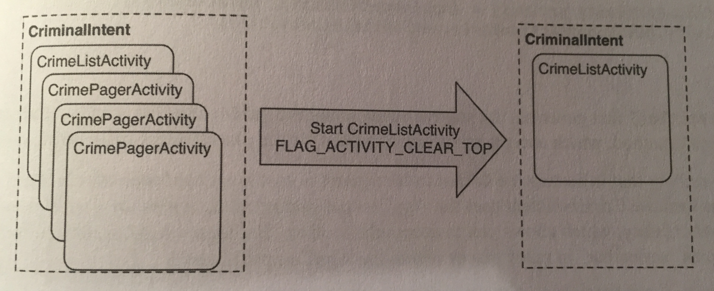

Now, let’s go over how to add an action item that lets users show and hide the subtitle of CrimeListActivity’s toolbar. The subtitle is text that appears below the title of the activity in the toolbar.

In our fragment_crime_list.xml file in res/menu, we add an action item that will read “Show Subtitle” and will appear in the toolbar if there is room. The XML for this is on the top of page 262. It will display the number of crimes we have.

We create a new method called updateSubtitle() in CrimeListFragment that will set the subtitle of the toolbar:

private void updateSubtitle(){

CrimeLab crimeLab = CrimeLab.get(getActivity());

int crimeCount = crimeLab.getCrimes().size();

String subtitle =

getString(R.string.subtitle_format,

crimeCount);

AppCompatActivity activity =

(AppCompatActivity) getActivity();

activity.getSupportActionBar()

.setSubtitle(subtitle);

}

This function first generates the subtitle string using:

getString(int resId, Object…formatArgs) method, which accepts replacement values for the placeholders in the string resource.

Next, the activity that is hosting the CrimeListFragment is cast to AppCompatActivity, since the project uses the AppCompat library and all activities are subclasses of AppCompatActivity, and this allows us to access the toolbar. For legacy reasons, the toolbar is still referred to as “action bar”, so don’t freak out when you see that in function names.

Now, we call updateSubtitle() when the user presses on the new “Show Subtitle” action item:

public boolean onOptionsItemSelected(MenuItem item){

…

case R.id.show_subtitle:

updateSubtitle();

return true;

…

}

Now the subtitle is visible, but the action item still reads “Show Subtitle”. It would be better if the action item toggled its title and function to show or hide the subtitle.

When onOptionsItemSelected(MenuItem) is called, you’re given the MenuItem that the user pressed as a parameter. You could update the text of Show Subtitle item in this method, but the subtitle change would be lost as you rotate the device and the toolbar was recreated.

A better solution is to update the Show Subtitle MenuItem in onCreateOptionsMenu(…) and trigger a re-creation of the toolbar when the user presses the subtitle item (we trigger it in onOptionsItemSelected(…) ). This allows us to share the code for updating the action item in the case that the user selects an action item or the toolbar is re-created.

We first add a member variable to keep track of the subtitle visibility. Next, we modify the subtitle in onCreateOptionsMenu(…) and trigger the re-creation of the action items in onOptionsItemSelected(…) when the user presses the Show Subtitle action item:

@Override

public void onCreateOptionsMenu(Menu menu,

MenuInflater inflater){

…

MenuItem subtitleItem =

menu.findItem(R.id.show_subtitle);

if(mSubtitleVisible){

subtitleItem.setTitle(R.string.hide_subtitle);

}

else{

subtitleItem.setTitle(R.string.show_subtitle);

}

}

…

@Override

public boolean onOptionsItemSelected(MenuItem item){

…

case R.id.menu_item_show_subtitle:

**mSubtitleVisible = !mSubtitleVisible;**

**getActivity().invalidateOptionsMenu();**

updateSubtitle();

return true;

…

}

Finally, we use the Boolean subtitle visibility variable to show or hide the subtitle string by setting the string to null when we have to hide it:

private void updateSubtitle(){

…

if(!mSubtitleVisible){

subtitle = null;

}

…

}

This makes it so that we don’t show the subtitle when we toggle it off.

There are still some more issues we need to take care of.

First, when we create a new crime and then return to our list by using the Back button, the number of crimes in the subtitle will not update.

The solution to this problem is to update the subtitle text when returning to CrimeListActivity. We trigger a call to updateSubtitle() in our updateUI() function, because updateUI() is called in onResume() and onCreate().

Lastly, the visibility of the subtitle is lost across rotation. To fix this problem, save the mSubtitleVisible instance variable across rotation with the saved instance state mechanism:

* First we create a key for the variable we’re passing:

private static final String SAVED_SUBTITLE_VISIBLE

= "subtitle";

* Next override onSaveInstanceState() to save the Boolean to the bundle:

@Override

public void onSaveInstanceState(Bundle outState){

super.onSaveInstanceState(outState);

outState.putBoolean(SAVED_SUBTITLE_VISIBLE,

mSubtitleVisible);

}

* Lastly, get the variable when we create the view:

@Override

public View onCreateView(….){

…

if(savedInstanceState != null){

mSubtitleVisible =

savedInstanceState.getBoolean(

SAVED_SUBTITLE_VISIBLE);

}

…

}

Toolbars can be very flexible. You can manually include a toolbar as a normal view in your activity or fragment’s layout file. You can place this toolbar anywhere you like and you can even include multiple toolbars on the screen at the same time.

This flexibility allows for interesting designs; for example, imagine if each fragment that you use maintains its own toolbar. When you host multiple fragments on the screen at the same time, each of them can bring along their own toolbar instead of sharing a single toolbar at the top of the screen.

Another interesting thing about the toolbar is the ability to place Views inside the toolbar and to also adjust the height of the toolbar.

**Chapter 14 - SQLite Databases:**

Almost every application needs a place to save data for the long term, longer than savedInstanceState will keep it around. Android provides a place to do this for you: a local filesystem on your phone or tablet’s flash memory storage.

Each application on an Android device has a directory in its *sandbox*. Keeping files in the sandbox protects them from being accessed by other applications or even the prying eyes of users (unless the device has been “rooted,” in which case the user can get to whatever he or she likes).

Each application’s sandbox directory is a child of the device’s /data/data directory named after the application package. For example, CriminalIntent’s full sandbox path is /data/data/com.bignerdranch.android.criminalintent.

However, most application data is not stored in plain old files. This would be inefficient. Instead, they are written to a database file. This is where SQLite comes in. SQLite is an open source relational database, like MySQL or Postgresql. Unlike other databases, though, SQLite stores its data in simple files, which you can read and write using the SQLite library. Android includes this SQLite library in its standard library, along with some additional Java helper classes.

Now, before you create a database, you have to decide what will be in that database. People do this decision in a lot of different ways. We will look at the way of defining a *database schema* in Java code that says what your table is named and what its columns are.

We first create a class to put our schema in. We name this class database.CrimeDbSchema so that Android Studio puts our Java file in its own database package, which we will use to organize all of our database-related code.

Inside our database file, we define an inner class called CrimeTable to describe our table:

public static final class CrimeTable{

public static final String NAME = "crimes";

}

The CrimeTable class only exists to define the String constants needed to describe the moving pieces of our table definition. The first piece of that definition is the name of the table in our database, CrimeTable.NAME.

Next, we describe the columns:

public class CrimeDbSchema {

public static final class CrimeTable{ public static final String NAME = "crimes";

**public static final class Cols{**

**public static final String UUID = "uuid";**

**public static final String TITLE =**

**"title";**

**public static final String DATE = "date";**

**public static final String SOLVED =**

**"solved";**

**}**

}

}

With that, you will be able to refer to the column named “title” in a Java-safe way: CrimeTable.Cols.TITLE. That makes it much easier to change your program if you ever need to change the name of that column or add additional data to the table.

With your schema defined, you’re ready to create the database itself. Android provides some low-level methods on Context to open a database file into an instance of SQLiteDatabase: openOrCreateDatabase(…) and databaseList().

However, in practice you will always need to follow a few basic steps:

1. Check to see if the database already exists.
2. If it doesn’t, create it and create the tables and initial data it needs.
3. If it does, open it up and see what version of your database it has. (You may want to add or remove things in future versions of your project).
4. If it’s an old version, run code to upgrade it to a newer version.

Android provides the SQLiteOpenHelper class to handle all of this for you. We first need to create a class that extends it:

public class CrimeBaseHelper extends SQLiteOpenHelper{

private static final int VERSION = 1;

private static final String DATABASE_NAME =

"crimeBase.db";

public CrimeBaseHelper(Context context){

super(context, DATABASE_NAME, null, VERSION);

}

@Override

public void onCreate(SQLiteDatabase db){

}

@Override

public void onUpgrade(SQLiteDatabase db,

int oldVersion, int newVersion){

}

}

A SQLiteOpenHelper is a class designed to get rid of the grunt work of opening a SQLiteDatabase. We use it inside our CrimeLab store to create our crime database:

private CrimeLab(Context context){

**mContext = context.getApplicationContext();**

**mDatabase = new CrimeBaseHelper(mContext)**

**.getWritableDatabase();**

mCrimes = new ArrayList<>();

}

When you call getWritableDatabase() here, CrimeBaseHelper will do the following:

1. Open up /data/data/com.bignerdranch.android.criminalintent/databases/crimeBase.db, creating a new database file of it doesn’t already exist.
2. If this is the first time the database has been created, call onCreate(SQLiteDatabase), then save out the latest version number.
3. If this is not the first time, check the version number in the database. If the version number in CrimeBaseHelper is higher, call onUpgrade(SQLiteDatabase, int, int).

The upshot is this: you put your code to create the initial database in onCreate(…), your code to handle any upgrades in onUpgrade(…), and it just works.

To create your database tables in onCreate(…), you need to refer to the CrimeTable inner class of CrimeDbSchema. The import to do this written is a two-step process. First, write the initial part of your SQL creation code, like this:

public void onCreate(SQLiteDatabase db){

**db.execSQL("create table " + CrimeTable.NAME);**

}

Then put your cursor over the word CrimeTable and press Alt+Enter. Then, in the menu that pops up, select the item showing com.bignerdranch… This will make Android Studio give you the right import and you’ll be able to refer to the String constants in CrimeDbSchema.CrimeTable.

Use this to finish filling out our table definition:

public void onCreate(SQLiteDatabase db){

db.execSQL("create table " + CrimeTable.NAME +

"(" + " _id integer primary key autoincrement, " +

CrimeTable.Cols.UUID + ", " +

CrimeTable.Cols.TITLE + ", " +

CrimeTable.Cols.DATE + ", " +

CrimeTable.Cols.SOLVED +

")"

);

}

Creating a table in SQLite requires less work than in other databases: you don’t have to specify the type of column at creation time. It’s a good idea to do that, but here you’ll save a bit of labor by doing without it.

Now, when we have our database setup, the next step is to change our CrimeLab store to use it. What we do first is delete all instances of our List<Crime> from the CrimeLab, since we’re using the database now.

Then, we need to find a way to write to our database. We will need to insert new rows into the crime table as well as update rows that are already there when Crimes are changed.

Writes and updates to databases are done with the assistance of a class called ContentValues. ContentValues is a key-value store class, like a HashMap or a Bundle. However, unlike a HashMap or Bundle, it’s specifically designed to store the kinds of data SQLite can hold.

We first add a private method to our CrimeLab to shuttle a Crime into a ContentValues:

private static ContentValues getContentValues(

Crime crime){

ContentValues values = new ContentValues();

values.put(CrimeTable.Cols.UUID,

crime.getId().toString());

values.put(CrimeTable.Cols.TITLE,

crime.getTitle());

values.put(CrimeTable.Cols.DATE,

crime.getDate().getTime());

values.put(CrimeTable.Cols.SOLVED,

crime.isSolved() ? 1 : 0);

return values;

}

For the keys, you use your column names. These are not arbitrary names; they specify the columns that you want to insert or update. If they are misspelled or typo’d compared to what is in the database, your insert or update will fail. Every column is specified here except for _id, which is auto-incremented for you as a unique row ID.

Now that we have a ContentValues from a Crime, it’s time to add rows to the database. We change addCrime to do this:

public void addCrime(Crime c){

**ContentValues values = getContentValues(c);**

**mDatabase.insert(CrimeTable.NAME, null, values);**

}

The insert(String, String, ContentValues) method has two important arguments, and one that is rarely used. The first argument is the table that you want to insert into; the last argument is the data you want to put in.

The second argument is called nullColumnHack. Let’s say you decided to call insert(…) with an empty ContentValues. SQLite does not allow this, so your insert(…) call would fail.

If you passed a value of uuid for nullColumnHack, though, it would ignore that empty ContentValues. Instead, it would pass in a ContentValues with uuid set to null. This would allow your insert(…) to succeed and create a new row.

Next, we add a method to our CrimeLab to update rows in a database:

public void updateCrime(Crime crime){

String uuidString = crime.getId().toString();

ContentValues values = getContentValues(crime);

**mDatabase.update(CrimeTable.NAME, values,**

**CrimeTable.Cols.UUID + " = ?",**

**new String[]{uuidString});**

}

The update(String, ContentValues, String, String[]) method starts off similarly to insert(…) - you pass in the table name you want to update and the ContentValues you want to assign to each row you update.

However, the last bit is different, because now you have to specify *which* rows get updated. You do that by building a where clause (the third argument), and then specifying values for the arguments in the where clause (the final argument).

You may be wondering why you’re doing “= ?” The answer is that in some cases your String might itself contain SQL code. If you put that String directly in your query, that code could change the meaning of your query, or even alter your database. This is called an SQL injection attack.

If you use ?, though, your code will treat that value as a literal String, not code. So it’s used for safety.

OK, now Crime instances get modified in CrimeFragment, and will need to be written out when CrimeFragment is done. To do this we override CrimeFragment.onPause() so that it updates CrimeLab’s copy of our Crime:

@Override

public void onPause(){

super.onPause();

CrimeLab.get(getActivity()).updateCrime(mCrime);

}

Now let’s talk about reading from our database. Reading in data from SQLite is done using the query(…) method. SQLiteDatabase.query(…) has quite a lot going on. Here is its prototype:

public Cursor query(

String table,

String[] columns,

String where,

String[] whereArgs,

String groupBy,

String having,

String orderBy,

String limit);

We only need to worry about the first four parameters. The table argument is a table to query, the columns argument names which columns you want values for and what order you want to receive them in. The where and whereArgs do the same thing they do in the last two arguments in update(…).

We first create a convenience method to call query(…) in CrimeLab:

private Cursor queryCrimes(String whereClause,

String[] whereArgs){

Cursor cursor = mDatabase.query(

CrimeTable.NAME,

null, //columns - null selects all columns

whereClause,

whereArgs,

null,

null,

null

);

return cursor;

}

A Cursor sucks when you’re trying to get shit outta a table. All it does is give you raw column values. What we need to do is create a Cursor subclass that takes care of reading the data and pulling out its values. The easiest way to write a Cursor subclass is to use CursorWrapper. A CursorWrapper lets you wrap a Cursor you received from another place and add new methods on top of it.

We create a new class in the database package that extends CursorWrapper:

public class CrimeCursorWrapper extends CursorWrapper { public CrimeCursorWrapper(Cursor cursor){

super(cursor);

}

}

This creates a thin wrapper around a Cursor. It has all the same methods as the Cursor it wraps, and calling those methods does the exact same thing. This would be stupid, except it makes it possible to add new methods that operate on the underlying Cursor.

We add a getCrime() method in this cursor wrapper class that pulls out relevant column data:

public Crime getCrime(){

String uuidString =

getString(getColumnIndex(CrimeTable.Cols.UUID));

String title =

getString(getColumnIndex(CrimeTable.Cols.TITLE));

long date =

getLong(getColumnIndex(CrimeTable.Cols.DATE));

int isSolved =

getInt(getColumnIndex(CrimeTable.Cols.SOLVED));

Crime crime = new

Crime(UUID.fromString(uuidString));

crime.setTitle(title);

crime.setDate(new Date(date));

crime.setSolved(isSolved != 0);

return crime;

}

In order to use the above code, we need to change the model Crime.java file to take in a UUID. The code to do this is on the top of page 283.

With CrimeCursorWrapper, vending out a List<Crime> from CrimeLab will be straightforward. You just need to wrap the cursor you get back from your query in a CrimeCursorWrapper, then iterate over it calling getCrime() to pull out its Crimes:

For the first part, change queryCrimes(…) in CrimeLab to return a CrimeCursorWrapper:

private CrimeCursorWrapper queryCrimes(

String whereClause, String[] whereArgs){

…

return new CrimeCursorWrapper(cursor);

}

Next, we need to change getCrimes() so that it properly query’s all crimes, walks the cursor, and populates a Crime list:

public List<Crime> getCrimes(){

List<Crime> crimes = new ArrayList<>();

CrimeCursorWrapper cursor =

queryCrimes(null, null);

try{

cursor.moveToFirst();

while(!cursor.isAfterLast()){

crimes.add(cursor.getCrime());

cursor.moveToNext();

}

}

finally{

cursor.close();

}

return crimes;

}

Database cursors are called cursors because they always have their finger on a particular place in a query. So to pull the data out of a cursor, you move it to the first element by calling moveToFirst(), and then read in row data. Each time you want to advance to a new row, you call moveToNext(), until finally isAfterLast() tells you that your pointer is off the end of the dataset.

The last important thing to do is call close() on your Cursor. This bit of housekeeping is important. If you don’t do it, your Android device will spit out nasty error bugs, and if you make a habit out of not closing your cursors, you’ll eventually run out of open file handles and crash your app. So, close your cursors.

The next thing we need to do is implement getCrime(…) of the CrimeLab store to pull the first and only item that matches the UUID we pass in:

public Crime getCrime(UUID id){

CrimeCursorWrapper cursor = queryCrimes(

CrimeTable.Cols.UUID + " = ?",

new String[] {id.toString()}

);

try{

if(cursor.getCount() == 0){

return null;

}

cursor.moveToFirst();

return cursor.getCrime();

}

finally {

cursor.close();

}

}

We are not quite done yet. Our crimes are persistently stored in the database, but the persistent data is not read back in. So if we press the Back button after editing our new Crime, it’ll not show up in our CrimeListActivity.

This is because CrimeLab works a little differently now. Before, there was only one List<Crime>, and one object for each Crime: the one in the List<Crime>. That was because mCrimes was the only authority for which Crimes your app knew about.

Now, mCrimes is gone. The List<Crime> we get back from getCrimes() is a snapshot of the Crimes at one point in time. To refresh our CrimeListActivity, we need to update that snapshot.

Most of the work to do this is already in place. CrimeListActivity already calls updateUI() to refresh other parts of its interface. All we need to do now is have it refresh its view of CrimeLab too.

First, we add a setCrimes(…) method to the CrimeAdapter to swap out the crimes it displays:

public void setCrimes(List<Crime> crimes){

mCrimes = crimes;

}

Now, we call setCrimes(…) in updateUI():

private void updateUI(){

…

if(mAdapter == null) {

…

}

else{

**mAdapter.setCrimes(crimes);**

mAdapter.notifyDataSetChanged();

}

…

}

Now everything should work correctly.

In CrimeLab, we use the *Application Context* in the constructor of the CrimeLab:

private CrimeLab(Context context){

mContext = context.getApplicationContext();

mDatabase = new

CrimeBaseHelper(mContext).getWritableDatabase();

}

What makes the Application Context special? When should you use the application context over an activity as a context?

It’s important to think about the lifetime of each of these objects. If any of your activities exist, Android will have also created an *application* object. Activities come and go as the user navigates thru your application, but the application object will still exist. It has a much longer lifetime than any one activity.

The CrimeLab is a singleton, which means that once it’s created, it’ll not be destroyed until your entire process is destroyed. The CrimeLab maintains a reference to its mContext object. If you store an activity as the mContext object, that activity will never be cleaned up by the garbage collector because the CrimeLab has a reference to it. Even if the user has navigated away from that activity, it’ll never be cleaned up.

To avoid this wasteful situation, you use the application context so that your activities can come and go and the CrimeLab can maintain a reference to a Context object. **Always think about the lifetime of your activities as you keep a reference to them.**

**Chapter 15 - Implicit Intents:**

In Android, you start an activity in another application on the device using an *implicit intent*. In an explicit intent, you specify the class of the activity to start, and the OS will start it. In an implicit intent, you describe the job you need to get done, and the OS will start an activity in an appropriate application for you.

Using implicit intents to harness other applications is far easier than writing your own implementations for common tasks. Users also appreciate being able to use apps they already know and like in conjunction with your app.

In this chapter, we need to create a template string that can be configured at runtime. To do this, we use a format string with placeholders that can be replaced at runtime. Here is the format string we use:

<string name="crime_report">%1$s!

The crime was discovered on %2$s. %3$s, and %4$s </string>

The %1$s, %2$s, etc. are placeholders that expect string arguments. In code, you will call getString(…) and pass in the format string and four other strings in the order in which they should replace the placeholders:

String report = getString(R.string.crime_report,

mCrime.getTitle(), dateString, solvedString,

suspect);

Now let’s look at implicit intents.

An Intent is an object that describes to the OS something that you want it to do. With the *explicit* intents that you have created thus far, you explicitly name the activity that you want the OS to start.

With an *implicit* intent, you describe to the OS the job that you want done. The OS then starts the activity that has advertised itself as capable of doing that job. If the OS finds more than one capable activity, then the user is offered a choice.

Here are the critical parts of an intent that you can use to define the job you want done:

* The *action* that you’re trying to perform.
  + These are typically constants from the Intent class. If you want to view a URL, you can use Intent.ACTION_VIEW for your action. To send something, you use Intent.ACTION_SEND.
* The location of any *data*.
  + This can be something outside the device, like the URL of a web page, but it can also be a URI to a file or a *content URI* pointing to a record in a ContentProvider.
* The *type* of data that the action is for.
  + This is a MIME type, like text/html or audio/mpeg3. If an intent includes a location for data, then the type can usually be inferred from that data.
* Optional *categories*.
  + If the action is used to describe *what* to do, the category usually describes *where*, *when*, and *how* you’re trying to use an activity.
  + Android uses the category android.intent.category.LAUNCHER to indicate that an activity should be displayed in the top-level app launcher.
  + The android.intent.category.INFO category, on the other hand, indicates an activity that shows information about a package to the user but should not show up in the launcher.

A simple implicit intent for viewing a website would include an action of Intent.ACTION_VIEW and a data Uri that is the URL of a website.

Based on this info, the OS will launch the appropriate activity of an appropriate application. If it finds more than one candidate, the user gets a choice.

An activity would advertise itself as an appropriate activity for ACTION_VIEW via an intent filter in the manifest. If you wanted to write a browser app, for instance, you would include the following intent filter in the declaration of the activity that should respond to ACTION_VIEW:

<activity

android:name=”.BrowserActivity”

android:label=”@string/app_name”>

<intent-filter>

**<action**

**android:name=”android.intent.action.VIEW”/>**

**<category**

**android:name=**

**”android.intent.category.DEFAULT”/>**

<data android:scheme=”http”

android:host=www.bignerdranch.com/>

</intent-filter>

</activity>

To respond to implicit intents, a DEFAULT category must be set explicitly in an intent filter. The action element in the intent filter tells the OS that the activity is capable of performing the job, and the DEFAULT category tells the OS that this activity should be considered for the job when the OS is asking for volunteers. This DEFAULT category is implicitly added to every implicit intent.

Implicit intents can also include extras just like explicit intents. Any extras on an implicit intent, however, are **not** used by the OS to find an appropriate activity.

Note that the action and data parts of an intent can also be used in conjunction with an explicit intent. That would be the equivalent of telling a particular activity to do something specific.

Let’s see how this works by creating an implicit intent to send a crime report in our project. The job you want done is sending plain text; the crime report is a string. So the implicit intent’s action will be ACTION_SEND. It will not point to any data or have any categories, but it will specify a type of text/plain.

In CrimeFragment’s onCreateView(…) we get a reference to the Send Crime Report button and set a listener on it that will create an implicit intent and pass it into startActivity(Intent):

public View onCreateView(LayoutInflater inflater,

ViewGroup container, Bundle savedInstanceState){

…

**mReportButton =**

**(Button)v.findViewById(R.id.crime_report);**

**mReportButton.setOnClickListener(**

**new View.OnClickListener(){**

**public void onClick(View v){**

**Intent i = new Intent(Intent.ACTION_SEND);**

**i.setType("text/plain");**

**i.putExtra(Intent.EXTRA_TEXT,**

**getCrimeReport());**

**i.putExtra(Intent.EXTRA_SUBJECT,**

**getString(R.string.crime_report_subject));**

**startActivity(i);**

**}**

**});**

return v;

}

Here you use the Intent constructor that accepts a string that is a constant defining the action. There are other constructors that you can use depending on what kind of implicit intent you need to create. Check the documentation for them. There is no constructor that accepts a type, so you set it explicitly.

You include the text of the report and the string for the subject of the report as extras. Note that these extras use constants defined in the Intent class. Any activity responding to this intent will know these constants and what to do with the associated values.

When setting shit up, you often want to set a default app to handle the implicit intent. However, you always want the user to have a choice for ACTION_SEND. They might want to send info different ways on different days.

You can create a chooser to be shown every time an implicit intent is used to start an activity. After you create your implicit intent as before, you call the following Intent method and pass in the implicit intent and a string for the chooser’s title:

public static Intent createChooser(Intent target, String title);

Then you pass the intent returned from this function into startActivity(…), like so:

**i = Intent.createChooser(i,**

**getString(R.string.send_report));**

startActivity(i);

Now we’re going to create another implicit intent to choose a suspect from a contact list. This implicit intent will have an action of Intent.ACTION_PICK and a data location of ContactsContract.Contacts.CONTENT_URI. Since you expect a result back from the started activity, you pass the intent via startActivityForResult(…). The code for this is on page 299, and it’s very similar to the code we wrote above.

Now you need to get a result back from the contacts application. Contacts info is shared by many applications, so Android provides an in-depth API for working with contacts info through a ContentProvider. Instances of this class wrap databases and make them available to other applications. You can access a ContentProvider thru a ContentResolver.

Because you started the activity for a result with ACTION_PICK, you will receive an intent via onActivityResult(…). This intent includes a data URI. The URI is a locator that points at the single contact the user picked. Here’s the code in onActivityResult(…) in the CrimeFragment class:

public void onActivityResult(int requestCode,

int resultCode, Intent data){

…

**else if(requestCode == REQUEST_CONTACT &&**

**data != null){**

**Uri contactUri = data.getData();**

**//specify which fields you want your query to**

**//return values for**

**String[] queryFields = new String[]{**

**ContactsContract.Contacts.DISPLAY_NAME**

**};**

**//perform your query - the contactUri is like**

**//a "where" clause here**

**Cursor c = getActivity().getContentResolver()**

**.query(contactUri, queryFields,**

**null, null, null);**

**try{**

**//double-check that you actually got**

**//results**

**if(c.getCount() == 0){**

**return;**

**}**

**//pull out the first column of the first**

**//row of data**

**//this is your suspect's name**

**//there is only one row of data: the**

**//contact the user picked**

**c.moveToFirst();**

**String suspect = c.getString(0);**

**mCrime.setSuspect(suspect);**

**mSuspectButton.setText(suspect);**

**}**

**finally{**

**c.close();**

**}**

**}**

}

How are you getting permission to read from the contacts database? The contacts app is extending its permissions to you. The contacts app has full permissions to the contacts database. When the contacts app returns a data URI in an Intent to the parent activity, it also adds the flag Intent.FLAG_GRANT_READ_URI_PERMISSION.

This flag signals to Android that the parent activity in your project should be allowed to use this data one time. This works because you don’t really need access to the entire contacts database. You only need access to the one contact inside that database.

There is one more thing we need to take care of. The first implicit intent we created in this chapter will always be responded to in some way: there may be no way to send a report, but the chooser will still display properly. However, that’s not the case for the second implicit intent: some devices or users may not have a contacts app, and if the OS can’t find a matching activity, then the app will crash.

The fix is to check which part of the OS called the PackageManager first. Do this in onCreateView(…) in the CrimeFragment class:

PackageManager packageManager =

getActivity().getPackageManager();

**if(packageManager.resolveActivity(pickContact,**

**PackageManager.MATCH_DEFAULT_ONLY) == null)**{

mSuspectButton.setEnabled(false);

}

PackageManager knows about all the components installed on your Android device, including all of its activities. By calling resolveActivity(Intent, int), you ask it to find an activity that matches the Intent you gave it. The MATCH_DEFAULT_ONLY flag restricts this search to activities with the CATEGORY_DEFAULT flag, just like startActivity(intent) does.

If the search is successful, it’ll return an instance of ResolveInfo telling you all about which activity it found. On the other hand, if the search returns null, then there is no contacts app. So we disable the useless suspect button.

**Chapter 16 - Taking Pictures with Intents:**

Taking a picture will involve a couple of new tools, used in combination with the implicit intent. An implicit intent can be used to start up the user’s favorite camera application and take a new picture with it.

You need a place for a photo to live in your app. You create an ImageView to do so.

Now, your photo needs more than a place on the screen. Full-size pictures are too large to stick inside a SQLite database, much less an Intent. They need a place to live on your device’s filesystem.

Normally, you would put them in your private storage. Recall that we used private storage to save our SQLite database. With Context methods, you can do the same thing with regular files too. They will live in a subfolder adjacent to the databases subfolder your SQLite database lives in.

Here are some basic file and directory methods in Context:

* File getFilesDir(): Returns a handle to the directory for private application files.
* FileInputStream openFileInput(String name): Opens an existing file for input (relative to the files directory).
* FileOutputStream openFileOutput(String name,

int mode): Opens a file for output, possibly creating it (relative to the files directory).

* File getDir(String name, int mode): Gets (and possibly creates) a subdirectory within the files directory.
* String[] fileList(): Gets a list of file names in the main files directory, such as for use with openFileInput(String).
* File getCacheDir(): Returns a handle to a directory you can use specifically for storing cache files.
  + **You should take care to keep this directory tidy and use as little space as possible.**

If you are storing files that *only your current application* needs to use, these methods are exactly what you need.

On the other hand, if you need another application to write to those files (like we’re doing here writing photo data to our app), you’re outta luck: while there is a Context.MODE_WORLD_READABLE flag you can pass in to openFileOutput(String, int), it’s deprecated, and not completely reliable in its effects on newer devices.

If you need to share or receive files from other apps (files like stored pictures), you need to expose those files thru a ContentProvider. A ContentProvider allows you to expose content URIs to other apps. They can then download from or write to those content URIs. Either way, you are in control and always have the option to deny those reads or writes if you so choose.

When all you need to do is receive a file from another application, implementing an entire ContentProvider is overkill. Fortunately, Google has provided a convenience class called FileProvider that takes care of everything except the configuration work.

The first step is to declare FileProvider as a ContentProvider hooked up to a specific *authority*. This is done by adding a content provider declaration to our manifest file, like so:

<provider

android:authorities=

"com.bignerdranch.android.criminalintent.fileprovider"

android:name="android.support.v4.content.FileProvider"

android:exported="false"

android:grantUriPermissions="true">

</provider>

The authority is a location, a place that files will be saved to. By hooking up FileProvider to your authority, you give other apps a target for their requests. By adding exported=”false”, you keep anyone from using your provider except you or anyone you grant permission to. And by adding the grantUriPermissions attribute, you add the ability to grant other apps permission to write to URIs on this authority when you send them out in an intent (more on this later).

Now that you have told Android where your FileProvider is, you also need to tell your FileProvider which files it’s exposing. This bit of configuration is done with an extra XML resource file, which we create and add this to:

<paths>

<files-path name="crime_photos" path="."/>

</paths>

This XML file is a description that says, “Map the root path of my private storage as crime_photos.” You won’t use the crime_photos name yourself, FileProvider uses that internally.

Now, we hook up our XML file, which we named files.xml, to our FileProvider by adding a meta-data tag in our manifest file, like so:

<provider

android:authorities=

"com.bignerdranch.android.criminalintent.fileprovider"

android:name="android.support.v4.content.FileProvider"

android:exported="false"

android:grantUriPermissions="true">

**<meta-data**

**android:name="android.support.FILE_PROVIDER_PATHS"**

**android:resource="@xml/files"/>**

</provider>

Now it’s time to give our pictures a place to live. First, we add a method to the model object Crime class to get a unique filename for our photo:

public String getPhotoFilename(){

return "IMG_" + getId().toString() + ".jpg";

}

Next, we need to get where the photos should live. Our CrimeLab store is responsible for everything related to persisting data, so it should be the class doing this. We add a method here to get our photo file location:

public File getPhotoFile(Crime crime){

File filesDir = mContext.getFilesDir();

return new File(filesDir,

crime.getPhotoFilename());

}

This code **does not** create any files on the filesystem. It only returns File objects **that point to the right locations**. Later on, we will use FileProvider to expose these paths as URIs.

The next step is to actually take the picture. This is the easy part: you use an implicit intent.

Start by stashing the location of the photo file, because we will use it many times. We use our getPhotoFile(…) method that we just created to do so. Code for this is simple and is on page 311.

Next, we’ll hook up the camera button to actually take a picture. The camera intent is defined in MediaStore, Android’s lord and master of all things media related. You send an intent with an action of MediaStore.ACTION_IMAGE_CAPTURE, and Android will fire up a camera activity and take a picture for you.

Now we’re ready to fire our camera intent. The action we want is called ACTION_IMAGE_CAPTURE, and it’s defined in the MediaStore class. MediaStore defines the public interfaces used in Android for interacting with common media - images, videos, and music. This includes the image capture intent, which fires up the camera.

By default, ACTION_IMAGE_CAPTURE will dutifully fire up the camera app and take a picture, but it will not be a full-resolution picture. Instead, it will take a small resolution thumbnail pic, and stick the whole thing inside the Intent object returned in onActivityResult(…).

For a full-resolution output, you need to tell it where to save the image on the filesystem. This can be done by passing a Uri pointing to where you want to save the file in MediaStore.EXTRA_OUTPUT. This Uri will point at a location serviced by FileProvider.

Here’s the code to do all of this. We put it in onCreateView(…) in CrimeFragment’s class:

mPhotoButton = (ImageButton)v.findViewById(R.id.crime_camera);

**final Intent captureImage =**

**new Intent(MediaStore.ACTION_IMAGE_CAPTURE);**

**boolean canTakePhoto =**

**mPhotoFile != null && captureImage.resolveActivity(packageManager)**

**!= null;**

**mPhotoButton.setEnabled(canTakePhoto);**

**mPhotoButton.setOnClickListener(**

**new View.OnClickListener(){**

**@Override**

**public void onClick(View v){**

**Uri uri = FileProvider.getUriForFile(getActivity(),**

**"com.bignerdranch.android.criminalintent**

**.fileprovider",**

**mPhotoFile);**

**captureImage.putExtra(MediaStore.EXTRA_OUTPUT,**

**uri);**

**List<ResolveInfo> cameraActivities =**

**getActivity().getPackageManager()**

**.queryIntentActivities(**

**captureImage,**

**PackageManager.MATCH_DEFAULT_ONLY);**

**for(ResolveInfo activity : cameraActivities){**

**getActivity().grantUriPermission(**

**activity.activityInfo.packageName, uri, Intent.FLAG_GRANT_WRITE_URI_PERMISSION);**

**}**

**startActivityForResult(captureImage,**

**REQUEST_PHOTO);**

**}**

**});**

mPhotoView = (ImageView)v.findViewById(R.id.crime_photo);

Calling FileProvider.getUriForFile(…) translates your local file path into a Uri the camera app can see. To actually write to it though, you need to grant the camera app permission. To do this, you grant the Intent.FLAG_GRANT_WRITE_URI_PERMISSION flag to every activity your captureImage intent can resolve to. This grants them all a write permission specifically for this one Uri. Adding the android:grantUriPermissions attribute in our FileProvider declaration was necessary to open this bit of functionality. Later, however, we need to revoke this permission to close up that gap.

Now you can press your camera button on the app to run your camera app and take a picture. Your image will be saved to a file on the filesystem for you to use.

Our next step will be to take this file, load it up, and show it to the user. To do this, we need to load it into a reasonably sized Bitmap object. To get a Bitmap from a file, all you need to do is use the BitmapFactory class:

Bitmap bitmap =

BitmapFactory.decodeFile(mPhotoFile.getPath());

However, we can’t just use the above method directly. When we said “reasonably sized” before, we meant it. A Bitmap is a simple object that stores literal pixel data. That means that even if the original file was compressed, there is no compression in the Bitmap itself. So a 16 megapixel 24-bit camera image which might only be a 5MB JPG would blow up to 48MB when loaded into a Bitmap object!

We need to get around this, but that means that we need to scale the bitmap down by hand. We can do this by first scanning the file to see how big it is, next figure out how much we need to scale it by to fit in a given area, and finally rereading the file to create a scaled-down Bitmap object.

We create a new class called PictureUtils to do this and add a static method to it to get the scaled bitmap:

public class PictureUtils {

public static Bitmap getScaledBitmap(String path,

int destWidth, int destHeight){

//read in the dimensions of the image on disk

BitmapFactory.Options options =

new BitmapFactory.Options();

options.inJustDecodeBounds = true;

BitmapFactory.decodeFile(path, options);

float srcWidth = options.outWidth;

float srcHeight = options.outHeight;

//figure out how much to scale down by

int inSampleSize = 1;

if(srcHeight > destHeight ||

srcWidth > destWidth){

float heightScale =

srcHeight / destHeight;

float widthScale = srcWidth / destWidth;

inSampleSize = Math.round(

heightScale > widthScale ? heightScale

: widthScale);

}

options = new BitmapFactory.Options();

options.inSampleSize = inSampleSize;

//read in and create final bitmap

return BitmapFactory.decodeFile(

path, options);

}

}

The key parameter here is inSampleSize. This describes how big each “sample” should be for each pixel: a sample size of 1 has one final horizontal pixel for each horizontal pixel in the original file, and a sample size of 2 has one horizontal pixel for every two horizontal pixels in the original file.

So when inSampleSize is 2, the image has a quarter of the number of pixels of the original.

One more thing to handle: when your fragment initially starts up, you will not know how big PhotoView is. Until a layout pass happens, views do not have dimensions on screen. The first layout pass happens after onCreate(…), onStart(…), and onResume(…) initially run, which is why PhotoView doesn’t know how big it is.

There are two solutions to this problem: either you can wait until a layout pass happens, or you can use a conservative estimate. The conservative estimate approach is less efficient, but more straightforward, and will work in reducing the image down to a manageable size.

We write another static method to do this:

public static Bitmap getScaledBitmap(String path,

Activity activity){

Point size = new Point();

activity.getWindowManager().getDefaultDisplay()

.getSize(size);

return getScaledBitmap(path, size.x, size.y);

}

Notice that we call our first getScaledBitmap(…) function from this one. This method checks to see how big the screen is, and then scales the image down to that size. The ImageView you load into will **always** be smaller than this size, so this is a very conservative estimate.

Now, to load this Bitmap into our ImageView, we add a method to CrimeFragment to update its mPhotoView:

private void updatePhotoView(){

if(mPhotoFile == null || !mPhotoFile.exists()){

mPhotoView.setImageDrawable(null);

}

else{

Bitmap bitmap = PictureUtils.getScaledBitmap(

mPhotoFile.getPath(), getActivity());

mPhotoView.setImageBitmap(bitmap);

}

}

Finally, we call this method inside onCreateView(…) and onActivityResult(…):

@Override

public View onCreateView(…){

…

mPhotoView =

(ImageView)v.findViewById(R.id.crime_photo);

**updatePhotoView();**

return v;

}

…

@Override

public void onActivityResult(…){

…

**else if(requestCode == REQUEST_PHOTO){**

**Uri uri =**

**FileProvider.getUriForFile(getActivity(),**

**"com.bignerdranch.android.criminalintent**

**.fileprovider", mPhotoFile);**

**getActivity().revokeUriPermission(uri,**

**Intent.FLAG_GRANT_WRITE_URI_PERMISSION);**

**updatePhotoView();**

**}**

}

Now that you’re done writing to your file, you can revoke the permission, closing off access to your file again.

And that’s it! We should see our image displayed in the thumbnail view.

Your camera implementation works now, but there’s one more thing to do: tell potential users about it. When your app uses a feature like the camera or any other feature that may vary from device to device, it’s strongly recommended that you tell Android about it. This allows other apps, like the Google Play Store, to refuse to install your app if it uses a feature the device doesn’t support.

To declare that you use the camera, add a <uses-feature> tag to your manifest file, like so:

<uses-feature android:name="android.hardware.camera"

android:required="false"/>

You include the optional attribute android:required here because by default, declaring that you use a feature means that your app will not work correctly at all without that feature.

This is not the case for us. We call resolveActivity(…) to check for a working camera app, then gracefully disable that button if we don’t find one.

Passing in android:required="false" handles this situation correctly. You tell Android that your app can work fine without the camera, but that some parts will be disabled as a result.

**Chapter 17 - Two-Pane Master-Detail Interfaces:**

In this chapter we will make a tablet version of our product that uses a *master-detail interface*.

We’ll have different layouts on phones and tablets, as shown below:

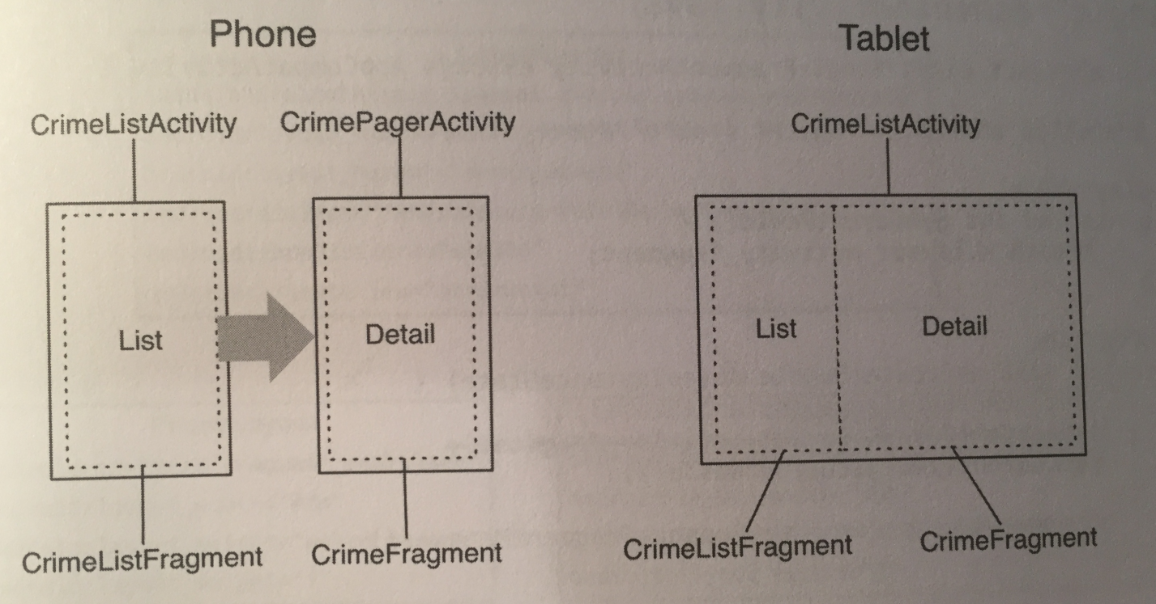

To make this happen, we must:

* Modify our SingleFragmentActivity class so that the layout that gets inflated is **not** hardcoded.
* Create a new layout that consists of two fragment containers.
* Modify CrimeListActivity so that it will inflate a single-container layout on phones and a two-container layout on tablets.

For the first task, we need to add a protected method to SingleFragmentActivity that lets subclasses of it, like CrimeListActivity, pass in its own layout. To do this we create a protected method that returns the ID of the layout that the activity will inflate, and then use that method to inflate.

Here’s the method itself:

**@LayoutRes**

**protected int getLayoutResId(){**

**return R.layout.activity_fragment;**

**}**

…

@Override

public void onCreate(…){

…

setContentView(getLayoutResId());

…

}

Now any subclass can choose to override getLayoutResId() to return a layout other than activity_fragment.xml. We annotate getLayoutResId() with @LayoutRes to tell Android Studio that any implementation of this method should return a valid layout resource ID.

Next, we create an XML file for the two-pane layout.

When we create our two-pane layout, we name the master fragment’s ID fragment_container, so the code in SingleFragmentActivity.onCreate(…) can work as before. When the activity is created, the fragment that’s returned in createFragment() in CrimeListActivity will appear in the lefthand pane.

We need to override getLayoutResId() in CrimeListActivity to use this new layout. We do so like this:

@Override

protected int getLayoutResId(){

return R.layout.activity_twopane;

}

However, this layout currently appears in both the phone and tablet versions of the app. We need to fix that using an alias resource.

An *alias resource* is a resource that points to another resource. Alias resources live in res/values/ and, by convention, are defined in a refs.xml file.

We use alias resources to show a different layout depending on whether our device is a phone or tablet. We do this the same way we show a different layout for landscape and portrait: by using a resource qualifier.

We first create a values resource file in res/values/ called refs.xml, make sure it has no qualifiers, and then add this to the file:

<item name="activity_masterdetail" type="layout">

@layout/activity_fragment

</item>

This resource’s value is a reference to the single-pane layout. It also has a resource ID: R.layout.activity_masterdetail. Note that the alias’s type attribute is what determines the inner class of the ID. Even though the alias itself is in res/values/, its ID is in R.layout.

Now we use this alias instead of a specific value in CrimeListActivity’s getLayoutResId() function, like so:

protected int getLayoutResId(){

return R.layout.activity_masterdetail;

}

Now, because your alias is in res/values/, it is the default alias. So, by default, CrimeListActivity inflates the single-pane layout.

Now we need to create an alternative resource so that the activity_masterdetail alias will point to activity_twopane.xml on larger devices.

What we do is create a new values resource file in res/values/ called refs.xml. However, this time we select a Smallest Screen Width qualifier. This qualifier is a bit different. It asks you to specify a value for the smallest screen width. We type in 600 and click OK.

Then, we add this item to the file:

<item name="activity_masterdetail" type="layout">

@layout/activity_twopane

</item>

Let’s explain what’s going on here. Our goal is to have logic that works like this:

* For devices that are under a specified size, use activity_fragment.xml.
* For devices that are over a specified size, use activity_twopane.xml.

Android does not provide a way to use a resource only when a device is under a particular size, only when it is over. The sw in -sw600dp where our refs.xml file is stored stands for “smallest width”, but refers to the screen’s smallest *dimension*, and thus is independent of the device’s current orientation.

With a -sw600dp qualifier, we’re saying, “Use this resource on any device whose smallest dimension is 600dp or greater.” This is a good rule of thumb for specifying a tablet-sized screen.

Smaller devices will not match our -sw600dp resource, so the default will be used: activity_fragment.xml.

And that’s how we get different layouts into different device widths.

Now we can focus on adding CrimeFragment to the detail fragment container. The best way to do this is to maintain the independence of your fragments by delegating work back to the hosting activity. You do this by defining callback interfaces in your fragments. The hosting activities will implement these interfaces to perform fragment-bossing duties and layout-dependent behavior.

To delegate functionality back to the hosting activity, a fragment typically defines a callback interface named Callbacks. This interface defines work that the fragment needs done by its boss, the hosting activity. Any activity that will host the fragment **must** implement this interface.

With a callback interface, a fragment is able to call methods on its hosting activity without having to know anything about which activity hosted it, because the activity implemented the interface and therefore has the methods the fragment needs.

To implement a Callbacks interface, you must define a member variable in the fragment that holds an object that implements Callbacks. Then, you cast the hosting activity to Callbacks and assign it to that variable.

You assign the activity in the Fragment lifecycle method:

public void onAttach(Context context);

This method is called when a fragment is attached to an activity, whether it was retained or not.

Similarly, you will set the variable to null in the corresponding waning lifecycle method:

public void onDetatch();

You set the variable to null here because afterward you cannot access the activity or count on the activity continuing to exist.

Let’s do all this now, in CrimeListFragment:

**private Callbacks mCallBacks;**

/*

//REQUIRED interface for hosting activities

*/

**public interface Callbacks{**

**void onCrimeSelected(Crime crime);**

**}**

@Override

public void onAttach(Context context){

super.onAttach(context);

**mCallBacks = (Callbacks) context;**

}

@Override

public void onDetach(){

super.onDetach();

**mCallBacks = null;**

}

Now CrimeListFragment has a way to call methods on its hosting activity. It doesn’t matter which activity does the hosting. As long as the activity implements CrimeListFragment.Callbacks, everything in CrimeListFragment can work the same.

Note that CrimeListFragment performs an unchecked cast of its activity to CrimeListFragment.Callbacks. This means that the hosting activity *must* implement CrimeListFragment.Callbacks, or else shit crashes. That’s not a bad dependency to have, but it’s important to document it.

Next, in CrimeListActivity, implement CrimeListFragment.Callbacks. The code to do this is simple and is on page 328.

Eventually, CrimeListFragment will call this method in CrimeHolder.onClick(…) and also when the user chooses to create a new crime. First, let’s figure out CrimeListActivity.onCrimeSelected(Crime)’s implementation.

When onCrimeSelected(Crime) is called, CrimeListActivity needs to do one of two things:

* If using the phone interface, start a new CrimePagerActivity.
* If using the tablet interface, put a CrimeFragment in detail_fragment_container.

To determine which interface was inflated, you could check for a certain layout ID. But the better solution is to check whether the layout has a detail_fragment_container.

Checking a layout’s capabilities is a more precise test of what we need. Filenames can change, and you don’t really care what file the layout was inflated from; you just need to know whether it has a detail_fragment_container to put your CrimeFragment in.

If the layout has a detail_fragment_container, then you’re going to create a fragment transaction that removes the existing CrimeFragment from detail_fragment_container (if there is one in there) and adds the CrimeFragment that we wanna see.

Here’s the implementation in CrimeListActivity:

@Override

public void onCrimeSelected(Crime crime){

if(findViewById(R.id.detail_fragment_container)

== null){

Intent intent =

CrimePagerActivity.newIntent(this,

crime.getId());

startActivity(intent);

}

else{

Fragment newDetail =

CrimeFragment.newInstance(crime.getId());

getSupportFragmentManager().beginTransaction()

.replace(R.id.detail_fragment_container,

newDetail)

.commit();

}

}

Finally, in CrimeListFragment, we call onCrimeSelected(Crime) in the places where we currently start a new CrimePagerActivity. These places are CrimeHolder.onClick(View) and onOptionsItemSelected(MenuItem):

public boolean onOptionsItemSelected(MenuItem item){

switch(item.getItemId()){

case R.id.menu_item_new_crime:

Crime crime = new Crime();

CrimeLab.get(getActivity()).

addCrime(crime);

**updateUI();**

**mCallBacks.onCrimeSelected(crime);**

return true;

…

}

…

private class CrimeHolder extends

RecyclerView.ViewHolder implements View.OnClickListener{

@Override

public void onClick(View v){

**mCallBacks.onCrimeSelected(mCrime);**

}

}

When you call back in onOptionsItemSelected(…), you also reload the list immediately upon adding a new crime. This is necessary because, on tablets, the list remains visible after adding a new crime. Before, we were guaranteed that the detail screen would appear in front of it.

That’s it! However, we still have one problem. If we make a change to a crime, the list will not update to reflect them. Right now, we only reload the list immediately after adding a crime and in CrimeListFragment.onResume(). But on a tablet, CrimeListFragment stays visible alongside the CrimeFragment. The CrimeListFragment is not paused when the CrimeFragment appears, so it’s never resumed. Thus, the list isn’t reloaded.

We can fix this problem with another callback interface - this one in CrimeFragment.

CrimeFragment will define the following interface:

public interface Callbacks{

void onCrimeUpdated(Crime crime);

}

For CrimeFragment to push updates to its peer master Fragment, it will need to do two things. First, since our project’s single source of truth is its SQLite database, it will need to save its Crime to CrimeLab. Then CrimeFragment will call onCrimeUpdated(Crime) on its hosting activity.

CrimeListActivity will implement onCrimeUpdated(Crime) to reload CrimeListFragment’s list, which will pull the latest data from the database and display it.

We first need to change the visibility of updateUI() to public so that it can be called from CrimeListActivity.

Then, in CrimeFragment, add the callback interface along with an mCallbacks variable and implementations of onAttach(…) and onDetatch(…). Code to do all of this is very similar to what we did before and is on page 331.

Next, we implement CrimeFragment.Callbacks in CrimeListActivity to reload the list in onCrimeUpdated(Crime):

public void onCrimeUpdated(Crime crime){

CrimeListFragment listFragment =

(CrimeListFragment)

getSupportFragmentManager()

.findFragmentById(

R.id.fragment_container);

listFragment.updateUI();

}

CrimeFragment.Callbacks must be implemented in all activities that host CrimeFragment. So provide an empty implementation in CrimePagerActivity, too. This is shown in the middle of page 332.

Now, CrimeFragment will be doing the same process a lot of the time. That process is first saving mCrime to CrimeLab, then calling mCallbacks.onCrimeUpdated(Crime). Let’s add a method to CrimeFragment to make this more convenient:

private void updateCrime(){

CrimeLab.get(getActivity()).updateCrime(mCrime);

mCallbacks.onCrimeUpdated(mCrime);

}

Now, add calls for this method when a Crime’s title or solved status has been changed. This happens in the listeners of the text field and checkbox. Page 333 shows where to put updateCrime().

We also need to call updateCrime() in onActivityResult(…) where the Crime’s date, photo, and suspect can be changed. Code to do this is on page 334, and it calls onCrimeUpdated(Crime) through updateCrime().

AND THAT’S IT!!!

**Chapter 18 - Localization:**

*Localization* is the process of providing the appropriate resources for your app based on the user’s language setting. Language settings are part of the device’s configuration. Android provides qualifiers for different languages, just as it does for screen orientation, screen size, and other configuration factors.

This makes localization straightforward: You create resource subdirectories with the desired language configuration qualifier and put the alternative resources in them. The Android resource system does the rest.

The process to create the separate language strings file is easy and is explained on page 338.

Then, you can just put in your different language strings with the same string ID names in your separate language file, and shit just works.

However, be careful to **always provide a default resource for each of your resources.** If you don’t do this, and Android isn’t in a language you’ve covered, either garbage will get printed out or your app will straight up crash.

Resources in unqualified resource directories are your *default resources*. Default resources will be used if no match for the current device configuration is found.

The only resource that is an exception to this rule is drawables, which have their own specified directories which Android will choose from by seeing the screen size and density of your device.

As you add more languages, making sure you provide a version of each string for each language becomes more difficult. Luckily, Android Studio provides a handy Translations Editor to see all of your translations in one place. The book shows you how to use it on page 344.

You can qualify a resource directory with a language-plus-region qualifier that targets resources even more specifically. For instance, the qualifier for Spanish spoken in Spain is -es-rES, where the r denotes a region qualifier and ES is the ISO code for Spain.

The figure below shows the locale resource resolution strategy and how it differs based on the device’s Android version:

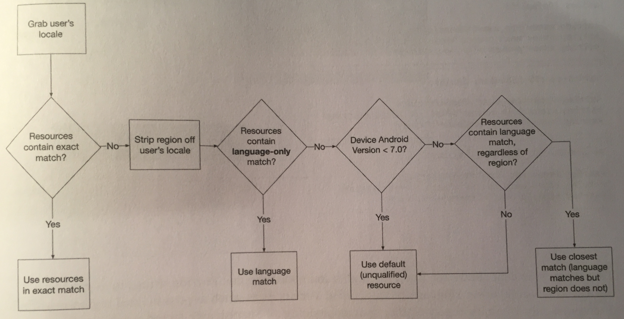

Provide strings in as general a context as possible, using language-only qualified directories as much as possible and region-qualified directories only when necessary,

For example, rather than maintaining all Spanish user-facing strings in three region-qualified directories, store the Spanish strings in a language-only qualified values-es directory and provide region-qualified strings only for words and phrases that are different in the different regional dialects. This not only makes maintaining the strings files easier for the programmer, but it also helps the system resolve the resources on both pre-Nougat devices and Nougat devices by providing a language-only match.

If you wanna test locales that are not on a physical device, you can run the Custom Locale tool to test them on the simulator. The book shows you how to do this on page 347.

The device configurations for which Android provides configuration qualifiers to target resources are:

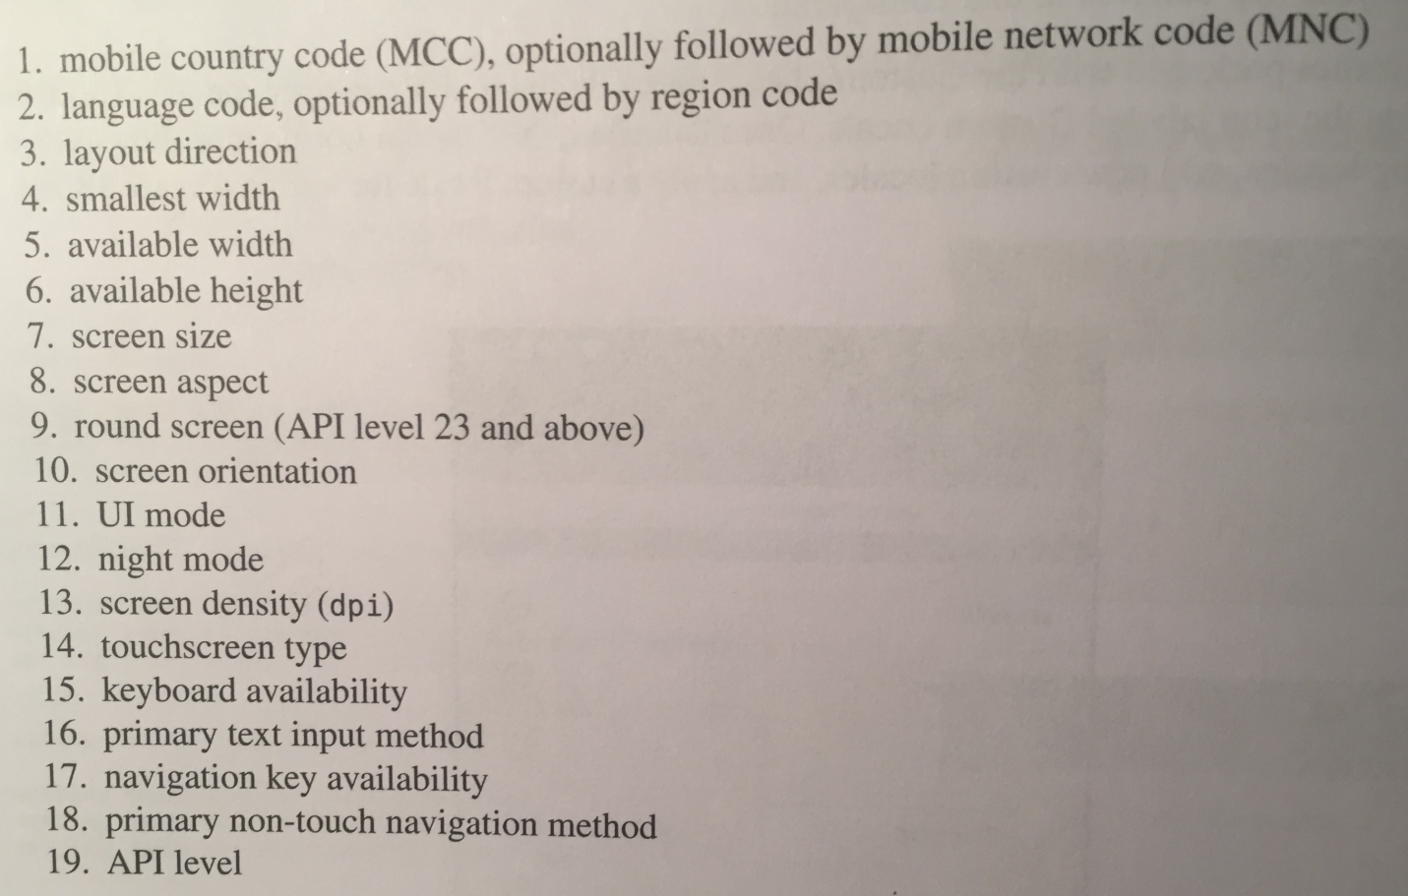

Not all qualifiers are supported by earlier versions of Android. Luckily the system implicitly adds a platform version qualifier to qualifiers that were introduced after Android 1.0. So if, for example, you use the round qualifier, Android will automatically include the v23 qualifier, because round screen qualifiers were added in API level 23. This means you don’t have to worry about problems on older devices when you introduce resources qualified for newer devices.

Given the many types of configuration qualifiers for targeting resources, there may be times when the device configuration will match more than one alternative resource. When this happens, qualifiers are given precedence in the order shown in the list above.

You can add multiple qualifiers to resources that show when all the qualifiers are met. To figure out which resource to use, Android starts at the top of the precedence list, and any resource that **has** a qualifier rules out all the others that **do not**. Then, if more than one resource have the qualifier, Android moves to the next qualifier on the list and keeps going until one resource remains.

You can also see all your different resources in action by using the graphical layout tool’s toolbar to set different devices, API levels, orientations, and languages.

**Chapter 19 - Accessibility:**

We will use a screen reader made by Google called TalkBack to give accessibility to people who are visually impaired.

The book shows you how to set up TalkBack on your device on pages 356-358.

Android framework widgets, such as Toolbar, RecyclerView, ListView, and Button, have basic TalkBack support built in. You should use framework widgets as much as possible so you can leverage the accessibility work that has already been done for those widgets.

To make your widgets recognized by TalkBack, you need to specify a *content description* for them. A content description is a piece of text that describes the widget and is read by TalkBack.

You can set a widget’s content description in the XML layout file by setting a value for the attribute android:contentDescription. You can also set it in your UI setup code, using someView.setContentDescription(someString).

So, the first step is to add descriptive strings in your strings.xml file that we’ll use for the content description. Next, set the content description for the widgets in their layout file, like so:

<ImageView

…

**android:contentDescription=**

**"@string/crime_photo_no_image_description"**/>

However, you may have a problem with some of your widgets. The problem is that TalkBack will not recognize them and give them focus, because they’re not focusable. To make them focusable, you need to set the widgets’ android:focusable attribute to true (or add a click listener). Here’s how that would look:

<ImageView

…

android:contentDescription=

"@string/crime_photo_no_image_description"

**android:focusable="true"**/>

Ok, so we have a problem. The way the content description is being set for the above image view, it’ll **always** say that a photo is not set, even when we take a photo and set it. Therefore, we need to change the content description in code when the photo is set, like so:

private void updatePhotoView(){

if(mPhotoFile == null || !mPhotoFile.exists()){

mPhotoView.setImageDrawable(null);

**mPhotoView.setContentDescription(**

**getString(**

**R.string.crime_photo_no_image_description));**

}

else{

…

mPhotoView.setImageBitmap(bitmap);

**mPhotoView.setContentDescription(**

**getString(**

**R.string.crime_photo_image_description));**

}

}

We have one more small issue to go over. If you have a text box that you can enter in information for, and a title for that text box that lets you know what the info you’re editing is used for, TalkBack needs more information to make that connection. To give it that info, add the android:labelFor attribute in your layout file, like so:

<TextView

…

**android:labelFor="@+id/crime_title"**/>

The android:labelFor attribute tells TalkBack that the text view serves as a label to the view specified by the ID value. labelFor is defined on the View class, so you can associate any view as the label for any other view. Note that you must use the @+id syntax here because you’re reffering to an ID that has not been defined at that point in the file (it’s defined right below it in our file, but could be defined anywhere in other layout files). You could remove the + from the android:id=”@+id/crime_title” line in your EditText’s definition, but it’s not necessary to do so.

To make sure your app is accessible, you can install and run Google’s Accessibilty Scanner app, which analyzes and evaluates how accessible your app is, and gives suggestions as to how to make it more accessible. The book goes over this on pages 370-372.

**Chapter 20 - Data Binding and MVVM:**

In this chapter, we will look at a new kind of data architecture, Model-View-ViewModel (of MVVM), and a new tool called data binding.

So why use MVVM? Well, when you’re working on a big project, it can become unwieldy to deal with big controller objects, like big activities and fragments. So, what you can do is break controller classes down into smaller pieces, smaller jobs, and assign each small job to a class. Then, instead of one big class, you have instances of a few classes doing the job as a team.

MVVM does a great job of lifting a lot of boring controller code into the layout file, where you can easily see which parts of your interface are dynamic. At the same time, it pulls the non-boring dynamic controller code into a ViewModel class, where it can be more easily tested and verified.

To use data binding, we inflate a layout file and wire it up using a data binding inflater. The first thing we need to do is enable data binding in our app’s build.gradle file:

android{

…

**dataBinding{**

**enabled = true**

**}**

}

This turns on the IDE integration that will allow you to access the classes data binding will generate for you and integrate that class generation into your build.

To use data binding within a particular layout file, you have to change it into a data binding layout file. The way you do that is by wrapping the entire XML file in a <layout> tag, like so:

**<layout**

**xmlns:android=**

**"http://schemas.android.com/apk/res/android">**

<android.support.v7.widget.RecyclerView

android:id="@+id/recycler_view"

android:layout_width="match_parent"

android:layout_height="match_parent" />

**</layout>**

The <layout> tag is your signal to the data binding tool that it should get to work on your layout file. Once it’s done, it’ll generate a *binding class* for you. By default, this class is named after your layout file, but in camel case.

So, for example, if your layout file is fragment_beat_box.xml, the binding class will be named FragmentBeatBoxBinding. This class is what you’ll use for data binding: instead of inflating a view hierarchy with a LayoutInflater, you will inflate an instance of FragmentBeatBoxBinding.

FragmentBeatBoxBinding will hold on to the view hierarchy for you in a getter called getRoot(). In addition to that, it holds on to named references for each view you tagged with an android:id attribute in your layout file.

So our FragmentBeatBoxBinding class has two references: getRoot(), which refers to the entire layout, and recyclerView, which is the ID, in camel case, that we gave to our recycler view in the layout file:

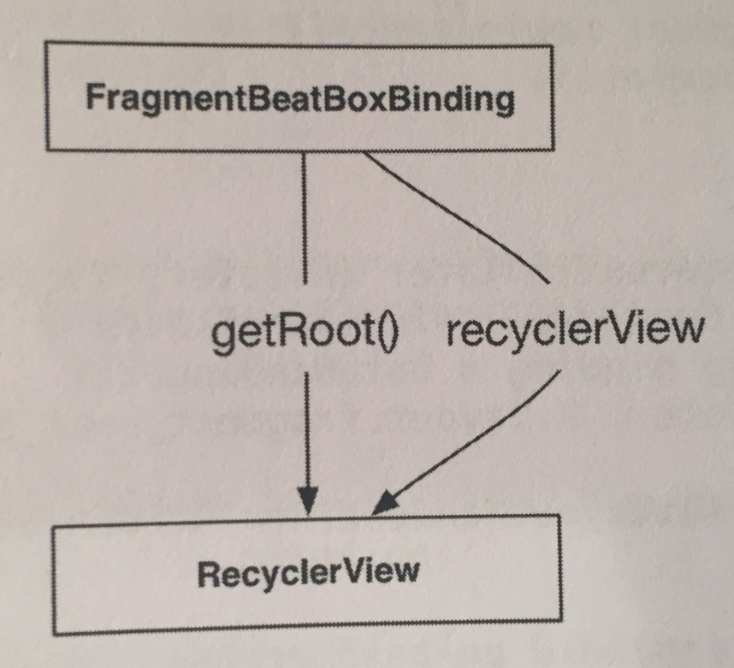

Our layout right now currently has one view, so both references point to the same recycler view.

To use this binding class, we override onCreateView(…) and use DataBindingUtil to inflate an instance of FragmentBeatBoxBinding, like so:

@Override

public View onCreateView(LayoutInflater inflater, ViewGroup container, Bundle savedInstanceState){

**FragmentBeatBoxBinding binding =**

**DataBindingUtil.inflate(inflater,**

**R.layout.fragment_beat_box, container,**

**false);**

**return binding.getRoot();**

}

With your binding created, you can now get at your RecyclerView and configure it:

@Override

public View onCreateView(LayoutInflater inflater, ViewGroup container, Bundle savedInstanceState){

FragmentBeatBoxBinding binding =

DataBindingUtil.inflate(inflater,

R.layout.fragment_beat_box, container,

false);

**binding.recyclerView.setLayoutManager(**

**new GridLayoutManager(getActivity(), 3));**

return binding.getRoot();

}

This is what we call simple data binding: using data binding to automatically pull out views for you, instead of writing findViewById(…).

Next, we create another layout file, that uses the <layout> tag for data binding, for a button. Then, in our fragment class, we create a SoundHolder RecyclerView view holder wired up to this new layout file (which is list_item_sound.xml), like so:

private class SoundHolder

extends RecyclerView.ViewHolder{

private ListItemSoundBinding mBinding;

private SoundHolder(ListItemSoundBinding binding){

**super(binding.getRoot());**

**mBinding = binding;**

}

}

Then, we create a SoundAdapter hooked up to SoundHolder:

private class SoundAdapter extends RecyclerView.Adapter<SoundHolder>{

@Override

public SoundHolder onCreateViewHolder(

ViewGroup parent, int viewType) {

LayoutInflater inflater =

LayoutInflater.from(getActivity());

ListItemSoundBinding binding =

DataBindingUtil.inflate(inflater,

R.layout.list_item_sound, parent,   
 false);

return new SoundHolder(binding);

}

@Override

public void onBindViewHolder(SoundHolder holder,

int position) {

}

@Override

public int getItemCount() {

return 0;

}

}

Now we wire up SoundAdapter in the onCreateView(…) of our fragment:

@Override

public View onCreateView(…){

…

**binding.recyclerView.setAdapter(**

**new SoundAdapter());**

return binding.getRoot();

}

To add static shit like graphics and sound files, we use raw assets. You can think of assets as stripped down resources. They are packaged into your APK like resources, but without any of the configuration system tooling that goes on top of resources.

The pro to this is that because there’s no configuration system, you can name assets whatever you want and organize them with your own folder structure. The con is that without a configuration system, you can’t automatically respond to changes in pixel density, language, or orientation, nor can you automatically use assets in layout files or other resources.

Assets are good to use when you only access them programmatically.

The book goes over importing assets on pages 382-384.

To keep track of our assets and do asset management, we create a class to do this work:

public class BeatBox {

private static final String TAG = "BeatBox";

private static final String SOUNDS_FOLDER =

"sample_sounds";

}

We first create constants for logging and to keep track of the folder that contains our assets.

Assets are accessed using the AssetManager class. Our class that manages our assets needs one of these, and we can get one from any Context. Therefore, we create a constructor that takes in a Context as a dependency, pulls out an AssetManager, and stashes it away in a private instance variable:

private AssetManager mAssets;

public BeatBox(Context context){

mAssets = context.getAssets();

}

When getting at assets, in general you don’t need to worry about which Context you’re using. In every situation you’re likely to encounter in practice, every Context’s AssetManager will be wired up to the same set of assets.

To get a listing of what you have in your assets, you can use the list(String) method, which lists filenames contained in the folder path you pass in:

String[] soundNames = mAssets.list(SOUNDS_FOLDER);

So, now we need to wire everything up.

First, we create an object called Sound that’s responsible for keeping track of the info for **each individual asset** (whereas the BeatBox class keeps track of all the assets):

public class Sound {

private String mAssetPath;

private String mName;

public Sound(String assetPath){

mAssetPath = assetPath;

String[] components = assetPath.split("/");

String filename =

components[components.length - 1];

mName = filename.replace(".wav", "");

}

public String getAssetPath() {

return mAssetPath;

}

public String getName() {

return mName;

}

}

In the constructor, we do a little work to make a presentable name for our sound. First, we split off the filename using String.split(String), and then we use String.replace(String, String) to strip off the file extension too.

Next, we create a method called loadSounds() to load up our sounds into our BeatBox class which manages all of them:

public class BeatBox {

…

**private List<Sound> mSounds = new ArrayList<>();**

public BeatBox(Context context){

mAssets = context.getAssets();

**loadSounds();**

}

**private void loadSounds(){**

**String[] soundNames;**

**try{**

**soundNames = mAssets.list(SOUNDS_FOLDER);**

**}**

**catch(IOException ioe){**

**Log.e(TAG, "Could not list assets", ioe);**

**return;**

**}**

**for(String filename: soundNames){**

**String assetPath =**

**SOUNDS_FOLDER + "/" + filename;**

**Sound sound = new Sound(assetPath);**

**mSounds.add(sound);**

**}**

**}**

**public List<Sound> getSounds(){**

**return mSounds;**

**}**

}

Next, we wire up SoundAdapter to a List of Sounds:

private class SoundAdapter

extends RecyclerView.Adapter<SoundHolder>{

**private List<Sound> mSounds;**

**public SoundAdapter(List<Sound> sounds){**

**mSounds = sounds;**

**}**

@Override

public int getItemCount() {

**return mSounds.size();**

}

}

Then we hook everything up in BeatBoxFragment:

public class BeatBoxFragment extends Fragment {

**private BeatBox mBeatBox;**

…

**@Override**

**public void onCreate(Bundle savedInstanceState){**

**super.onCreate(savedInstanceState);**

**mBeatBox = new BeatBox(getActivity());**

**}**

…

@Override

public View onCreateView(…){

…

**binding.recyclerView.setAdapter(**

**new SoundAdapter(mBeatBox.getSounds()));**

return binding.getRoot();

}

…

}

With that, we should see a grid of buttons!

To populate our buttons with titles, we’ll use some more tools data binding offers.

With data binding, you can declare data objects within your layout file:

<layout …>

<data>

<variable

name=“crime

type=”com.bignerdranch.android

.criminalintent.Crime”/>

</data>

</layout>

Then, you can use values from those data objects directly in your layout file by using the binding mustache operator - @{}:

<CheckBox

…

android:checked=”@{crime.isSolved()}”

…

/>

This looks like so:

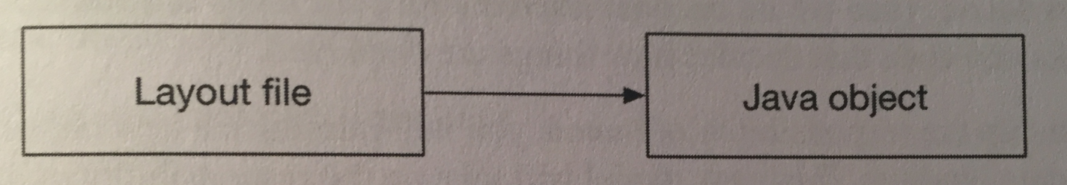

What we need to do right now is put the sound names on their buttons. The most direct way of doing that using data binding is to bind directly to a Sound object in the layout file:

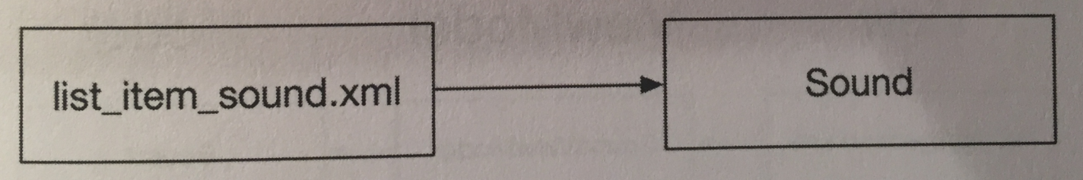

However, this causes architectural issues, because we’re now putting Sound model objects in charge of modeling our sounds and how they are displayed, which puts too much responsibility on a Sound object.

So, what we do is introduce a new object called a *view model* to use with data binding. This view model will take on the responsibility of deciding how things are displayed:

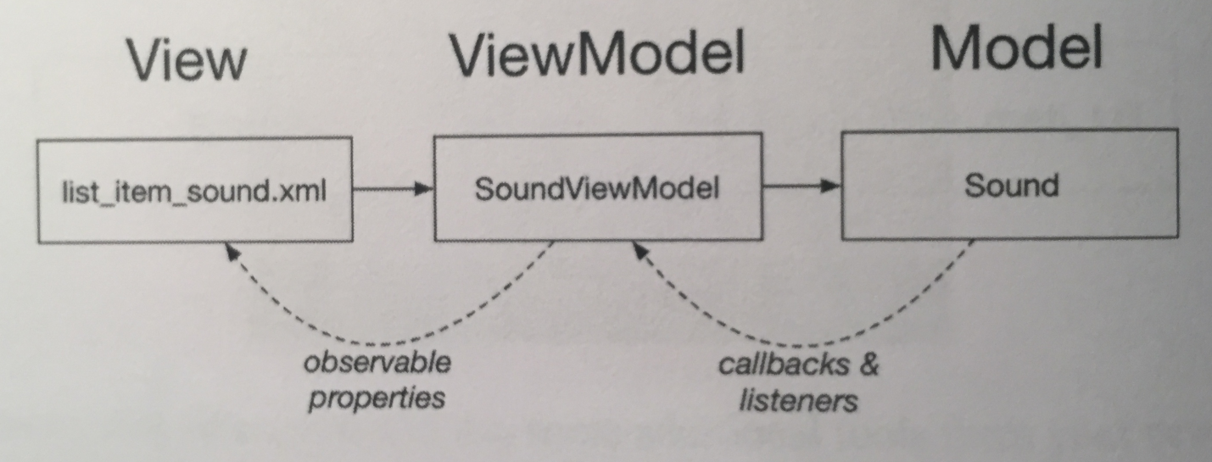

This architecture is called MVVM. Most of the work your controller classes once did at runtime to format data for display will now go in the view model. Wiring up widgets with that data will be handled directly in the layout file using data binding to that view model.

The controller (your activity or fragment) will be in charge of things like initializing the binding and the view model and creating the link between the two.

So, we create our view model class and give it two properties: a Sound for it to use and a BeatBox to play the sound with (we will implement this shortly):

public class SoundViewModel {

private Sound mSound;

private BeatBox mBeatBox;

public SoundViewModel(BeatBox beatBox){

mBeatBox = beatBox;

}

public Sound getSound() {

return mSound;

}

public void setSound(Sound sound) {

mSound = sound;

}

public String getTitle(){

return mSound.getName();

}

}

All this code except for getTitle() is the interface your adapter will use. The getTitle() method is for the layout file to get the title the button should display.

Now we can integrate the view model into our layout file. The first step is to declare a property on our layout file, like so:

<layout…>

**<data>**

**<variable**

**name="viewModel"**

**type=**

**"com.bignerdranch.android**

**.beatbox.SoundViewModel"/>**

**</data>**

…

</layout>

This defines a property named viewModel on our binding class (our RecyclerView **and** the layout file the RecyclerView uses). Now within your binding class, we can use viewModel in binding expressions:

<Button

android:layout_width="match_parent"

android:layout_height="120dp"

**android:text="@{viewModel.title}"**

tools:text="Sound name"/>

Within the binding mustache, you can write simple Java expressions, including chained method calls, math, and anything else you want to include. You also get some “syntactic sugar”, conveniences to save you typing. For example, viewModel.title above is shorthand for viewModel.getTitle(). Data binding knows how to translate your property reference into the appropriate method call.

Now we can hook up our view model. To do that, we create a SoundViewModel and attach it to our binding class (our RecyclerView). Then, we add a binding method to our SoundHolder:

private class SoundHolder

extends RecyclerView.ViewHolder{

private ListItemSoundBinding mBinding;

private SoundHolder(ListItemSoundBinding binding){

super(binding.getRoot());

mBinding = binding;

**mBinding.setViewModel(**

**new SoundViewModel(mBeatBox));**

}

**public void bind(Sound sound){**

**mBinding.getViewModel().setSound(sound);**

**mBinding.executePendingBindings();**

**}**

}

Inside our constructor above, we construct and attach our view model. Then, in our bind(…) method, we update the data that view model is working with.

Calling executePendingBindings() is not normally necessary, but we do it here because RecyclerView updates data very fast, and calling this method forces the layout to immediately update itself, rather than waiting a ms to two. This keeps everything in step.

Finally, we finish hooking up our view model by implementing onBindViewHolder(…) in SoundAdapter:

@Override

public void onBindViewHolder(SoundHolder holder,

int position) {

**Sound sound = mSounds.get(position);**

**holder.bind(sound);**

}

Now we should be able to see the titles on all of our recycler view buttons.

We have one more issue to deal with. Our layout has no way of knowing that we updated SoundViewModel’s Sound inside SoundHolder.bind(Sound). Our view model doesn’t talk back to the layout file, and we need it to.

So, to do this we will extend the BaseObservable class to add observables that can make this connection. This lets our binding class (our recycler view in this case) set listeners on our view model so that it automatically receives callbacks when its fields are modified.

To extend BaseObservable properly:

1. Subclass BaseObservable in our view model.
2. Annotate our view model’s bindable properties with @Bindable.
3. Call notifyChange() or notifyPropertyChange(int) each time a bindable property’s value changes.

Here’s how this would go:

public class SoundViewModel **extends BaseObservable**{

…

public void setSound(Sound sound) {

mSound = sound;

**notifyChange();**

}

**@Bindable**

public String getTitle(){

return mSound.getName();

}

}

When we call notifyChange() here, it notifies our binding class (again, our recycler view) that all of the Bindable fields on our objects have been updated. The binding class then runs the code inside the binding mustaches again to repopulate the view. So now, when setSound(Sound) is called, ListItemSoundBinding will be notified and call Button.setText(String) as we specified in our layout file.

We mentioned the method notifyPropertyChanged(int). This method does the same thing as notifyChange(), except it’s more particular. By writing notifyChanged(), we state we want to update everything. But by writing notifyPropertyChanged(BR.title), we instead say that only getTitle()’s value has changed, and we need to update only the title. Since we’re only updating one value, cause only one field has @Bindable here, we don’t need to use notifyPropertyChanged(int).

We need to go over how to access your assets. Your Sound object has an asset path defined on it. Asset file paths will not work if you try to open them with a File; you must use them with an AssetManager:

String assetPath = sound.getAssetPath();

//mAssets is an AssetManager

InputStream soundData = mAssets.open(assetPath);

This gives you a standard InputSteam for the data, which you can use like any other InputStream in Java.

Some APIs require FileDescriptors instead (like SoundPool in the next chapter). If you need that, you can call AssetManager.openFd(String) instead:

String assetPath = sound.getAssetPath();

//AssetFileDescriptors are different from //FileDescriptors

AssetFileDescriptor assetFd = mAssets.openFd(assetPath);

//but you can get a regular FileDescriptor easily if //you need to

FileDescriptor fd = assetFd.getFileDescriptor();

Let’s look at some more things you can do with data binding.

You can write short callbacks directly in your layout file using lambda expressions, which are simplified versions of Java’s lambda expressions:

<Button

…

**android:onClick=**

**”@{(view) -> viewModel.onButtonClick()}”**

…

/>

Like Java 8 lambda expressions, these are turned into implementations for the interface you use them for (in this case, View.OnClickListener). Unlike Java 8 lambda expressions, these expressions must use this exact syntax: the parameter must be in parentheses, and you must have exactly one expression on the right-side.

Also, unlike in Java lambdas, you can omit the lambda parameters if you aren’t using them. So this works fine too:

android:onClick=”@{() -> viewModel.nnButtonClick()}”

You also can use backtics for double quotes, like so:

android:text=”@{`File name: ` + viewModel.title}”

Here, `File name` means the same thing as “File name”.

Binding expressions also gets a null coalescing operator:

android:text=”@{`File name: ` + viewModel.title ??

`No file`}”

In addition, there’s automatic null handling provided for you in data binding. Even if viewModel is null in the above code, data binding will provide appropriate null checks so that it doesn’t crash the app. Instead of crashing, the subexpression viewModel.title will yield “null”.

By default, data binding interprets a binding expression as a property invocation. So the following:

android:text=”@{`File name: ` + viewModel.title ??

`No file`}”

is translated into an invocation of the setText(String) method.

Sometimes, though, that’s not enough, and you want some custom behavior to be applied for a particular attribute. In these cases, you can write a BindingAdapter:

public class BeatBoxBindingAdapter{

@BindingAdapter(“app:soundName”)

public static void bindAssetSound(

Button button, String assetFileName){

…

}

}

Simply create a static method in any class in your project and annotate it with @BindingAdapter, passing in the name of the attribute you want to bind as a parameter. Whenever data binding needs to apply that attribute, it’ll call your static method.

**However, make sure that Android does not already define BindingAdapters for what you wanna write.** For example, TextViewBindingAdapter provides additional attributes for TextView.

We used assets instead of resources with this chapter because with assets, you basically have a little file system that ships with your app, and you can have whatever folder structure you want, unlike with resources, where the folder structure is flat, and where you can’t store all the assets in one folder.

**Chapter 21 - Unit Testing and Audio Playback:**

One reason MVVM architecture is so appealing is that it makes a critical programming practice easier: unit testing.

We will use the SoundPool API for audio playback.

SoundPool is an Android audio API that can load a large set of sounds into memory and control the maximum number of sounds that are playing back at any one time. So, if your app’s user gets super excited and mashes all the buttons at once, it won’t break your app or overtax your phone.

The first thing we need to do is create a SoundPool. We do so in our class that manages our assets (the BeatBox class in our case):

mSoundPool = new SoundPool(MAX_SOUNDS,

AudioManager.STREAM_MUSIC, 0);

MAX_SOUNDS is a constant that’s 5. Lollipop introduced a new way of creating a SoundPool using SoundPool.Builder. However, since SoundPool.Builder is not available on our min-supported API (which is 19), we’re using the older SoundPool(int, int, int) constructor instead.

The first parameter specifies how many sounds can play at a given time. Here, we pass in 5. If five sounds are playing and we try to play a sixth one, the SoundPool will stop playing the oldest one.

The second parameter determines the kind of audio stream our SoundPool will play on. Android has a variety of different audio streams, each of which has its own independent volume settings. This is why turning down the music does not also turn down your alarms. Here we use STREAM_MUSIC to put us on the same volume setting as music and games on the device.

The last parameter specifies the quality for the sample rate converter. The documentation says it’s ignored, so just pass in 0.

Now we load our sounds in. The main benefit of using a SoundPool over some other methods of playing audio is that SoundPool is responsive: when you tell it to play a sound, it’ll play the sound immediately, with no lag.

The trade-off for that is that we have to load sounds into our SoundPool before we play them. Each sound we load will get its own integer ID. So, we need to add an Integer field to our Sound class to store this. We use Integer instead of int to make it possible to represent the state where a Sound has no value for mSoundId by assigning it a null value.

Now to load our sounds in, we add a load(Sound) method to BeatBox, our asset management class, to load a Sound into our SoundPool:

private void load(Sound sound) throws IOException{

AssetFileDescriptor afd =

mAssets.openFd(sound.getAssetPath());

int soundId = mSoundPool.load(afd, 1);

sound.setSoundId(soundId);

}

Calling mSoundPool.load(AssetFileDescriptor, int) loads a file into our SoundPool for later playback. To keep track of the sound and play it back again (or unload it), mSoundPool.load(…) returns an int ID, which we stash in the mSoundId field we defined in the Sound class. And since calling openFd(String) throws IOException, load(Sound) throws it too. The 1 here is the priority.

Now we load up all of our sounds by calling load(Sound) inside our loadSounds() method:

private void loadSounds(){

…

for(String filename: soundNames){

**try {**

String assetPath =

SOUNDS_FOLDER + "/" + filename;

Sound sound = new Sound(assetPath);

**load(sound);**

mSounds.add(sound);

**}**

**catch(IOException ioe){**

**Log.e(TAG, "Could not load sound " +**

**filename, ioe);**

**}**

}

}

Now that our sounds are loaded, we are going to play them back. We add a method to BeatBox to play a specified sound:

public void play(Sound sound){

Integer soundID = sound.getSoundId();

if(soundID == null){

return;

}

mSoundPool.play(soundID, 1.0f, 1.0f, 1, 0, 1.0f);

}

Before playing our sound, we check to make sure its ID is not null. This might happen if the Sound failed to load.

Once we are sure we have a non-null value, we play the sound by calling SoundPool.play(int, float, float, int, int, float). Those parameters are, respectively: the sound ID, volume on the left, volume on the right, priority (which is ignored), whether the audio should loop, and playback rate.

For full volume and normal playback rate, we pass in 1.0. Passing in 0 for the looping value tells the sound not to loop.

With this method written, you’re now ready to integrate sound playback into SoundViewModel. You’ll perform this integration in a test-first manner. That is, you’ll first write a failing unit test and then implement the integration to make the test pass.

First we add the Mockito and Hamcrest (part of JUnit) libraries. The book does this on pages 402-403.

The book then goes over what you need to do to create a test class on pages 403-404.

Tests in the androidTest folder are **integration tests**, and run on an Adroid device or emulator. The advantage of that is that you can test any behavior of your app at runtime. The downside is that since they must build and run an APK on a device, they take forever to run.

Tests in the test folder are **unit tests**. Unit tests are run on your local machine, without any of the Android runtime available. Leaving out that baggage makes them quick.

The book then goes over the unit test setup code on pages 405-406.

The book then goes over using JUnit and Mockito to run tests on our Android code. I already made two huge summaries of JUnit and Mockito, so I’m not gonna do that here.

However, the book does create a method in the SoundViewModel class that triggers a sound to play:

public void onButtonClicked() {

mBeatBox.play(mSound);

}

One last step to get our buttons working: we need to hook up this method to our button. We do that with a lambda expression in our layout file, like so:

<Button

android:layout_width="match_parent"

android:layout_height="120dp"

**android:onClick=**

**"@{() -> viewModel.onButtonClicked()}"**

android:text="@{viewModel.title}"

tools:text="Sound name"/>

The app works, but we still have some cleanup to do. To be a good citizen, we should clean up our SoundPool by calling SoundPool.release() when we’re done with it. We add a matching BeatBox.release() method to do so:

public void release(){

mSoundPool.release();

}

Then, clean our SoundPool up when we’re done with it in BeatBoxFragment:

@Override

public void onDestroy(){

super.onDestroy();

mBeatBox.release();

}

Ok, now we’re doing everything correctly, loading and closing assets, and playing them when triggered. We have a problem though: our app no longer handles rotation correctly. When we play a sound and rotate, the sound will stop abruptly.

Here is the problem: on rotation, our activity is destroyed. As this happens, the FragmentManager destroys our fragment, too. In doing that, it calls the fragment’s waning lifecycle methods: onPause(), onStop(), and onDestroy(). In our onDestroy() method, we call release() on the SoundPool, which stops sound playback.

We have seen how Activity and Fragment instances die on rotation before, and we have solved these issues using onSaveInstanceState(Bundle). However, that solution will not work this time, because it relies on saving data out and restoring it using Parcelable data inside a Bundle.

Parcelable, like Serializable, is an API for saving an object out to a stream of bytes. Objects may elect to implement the Parcelable interface if they are what we will call “stashable” here. Objects are stashed in Java by putting them in a Bundle, or by marking them Serializable so that they can be serialized, or by implementing the Parcelable interface. Whichever way you do it, the same idea applies: you should not be using any of these tools unless your object is stashable.

You can’t stash a sound that is playing. Once it stops, it stops. There’s nothing left to save.

Some parts of BeatBox are stashable: everything contained in the Sound object class is stashable. SoundPool is not. Yes, you can create a new SoundPool that has all the same sounds as the older one. You can even start playing again right where you left off. However, you will always experience a brief interruption, no matter what you do. That means that SoundPool is not stashable.

Non-stashability tends to be contagious. If a non-stashable object is critical to another object’s mission, that other object is probably not stashable either. Here, BeatBox has the same mission as SoundPool: to play back sounds. Therefore, BeatBox is also not stashable.

We need BeatBox to be continuously available as our Activity is created and destroyed. What do we do?

Fortunately, fragments have a feature that we can use to keep the BeatBox instance alive across a configuration change: retainInstance. We just need to do this in the onCreate(…) function of the BeatBoxFragment:

setRetainInstance(true);

By default, the retainInstance property of a fragment is false. This means it’s not *retained*, and it’s destroyed and re-created on rotation along with the activity that hosts it. Calling setRetainInstance(true) *retains* the fragment. When a fragment is *retained*, the fragment is not destroyed with the activity. Instead, it’s preserved and passed along intact to the new activity.

When you retain a fragment, you can count on all of its instance variables (like mBeatBox) to keep the same values. When you reach for them, they’re simply there.

Now our sound should continue uninterrupted during rotation.

Let’s take a closer look at how retained fragments work. Retained fragments take advantage of the fact that a fragment’s view can be destroyed and re-created without having to destroy the fragment itself.

During a configuration change, the FragmentManager first destroys the views of the fragments in the list. Fragment views always get destroyed and re-created on a configuration change for the same reasons that activity views are destroyed and re-created: If you have a new config, then you might need new resources. Just in case matching resources are now available (like landscape mode on a view), you rebuild the view from scratch.

Next, the FragmentManager checks the retainInstance property of each fragment. If it’s false, which is the default, then the FragmentManager destroys the fragment instance. The fragment and its view will be re-created by the new FragmentManager of the new activity “on the other side”:

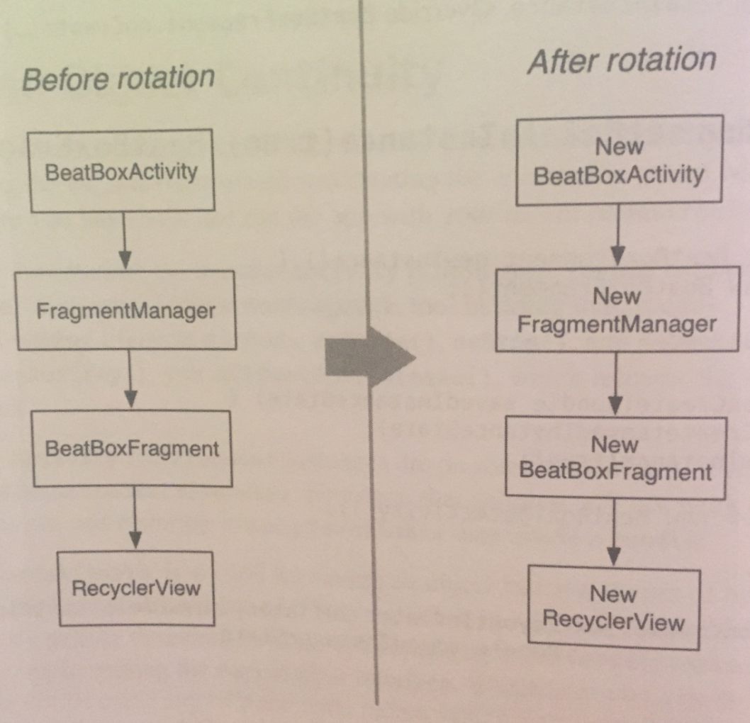

On the other hand, if retainInstance is true, then the fragment’s view is destroyed but the fragment itself is not. When the new activity is created, the new FragmentManager finds the retained fragment and re-creates its view:

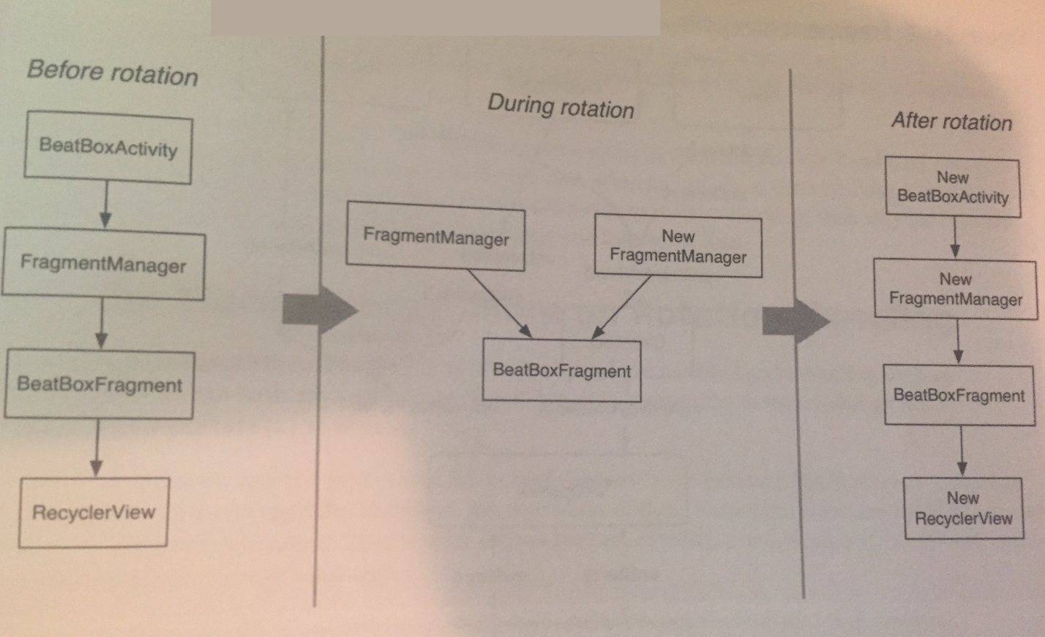

A retained fragment is not destroyed, but it is *detached* from the dying activity. This puts the fragment in a *retained* state. The fragment still exists, but it’s not hosted by any activity:

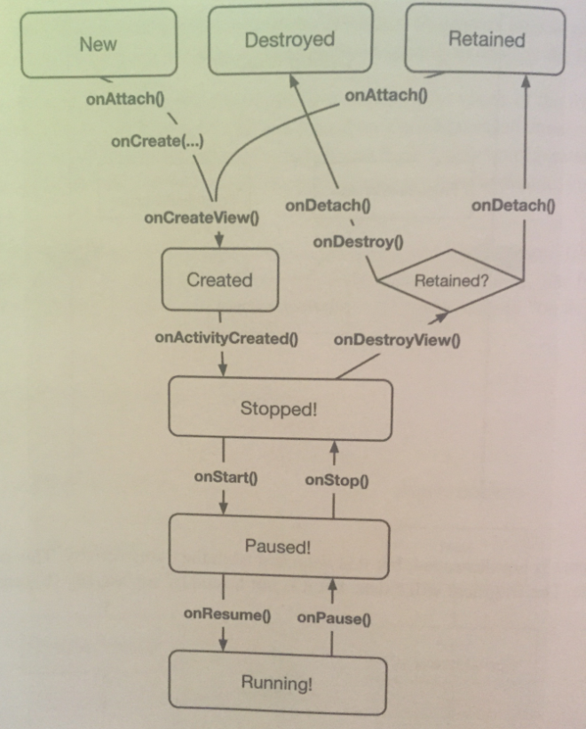

The retained state is only entered into when two conditions are met:

* setRetainInstance(true) has been called on the fragment.
* The hosting activity is being destroyed for a configuration change (typically rotation).

So why don’t we just retain fragments all the time? The first reason we don’t wanna do this is because **retained fragments are more complicated than unretained fragments**. When something goes wrong with them, it takes longer to get to the bottom of what went wrong.

The other reason is that **fragments that handle rotation using saved instance state handle all lifecycle situations, but retained fragments only handle the case when an activity is destroyed for a configuration change**. If your activity is destroyed because the OS needs to reclaim memory, then all your retained fragments are destroyed, too, which may mean that you lose some data.

In short, if you need something to be saved for a short amount of time, use retaining. If something needs to be saved for a long time and thru shit like a shutdown, then you need to use onSaveInstanceState(…) to save the state of the app so you can restore it.

The book then briefly goes over Espresso for use with integration testing on pages 417-418. **Javid, look this up cause the book goes over unit testing, but not integration testing, and you should be doing both for your apps!**

Mocking has a much different role in integration testing than it does in unit testing. Mock objects exist to isolate the component under test by pretending to be other unrelated components. **Unit tests test an individual class; each class will have its own distinct dependencies, so each test class has a different set of mock objects.** Since the mock objects are different in each test class, and the behavior rarely matters, mock frameworks that make it easy to create simple mock objects (like Mockito) are a great fit for unit tests.

**Integration tests**, on the other hand, are meant to test the entire app as a single piece. Instead of isolating pieces of the app from each other, you **use mocks to isolate the app from anything external it might interact with**; for example, by providing a web service with fake data and responses. Because the mocks are larger and shared among many tests, and because it’s more common to implement mock behavior, it’s better to avoid automatic mocking frameworks for integration tests and instead manually write mock objects.

In either case, the same rule applies: **Mock out the entities at the boundary of the component under test**. This focuses the scope of your test and keeps it from breaking except when the component itself is broken.

**Chapter 22 - Styles and Themes:**

In this chapter we will learn how to give a custom look and feel to our app.

We can define a few colors that we will use to style our app. We create a colors.xml file in res/values and put these color attributes into it:

<color name="red">#F44336</color>

<color name="dark_red">#C3352B</color>

<color name="gray">#607D88</color>

<color name="soothing_blue">#0083BF</color>

<color name="dark_blue">#005A8A</color>

Color resources are a convenient way to specify color values in one place that you reference throughout your app.

Now, we can define a style that uses these colors (among other things). A *style* is a set of attributes that you can apply to a widget. We put styles in our styles.xml file that was created for us, like so:

<style name="BeatBoxButton">

<item name="android:background">

@color/dark_blue

</item>

</style>

Here, we create a style called BeatBoxButton. This style defines a single attribute, android:background, and sets it to a dark blue color. We can apply this style to as many widgets as we like and then update the attributes of all of those widgets in this one place.

We apply this style to a widget like so:

style="@style/BeatBoxButton"

We can create a style for any set of attributes we want to reuse in our app.

Styles also support inheritance. A style can inherit and override attributes from another style. For example, here’s a style that overrides our BeatBoxButton style from above:

<style name=**"BeatBoxButton.Strong"**>

<item name="android:textStyle">bold</item>

</style>

While we could have added the android:textStyle to the BeatBoxButton style directly, we did this to demonstrate inheritance.

The naming convention BeatBoxButton.Strong is saying that our theme inherits from BeatBoxButton.

There is also an alternative inheritance naming style. We can specify a parent when declaring the style:

<style **name="StrongBeatBoxButton"**

**parent=”@style/BeatBoxButton”**>

<item name="android:textStyle">bold</item>

</style>

Let’s stick with the first style.

To use our new style, do:

style="@style/BeatBoxButton.Strong"

Styles are cool. They allow you to define a set of attributes in one place and then apply them to as many widgets as you want. The downside of styles is that we have to apply them to each and every widget, one at a time. What if we had a more complex app with lots of buttons in lots of layouts? This is not good to place styles one at a time.

That is where themes come in. *Themes* take styles a step further: they allow you to define a set of attributes in one place, like a style - but then take those attributes and automatically apply them throughout your app.

Theme attributes can store a reference to concrete resources, such as colors, and they can also store a reference to styles. In a theme, you can say, for example, “I want all buttons to use this style.” And you don’t then need to find every button widget and tell it to use the theme.

Every app is given a default theme, it’s in the manifest file under the attribute android:theme. You declare themes in your styles.xml file.

A theme is also a style, but themes specify different attributes than a style does. Themes are also given superpowers by being declared in the manifest. This is what causes the theme to be applied across the entire app automatically.

When you start a project, you’re given a theme with one of three values:

* Theme.AppCompat
* Theme.AppCompat.Light
* Theme.AppCompat.Light.DarkActionBar

To specify attributes on a theme, do something like this:

<style name="AppTheme"

parent="Theme.AppCompat.Light.DarkActionBar">

<item name="colorPrimary">@color/red</item>

<item name="colorPrimaryDark">@color/dark_red</item>

<item name="colorAccent">@color/gray</item>

</style>

Here, we define three theme attributes. These attributes are different than style attributes. Style attributes specify properties for an individual widget, such as the textStyle that we used earlier to bold text.

Theme attributes have a larger scope: they are properties that are set on the theme that any widget can access. For example, the toolbar will look at the colorPrimary attribute on the theme to set its background color.

These three attributes in particular that we defined above have a large impact. The colorPrimary attribute is the primary color for our app’s brand. This color will be used as the toolbar’s background as well as in a few other places.

colorPrimaryDark is used to color the status bar, which shows up at the top of the screen. **Typically colorPrimaryDark will be a slightly darker version of our colorPrimary color.** Status bar theming is a feature that was added to Android in Lollipop. Keep in mind that the status bar will be black on older devices (no matter what the theme specifies).

Here is what this looks like:

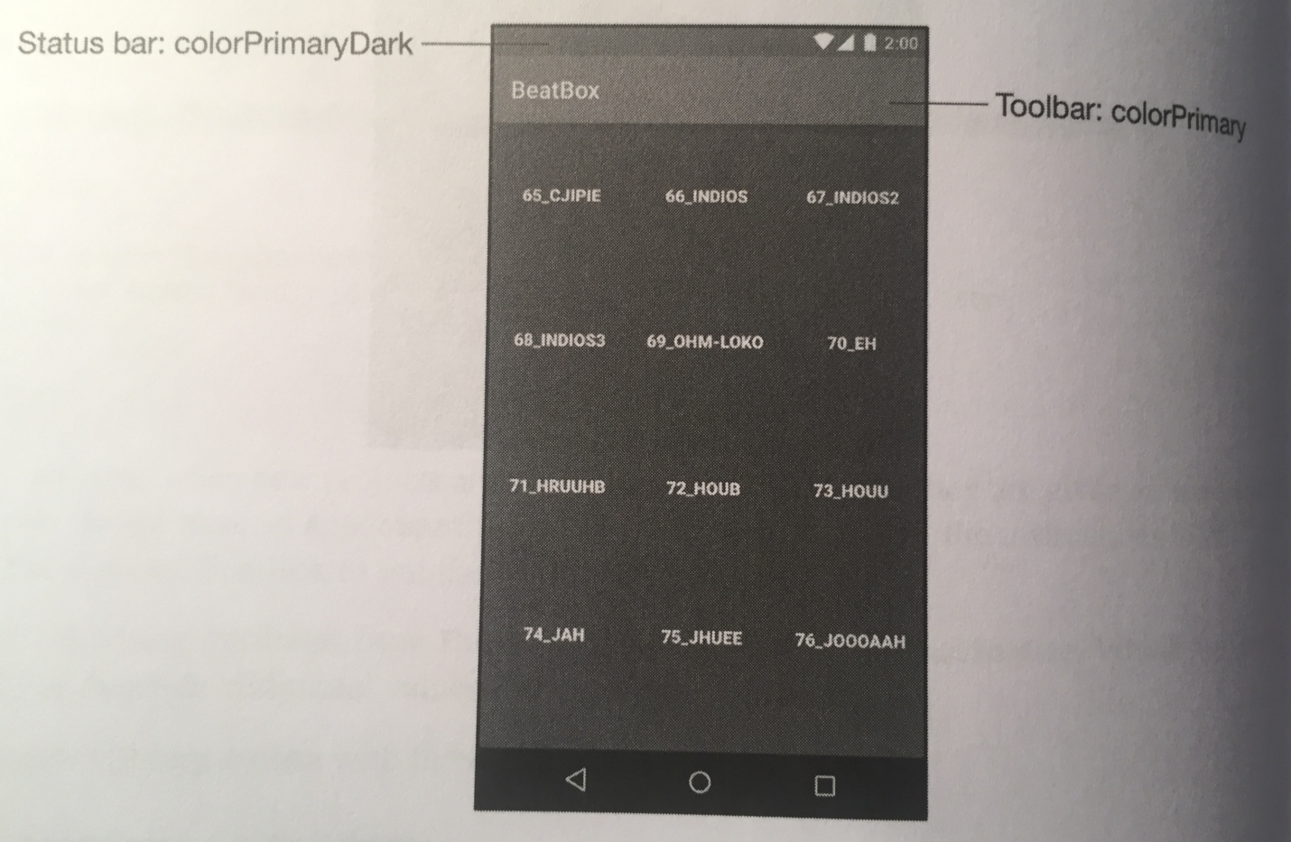

Finally, we set the colorAccent to a gray color. **colorAccent should contrast with our colorPrimary attribute**; it’s used to tint some widgets, like a TextEdit.

It’s a good idea to think about these three attributes (colorPrimary, colorPrimaryDark, and colorAccent) together. These colors should mesh and the default colorAccent attribute from your parent theme may clash with the other colors you specified, if you don’t overwrite colorAccent.

Now that the colors are worked out, it’s time to dive in and see what theme attributes exist that we can override.

**Be warned, theme spelunking is tough. There is little to no documentation about which attributes exist, which ones you can override yourself, and even what the attributes do. You just override an attribute you find and hope shit works out.**

To theme spelunk, we go to our base theme that’s defined in our styles.xml file, and Ctrl-click on Windows to go up one level in the hierarchy. The process is to keep going up this level until you find the attribute that you wanna override, and then override it in your styles.xml file.

If a theme is resource qualified (that is, there are different versions of it for different versions of the API), then a menu will appear asking where you would like to go. Choose to go to the file with the highest theme right before the min theme your app supports.

For example, suppose your app supports API level 16 or higher, and the choices you’re given are for v21, v14, and v11. You’d pick v14, because that is the highest theme that covers v16.

If you’ve added the AppCompat dependency to your project, if you find an attribute to override you can just do it directly because this dependency is automatically included with your app. If your theme exists in the Android OS, then you must use an android: namespace when overriding your theme.

When you find the theme you want to override, do so in your styles.xml file.

Ok, now let’s look at specifying an attribute for a widget embedded in the Android OS, a button. Before, we added a style attribute to our button directly and individually. This is inefficient. We want to style shit in a way that **all** buttons have the same style.

To do this, we must theme spelunk until we find what to override.

If we navigate up the style stack to Base.v7.Theme.AppCompat, we see an attribute for buttonStyle:

<item name=”buttonStyle”>

@style/Widget.AppCompat.Button

</item>

The buttonStyle attribute points to a style resource rather than a value. When we navigate to that style, we see all the attributes that a button has, like background, textAppearance and minHeight.

What we do is inherit from this style resource and overwrite what we wanna change:

<style name="BeatBoxButton"

**parent="Widget.AppCompat.Button"**>

**<item name="android:background">@color/dark_blue</item>**

</style>

Now, we use this style in our app’s theme like so:

<item name="buttonStyle">@style/BeatBoxButton</item>

That’s it! You’ve overridden the style for all your buttons in your app. This process is very similar for overriding other style attributes in other stock widgets in Android.

Let’s talk about style inheritance a little more. When theme spelunking, you may have noticed a switch in inheritance style as you were exploring the theme hierarchy. The AppCompat themes used the name of the theme to indicate inheritance until we arrived at the Platform.AppCompat theme, which switched to using the parent attribute style when doing inheritance.

So why the switch?

Specifying a parent theme in the theme name only works for themes that exist in the same package. So, we will see Android OS themes use the theme name inheritance style most of the time, and we’ll see the AppCompat library do the same. But once the AppCompat library crosses over to a parent outside of itself, the explicit parent attribute is used.

We should do the same: specify our theme parent in the name of our theme if we are inheriting from one of our own themes. **If we inherit from a style or theme in the Android OS, explicitly specify the parent attribute.**

Once attributes are declared in our theme, we can access them in XML. To access a theme attribute in XML, we use the ? notation. When referencing a concrete value in XML, such as color, we use the @ notation. For example, @color/gray points to a specific resource.

To use the ? notation, do this:

android:background=”?attr/colorAccent”

The ? notation says to use the resource that the colorAccent attribute on our theme points to. In our case, this is the gray color that we defined in our colors.xml file.

**Chapter 23 - XML Drawables:**

Android calls anything that’s intended to be drawn to the screen a drawable, whether it’s an abstract shape, a clever bit or code that subclasses the Drawable class, or a bitmap image.

In this chapter, we’re gonna see a few more kinds of drawables: state list drawables, shape drawables, and layer list drawables. All three are defined in XML files, so we group them together in the broader category of *XML drawables*.

We use XML drawables to do shit like make our buttons respond when we press them.

The first thing we do is wrap our Button widget up in a FrameLayout, and give our buttons a width and height of a specific size (the book does 100dp). This gives each button a specific size so when we make them circles later on they won’t be skewed.

Our recycler view will always show three columns, no matter what the screen size is. If there is extra room, the recycler view will stretch those columns to fit the device. We don’t want the recycler view to stretch our buttons, so we wrap our buttons in a frame layout. The frame layout will be stretched and our buttons will not.

The XML code to do all this is on age 438.

Now, let’s make our buttons round with a ShapeDrawable. Since XML drawables are not density specific (they don’t look different on different devices), they are placed in the default drawable folder instead of a density-specific one.

Create a new XML file in res/drawable names button_beat_box_normal.xml that will define your ShapeDrawable:

<shape

xmlns:android=

"http://schemas.android.com/apk/res/android"

android:shape="oval">

<solid android:color="@color/dark_blue"/>

</shape>

This creates an oval shape drawable that is filled in with a dark blue color. There are additional customization options with shape drawables, including rectangles, lines, and gradients. The book provides a link to the documentation to all of this on the bottom of page 439.

With this drawable complete, we simply apply it as the background for our buttons to see the effect:

<style name="BeatBoxButton"

parent="Widget.AppCompat.Button">

<item name="android:background">

**@drawable/button_beat_box_normal**

</item>

</style>

Now, our buttons should be circles.

Let’s get our buttons to also change their appearance if they’re pressed. To do this, we first make another shape drawable in another XML file in res/drawable:

<shape

xmlns:android=

"http://schemas.android.com/apk/res/android"

android:shape="oval">

<solid android:color="@color/red"/>

</shape>

Next, we’re gonna use this version when the user presses the button. To do this, we’ll make use of a state list drawable. A *state list drawable* is a drawable that points to other drawables based on the state of something. A button has a pressed and an unpressed state. We will use a state list drawable to specify one drawable as the background when pressed and a different drawable when not pressed.

We define a state list drawable XML file in res/drawable called button_beat_box.xml:

<selector xmlns:android=

"http://schemas.android.com/apk/res/android">

<item

android:drawable=

"@drawable/button_beat_box_pressed"

android:state_pressed="true"/>

<item

android:drawable=

"@drawable/button_beat_box_normal"/>

</selector>

Now, we modify our button style to use this new state list drawable as the button background:

<style name="BeatBoxButton"

parent="Widget.AppCompat.Button">

<item

name="android:background">

**@drawable/button_beat_box**</item>

</style>

When the state of the button is pressed, button_beat_box_pressed will be used as the background. Otherwise, button_beat_box_normal will be the background of the button.

State list drawables are a handy customization tool. Many other states are also supported including disabled, focused, and activated. The book gives the documentation link on page 442.

Let’s use a layer list drawable now to make our buttons look even more unique. Layer list drawables allow you to combine two XML drawables into one. Here’s an example:

<layer-list xmlns:android=

"http://schemas.android.com/apk/res/android">

<item>

<shape xmlns:android=

"http://schemas.android.com/apk/res/android"

android:shape="oval">

<solid android:color="@color/red"/>

</shape>

</item>

<item>

<shape android:shape="oval">

<stroke

android:width="4dp"

android:color="@color/dark_red"/>

</shape>

</item>

</layer-list>

We specified two drawables in this list layer drawable. The first drawable is a red circle, as it was before this change. The second drawable will be drawn on top of the first. In the second drawable, we specified another oval with a stroke of 4dp. This will create a ring of dark red.

These two drawables combined form the layer list drawable. You can combine more than two drawables with a layer list to make something even more complex.

XML drawables are great because they will look excellent in any screen density and are easy to modify, so you don’t have to do complicated shit like use an image editor.

XML drawables are flexible. You can use them for many purposes and you can easily update them in the future. With a combination of layer list drawables and shape drawables, you can create complex backgrounds without using an image editor. For example, if you decide to change the color scheme of something in your application, updating the colors in an XML drawable is easy.

XML drawables are density independent. With a standard background that’s an image, you’ll typically create multiple versions of that same image in different densities so that the image will look crisp on most devices. XML drawables only need to be defined once and will look crisp at any screen density.

Resource qualifiers and drawables are handy. When you need an image in your app, you generate the image at a few different sizes and add them to your resource-qualified folders: drawable-mdpi, drawable-hdpi, etc. Then, you reference the image by name and Android figures out which density to use based on the current device.

However, there is a downside to this system. The APK file that you release to the Google Play Store will contain all of the images in your drawable directories at each density that you added to your project - even though many of them will not be used. That’s a lot of extra bloat.

To reduce this bloat, you can generate separate APKs for screen density. You would have an mdpi APK of your app, an hdpi APK, and so on. The book gives the link to the documentation for APK splitting on the bottom of page 381.

But, we have one exception to all this. We want to maintain every density of our launcher icon.

A launcher on Android is a home screen application. When we press the Home button on our device, we are taken to the launcher.

Some newer launchers display app icons at a larger size than launchers have traditionally displayed them. To make this larger icon look nice, these launchers will take the icon from the next density bucket up. If your device is an hdpi device, the launcher will use the xhdpi icon to represent your app. But, if the xhdpi version has been stripped from your APK, the launcher will have to fall back to the lower resolution version.

This makes your app icon look fuzzy, which is NOT good.

The *mipmap* directory is Android’s solution to this problem. When APK splitting is enabled, mipmaps are **not** pruned from the APKs. Otherwise, mipmaps are identical to drawables.

So, the book recommends putting just your launcher icon in the various mipmap directories. All other images belong in the drawable directories.

Sometimes (or maybe often), you will fall back to regular old image files for your button backgounds. If these image files are displayed in different screen sizes, they will be stretched out and look fucked up.

What we need is control over how the image will stretch, and Android provides us with a way to do that with 9-patch buttons.

The first thing we need to do is modify our Button XML to allow the button size to change based on the available space. We do this by putting the button in a FrameLayout and setting its width and height to match_parent.

Next, we load in an image file to be used for the buttons, and then apply them as your button background by modifying your state list drawable XML file. Code to do this is simple and is on page 447.

However, when we run the program now, the image files we loaded are fucked up.

Why are they fucked up? Android is uniformly stretching them. It would look better if you could specify which parts of the image to stretch and which parts not to stretch. Enter *9-patch* images.

A 9-patch image file is specially formatted so that Android knows which portions can and cannot be scaled. Done properly, this ensures that the edges and corners of our background remain consistent with the image as it was created.

Why are they called 9-patches? A 9-patch breaks your image into a 3x3 grid - a grid with 9 sections, or patches. The corners of the grid remain unscaled, the sides are only scaled in one dimension, and the center is scaled in both dimensions, as shown in the figure below:

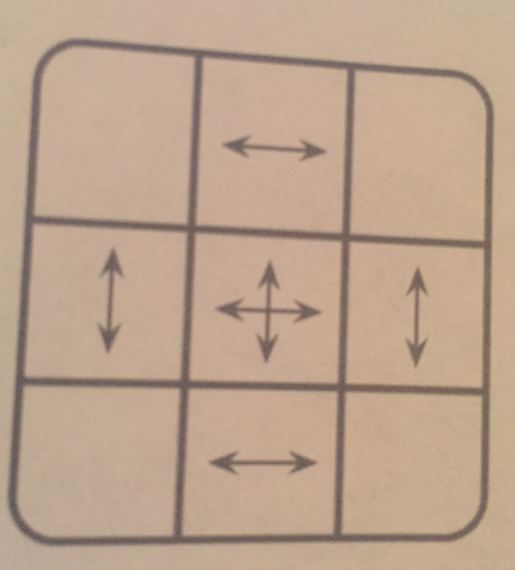

A 9-patch image is like a regular PNG image in everything except two aspects: its filename ends with .9.png, and it has an additional one-pixel border around the edge. This border is used to specify the location of the center square of the 9-patch. Border pixels are drawn black to indicate the center and transparent to indicate the edges.

You can create a 9-patch using any image editor, with the draw9patch tool provided as part of the Android SDK, or using Android Studio.

First, we change the filenames of our images to have a .9.png at the end. Next, double click on the image in the Project tool window to open it in Android Studio’s built-in 9-patch editor.

In the 9-patch editor, fill in black pixels on **some/part** of the top and left borders to mark the stretchable regions of the image.

With these two black-pixeled lines on **part** of the border, you’re telling Android not to stretch the top-right area of the image and each corner if this file changes size.

So the top and left lines indicate the areas of the image to stretch. What about the bottom and right borders? You use them to define an optional drawable region for the 9-patch image. The drawable region is the area where content (usually text) should be rendered. If you don’t include a drawable region, it defaults to be the same as your stretchable region. This is what we want here, the buttons’ text to be on the stretchable region.

Be extra sure that **all** your 9-patch images are updated with the correct content area lines. When 9-patch images are specified thru state list drawables, the content area doesn’t behave as you might expect. Android will set the content area as the background is initialized and **will not change** the content area while you press on the button. This means that the content area from one of your two images is ignored, and exactly what image is ignored is undefined by Android. So, it’s best to make sure that all of your 9-patch images in a state list drawable have the same content area.

If we run the app now, the buttons look correct, even in landscape mode.

**Chapter 24 - More About Intents and Tasks:**

This chapter takes all of your apps and creates a custom launcher so you can launch them from within your app.

The app will show the user a list of launchable apps on the device. (A launchable app is an app the user can open by clicking an icon on the Home or launcher screen.) To do so, it’ll query the system (using the PackageManager) for launchable main activities.

Launchable main activities are simply activities with intent filters that include a MAIN action and a LAUNCHER category. We have seen these before in our manifest file.

The first thing we need to do is create an implicit intent and get a list of activities that match the intent from the PackageManager query and call this method in onCreateView(…) before we return the view:

private void setupAdapter(){

Intent startupIntent =

new Intent(Intent.ACTION_MAIN);

startupIntent.addCategory(

Intent.CATEGORY_LAUNCHER);

PackageManager pm =

getActivity().getPackageManager();

List<ResolveInfo> activities =

pm.queryIntentActivities(startupIntent, 0);

Log.i(TAG, "Found " + activities.size() + "

activities.");

}

Before when we used an implicit intent, we presented an activity chooser by creating an implicit intent, wrapping it in a chooser intent, and sending it to the OS with startActivity(Intent).

We are not doing that here. The short explanation why is because the MAIN/LAUNCHER intent filter may or may not match a MAIN/LAUNCHER implicit intent that’s sent via startActivity(…).

It turns out that startActivity(Intent) does not mean “Start an activity matching this implicit intent.” It means, “Start the *default* activity matching this implicit intent.” When you send an implicit intent via startActivity(…) (or startActivityForResult(…) ), the OS secretly adds the Intent.CATEGORY_DEFAULT category to the intent.

Thus, if we want an intent filter to match implicit intents sent via startActivity(…), we **must** include the DEFAULT category in that intent filter.

An activity that has the MAIN/LAUNCHER intent filter is the main entry point for the app that it belongs to. It only wants the job of the main entry point for that application. It typically does not care about being the “default” main entry point, so it does not have to include the CATEGORY_DEFAULT category.

Because MAIN/LAUNCHER intent filters may not include CATEGORY_DEFAULT, you cannot reliably match them to an implicit intent sent via startActivity(…). So, instead we use the intent to query the PackageManager **directly** for activities with the MAIN/LAUNCHER intent filter.

The next step is to display the labels of these activities in our RecyclerView. An activity’s *label* is its display name - something the user should recognize. Given that these activities are launcher activities, the label is most likely the application name.

You can find the labels for the activities, along with other metadata, in the ResolveInfo objects that the PackageManager returned.

First, we sort the ResolveInfo objects returned from the PackageManager alphabetically by label using the ResolveInfo.loadLabel(…) method in setupAdapter():

List<ResolveInfo> activities =

pm.queryIntentActivities(startupIntent, 0);

**Collections.sort(activities,**

**new Comparator<ResolveInfo>() {**

**@Override**

**public int compare(ResolveInfo lhs,**

**ResolveInfo rhs) {**

**PackageManager pm =**

**getActivity().getPackageManager();**

**return String.CASE_INSENSITIVE_ORDER.compare(**

**lhs.loadLabel(pm).toString(),**

**rhs.loadLabel(pm).toString()**

**);**

**}**

**});**

Next we define a ViewHolder that displays an activity’s label. We store the activity’s ResolveInfo in a member variable because we will be using it regularly. The code to define this ActivityHolder class is on page 458.

Next, we add a RecyclerView.Adapter implementation called ActivityAdapter. The code for this is on page 549. It’s very similar to the adapter code we’ve written before.

Last but not least, we update setupAdapter() to create an instance of ActivityAdapter and set it as the RecyclerView’s adapter. The code for this is simple and is on the bottom of page 459.

Now we can run our project and see our RecyclerView populated with activity labels.

We used an implicit intent to gather the desired activities and present them in a list. The next step is to start the selected activity when the user presses its list item. We start the activity using an explicit intent.

To create an explicit intent, we need to get the activity’s package name and class name from the ResolveInfo. We can get this data from a part of the ResolveInfo called ActivityInfo.

We implement a click listener on the activity holder and when an activity in the list is pressed, we use the ActivityInfo for that activity to create an explicit intent. Then we use that explicit intent to launch the selected activity:

@Override

public void onClick(View v){

ActivityInfo activityInfo =

mResolveInfo.activityInfo;

Intent i =

new Intent(Intent.ACTION_MAIN) .setClassName(

activityInfo.applicationInfo.packageName,

activityInfo.name);

startActivity(i);

}

Notice that in this intent we’re sending an action as part of an explicit intent. Most apps will behave the same whether you include the action or not. However, some may change their behavior. The same activity can display different interfaces depending on how it’s started. As a programmer, it’s best to declare your intentions clearly and let the activities you start do what they will.

In the code above, we get the package name and class name from the metadata and use them to create an explicit intent using the Intent method:

public Intent setClassName(String packageName,

String className);

This is different than how we did shit before, where we used an Intent constructor that accepts a Context and a Class object:

public Intent(Context packageContext, Class<?> cls);

This constructor uses its parameters to get what the Intent really needs - a ComponentName. A ComponentName is a package name and a class name stuck together. When you pass in an Activity and a Class to create an Intent, the constructor determines the fully qualified package name from the Activity.

We could also create a ComponentName ourselves from the package and class names and use the following Intent method to create an explicit intent:

public Intent setComponent(ComponentName component);

However, it’s less code to use setClassName(…), which creates the component name behind the scenes.

Now we can launch apps from our custom launcher.

**Android uses tasks to keep track of the user’s state within each running application.** Each application opened from Android’s default launcher app gets its own task. This is the desired behavior, but not the default one. In our launcher project, we need to make this behavior the desired behavior, but first let’s discuss what tasks are and how they work.

A *task* is a stack of activities that the user is concerned with. The activity at the bottom of the stack is called the *base activity*, and whatever activity is on top is the activity that the user sees. When you press the back button, you’re popping the top activity off of this stack. If you’re looking at the base activity and hit the Back button, it’ll send you to the Home screen.

By default, new activities are started in the current task. This is true even if the activity is not part of your app, like when you use an implicit intent to start the camera app, for instance:

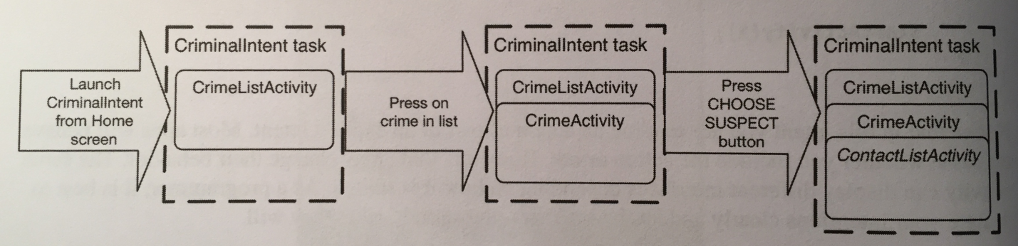

The benefit of adding an activity to the current task is that the user can navigate back thru the task instead of the application hierarchy:

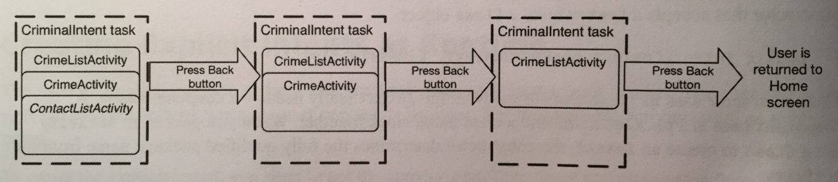

Using the *overview screen*, you can switch between tasks without affecting each task’s state. For instance, if you start entering a new contact and switch to checking your Twitter feed, you will have two tasks started. If you switch back to editing contacts, your place in both tasks will be saved.

The overview screen has many other names. You many hear it called the task manager, recents screen, recent apps screen, or recent tasks list.

Sometimes, when you start an activity, you want the activity added to the current task. Other times, you want it started in a new task that’s independent of the activity that started it.

Right now, our project has activities starting from the same task as the project:

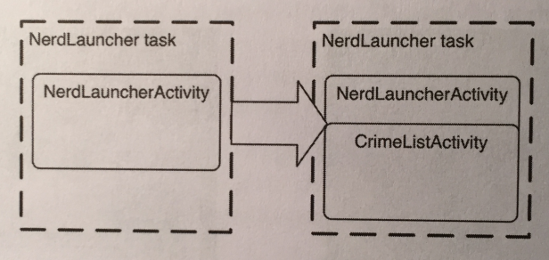

Because we implemented our own launcher, we want to start activities in new tasks. This way each app opened by pressing an item in our launcher list gets its own task, which will allow users to switch between running applications as they like, via the overview screen, our launcher, or the home screen:

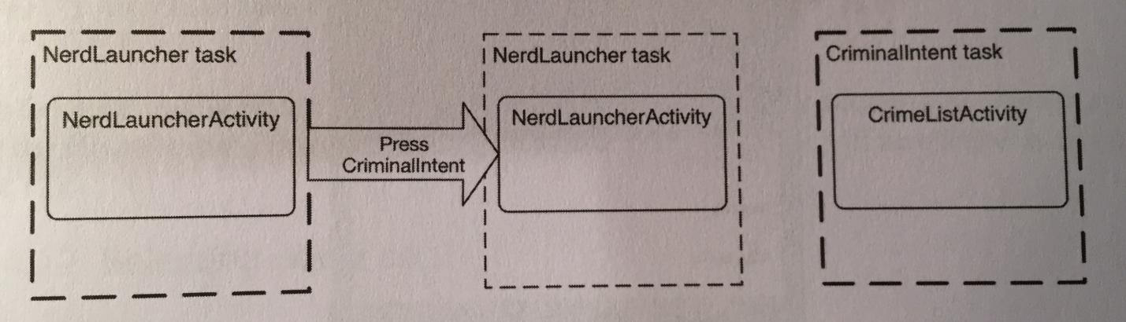

To start a new task when we start an activity, add this flag to the intent:

Intent i =

new Intent(Intent.ACTION_MAIN)

.setClassName(

activityInfo.applicationInfo.packageName,

activityInfo.name)

**.addFlags(Intent.FLAG_ACTIVITY_NEW_TASK)**;

That’s it.

If you start an **already open activity** from our custom launcher again, you will **not** create a second task. The FLAG_ACTIVITY_NEW_TASK by itself creates one task per activity. Because you already have a task running, Android will switch to that task instead of starting a new one.

Now, to use this app as a replacement for the Home screen, open the project’s manifest file and add this to the main intent filter:

<category android:name="android.intent.category.HOME"/>

<category

android:name="android.intent.category.DEFAULT"/>

By adding the HOME and DEFAULT categories, our project is asking to be offered as an option for the Home screen. When we press the home buttom now, our project will be offered as an option.

If we make our project the default launcher, we can easily change it back to the default launcher by:

* Going to Settings🡪Apps in Lollipop, or Settings🡪Applications🡪Manage Applications pre-Lollipop.
* Select All to find NerdLauncher.
* Once we’ve selected NerdLauncher, we should be on the App Info screen. Scroll down to Launch by default and press the CLEAR DEFAULTS button. The next time we press the Home button, we will be able to select another default.

Let’s talk about processes vs. tasks.

A *process* is a place created by the OS for your application’s objects to live and for your application to run.

Processes may own resources managed by the OS, like memory, network sockets, and open files. Processes also have at least one, possibly many, threads of execution. On Android, your process will also always have **exactly one** *virtual machine* running.

While there are some obscure exceptions, in general every application component in Android is associated with exactly one process. Your application is created with its own process, and this is the default process for all components in your application.

You can assign individual components to different processes, but it’s recommended sticking to the default process. If you think you need something running in a different process, you can usually achieve the same ends with multi-threading, which is more straightforward to program in Android than using multiple processes.

Every activity instance lives in exactly one process and is referenced by exactly one task. But that’s where the similarities between processes and tasks end. Tasks contain only activities and often consist of activities living in different application processes. Processes, on the other hand, contain all running code and objects for a single application.

Processes and tasks can be easy to confuse, because both are often referred to by an application name. For example, when we launched CriminalIntent from NerdLauncher, the OS created a CriminalIntent process and a new task for which CrimeListActivity was the base activity. In the overview screen, this task was labeled CriminalIntent.

The task that an activity is referenced by can be different from the process it lives in. For example, consider the CriminalIntent and contact applications and walk thru the following scenario.

We open CriminalIntent, select a crime from the list (or add a new crime), then press the CHOOSE SUSPECT button. This launches the contacts application to choose a contact. The contact list activity is added to the CriminalIntent task. This means that when your user presses the Back button to navigate between different activities, he or she may unknowingly be switching between processes, which is nifty.

However, the contact list activity instance is actually created in the contacts app’s process’s memory space, and it runs on the virtual machine living in the contacts applicaton’s process:

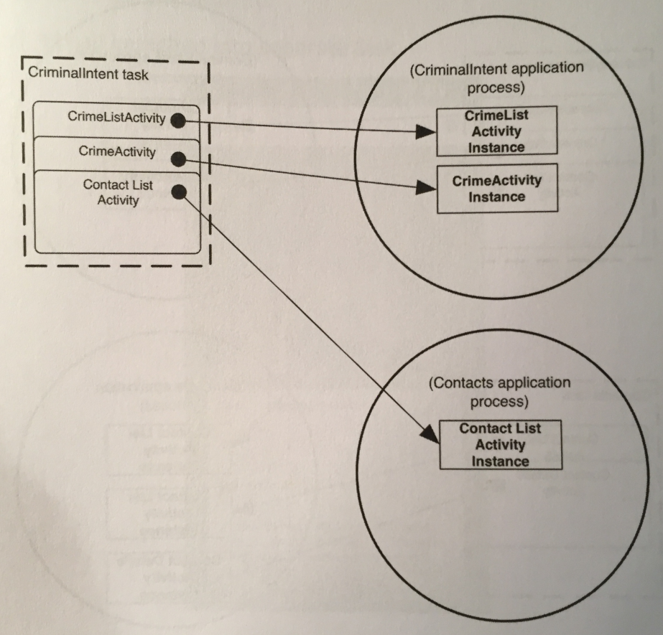

Now, if we were to leave the CriminalIntent app running, and close it and open the contacts app, a new task will be created for the contacts application, and that task will reference the new contact list and contact details activity instances:

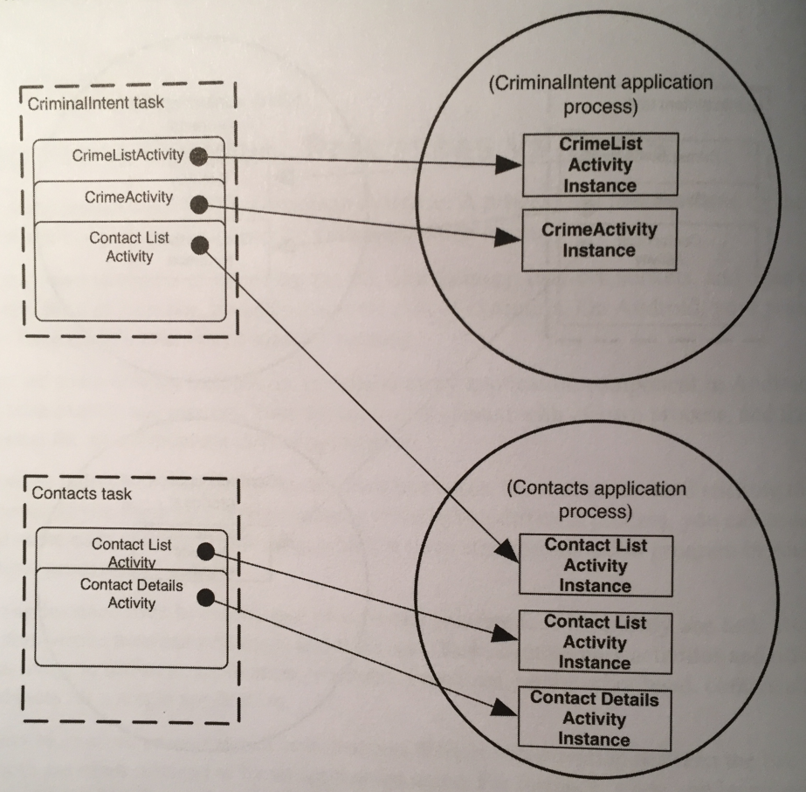

Be aware that apps advertised on the Google Play store as “task killers” are, in fact, process killers. Such apps kill a particular process, which means you may be killing activities referenced by other application’s tasks (like if killing the contacts process kills activities referenced by the contacts task AND the CriminalIntent task).

If we’re running our tasks on a Lollipop device, the implicit intent chooser creates a new, separate task for activities launched with the android.intent.action.SEND or android.intent.action.SEND_MULTIPLE actions. On older versions of Android, this doesn’t happen.

This behavior uses a new notion in Lollipop called *concurrent documents*. Concurrent documents allow any number of tasks to be dynamically created for an app at runtime. Prior to Lollipop, apps could only have a predefined set of tasks, each of which had to be named in the manifest.

You can **set up to start multiple tasks** from your own app running on a Lollipop device by either adding the Intent.FLAG_ACTIVITY_NEW_DOCUMENT flag to an intent before calling startActivity(…) or by setting the documentLaunchMode on the activity in the manifest like so:

<activity

…

android:documentLaunchMode=”intoExisting”/>

Using this approach, only one task per document will be created. So if you issue an intent with the same data as an already existing task, no new task is created. **This by itself will NOT start multiple tasks.**

You can **enforce a new task to always be created**, even if one already exists for a given task, by either adding the Intent.FLAG_ACTIVITY_MULTIPLE_TASK flag along with the Intent.FLAG_ACTIVITY_NEW_DOCUMENT flag before issuing the intent, or by using always as the value for documentLaunchMode in your manifest.

**Chapter 25 - HTTP and Background Tasks:**

In this chapter we will learn how to use Android’s high-level HTTP networking. Almost all day-to-day programming of web services these days is based on the HTTP networking protocol.

We are going to have one class handle the networking in our project. It will start with only two methods, getUrlBytes(String) and getUrlString(String). The first method fetches raw data from a URL and returns it as an array of bytes. The second method converts the result from the first into a String. Here are the two methods:

public byte[] getUrlBytes(String urlSpec)

throws IOException{

URL url = new URL(urlSpec);

HttpURLConnection connection =

(HttpURLConnection)url.openConnection();

try{

ByteArrayOutputStream out =

new ByteArrayOutputStream();

InputStream in = connection.getInputStream();

if(connection.getResponseCode() !=

HttpURLConnection.HTTP_OK){

throw new IOException(

connection.getResponseMessage() +

": with " + urlSpec);

}

int bytesRead = 0;

byte[] buffer = new byte[1024];

while((bytesRead = in.read(buffer)) > 0){

out.write(buffer, 0, bytesRead);

}

out.close();

return out.toByteArray();

}

finally{

connection.disconnect();

}

}

public String getUrlString(String urlSpec)

throws IOException{

return new String(getUrlBytes(urlSpec));

}

This code creates a URL object from a string, like https://www.bignerdranch.com. Then it calls openConnection() to create a connection object pointed at the URL. URL.openConnection() returns a URLConnection, but because we’re connecting to an http URL, we can cast it to HttpURLConnection. This gives us HTTP-specific interfaces for working with request methods, response codes, streaming methods, and more.

HttpURLConnection represents a connection, but it will not actually connect to our endpoint until we call getInputStream() (or getOutputStream() for POST calls). Until then, we cannot get a valid response code.

Once we create our URL and open a connection, we call read() repeatedly until our connection runs out of data. The InputStream will yield bytes as they are available. When we are done, we close it and spit out our ByteArrayOutputStream’s byte array.

Now, while getUrlBytes(String) does the heavy lifting, getUrlString(String) is what we will actually use. It converts the bytes fetched from getUrlBytes(String) into a String. Splitting this work into two methods will be useful when we start downloading images or other data.

One other thing is required to get networking up and running: you have to ask permission. Just as users would not want you secretly taking their pictures, they also do not want you to secretly download pictures for them.

To ask for permission to network, add the following permission to your manifest file:

<uses-permission android:name="android.permission.INTERNET"/>

When a user tries to download your app, a dialog showing these permissions is displayed. The user can then accept or deny permission.

The next step is to call and test the networking code that we just added. However, we cannot simply call getUrlString(String) directly in our PhotoGalleryFragment. Instead, we need to create a background thread and run our code there.

The easiest way to work with a background thread is with a utility class called AsyncTask. AsyncTask creates a background thread for you and runs the code in the doInBackground(…) method on that thread.

All we need to do is create an inner class in our fragment class, subclass AsyncTask, and override it’s doInBackground(…) method, like so:

private class FetchItemsTask

extends AsyncTask<Void, Void, Void>{

@Override

protected Void doInBackground(Void... params){

try{

String result =

new FlickrFetchr().

getUrlString(

"https://www.bignerdranch.com");

Log.i(TAG, "Fetched contents of URL: " +

result);

}

catch(IOException ioe){

Log.e(TAG, "Failed to fetch URL: " + ioe);

}

return null;

}

}

Then, in our fragment’s onCreate(…) method, call execute() on a new instance of FetchItemsTask, the AsyncTask inner class we just created:

public void onCreate(Bundle savedInstanceState){

…

**new FetchItemsTask().execute();**

}

The call to execute() will start AsyncTask, which will then fire up its background thread and call doInBackground(…).

Let’s take a closer look at threads in Android.

Networking does not happen immediately. A web server may take as long as a second or two to respond, and a file download can take even longer than that. Because networking can take so long, **Android disallows all networking on the *main thread***. If you try to do it, Android will throw a NetworkOnMainThreadException.

Why does Android do this? Let’s start at the beginning.

A thread is a single sequence of execution. Code running within a single thread will execute one step after another. Every Android app starts life with a *main thread*. The main thread, however, is not a preordained set of steps. Instead, it sits in an infinite loop and waits for events initiated by the user or the system. Then it executes code in response to those events as they occur:

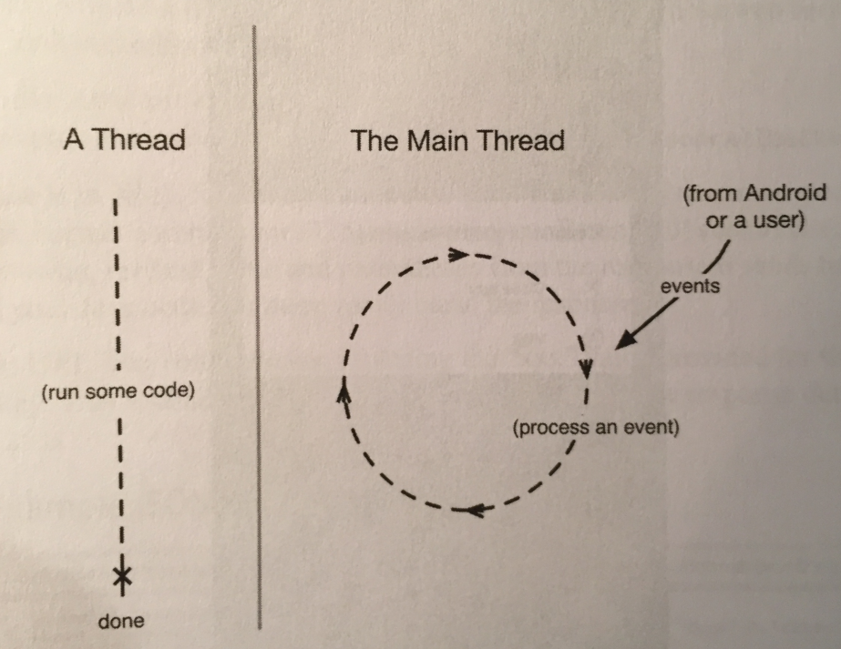

The main thread runs all the code that updates the UI. This includes code executed in response to different UI-related events - activity startup, button presses, etc. Because these events are all related to the user interface in some way, the main thread is sometimes called the *UI thread*.

The event loop keeps the UI code in sequence. It makes sure that none of these operations step on each other while still ensuring that the code is executed in a timely fashion.

The main thread cannot spend any time waiting to respond to events like networking connects. It needs to stay sharp. Another thread of execution needs to handle networking so that the main thread can do its thing. If this didn’t happen, then the UI would be completely unresponsive, which might result in an *application not responding*, or ANR.

An ANR occurs when Android’s watchdog determines that the main thread has failed to respond to an important event, like pressing the Back button.

**To take care of networking tasks, we create a *background thread* and access the network from there.**

JSON stands for JavaScript Object Notation, a format that has become popular in recent years, particularly for web services. Android includes the standard org.json package, which has classes that provide simple access to creating and parsing JSON text.

Flickr offers a fine JSON API. You need to get an API key from Flickr in order to use their services tho, and the book shows you how on page 483. Flickr will give you an API key and a “secret” key. We don’t need the “secret” key for this book, as it’s only used when an app will access user-specific information or images.

With all of this, you need to request a GET URL to get the photos, using the getRecent() method from Flickr’s API.

Here’s the code to do this:

public void fetchItems(){

try{

String url =

Uri.parse(

"https://api.flickr.com/services/rest/")

.buildUpon()

.appendQueryParameter("method",

"flickr.photos.getRecent")

.appendQueryParameter("api_key", API_KEY)

.appendQueryParameter("format", "json")

.appendQueryParameter("nojsoncallback",

"1")

.appendQueryParameter("extras", "url_s")

.build().toString();

String jsonString = getUrlString(url);

Log.i(TAG, "Received JSON: " + jsonString);

}

catch(IOException ioe){

Log.e(TAG, "Failed to fetch items", ioe);

}

}

Here we use a Uri.Builder to build the complete URL for our Flickr API request. Uri.Builder is a convenience class for creating properly escaped parameterized URLs. Uri.Builder.appendQueryParameter(String, String) will automatically escape query strings for you.

We added a method parameter calling the Flickr method we need, an api_key method parameter that passes in our Flickr-generated API key, a format method parameter that specifies the format our response should be in (JSON in our case), and a nojsoncallback method parameter that, when set to 1, tells Flickr to exclude the enclosing method name and parentheses from the response it sends back. This parameter is necessary so that our Java code can more easily parse the response.

We also specified a parameter called extras, with a value of url_s. Specifying the url_s extra tells Flickr to include the URL for the small version of the picture if one is available.

To get this to work we call:

new FlickrFetchr().fetchItems();

from our doInBackground(…) method in our AsyncTask inner class.

Now that we’re getting JSON from Flickr, we need to create a model object to store that data in. The book creates this model object on page 486.

Once we create our model objects, we need to fill them with data from the JSON we got from Flickr. Flickr returns shit in a JSON object.

A JSON object is a set of name-value pairs enclosed in curly braces. A JSON array is a comma-seperated list of JSON objects enclosed in square brackets. You can have objects nested within each other, resulting in a hierarchy.

The json.org API provides Java objects corresponding to JSON text, such as JSONObject and JSONArray. You can easily parse JSON text into corresponding Java objects using the JSONObject(String) constructor. Here’s how we do it:

public void fetchItems(){

try{

…

**JSONObject jsonBody =**

**new JSONObject(jsonString);**

}

**catch (JSONException je){**

**Log.e(TAG, "Failed to parse JSON", je);**

**}**

catch(IOException ioe){

Log.e(TAG, "Failed to fetch items", ioe);

}

}

The JSONObject constructor parses the JSON string you passed it, resulting in an object hierarchy that maps to the original JSON text. The object hierarchy for the JSON returned from Flickr is shown in Figure 23.11 on page 487.

Here we get a top-level JSONObject that maps to the outermost curly braces in the original JSON text. This top-level object contains a nested JSONObject named photos. Within this nested JSONObject is a JSONArray named photo. This array contains a collection of JSONObjects, each representing metadata for a single photo.

We need to write a method that pulls out information for each photo, makes a GalleryItem model object for each photo, and adds it to a list:

private void parseItems(List<GalleryItem> items,

JSONObject jsonBody)

throws IOException, JSONException{

JSONObject photosJsonObject =

jsonBody.getJSONObject("photos");

JSONArray photoJsonArray =

photosJsonObject.getJSONArray("photo");

for(int i = 0; i < photoJsonArray.length(); i++){

JSONObject photoJsonObject =

photoJsonArray.getJSONObject(i);

GalleryItem item = new GalleryItem();

item.setId(

photoJsonObject.getString("id"));

item.setCaption(

photoJsonObject.getString("title"));

if(!photoJsonObject.has("url_s")){

continue;

}

item.setUrl(

photoJsonObject.getString("url_s"));

items.add(item);

}

}

This code uses convenience methods such as getJSONObject(String name) and getJSONArray(String name) to navigate the JSONObject hierarchy.

Flickr does not always return a url_s component for each image. You can add a check here to ignore images that don’t have an image url.

This parseItems(…) method needs a List and JSONObject. We need to update fetchItems() to call parseItems(…) and return a List of GalleryItems:

public **List<GalleryItem>** fetchItems(){

**List<GalleryItem> items = new ArrayList<>();**

try{

…

JSONObject jsonBody = new

JSONObject(jsonString);

**parseItems(items, jsonBody);**

}

catch (JSONException je){

Log.e(TAG, "Failed to parse JSON", je);

}

catch(IOException ioe){

Log.e(TAG, "Failed to fetch items", ioe);

}

**return items;**

}

We still need a way of reporting the contents of our List. Let’s fix that now.

The first thing we need to do is create a view holder to bind our views and an adapter to provide view holders as needed based on a list of model objects. The code for our view holder and adapter is pretty similar to what we’ve done before and is on pages 491-492.

After the view holder and adapter have been set up, we need to implement code to setup our adapter every time our RecyclerView is created, and every time our set of model objects change.

First, we need to create a setupAdapter() method that looks at the current model state, namely our List of model objects, and configures the adapter appropriately on our RecyclerView. Here is the code for setupAdapter():

private void setupAdapter(){

if(isAdded()){

mPhotoRecyclerView.setAdapter(

new PhotoAdapter(mItems));

}

}

We call this method at the bottom of onCreateView(…) in our PhotoGalleryFragment so that every time a new RecyclerView is created, it’s configured with an appropriate adapter.

Notice that we check to see whether isAdded() is true before setting the adapter. This method belongs to the Fragment class and confirms that the fragment has been attached to an activity, and in turn that getActivity() will **not** be null.

Remember that fragments can exist unattached to any activity. Before now, this possibility has not come up because your method calls have been driven by callbacks from the framework. In this scenario, if a fragment is receiving callbacks, then it’s definitely attached to an activity. No activity, no callbacks.

However, now that we’re using an AsyncTask we are triggering some callbacks from a background thread. Thus we cannot assume that the fragment is attached to an activity. We must check to make sure that our fragment is still attached. If it’s not, then operations that rely on that activity (like creating our PhotoAdapter, which in turn creates a TextView using the hosting activity as the context) will fail. This is why, in the code above, we check that isAdded() is true before setting the adapter.

The other place we need to call setupAdapter() is after data has been fetched from Flickr, when our model objects change. We **cannot** call setupAdapter() from doInBackground(…) because that method is running on a background thread, and updating model objects from a separate thread is not a good idea because two separate threads updating model objects can cause BIIIIG problems.

Because of this, we’re not allowed to update the UI from a background thread, nor is it safe or advisable to do so.

So, what do we do? AsyncTask has another method we can override called onPostExecute(…). onPostExecute(…) is run after doInBackground(…) completes. More importantly, onPostExecute(…) is run on the main thread, not the background thread, so it’s safe to update the UI within it.

However, this requires us to make some changes to our AsyncTask class. Here is our new AsyncTask class:

private class FetchItemsTask extends

AsyncTask<Void, Void, **List<GalleryItem>**>{

@Override

protected List<GalleryItem>

doInBackground(Void... params){

**return new FlickrFetchr().fetchItems();**

}

**@Override**

**protected void onPostExecute(**

**List<GalleryItem> items){**

**mItems = items;**

**setupAdapter();**

**}**

}

We made three changes. First, we changed the type of the FetchItemsTask’s third generic parameter. This parameter is the type of result produced by our AsyncTask. It sets the type of value returned by doInBackground(…) as well as the type of onPostExecute(…)’s input parameter.

Second, we modified doInBackground(…) to return our list of GalleryItems. By doing this, we fix our code so that it compiles properly. We also pass our list of items off so that it may be used from within onPostExecute(…).

Finally, we added an implementation of onPostExecute(…). This method accepts as input the list we fetched and returned inside doInBackground(…), puts it in mItems (our model object list), and updates our RecyclerView’s adapter.

Now everything should work!

In this chapter, our AsyncTask and other code was carefully structured so that we would not have to keep track of the AsyncTask instance. For example, we retained the fragment (called setRetainInstance(true)) so that rotation does not repeatedly fire off new AsyncTasks to fetch the JSON data. However, in other situations we will need to keep a handle on our AsyncTasks, even canceling and rerunning them at times.

For these more complicated uses, we will want to assign our AsyncTask to an instance variable. Once we have a handle on it, we can call AsyncTask.cancel(boolean). This method allows us to cancel an ongoing AsyncTask.

AsyncTask.cancel(boolean) can work in a more rude or less rude fashion. If we call cancel(false), it will be polite and simply set isCancelled() to true. The AsyncTask can then check isCancelled() inside of doInBackground() and elect to finish prematurely.

If we call cancel(true), however, it will be impolite and interrupt the thread doInBackground(…) is in, if it’s currently running. AsyncTask.cancel(true) is a more severe way of stopping the AsyncTask. If we can avoid it, we should.

When and where should we cancel our AsyncTask? It depends. We have to see if the work the AsyncTask is doing should stop if the fragment or activity is destroyed or goes out of view. If so, we should cancel the AsyncTask instance in either onStop(…) (to cancel the task when the view is no longer visible) or onDestroy(…) (to cancel the task when the fragment/activity instance is destroyed).

What if we want the work the AsyncTask is doing to survive the life of the fragment/activity and its view? We could just let the AsyncTask run to completion, without canceling. However, this has potential for memory leaks (e.g. the Activity instance is kept alive past when it should have been destroyed) or problems related to updating or accessing the UI when it’s in an invalid state.

If we have important work that must be completed regardless of what the user is doing, it’s better to consider alternative options, such as launching a Service (we will see Services in Chapter 28).

In this chapter, we saw how to use the last type parameter on AsyncTask, which specifies the return type. What about the other two?

The first type parameter allows you to specify the type of input parameters you will pass to execute(), which in turn dictates the type of input parameters doInBackground(…) will receive. You would use it in the following way:

AsyncTask<**String**, Void, Void> task =

new AsyncTask<**String**, Void, Void(){

public Void doInBackground(**String… params**){

for(String parameter: params){

…

}

return null;

}

};

Input parameters are passed into the execute(…) method, which takes in a variable number of arguments. For example:

task.execute(“First parameter”,

“Second parameter”, “etc.”);

Those variable arguments are then passed on to doInBackground(…).

The second type parameter allows you to specify the type for sending progress updates. Here is what the code pieces look like:

final ProgressBar myBar =

/*a determinate progress bar*/;

myBar.setMax(42); /*max allowed value*/

AsyncTask<Void, Integer, Void> haveABaby =

new AsyncTask<Void, Integer, Void>(){

public Void doInBackground(Void… params){

while(!babyIsBorn()){

Integer weeksPassed =

getNumberOfWeeksPassed();

**publishProgress(weeksPassed);**

waitForBaby();

}

}

public void onProgressUpdate(Integer… params){

int progress = params[0];

myBar.setProgress(progress);

}

};

//call when you wanna execute the AsyncTask

haveABaby.execute();

Progress updates usually happen in the midle of an ongoing background process. The problem is that you cannot make the necessary UI updates inside that background process. So AsyncTask provides publishProgress(…) and onProgressUpdate(…).

Here’s how it works: you call publishProgress(…) from doInBackground(…) in the background thread. This will make onProgressUpdate(…) be called on the UI thread. So you can do your UI updates in onProgressUpdate(…), but control them from doInBackground(…) with publishProgress(…).

If you use an AsyncTask to load data, you are responsible for managing its lifecycle during configuration changes, such as rotation, and stashing its data somewhere that lives through them. Often, this is simplified by using setRetainInstance(true) on a Fragment and storing the data there, but there are still situations where you have to intervene and code you have to write in order to ensure that everything happens correctly. Such situations include the user pressing the Back button while the AsyncTask is running, or the fragment that launched the AsyncTask getting destroyed during execution by the OS due to a low-memory situation.

Using a Loader is an alternative solution that takes some (but not all) of this responsibility off your hands. A loader is designed to load some kind of data (an object) from some source. The source could be a disk, a database, a ContentProvider, the network, or another process.

AsyncTaskLoader is an abstract Loader that uses an AsyncTask to move the work of loading data to another thread. Almost all useful loader classes you create will be a subclass of AsyncTaskLoader. The AsyncTaskLoader will do the job of fetching the data without blocking the main thread and delivering the results to whoever is interested.

Why would you use a loader instead of, say, an AsyncTask directly? Well, the most compelling reason is that the LoaderManager **will keep your component’s loaders alive, along with their data, between configuration changes like rotation**. LoaderManager is responsible for starting, stopping, and maintaining the lifecycle of any Loaders associated with your component.

If, after a configuration change, you initialize a loader that has already finished loading its data, it can deliver that data immediately rather than trying to fetch it again. This works whether your fragment is retained or not, which can make your life easier because you don’t have to consider the lifecycle complications that retained fragments can introduce.

**Chapter 26 - Loopers, Handlers, and HandlerThread:**

Our current PhotoHolder in PhotoGalleryFragment simply provides TextViews for the RecyclerView’s GridLayoutManager to display. Each TextView displays the caption of a GalleryView.

To display photos, we update PhotoHolder to provide ImageViews instead. These ImageViews will display photos downloaded from the mUrl of a GalleryItem.

We start by creating a new layout file for our gallery items. This layout will consist of a single ImageView.

These ImageViews will be managed by RecyclerView’s GridLayoutManager, which means that their width may vary. We set their height to be fixed, and set their scaleType to centerCrop in the XML. This centers the image and then scales it up so that the smaller dimension is equal to the view and the larger one is cropped on both sides.

Next, we update PhotoHolder to hold an ImageView instead of a TextView:

private class PhotoHolder extends

RecyclerView.ViewHolder{

private ImageView mItemImageView;

public PhotoHolder(View itemView){

super(itemView);

mItemImageView = (ImageView) itemView .findViewById(R.id.item_image_view);

}

public void bindDrawable(Drawable drawable){

mItemImageView.setImageDrawable(drawable);

}

}

Previously, the PhotoHolder constructor assumed it would be passed a TextView directly. The new version instead expects a view hierarchy that contains an ImageView with the resource ID R.id.item_image_view.

Next, we update PhotoAdapter’s onCreateViewHolder() to inflate the new XML file we created and pass it to PhotoHolder’s constructor:

@Override

public PhotoHolder onCreateViewHolder(

ViewGroup viewGroup, int viewType){

LayoutInflater inflater =

LayoutInflater.from(getActivity());

View view = inflater.inflate(

R.layout.list_item_gallery,

viewGroup, false);

return new PhotoHolder(view);

}

Finally, we place a placeholder image for each ImageView to display until we download an image to replace it. We update onBindViewHolder() to set the placeholder image as the ImageView’s Drawable:

@Override

public void onBindViewHolder(PhotoHolder photoHolder,

int position){

GalleryItem galleryItem =

mGalleryItems.get(position);

Drawable placeHolder =

getResources().getDrawable(

R.drawable.bill_up_close);

photoHolder.bindDrawable(placeHolder);

}

Now we should see our placeholder image everywhere.

Currently, out project’s networking works like this:

* PhotoGalleryFragment executes an AsyncTask that retrieves the JSON from Flickr on a background thread and parses the JSON into an array of GalleryItems.
* Each GalleryItem now has a URL, where a thumbnail-size photo lives.

The next step is to go and get those thumbnails. However, we need to be careful of how we do this. We can’t just go and download all the photos. This is because, first, it could take awhile, and the UI would not be updated until the downloading was complete. On a slow connection, users would be staring at the placeholder image a while.

Secondly, we can’t possibly store all the images on a Flickr feed on your phone. That’s fucking retarded.

Real-world apps download images only when they need to be displayed on screen. Downloading on demand puts the responsibility on the RecyclerView and its adaper. The adapter triggers the image downloading as part of its onBindViewHolder(…) implementation.

AsyncTask is the easiest way to get a background thread, **but it’s ill-suited for repetitive and long-running work.**

Instead of using an AsyncTask, we are going to create a dedicated background thread. This is the most common way to implement downloading on an as-needed basis.

Your dedicated thread will download photos, but how will it work with RecyclerView’s adapter to display them when it cannot directly access the main thread?

By using a *message queue*. A message queue is where threads put tasks they have to complete to either pass them along to each other, or to remind themselves to do the work later when they have the time and resources.

In Android, a thread that works by using a message queue is called a *message loop*; it loops again and again looking for new messages on its queue:

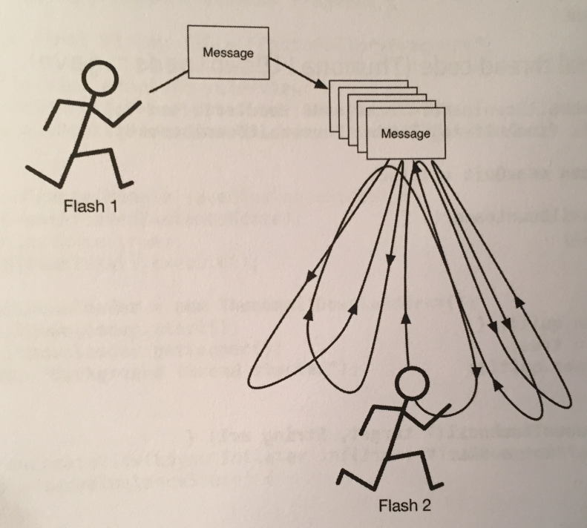

A message loop consists of a thread and a *looper*. The Looper is the object that manages a thread’s message queue.

The main thread in Android apps is a message loop and has a looper. Everything your main thread does is performed by its looper, which grabs messages off its message queue and performs the task they specify.

We are going to create a background thread that is also a message loop. We will use a class called HandlerThread that prepares a Looper for us.

We first create a new class that extends HandlerThread:

public class ThumbnailDownloader<T>

extends HandlerThread{

private static final String TAG =

"ThumbnailDownloader";

private boolean mHasQuit = false;

public ThumbnailDownloader(){

super(TAG);

}

@Override

public boolean quit(){

mHasQuit = true;

return super.quit();

}

public void queueThumbnail(T target, String url){

Log.i(TAG, "Got a URL: " + url);

}

}

Here we override the quit() method that signals when our thread has quit. We will use this method later.

Notice that we gave the class a single generic argument, <T>. Our ThumbnailDownloader’s user, PhotoGalleryFragment in this case, will need to use some object to identify each download and to determine which UI element to update with the image once it has downloaded. Rather than locking the user into a specific type of object as the identifier, using a generic makes the implementation more flexible.

The queueThumbnail() method expects an object of type T to use as the identifier for the download and a String containing the URL to download. This is the method you will have PhotoAdapter call in its onBindViewHolder(…) implementation.

We put a ThumbnailDownloader variable in PhotoGalleryFragment’s class, and in onCreate(…), we create the thread and start it. We override onDestroy() to quit the thread. Here is this code:

public class PhotoGalleryFragment extends Fragment {

…

private ThumbnailDownloader<PhotoHolder>

mThumbnailDownloader;

…

@Override

public void onCreate(Bundle savedInstanceState){

…

mThumbnailDownloader =

new ThumbnailDownloader<>();

mThumbnailDownloader.start();

mThumbnailDownloader.getLooper();

Log.i(TAG, "Background thread started");

}

…

@Override

public void onDestroy(){

super.onDestroy();

mThumbnailDownloader.quit();

Log.i(TAG, "Background thread destroyed");

}

…

}

You can specify any type for ThumbnailDownloader’s generic argument. However, recall that this argument specifies the type of the object that will be used as the identifier for your download. In this case, the PhotoHolder makes for a convenient identifier as it’s also the target where the downloaded images will eventually go.

A couple of safety notes. One: notice we call getLooper() after calling start() on our ThumbnailDownloader. This is a way to ensure that the thread’s guts are ready before proceeding, to obviate a potential (though rarely occurring) race condition. Until we call getLooper(), there is no guarantee that onLooperPrepared() has been called, so there is a possibility that calls to queueThumbnail(…) will fail due to a null Handler.

Safety note 2: you call quit() to terminate the thread inside onDestroy(). **This is critical.** If you don’t quit your HandlerThreads, they will never die.

Now, within PhotoAdapter.onBindViewHolder(…), we call the thread’s queueThumbnail(…) method and pass in the target PhotoHolder where the image will ultimately be placed and the GalleryItem’s URL to download from:

public void onBindViewHolder(PhotoHolder photoHolder,

int position){

…

mThumbnailDownloader.queueThumbnail(photoHolder,

galleryItem.getUrl());

}

Now our handler thread is up and running and loading things correctly dynamically when we scroll. The next step is to create a message with the information passed in to queueThumbnail(…) and put that message on the ThumbnailDownloader’s message queue.

Before we create a message, we need to understand what a Message is and the relationship it has with its Handler (often called its *message handler*).

Let’s first look at messages. The messages you put in your inbox are tasks to be handled. A message is an instance of Message and contains several fields. Three are relevant to your implementation:

* what: a user-defined int that describes the message
* obj: a user-specified object to be sent with the message
* target: the Handler that will handle the message

The target of a Message is an instance of Handler. You can think of the name Handler as being short for “message handler.” When you create a message, it’ll automatically be attached to a Handler. And when your Message is ready to be processed, Handler will be the object in charge of making it happen.

To do any real work with messages, you’ll need an instance of Handler first. A Handler is not just a target for processing your Messages. A Handler is your interface for creating and posting Messages, too. Take a look at the figure below:

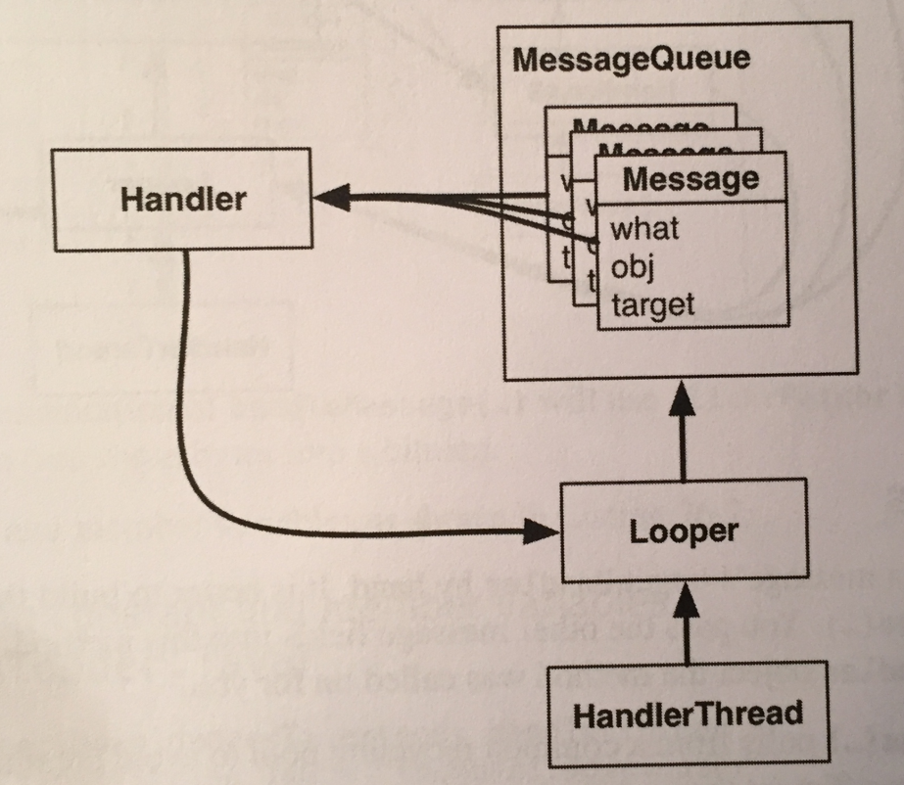

Messages must be posted and consumed on a Looper, because Looper owns the inbox of Message objects. So Handler always has a reference to its coworker, the Looper.

A Handler is attached to **exactly one** Looper, and a Message is attached to **exactly one** target Handler, called its *target*. A Looper has a whole queue of Messages. Multiple Messages **can** reference the same target handler.

Multiple Handlers can be attached to one Looper, as shown below. This means that your Handler’s Messages may be living side by side with another Handler’s messages:

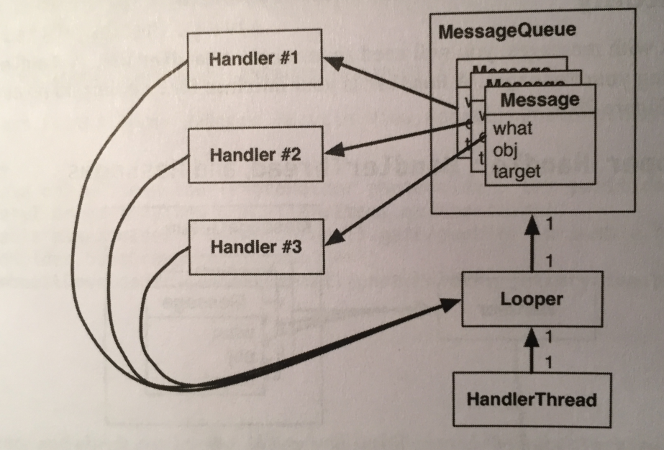

Usually, you do not set a message’s target Handler by hand. It’s better to build the message by calling Handler.obtainMessage(…). You pass the other message fields into this method, and it automatically sets the target to the Handler object the method was called on for you.

Handler.obtainMessage(…) pulls from the common recycling pool to avoid creating new Message objects, so it’s also more efficient than creating new instances.

Once you have obtained a Message, you call sendToTarget() to send the Message to its handler. The Handler will then put the Message on the end of Looper’s message queue.

In our case, we’re gonna obtain a message and send it to its target within the implementation of queueThumbnail(). The message’s what will be a constant defined as MESSAGE_DOWNLOAD. The message’s obj will be an object of type T, which will be used to identify the download. In our case, obj will be the PhotoHolder that the adapter passed into queueThumbnail().

When the looper pulls a Message from the queue, it gives the message to the message’s target Handler to handle. Typically, the message is handled in the target’s implementation of Handler.handleMessage(…).

The figure below shows the object relationships involved:

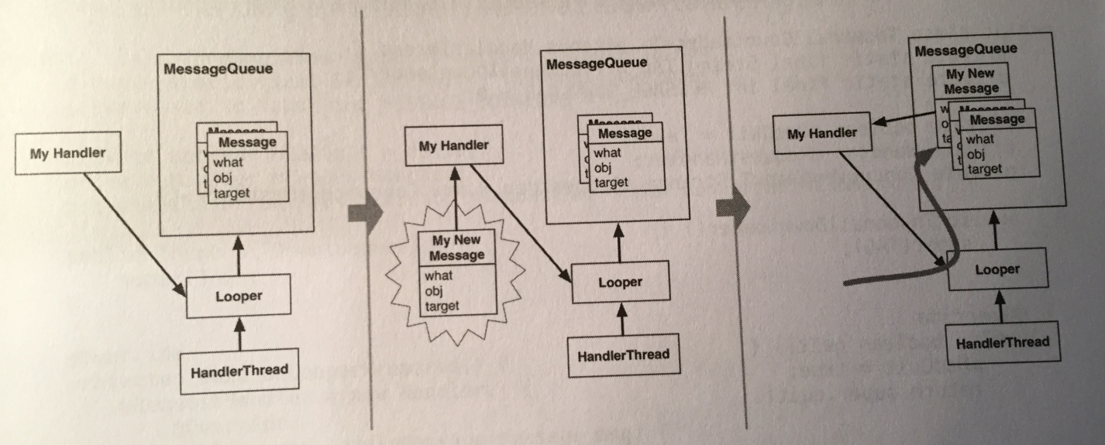

In our case, the implementation of handleMessage(…) will use FlickrFetchr to download bytes from the URL and then turn these bytes into a bitmap.

Ok, time to implement. First we add the constant and member variables we need to our HandlerThread class:

private static final int MESSAGE_DOWNLOAD = 0;

private Handler mRequestHandler;

private ConcurrentMap<T, String> mRequestMap =

new ConcurrentHashMap<>();

MESSAGE_DOWNLOAD will be used to ID messages as download requests. ThumbnailDownloader will set this as the what on any new download messages it creates.

The newly added mRequestHandler will store a **reference** to the Handler responsible for queueing download requests as messages onto the ThumbnailLoader background thread. This handler will also be in charge of processing download request messages when they’re pulled off the queue.

The mRequestMap variable is a ConcurrentHashMap. A ConcurrentHashMap is a thread-safe version of HashMap. Here, using a download request’s identifying object of type T as a key, you can store and retrieve the URL associated with a particular request. In our case, the identifying object is a PhotoHolder, so the request response can be easily routed back to the UI element where the downloaded image should be placed.

Next, we add code to queueThumbnail(…) to update mRequestMap and to post a new message to the background thread’s message queue:

public void queueThumbnail(T target, String url){

Log.i(TAG, "Got a URL: " + url);

**if(url == null){**

**mRequestMap.remove(target);**

**}**

**else{**

**mRequestMap.put(target, url);**

**mRequestHandler**

**.obtainMessage(MESSAGE_DOWNLOAD,**

**target).sendToTarget();**

**}**

}

You obtain a message directly from mRequestHandler, which automatically sets the new Message object’s target field to mRequestHandler. This means mRequestHandler will be in charge of processing the message when it’s pulled off the message queue. The message’s what field is set to MESSAGE_DOWNLOAD. Its obj field is set to the T target value (a PhotoHolder in this case) that’s passed to queueThumbnail(…).

The new message represents a download request for the specified T target (a PhotoHolder from the RecyclerView). Recall that PhotoGalleryFragment’s RecyclerView’s adapter implementation calls queueThumbnail(…) from onBindViewHolder(…), passing along the PhotoHolder the image is being downloaded for and the URL location of the image to be downloaded.

Notice that the message itself does not include the URL. Instead, we update mRequestMap with a mapping between the request identifier (a PhotoHolder) and the URL for the request. Later we will pull the URL from the mRequestMap to ensure that we’re always downloading the **most recently requested URL** for a given PhotoHolder instance. This is important because ViewHolder objects in RecyclerViews are recycled and reused.

Finally, we initialize mRequestHandler and define what that Handler will do when downloaded messages are pulled off the queue and passed to it:

@Override

protected void onLooperPrepared(){

mRequestHandler = new Handler(){

@Override

public void handleMessage(Message msg){

if(msg.what == MESSAGE_DOWNLOAD){

T target = (T)msg.obj;

Log.i(TAG, "Got a request for

URL: " +

mRequestMap.get(target));

handleRequest(target);

}

}

};

}

…

private void handleRequest(final T target){

try{

final String url = mRequestMap.get(target);

if(url == null){

return;

}

byte[] bitmapBytes =

new FlickrFetchr().getUrlBytes(url);

final Bitmap bitmap =

BitmapFactory.decodeByteArray(

bitmapBytes, 0, bitmapBytes.length);

Log.i(TAG, "Bitmap created");

}

catch(IOException ioe){

Log.e(TAG, "Error downloading image", ioe);

}

}

We implemented Handler.handleMessage(…) in our HandlerThread subclass within onLooperPrepared(). HandlerThread.onLooperPrepared() is called before the Looper checks the queue for the first time. This makes it a good place to create our Handler implementation.

Within Handler.handleMessage(…), we check the message type, retrieve the obj value (which will be of type T and serves as the ID for the request), and then pass it to handleRequest(…).

Recall that Handler.handleMessage(…) will get called when a download message is pulled off the queue and ready to be processed.

The handleRequest() method is a helper method where the downloading happens. Here we check for the existence of a URL. Then we pass the URL to a new instance of our FlickrFetchr. In particular, we use the getUrlBytes(…) method we created.

Finally, we use BitmapFactory to construct a bitmap with the array of bytes returned from getUrlBytes(…).

Of course, we’re not done yet. The request is still not handled until we set the bitmap on the PhotoHolder that originally came from PhotoAdapter. However, this is UI work, so it must be done on the main thread.

Everything we’ve seen so far uses handlers and messages on a single thread - ThumbnailDownloader putting messages in ThumbnailDownloader’s own inbox. Now let’s look at how ThumbnailDownloader can use a Handler to post requests to a separate thread (namely, the main thread).

So far we are able to schedule work on the background thread from the main thread using ThumbnailDownloader’s mRequestHandler. This looks like this:

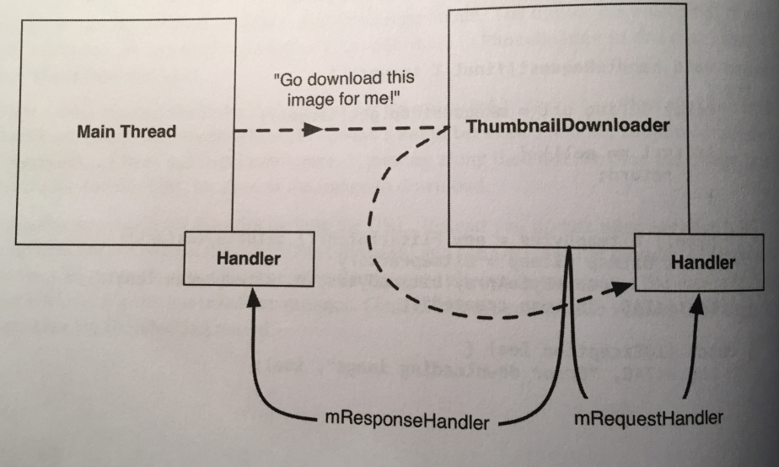

We can also schedule work on the main thread from the background thread using a Handler attached to the main thread. This looks like this:

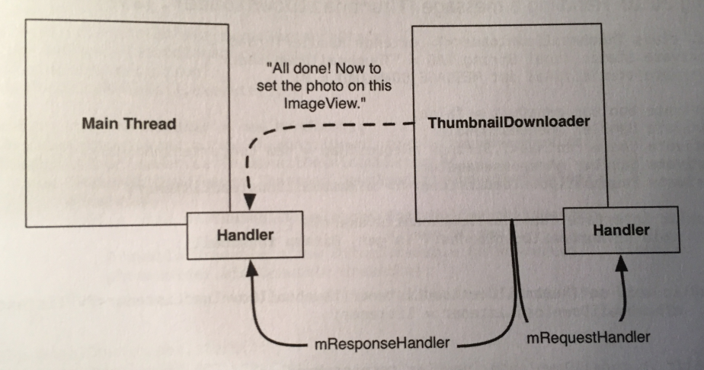

The main thread is a message loop with handlers and a Looper. When we create a Handler in the main thread, it will be associated with the main thread’s Looper. We can pass that Handler to another thread. The passed Handler maintains its loyalty to the Looper of the thread that created it. Any messages the Handler is responsible for will be handled on the main thread’s queue.

Therefore, what we do is add a handler variable to our HandlerThread class that is passed from the main thread. The constructor accepts this Handler and sets the variable.

We then add a listener interface to our HandlerThread class that will be used to communicate the responses (downloaded images in our case) with the requester (the main thread in our case). **This interface will be implemented in the fragment class that takes care of actually binding the view.**

Here is the code that handles our listener interface (in our ThumbnailDownloader class) and does everything else we said above:

private Handler mResponseHandler;

private ThumbnailDownloadListener<T>

mThumbnailDownloadListener;

public interface ThumbnailDownloadListener<T>{

void onThumbnailDownloaded(T target,

Bitmap bitmap);

}

public void setThumbnailDownloadListener(

ThumbnailDownloadListener<T> listener){

mThumbnailDownloadListener = listener;

}

public ThumbnailDownloader(Handler responseHandler){

super(TAG);

mResponseHandler = responseHandler;

}

The onThumbnailDownloaded(…) method defined in our new ThumbnailDownloadListener interface will eventually be called when an image has been fully downloaded and is ready to be added to the UI.

Using this listener delegates the responsibility of what to do with the downloaded image to a class other than ThumbnailDownloader (in our case, to PhotoGalleryFragment).

Doing so **separates** the downloading task from the UI updating task (putting the images into ImageViews), so that ThumbnailDownloader could be used for downloading into other kinds of View objects as needed.

Next, we modify PhotoGalleryFragment to pass a Handler attached to the main thread to ThumbnailDownloader. Also, we set a ThumbnailDownloadListener to handle the downloaded image **once it’s complete**:

public void onCreate(Bundle savedInstanceState){

…

**Handler responseHandler = new Handler();**

mThumbnailDownloader =

new ThumbnailDownloader<>(**responseHandler**);

**mThumbnailDownloader.setThumbnailDownloadListener(**

**new ThumbnailDownloader**

**.ThumbnailDownloadListener<PhotoHolder>(){**

**@Override**

**public void onThumbnailDownloaded(**

**PhotoHolder photoHolder,**

**Bitmap bitmap){**

**Drawable drawable =**

**new BitmapDrawable(**

**getResources(), bitmap);**

**photoHolder**

**.bindDrawable(drawable);**

**}**

**}**

**);**

mThumbnailDownloader.start();

mThumbnailDownloader.getLooper();

Log.i(TAG, "Background thread started");

}

Remember that by default, the Handler will attach itself to the Looper for the current thread. Because this Handler is created in onCreate(…), it’ll be attached to the main thread’s looper.

Now ThumbnailDownloader has access via mResponseHandler to a Handler that’s tied to the main thread’s Looper. It also has our ThumbnailDownloadListener to do the UI work with the returning Bitmaps. Specifically, the onThumbnailDownloaded implementation sets the Drawable of the originally requested PhotoHolder to the newly downloaded Bitmap.

Now, we need a way to hook the request up to the download listener so that when we handle the request of getting an image, the listener gets called to bind the drawable with the downloaded image.

Instead of sending a custom Message back to the main thread requesting to add the image to the UI (which would require another subclass of Handler, with another override to handleMessage(…) ), we use another handy Handler method: post(Runnable).

Handler.post(Runnable) is a convenience method for posting Messages that look like this:

Runnable myRunnable = new Runnable(){

public void run(){

//your code here

}

};

Message m = myHandler.obtainMessage();

m.callback = myRunnable;

When a Message has its callback field set, it’s **not** routed to its target Handler when pulled off the message queue. Instead, the run() method of the Runnable stored in callback is executed **directly**.

In ThumbnailDownloader.handleRequest(), we add the following code:

private void handleRequest(final T target){

try{

…

**mResponseHandler.post(new Runnable() {**

**@Override**

**public void run() {**

**if(mRequestMap.get(target) !=**

**url || mHasQuit){**

**return;**

**}**

**mRequestMap.remove(target);**

**mThumbnailDownloadListener**

**.onThumbnailDownloaded(target,**

**bitmap);**

**}**

**});**

}

catch(IOException ioe){

Log.e(TAG, "Error downloading image", ioe);

}

}

Because mResponseHandler is associated with the main thread’s Looper, all of the code inside of run() will be executed on the main thread.

This code first double-checks requestMap. This is necessary because the RecyclerView recycles its views. By the time ThumbnailDownloader finishes downloading the Bitmap, RecyclerView may have recycled the PhotoHolder and requested a different URL for it. This check ensures that each PhotoHolder gets the correct image, even if another request has been made in the meantime.

Next, we check mHasQuit. If ThumbnailDownloader has already quit, it’s unsafe to run any callbacks.

Finally, we remove the PhotoHolder-URL mapping from the requestMap and set the bitmap on the target PhotoHolder (via the ThumbnailDownloadListener).

That’s it! We should be able to see images loaded.

However, there is one more thing to take care of. If the user rotates the screen, ThumbnailDownloader may be hanging onto invalid PhotoHolders. Bad things will happen if the corresponding ImageViews get pressed on invalid PhotoHolders.

We write the following method in the ThumbnailDownloader class to clean out all the requests from our queue:

public void clearQueue(){

mRequestHandler.removeMessages(MESSAGE_DOWNLOAD);

mRequestMap.clear();

}

Then, we clean out our downloader in PhotoGalleryFragment when our view is destroyed:

@Override

public void onDestroyView(){

super.onDestroyView();

mThumbnailDownloader.clearQueue();

}

Now we’re truly finished!

We’ve learned about HandlerThread and AsyncTask. Why should you use HandlerThreads instead of AsyncTasks? There are a few reasons. The most fundamental one is **that AsyncTask is not designed for background thread work. It’s intended for work that is short lived and not repeated too often.** If you’re creating a lot of AsyncTasks or having them run for a long time, you’re probably using the wrong class.

Another, more compelling, reason is that in Android 3.2 AsyncTask changed its implementation in a significant way. Starting with Android 3.2, AsyncTask doesn’t create a thread for each instance of AsyncTask. Instead, it uses something called an Executor to run background work for all AsyncTasks on a single background thread. That means that each AsyncTask will run one after the other. A long-running AsyncTask will hog the thread, preventing other AsyncTasks from getting any CPU time.

It’s possible to safely run AsyncTasks in parallel using a thread pool executor instead, but it’s not recommended. It’s better to use Handlers to communicate back to the main thread when necessary.

The book talks about using the third-party library Picasso instead of all the code we’ve written in the last two chapters. The book shows how to set up Picasso and integrate it into our project (and other libraries like Glide and Fresco) on pages 518-519.

There are some things that you just shouldn’t do in your Android app - mistakes that lead to crashes and security holes. Executing a network request on the main thread is an example of this, which causes Android to throw a NetworkOnMainThread exception.

Android does this because of StrictMode, which notices these kinds of deadly mistakes. Without any configuration, networking on the main thread is guarded against. StrictMode can also help you detect other mistakes that could drag down your applictaion’s performance.

To enable all of StrictMode’s recommended policies, call StrictMode.enableDefaults(). Once this call is made, you’ll hear about the following violations in Logcat:

* Networking on the main thread.
* Disk reads and writes on the main thread.
* Activities kept alive beyond their natural lifecycle (also known as an “activity leak”).
* Unclosed SQLite database errors.
* Cleartext network traffic not wrapped in SSL/TLS.

For custom control over what happens when policy violations occur, we can configure the ThreadPolicy.Builder and VmPolicy.Builder classes. We can specify whether we want an exception to occur, a dialog to be shown, or just a log statement to alert us to the violation.

**Chapter 27 - Search:**

In this chapter we will implement search using SearchView. The user will submit a query using the SearchView, which will search Flickr using the query string and populate the RecyclerView with the search results. The query string submitted will be persisted to the filesystem. This means the user’s last query will be accessible across restarts of the app and even the device.

SearchView is an *action view* class - a view that can be embedded right into your toolbar.

The first thing the book does is refactor the FlickrFetchr class to support search and make it able to handle both searching and getting recent photos (thru methods that dynamically build the URL to do these tasks).

The refactoring code is on pages 521-526.

Now that FlickrFetchr supports searching, it’s time to add a way for the user to enter a query and initiate a search. We do this by adding a SearchView.

SearchView is an *action view* - a view that may be included within the toolbar. SearchView allows your entire search interface to live within your application’s toolbar.

The first thing we need to do is create an XML menu file in res/menu that will contain our search bar and menu clear icon in the overflow menu. The XML do do this is on the top of page 527.

We then open PhotoGalleryFragment and add a call to setHasOptionsMenu(true) in onCreate(…) to register the fragment to receive menu callbacks. We override onCreateOptionsMenu(…) to inflate the menu XML file we created. This will add the items listed in our menu XML to the toolbar. The code doing these two things is simple and is on page 528.

After this is done we should be able to fire up the menu and dismiss it. We can’t do anything yet though. We need to hook the functionality up next.

When the user submits a query, our app should execute a search against the Flickr web service and refresh the images the user sees with the search results. Fortunately, the SearchView.OnQueryListener interface provides a way to receive a callback when a query is submitted.

We need to update onCreateOptionsMenu(…) in PhotoGalleryFragment to add a SearchView.OnQueryListener to our SearchView:

public void onCreateOptionsMenu(Menu menu,

MenuInflater menuInflater){

super.onCreateOptionsMenu(menu, menuInflater);

menuInflater.inflate(R.menu.fragment_photo_gallery

,menu);

**MenuItem searchItem =**

**menu.findItem(R.id.menu_item_search);**

**final SearchView searchView =**

**(SearchView)searchItem.getActionView();**

**searchView.setOnQueryTextListener(**

**new SearchView.OnQueryTextListener() {**

**@Override**

**public boolean onQueryTextSubmit(String s) {**

**Log.d(TAG, "QueryTextSubmit: " + s);**

**updateItems();**

**return true;**

**}**

**@Override**

**public boolean onQueryTextChange(String s) {**

**Log.d(TAG, "QueryTextChange: " + s);**

**return false;**

**}**

**});**

}

**private void updateItems(){**

**new FetchItemsTask().execute();**

**}**

In onCreateOptionsMenu(…), we pull the MenuItem representing the search box from the menu and store it. Then we pull the SearchView object from the search box variable using the getActionView() method.

Once we have a reference to the SearchView we are able to set a SearchView.OnQueryTextListener using the setOnQueryTextListener(…) method. We must override the two methods in the SearchView.OnQueryTextListener implementation: onQueryTextSubmit(String) and onQueryTextChange(String).

The onQueryTextChange(String) callback is executed any time text in the SearchView text box changes. This means that it’s called every time a single character changes. We don’t really need to do anything in this case.

The onQueryTextSubmit(String) callback is executed when the user submits a query. The query the user submitted is passed as input. Returning true signifies to the system that the search request had been handled. This callback is where you will launch a FetchItemsTask AsyncTask to query for new results.

The updateItems() does not seem useful yet, but is needed as a wrapper because we have several places where we need to execute FetchItemsTask. Let’s use it in onCreate(…) instead of launching FetchItemsTask directly. The book does this simple change on page 531.

The last piece of functionality we need to add is to actually use the query entered into the SearchView when the search request is submitted.

In our app, what we do is process one query at a time. That query should be persisted (remembered by the app) between restarts of the app (even after the user turns off the device). We will do this by writing the query string to *shared preferences*.

Any time the user submits a query, we will first write the query to shared preferences, overwriting whatever query was there before. When a search is executed, we’ll pull the query from shared preferences and use it as the value for the text parameter of the URL query.

*Shared preferences* are files on your filesystem that you read and edit using the SharedPreferences class. An instance of SharedPreferences acts like a key-value store, much like Bundle, except that it’s backed by persistent storage. The keys are strings, and the values are atomic data types.

If we look at them we will see that the shared preferences files are simple XML, but SharedPreferences makes it easy to ignore that implementation detail. **Shared preference files are stored in your application’s sandbox, so you should not store sensitive info (like passwords) there.**

To get a specific instance of SharedPreferences, you can use the Context.getSharedPreferences(String, int) method. However, in practice, you’ll often not care too much about the specific instance, just that it’s shared across the entire app.

In that case, it’s better to use the PreferenceManager.getDefaultSharedPreferences(Context) method, which returns an instance with a default name and private permissions (so that preferences are only available from within your app).

We add a new class that will serve as a convenient interface for reading and writing the query from and to, respectively, shared preferences:

public class QueryPreferences {

private static final String PREF_SEARCH_QUERY =

"searchQuery";

public static String getStoredQuery(

Context context){

return PreferenceManager

.getDefaultSharedPreferences(context)

.getString(PREF_SEARCH_QUERY, null);

}

public static void setStoredQuery(Context context,

String query){

PreferenceManager

.getDefaultSharedPreferences(context)

.edit()

.putString(PREF_SEARCH_QUERY, query)

.apply();

}

}

PREF_SEARCH_QUERY is used as the key for the query preference. We’ll use this key any time we read or write the query value.

The getStoredQuery(Context) method returns the query value stored in shared preferences. It does so by first acquiring the default SharedPreferences for a given context, because QueryPreferences doesn’t have a Context of its own.

Getting a value we previously stored is as simple as calling SharedPreferences.getString(…), getInt(…), or whichever method is appropriate for our data type. The second input to SharedPreferences.getString(…) specifies the default return value that should be used if there’s no entry for the PREF_SEARCH_QUERY key.

The setStoredQuery(Context) method writes the input query to the default shared preferences for the given context. In our code, we call SharedPreferences.edit() to get an instance of SharedPreferences.Editor. This is the class we use to stash values in our SharedPreferences. It allows us to group sets of changes together in transactions. If we have a lot of changes, this will allow us to group them together into a single storage write operation.

Once we are done making all of our changes, we call apply() on our editor to make them visible to other users of that SharedPreferences file. The apply() method makes the change in memory immediately and then does the actual file writing on a background thread.

Now we update PhotoGalleryFragment to read and write the query as necessary. The first thing we do is add:

QueryPreferences.setStoredQuery(getActivity(), s);

in the setOnQueryTextListener method of the SearchView to set our query string in shared preferences.

Next, we clear the stored query (set it to null) whenever the user selects the “Clear Search” item from the overflow menu:

@Override

public boolean onOptionsItemSelected(MenuItem item){

switch(item.getItemId()){

case R.id.menu_item_clear:

**QueryPreferences.setStoredQuery(**

**getActivity(), null);**

updateItems();

return true;

default:

return

super.onOptionsItemSelected(item);

}

}

Note that we call updateItems() after we update the stored query. This ensures that the images displayed in the RecyclerView reflect the most recent search query.

Last, but not least, we update FetchItemsTask to use the stored query. We add a custom constructor to FetchItemsTask that accepts a query string as input and stashes it in a member variable.

We must also update updateItems() to pull the stored query from shared resources and use it to create a new instance of FetchItemsTask.

All these changes are very simple and are on page 535.

And that’s it! Search should now work!

For one last bit of polish, we pre-populate the search box with the saved query when the user presses on the search icon to expand the SearchView. SearchView’s View.OnClickListener.onClick() method is called when the user presses the search icon. Hook into this callback and set the SearchView’s query text when the view is expanded:

public void onCreateOptionsMenu(Menu menu,

MenuInflater menuInflater){

…

**searchView.setOnSearchClickListener(**

**new View.OnClickListener() {**

**@Override**

**public void onClick(View v){**

**String query = QueryPreferences**

**.getStoredQuery(getActivity());**

**searchView.setQuery(query, false);**

**}**

**});**

}

And that’s it! Everything should work great now.

**Chapter 28 - Background Services:**

All the code we have written so far has been hooked up to an activity, which means that it’s associated with some screen for the user to look at.

But what if we don’t need a screen? What if we need to do something like play music or check for new blog posts on an RSS feed? For this, we need a *service*.

Let’s start by creating a service. In this chapter, we will use an IntentService. IntentService is not the only kind of service, but it’s probably the most common. We create a subclass of IntentService that will be the service we use:

public class PollService extends IntentService {

private static final String TAG = "PollService";

public static Intent newIntent(Context context){

return new Intent(context,

PollService.class);

}

public PollService(){

super(TAG);

}

@Override

protected void onHandleIntent(Intent intent){

Log.i(TAG, "Received an intent: " + intent);

}

}

This is a very basic IntentService. It’s sort of like an activity. It is a context (Service is a subclass of Context) and it responds to intents (as we can see in onHandleIntent(Intent)). As a matter of convention, we added a newIntent(Context) method. Any component that wants to start this service should use newIntent(…).

A service’s intents are called *commands*. Each command is an instruction to the service to do something. Depending on the kind of service, that command could be serviced in a variety of ways.

An IntentService pulls its commands off of a queue:

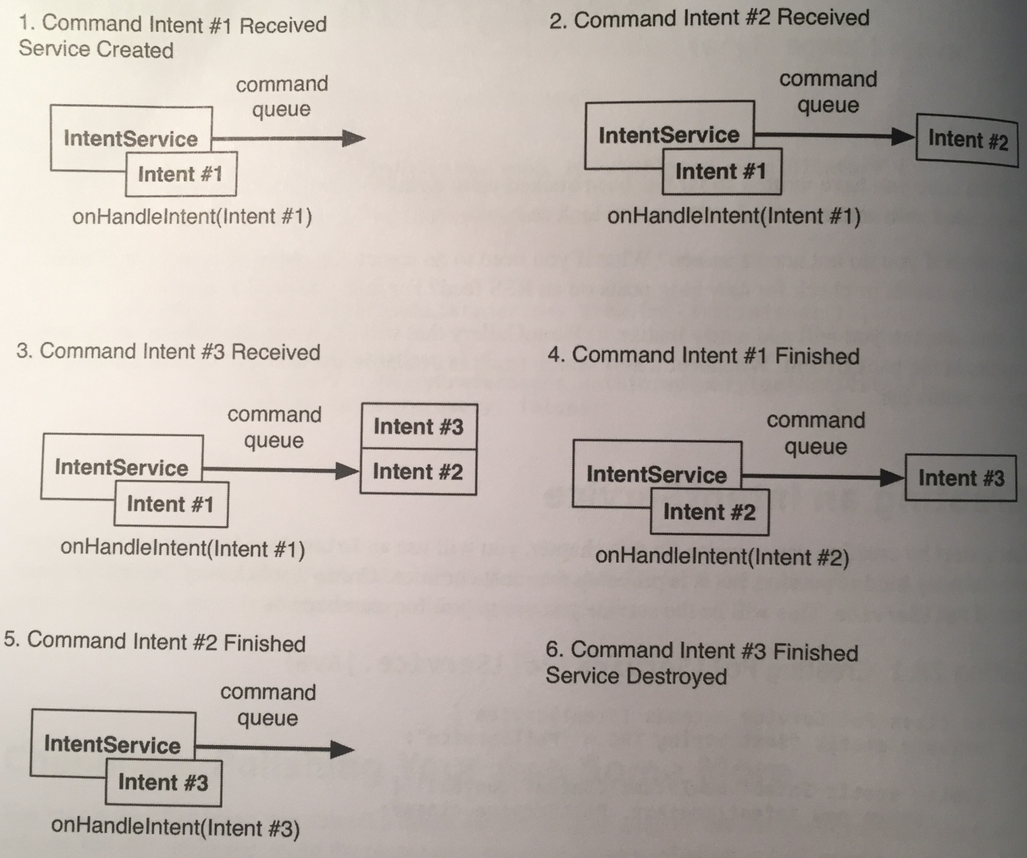

When it receives its first command, the IntentService starts up, fires up a background thread, and puts the command in a queue.

The IntentService then services each command in sequence, calling onHandleIntent(Intent) on its background thread for each command. New commands that come in go to the back of the queue. When there are no commands left in the queue, the service stops and is destroyed.

**This description only applies to IntentService.** Later, we will discuss the broader world of services and how commands work.

Services respond to intents. And because services, like activities, respond to intents, they must also be declared in your manifest file, like so:

<application

…>

**<service android:name=".PollService"/>**

</application>

We then add code to start our service inside PhotoGalleryFragment:

public void onCreate(Bundle savedInstanceState){

…

**Intent i = PollService.newIntent(getActivity());**

**getActivity().startService(i);**

…

}

Services allow you to do things in the background, when activities have long been destroyed and/or when the user is occupied elsewhere. Activities, on the other hand, are at the front-end giving your users a pleasant UI.

If your service polls applications in the background, like this chapter’s does, we need to check if we can perform networking in the background safely. Android provides the ability for a user to turn off networking for backgrounded applications. If the user has a lot of power-hungry apps, this can be a big performance improvement.

This does mean, however, that if we’re doing networking in the background, we need to verify with the ConnectivityManager that the network is available.

Here’s the code to do so (we put it in the PollService class):

protected void onHandleIntent(Intent intent){

**if(!isNetworkAvailableAndConnected()){**

**return;**

**}**

Log.i(TAG, "Received an intent: " + intent);

}

**private boolean isNetworkAvailableAndConnected(){**

**ConnectivityManager cm =**

**(ConnectivityManager)getSystemService(**

**CONNECTIVITY_SERVICE);**

**boolean isNetworkAvailable =**

**cm.getActiveNetworkInfo() != null;**

**boolean isNetworkConnected = isNetworkAvailable &&**

**cm.getActiveNetworkInfo().isConnected();**

**return isNetworkConnected;**

**}**

The logic for checking network availability is in isNetworkAvailableAndConnected(). Toggling the background data setting to disallow downloading data in the background disables the network entirely for use by background services.

In this case, ConnectivityManager.getActiveNetworkInfo() returns null, making it appear to the background service as if there’s no network available, even if there really is.

If the network is available to your background service, it gets an instance of android.net.NetworkInfo representing the current network connection. The code then checks whether the current network is fully connected by calling NetworkInfo.isConnected().

If the app doesn’t see a network available, or the device is not fully connected to a network, onHandleIntent(…) will return without executing shit. This is good practice because your app cannot download any data if it’s not connected to the network.

One more thing. To use getActiveNetworkInfo(), you also need to aquire the ACCESS_NETWORK_STATE permission. This is gotten in your manifest:

<uses-permission

android:name=

"android.permission.ACCESS_NETWORK_STATE"/>

Our service this chapter will be polling for new results, so it will need to know what the last result fetched was. This is a perfect job for another SharedPereferences entry.

First, let’s update QueryPreferences to store the ID of the most recently fetched photo:

public class QueryPreferences {

private static final String PREF_SEARCH_QUERY =

"searchQuery";

**private static final String PREF_LAST_RESULT_ID =**

**"lastResult";**

…

**public static String getLastResultId(**

**Context context){**

**return PreferenceManager**

**.getDefaultSharedPreferences(context)**

**.getString(PREF_LAST_RESULT_ID, null);**

**}**

**public static void setLastResultId(**

**Context context, String query){**

**PreferenceManager**

**.getDefaultSharedPreferences(context)**

**.edit()**

**.putString(PREF_LAST_RESULT_ID, query)**

**.apply();**

**}**

}

The next step is to fill out our service. Here’s what we need to do:

1. Pull out the current query and the last result ID from the default SharedPreferences.
2. Fetch the latest result set with FlickrFetchr.
3. If there are results, grab the first one.
4. Check to see whether it’s different from the last result ID.
5. Store the first result back in SharedPreferences as the last result ID.

Basically we’re checking the first result and basing the entire result set off that.

Here’s the code in PollService to do just that:

@Override

protected void onHandleIntent(Intent intent){

if(!isNetworkAvailableAndConnected()){

return;

}

String query =

QueryPreferences.getStoredQuery(this);

String lastResultId =

QueryPreferences.getLastResultId(this);

List<GalleryItem> items;

if(query == null){

items = new

FlickrFetchr().fetchRecentPhotos();

}

else{

items =

new FlickrFetchr().searchPhotos(query);

}

if(items.size() == 0){

return;

}

String resultId = items.get(0).getId();

if(resultId.equals(lastResultId)){

Log.i(TAG, "Got an old result: " +

resultId);

}

else{

Log.i(TAG, "Got an new result: " +

resultId);

}

QueryPreferences.setLastResultId(this, resultId);

}

To actually use your service in the background, we will need some way to make things happen when none of our activites are running. Say, by making a timer that goes off every 5 minutes or so.

The best way to do this is to use an AlarmManager. AlarmManager is a system service that can send Intents for you.

To tell an AlarmManager what intents to send, use a PendingIntent. We can use PendingIntent to package up a wish: “I want to start PollService.” You can then send that wish to other components on the system, like AlarmManager.

We write a new method called setServiceAlarm(Context, boolean) inside PollService that turns an alarm on and off for you. You write it as a static method to keep it with the PollService code, but allow other components to invoke it. You’ll usually want to turn it on and off from frontend code in a fragment or other controller.

Here is the alarm code:

…

//set interval to 1 minute

private static final long POLL_INTERVAL_MS =

TimeUnit.MINUTES.toMillis(1);

…

public static void setServiceAlarm(Context context,

boolean isOn){

Intent i = PollService.newIntent(context);

PendingIntent pi =

PendingIntent.getService(context, 0, i, 0);

AlarmManager alarmManager =

(AlarmManager)context.

getSystemService(Context.ALARM_SERVICE);

if(isOn){

alarmManager

.setRepeating(

AlarmManager.ELAPSED_REALTIME,

SystemClock.elapsedRealtime(),

POLL_INTERVAL_MS, pi);

}

else{

alarmManager.cancel(pi);

pi.cancel();

}

}

The first thing we do in our method is construct a PendingIntent that can be used to start PollService. You do this by calling PendingIntent.getService(…), which packages up an invocation of Context.startService(Intent). It takes four parameters:

* A Context with which to send the intent.
* A request code that you can use to distinguish this PendingIntent from others.
* The Intent object to send.
* A set of flags that we can use to tweak how PendingIntent is created.

After that, we need to either set the alarm or cancel it.

Because we used AlarmManager.ELAPSED_REALTIME as the time basis value, we specified the start time in terms of elapsed runtime: SystemClock.elapsedRealtime(). This triggers the alarm to go off when the specified amount of time has passed. If we had used AlarmManager.RTC, we would’ve instead based the start time on “wall clock time.” This would trigger the alarm to go off at a fixed point in time.

Canceling the alarm is done by calling AlarmManager.cancel(PendingIntent). We will also usually want to cancel the PendingIntent.

To use this code, do something like this:

PollService.setServiceAlarm(getActivity(), true);

This will make the AlarmManager fire intents to start PollService again and again, which is annoying and not really what we want. We need to fix this.

Now, how exact do you need your repeating to be? Repeatedly executing work from your background service has the potential to eat up the user’s battery power and data service allotment. Furthermore, waking the device from sleep is a costly operation. Luckily, you can configure your alarm to have a lighter usage footprint in terms of interval timing and wake requirements.

The setRepeating(…) method sets a repeating alarm, but that repetition is **not exact**. IOW, Android reserves the right to move it around a little bit. As a result, 60 seconds is the lowest possible interval time you can set for stock Android (other devices may make this value higher).

This is because alarms use a ton of battery life. Every time an alarm fires, it has to wake the device up and spin up the application. Many apps, like ours, need to turn on the phone’s radio to use the internet, which results in even more battery usage.

Now, if there are 15 apps all running 15-minute alarms, well then your device is waking up way too many times.

Inexactness means that Android is allowed to take the liberty of moving those alarms around, so that they don’t run **exactly** every 15 minutes. The result is that every 15 minutes, your device can wake up and run all 15 of those 15-minute alarms at the same time. That would pull you back down to only four wake-ups instead of many, greatly saving battery life.

Some apps do need exact alarms, of course. If that’s your app, then you must use either AlarmManager.setWindow(…) or AlarmManager.sexExact(…), which allows you to set an exact alarm to occur **only once. The repeating part you have to handle yourself.**

Another important decision is which time bases value to specify. There are two main options: AlarmManager.ELAPSED_REALTIME and AlarmManager.RTC.

AlarmManager.ELAPSED_REALTIME uses the amount of time that has passed since the last boot of the device (including sleep time) as the basis for interval calculations.

AlarmManager.RTC uses “wall clock time” in terms of UTC. UTC should only be used for wall-clock basis alarms. However, UTC does **NOT** represent locale, whereas the user’s idea of wall-clock time includes locale. Wall-clock basis alarms should represent locale somehow. This means you must implement your own locale handling in conjunction with using the RTC time basis if you want to set a wall-clock time alarm. Otherwise, use ELAPSED_REALTIME as the time basis.

If you use one of the time basis options outlined above, your alarm will **not** fire if the device is in sleep mode, even if it’s supposed to. If you need your alarm to occur anyways, you can force the alarm to wake up the device by using one of the following time basis constants: AlarmManager.ELAPSED_REALTIME_WAKEUP and AlarmManager.RTC_WAKEUP. However, you should avoid doing this unless you absolutely need to.

A PendingIntent is a token object. When you get one here by calling PendingIntent.getService(…), you say to the OS, “Please remember that I want to send this intent with startIntent(Intent).” Later on you can call send() on your PendingIntent token, and the OS will send the intent you originally wrapped up in exactly the way you asked.

The really nice thing about this is that when you give that PendingIntent token to someone else and they use it, it sends that token *as your application*. Also, because PendingIntent itself lives in the OS, not in the token, you maintain control of it. You could be an asshole and give someone else a PendingIntent object and then immediately cancel it (with cancel() ), so that send() does nothing.

If you request a PendingIntent twice **with the same intent**, you’ll get the same PendingIntent. You can use this to test whether a PendingIntent already exists or to cancel a previously issued PendingIntent (again, with cancel() ).

**You can only register one alarm for each PendingIntent.**

If we cancel the alarm manager at the same time as the PendingIntent (which we do in our project), we can check whether that PendingIntent exists or not to see whether the alarm is active or not. This is done by passing in the PendingIntent.FLAG_NO_CREATE flag to PendingIntent.getService(…). This flag says that if the PendingIntent doesn’t already exist, return null instead of creating it.

We can create a method that uses PendingIntent.FLAG_NO_CREATE to tell whether the alarm is on or not:

public static boolean isServiceAlarmOn(

Context context){

Intent i = PollService.newIntent(context);

**PendingIntent pi =**

**PendingIntent.getService(context, 0, i,**

**PendingIntent.FLAG_NO_CREATE);**

return pi != null;

}

Because this PendingIntent is only used for setting your alarm, a null PendingIntent here means that your alarm is not set, because we cancel the alarm and the PendingIntent together.

Now that we can turn our alarm on and off, as well as tell whether it’s on or off, let’s add an interface to turn it on and off.

We first add another menu item to fragment_photo_gallery.xml. This is shown on page 548.

Then, we add an implementation for our newly added menu item. This happens in PhotoGalleryFragment:

public boolean onOptionsItemSelected(MenuItem item){

…

**case R.id.menu_item_toggle_polling:**

**boolean shouldStartAlarm =**

**!PollService**

**.isServiceAlarmOn(getActivity());**

**PollService.setServiceAlarm(getActivity(),**

**shouldStartAlarm);**

**return true;**

…

}

With that, we should be able to trigger our alarm on and off.

However, we need a way to toggle the text of the menu item so that it states the proper toggle state. In onCreateOptionsMenu(…), check whether the alarm is on and change the text of menu_item_toggle_polling to show the appropriate label to the user:

public void onCreateOptionsMenu(Menu menu, MenuInflater menuInflater){

…

**MenuItem toggleItem =**

**menu.findItem(R.id.menu_item_toggle_polling);**

**if(PollService.isServiceAlarmOn(getActivity())){**

**toggleItem.setTitle(R.string.stop_polling);**

**}**

**else{**

**toggleItem.setTitle(R.string.start_polling);**

**}**

}

Now, in onOptionsItemSelected(MenuItem), tell PhotoGalleryActivity to update its toolbar options menu, so the above code can get called:

public boolean onOptionsItemSelected(MenuItem item){

…

case R.id.menu_item_toggle_polling:

boolean shouldStartAlarm =

!PollService

.isServiceAlarmOn(getActivity());

PollService.setServiceAlarm(getActivity(),

shouldStartAlarm);

**getActivity().invalidateOptionsMenu();**

return true;

…

}

Now your code should be toggling the alarm on and off and showing the proper menu text.

Our service is now running in the background, but the user never knows a thing about it. When our service needs to communicate something to the user, the proper tool is almost always a *notification*. Notifications are items that appear in the notifications drawer which the user can access by dragging it down from the top of the screen.

To post a notification, you first need to create a Notification object. Notifications are created by using a builder object, and at a minimum, your Notification should have:

* *ticker text* to display in the status bar when the notification is first shown on pre-Lollipop devices
  + starting with Android 5.0 (Lollipop), ticker text is no longer displayed in the status bar but is still relevant for accessibility devices
* an *icon* to show in the status bar (the icon will appear after the ticker text goes away on pre-Lollipop devices)
* a *view* to show in the notification drawer to represent the notification itself
* a *PendingIntent* to fire when the user presses the notification in the drawer

Once we have created a Notification object, we can post it by calling notify(int, Notification) on the NotificationManager system service.

First, we need to add some plumbing code to PhotoGalleryActivity. We add a new static newIntent(Context) method that will return an Intent instance that can be used to start PhotoGalleryActivity. Eventually, PollService will call PhotoGalleryActivity.newIntent(…), wrap the resulting intent in a PendingIntent, and set that PendingIntent on a notification.

Here is the code we added for PhotoGalleryActivity:

public static Intent newIntent(Context context){

return new Intent(context,

PhotoGalleryActivity.class);

}

Make PollService notify the user that a new result is ready by adding this code, which creates a Notification and calls NotificationManager.notify(int, Notification):

protected void onHandleIntent(Intent intent){

…

else{

Log.i(TAG, "Got an new result: " +

resultId);

**Resources resources = getResources();**

**Intent i =**

**PhotoGalleryActivity.newIntent(this);**

**PendingIntent pi =**

**PendingIntent.getActivity(this,**

**0, i, 0);**

**Notification notification =**

**new NotificationCompat.Builder(this)**

**.setTicker(resources.getString(**

**R.string.new_pictures_title))**

**.setSmallIcon(**

**android.R.drawable.**

**ic_menu_report_image) .setContentTitle(resources.getString(**

**R.string.new_pictures_title))**

**.setContentText(resources.getString(**

**R.string.new_pictures_text))**

**.setContentIntent(pi)**

**.setAutoCancel(true)**

**.build();**

**NotificationManagerCompat**

**notificationManager =**

**NotificationManagerCompat.from(this);**

**notificationManager.notify(0, notification);**

}

QueryPreferences.setLastResultId(this, resultId);

}

Let’s go over this from top to bottom:

* First, we configure the ticker text and small icon by calling setTicker(CharSequence) and setSmallIcon(int).
* After that, we configure the appearance of our Notification in the drawer itself.
  + It’s possible to create a completely custom look and feel, but it’s easier to use the standard look for a notification, which features an icon, a title, and a text area.
  + It will use the value from setSmallIcon(int) for the icon. To set the title and text, we call setContentTitle(CharSequence) and setContentText(CharSequence), respectively.
* Next, we must specify what happens when the user presses our Notification. Like AlarmManager, this is done using a PendingIntent. The PendingIntent you pass into setContentIntent(PendingIntent) will be fired when the user presses your Notification in the drawer.
  + Calling setAutoCancel(true) tweaks that behavior a little bit. With setAutoCancel(true) set, our notification will also be deleted from the notification drawer when the user presses it.
* Finally, we get an instance to NotificationManagerCompat from the current context (NotificationManagerCompat.from(this)) and call NotificationManagerCompat.notify(…) to post our notification.
  + The integer parameter we pass to notify(…) is an identifier for our notification. It should be unique across our application. If we post a second notification with this same ID, it’ll replace the last notification we posted with that ID. This is how we would implement a progress bar or other dynamic visuals.

That’s it! Notifications should work now.

If using IntentService for your service tasks doesn’t fit your architecture for a particular app, then you’re gonna need to understand more about services to implement your own.

A service is an application component that provides lifecycle callbacks, just like an activity. Those callbacks are even performed on the main UI thread for you, just like an activity.

A service does **not** run any code on a background thread out the box. This is the primary reason the book recommends IntentService. Most complicated services require a background thread of some kind, and IntentService automatically manages the boilerplate code you need to accomplish that.

For a servive started with startService(Intent), life is fairly simple. There are three lifecycle callbacks:

* onCreate(…) - called when the service is created.
* onStartCommand(Intent, int, int) - called once each time a component starts the service with startService(Intent). The two integer parameters are a set of flags and a start ID.
  + The flags are used to signify whether this intent delivery is an attempt to redeliver an intent or if it’s an attempt to retry a delivery which never made it to (or never returned from) onStartCommand(…).
  + The start ID will be different for every call to onStartCommand(…), so it may be used to distinguish this command from others.
* onDestroy() - called when the service no longer needs to be alive.

The onDestroy() callback is called when the service stops. This can happen in different ways, depending on what type of service you have written. The type of service is determined by the value returned from onStartCommand(…), which may be Service.START_NOT_STICKY, START_REDELIVER_INTENT, or START_STICKY.

IntentService is a *non-sticky service*. A non-sticky service stops when the service itself says it’s done. To make your service non-sticky, return either START_NOT_STICKY or START_REDELIVER_INTENT.

You tell Android that you’re done by calling stopSelf() or stopSelf(int). The first method, stopSelf(), is unconditional. It will always stop your service, no matter how many times onStartCommand(…) has been called.

The second method, stopSelf(int), is conditional. This method takes in the start ID received in onStartCommand(…). This method will only stop your service if this was the most recent start ID received. This is how IntentService works under the hood.

So what’s the difference between START_NOT_STICKY and START_REDELIVER_INTENT? The difference is in how your service behaves if the system needs to shut it down before it’s done. A START_NOT_STICKY service will die and disappear into the void. START_REDELIVER_INTENT, on the other hand, will attempt to start up the service again later, when resources are less constrained.

If your service is not critical, choose to use START_NOT_STICKY. To switch to using START_REDELIVER_INTENT, call IntentService.setIntentRedelivery(true).

A *sticky service* stays started until something **outside** the service tells it to stop by calling Context.stopService(Intent). To make your service sticky, return START_STICKY from onStartCommand(…).

Once a sticky service is started it’s “on” until a component calls Context.stopService(Intent). If the service needs to be killed for some reason, it’ll be restarted again with a null intent passed into onStartCommand(…).

A sticky service may be appropriate for a long-running service, like a music player, which needs to stick around until the user tells it to stop. Even then, it’s worth considering an alternative architecture using non-sticky services. Sticky service management is hard because it’s difficult to tell whether the service is already started.

In addition to all this, it’s possible to **bind to a service** by using bindService(Intent, ServiceConnection, int). This **allows you to call methods on the service directly**. ServiceConnection is an object that represents your service binding and receives all binding callbacks.

In a fragment, your binding code would look like this:

private ServiceConnection mServiceConnection =

new ServiceConnection(){

public void onServiceConnected(

ComponentName className, IBinder service){

//used to communicate with the service

MyBinder binder = (MyBinder)service;

}

public void onServiceDisconnected(

ComponentName className){}

};

@Override

public void onCreate(Bundle savedInstanceState){

super.onCreate(savedInstanceState);

Intent i = new Intent(getActivity(),

MyService.class);

**getActivity().bindService(i, mServiceConnection,**

**0);**

}

@Override

public void onDestroy(){

super.onDestroy();

getActivity().unbindService(mServiceConnection);

}

**On the service’s side**, binding introduces two additional lifecycle callbacks:

* onBind(Intent) - called every time the service is bound to. Returns the IBinder object received in ServiceConnection.onServiceConnected(…).
* onUnbind(Intent) - called when a service’s binding is terminated.

So what does MyBinder, defined above, look like? If the service is a local service, then it may be a simple Java object that lives in your local process.

Usually this is used to provide a handle to directly call methods on your service:

private class MyBinder extends IBinder{

public MyService getService(){

return MyService.this;

}

}

@Override

public void onBind(Intent intent){

return new MyBinder();

}

This pattern looks cool because it’s the only place in Android that enables one Android component to directly talk to another. However, the book recommends against it because since services are basically singletons, using them this way provides no major benefits over just using a singleton method.

Binding is more useful for remote services, because they give apps in other processes the ability to invoke methods on your service. Creating a remote service binder is beyond the scope of this book, but they give you a place to get more info on page 556.

In this chapter, we saw how to use AlarmManager, an IntentService, and PendingIntents to stitch together a periodically executing background task. In doing that, we had to do a few things manually:

* schedule a periodic task
* check whether that periodic task is currently running
* check whether the network is currently up

You might wanna do more than that in the real world. For example, you might wanna implement a backoff-and-retry policy if your request fails, or restrict network access to unmetered Internet access. What if we wanted to only check for new photos while the device was charging? These things are certainly possible, but they’re not easy or obvious.

On top of that, there are some fundamental problems with how the implementation in this chapter is hooked up to the OS. For example, even if our device spins up and sees that there’s nothing to do, it still has to spin up. There is no way to say, “Don’t spin up my service under these circumstances.” Another problem: we have to do extra work to make sure our job stays scheduled after a reboot.

The book does shit this way because that’s the way it was done in the old APIs. In Lollipop, however, a new API was introduced that’s designed to do exactly what our PollService does: the JobScheduler. JobScheduler allows you to define services to run particular jobs, and then schedule them to run only when particular conditions apply.

Here’s how it works. First, we create a service to handle our job. That’s going to be some kind of JobService subclass. A JobService has two methods to override: onStartJob(JobParameters) and onStopJob(JobParameters). Here’s an example:

public class PollService extends JobService{

@Override

public boolean onStartJob(JobParameters params){

return false;

}

@Override

public boolean onStopJob(JobParameters params){

return false;

}

}

When Android is ready to run your job, your service will be started and you will receive a call to onStartJob(…) on your main thread. Returning false from this method means, “I went ahead and did everything this job needs, so it’s complete.” Returning true means, “Got it. I am working on this job now, but I’m not done yet.”

Unlike IntentService, JobService expects you to do your own threading, which is a minor hassle. You might do that with an AsyncTask, like so:

private PollTask mCurrentTask;

@Override

public boolean onStartJob(JobParameters params){

mCurrentTask = new Polltask();

mCurrentTask.execute(params);

return true;

}

private class PollTask extends

AsyncTask<JobParameters,Void,Void>{

@Override

protected Void doInBackground(

JobParameters… params){

JobParameters jobParams = params[0];

//poll Flickr for new images

jobFinished(jobParams, false);

return null;

}

}

When we’re done with our job, we call jobFinished(JobParameters, boolean) to say that we’re done. Passing in true for the second parameter means that we’re not able to get the job done this time, and that the job should be rescheduled again for the future.

The onStopJob(JobParameters) callback is for when your job needs to be interrupted. Maybe we only want our job to run when a WiFi connection is available. If the phone moves out of WiFi range before we call jobFinished(…), we’ll get a call to onStopJob(…), which is our cue to drop everything immediately:

@Override

public boolean onStopJob(JobParameters params){

if(mCurrentTask != null){

mCurrentTask.cancel(true);

}

return true;

}

A call to onStopJob(…) is an indication that our service is about to be shut down. No waiting is allowed: you must stop your business immediately. Returning true here means that our job should be rescheduled to run again in the future. Returning false means, “Okay, I was done anyway. Do not reschedule me.”

When we register our service in the manifest, we must export it and add a permission:

<service

android:name=”.PollService”

android:permission=”android.permission

.BIND_JOB_SERVICE”

android:exported=”true”/>

Exporting it exposes it to the world at large, but adding the permission restricts it back down so that only JobScheduler can run it.

Once you have created a JobService, kicking it off is a snap. You can use JobScheduler to check on whether your job has been scheduled:

final int JOB_ID = 1;

JobScheduler scheduler =

(JobScheduler)context.getSystemService(

Context.JOB_SCHEDULER_SERVICE);

boolean hasBeenScheduled = false;

for(JobInfo jobInfo : scheduler.getAllPendingJobs()){

if(jobInfo.getId() == JOB_ID){

hasBeenScheduled = true;

}

}

And if it hasn’t, we can create a new JobInfo that says when we want our job to run, like this:

if(!hasBeenScheduled){

JobInfo jobInfo = new JobInfo.Builder(

JOB_ID, new ComponentName(context,

PollService.class))

.setRequiredNetworkType(

JobInfo.NETWORK_TYPE_UNMETERED)

.setPeriodic(1000 * 60 * 15)

.setPersisted(true);

.build();

scheduler.schedule(jobInfo);

}

This schedules our job to run every 15 minutes, but only on Wifi or another unmetered network. Calling setPersisted(true) also makes our job persisted: it will survive a reboot.

There are many other ways we can configure a JobInfo. Check the documentation to see.

Take note that the AlarmManager will soon be replaced by the JobScheduler, so if you can, use a JobScheduler and JobServices ASAP.

Yet another way to set up a regularly polling web service is to use a *sync adapter*. Sync adapters are NOT adapters like we have seen before. Instead, their sole purpose is to sync data with a data source (uploading, downloading, or both). Unlike JobScheduler, sync adapters have been around awhile, so they’ll work on all versions of Android.

Like JobScheduler, sync adapters can be used as a replacement for the AlarmManager setup that we did. Syncs from multiple applications are grouped together by default, without us having to set flags a certain way. Furthermore, we don’t have to worry about resetting the sync alarm across reboots because sync adapters handle this for us.

Sync adapters integrate nicely with the OS from a user’s POV. You can expose your app as a sync-able account that the user can manage through the Settings🡪Accounts menu. This is where users manage accounts for other apps that use sync adapters, like Google’s suite of apps.

While using a sync adapter makes correct usage of scheduling repeating network work easier, and allows you to get rid of the alarm management system and pending intent code, a sync adapter does require a bunch more code.

First, a sync adapter doesn’t do any of your web requests for you, so you still have to write that code (e.g., FlickrFetchr). Second, it requires a content provider implementation to wrap the data, account, and authenticator classes to represent an account on a remote server (even if the server doesn’t require authentication), as well as a sync adapter and sync service implementation. It also requires working knowledge of bound services.

So, if you have an application that already uses a ContentProvider for its data layer and requires account authentication, using a sync adapter is a good choice for you to consider. It’s a big advantage that sync adapters integrate with the UI provided by the OS, too. JobScheduler doesn’t do that. If none of these considerations apply, the extra code isn’t worth it.

There are online developer docs that provide tutorials for sync adapters. The book gives you a link to them on the bottom of page 560.

**Chapter 29 - Broadcast Intents:**

Things are happening all the time on an Android device. WiFi is going in and out of range, packages are getting installed, phone calls and text messages are coming and going.

When many components on the system need to know that some event has occurred, Android uses a *broadcast intent* to tell everyone about it. Broadcast intents work similarly to the intents we already use, except that they can be received by multiple components, called *broadcast receivers*, at the same time:

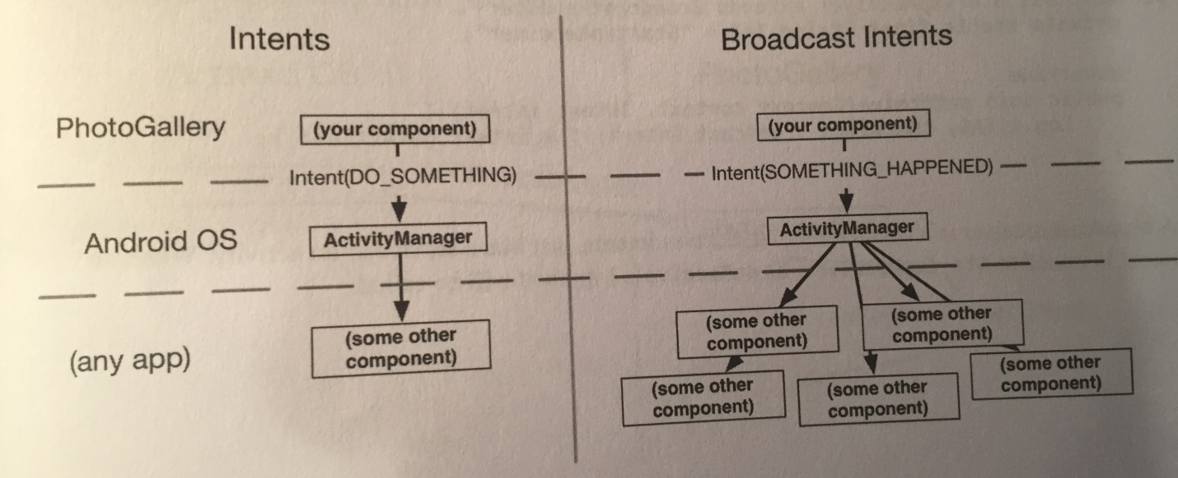

Activities and services should respond to implicit intents whenever they are used as part of a public API. In other circumstances, explicit intents are almost always sufficient. On the other hand, the entire reason broadcast intents exist is to send info to more than one listener. So while broadcast receivers *can* respond to explicit intents, they rarely, if ever, are used this way, because explicit intents have only one receiver.

Our project’s background alarm system works, but it’s not perfect. If the user reboots the device, the alarm will be forgotten.

Apps that perform an ongoing process for the user usually need to wake themselves up after the device is booted. We can detect when boot is completed by listening for a broadcast intent with the BOOT_COMPLETED action.

The system sends out a BOOT_COMPLETED broadcast intent whenever the device is turned on. We can listen for it by creating and registering a standalone broadcast receiver that filters for the appropriate action.

A *standalone receiver* is a broadcast receiver that’s declared in the manifest. Such a receiver can be activated even if your app process is dead. This is different from *dynamic receivers*, which can instead be tied to the lifecycle of a visible app component, like a fragment or activity.

Just like services or activities, broadcast receivers must be registered with the system in order to do anything useful. If the receiver is not registered with the system, the system will not send any intents its way and in turn the receiver’s onReceiver(…) will not get executed as desired.

Before we can register our broadcast receiver, we need to create it. We do so by subclassing android.content.BroadcastReceiver:

public class StartupReceiver

extends BroadcastReceiver {

private static final String TAG =

"StartupReceiver";

@Override

public void onReceive(Context context,

Intent intent){

Log.i(TAG, "Received broadcast intent: " +

intent.getAction());

}

}

A broadcast receiver is a component that receives intents, just like a service or an activity. When an intent is issued to our StartupReceiver, its onReceive(…) method will be called.

We now need to go into the manifest and hook up our StartupReceiver as a standalone receiver:

<uses-permission android:name=

"android.permission.RECEIVE_BOOT_COMPLETED"/>

…

<application …>

…

<receiver android:name=".StartupReceiver">

<intent-filter>

<action android:name=

"android.intent.action.BOOT_COMPLETED"/>

</intent-filter>

</receiver>

</application>

Registering a standalone receiver to respond to an implicit intent works just like registering an activity to do the same. You use the receiver tag with the appropriate intent-filters within. StartupReceiver will be listening for the BOOT_COMPLETED action. This action also requires a permission, so we include an appropriate uses-permission tag as well.

With your broadcast receiver declared in your manifest, it’ll wake up any time a matching broadcast intent is sent, even if your app is not currently running. Upon waking up, the ephemeral broadcast receiver’s onReceieve(Context, Intent) method will be run, and then it will die, as shown below:

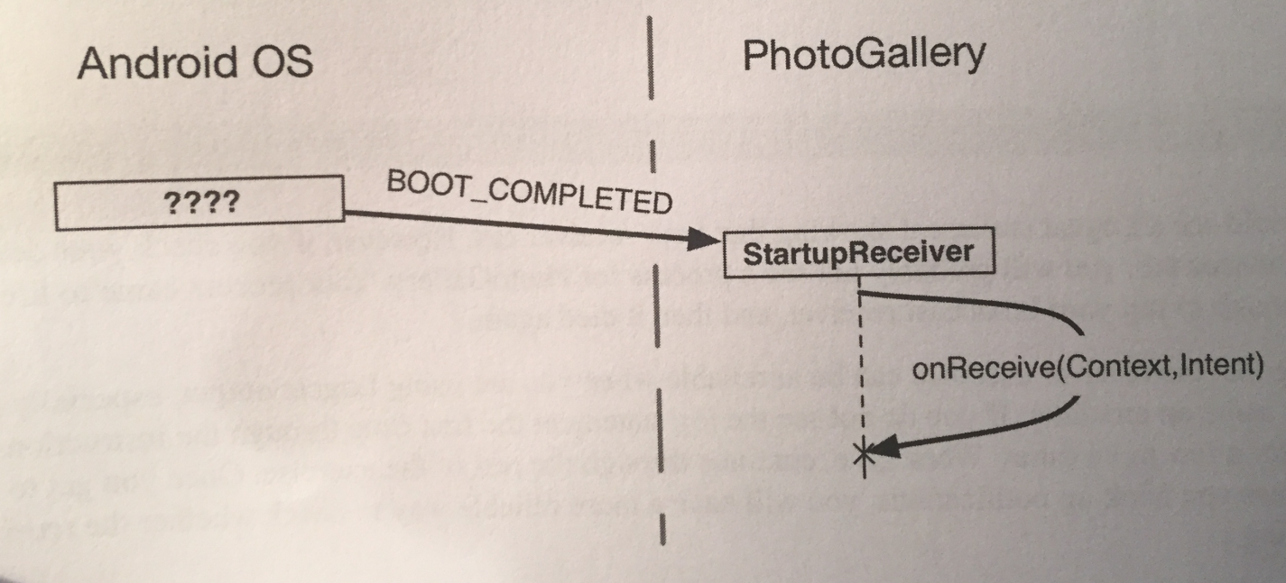

The fact that broadcast receivers live such short lives restricts the things you can do with them. You cannot use any asynchronous APIs, for example, or register any listeners, because your receiver will not be alive any longer than the length of onReceive(…). Also, because onReceive(…) runs on our main thread, we cannot do any heavy lifting inside it. That means no networking or heavy work with permanent storage.

This doesn’t make receivers useless, though. They are invaluable for all kinds of little plumbing code, such as starting an activity or service (as long as we don’t expect a result back) or resetting a recurring alarm when the system finishes rebooting.

What we will do now is set shit up so that when our project reboots, our receiver will put our alarm status to what it was when we shut down. If our alarm was on, the receiver will set it on; if it was off, it will be set off.

Our receiver needs to know whether the alarm should be on or off. We add a preference constant and convenience methods to our QueryPreferences class to store this info in shared resources:

private static final String PREF_IS_ALARM_ON =

“isAlarmOn”;

…

public static boolean isAlarmOn(Context context){

return PreferenceManager

.getDefaultSharedPreferences(context)

.getBoolean(PREF_IS_ALARM_ON, false);

}

public static void setAlarmOn(Context context,

boolean isOn){

PreferenceManager

.getDefaultSharedPreferences(context)

.edit()

.putBoolean(PREF_IS_ALARM_ON, isOn)

.apply();

}

Next, we need to update PollService.setServiceAlarm(…) to write to shared preferences when the alarm is set:

public static void setServiceAlarm(Context context,

Boolean isOn){

…

**QueryPreferences.setAlarmOn(context, isOn);**

}

Then, our StartupReceiver can use it to turn the alarm to the setting it was before it was shut off, at boot time:

@Override

public void onReceive(Context context, Intent intent){

Log.i(TAG, "Received broadcast intent: " +

intent.getAction());

**boolean isOn = QueryPreferences.isAlarmOn(context);**

**PollService.setServiceAlarm(context, isOn);**

}

Now, let’s look at something else we could do. Our notifications in our project work great, but they are sent even when the user already has the application open.

We can fix this problem with broadcast intents, too. But they will work in a completely different way.

First, we will send (and receive) our own custom broadcast intent (and ultimately will lock it down so it can be received by components in our application only). Second, we will register a receiver for our broadcast intent dynamically in code, rather than in the manifest. Finally, we’ll send an ordered broadcast to pass data along a chain of receivers, ensuring a certain receiver is run last.

The first thing we do is send the broadcast intent. Specifically, we will send a broadcast notifying interested components that a new search results notification is ready to post.

To send a broadcast intent, create an intent and pass it into sendBroadcast(Intent). In this case, we will want it to broadcast an action we define, so we define an action constant as well:

Add these items in the PollService class:

**public static final String ACTION_SHOW_NOTIFICATION = "com.bignerdranch.android.photogallery**

**.SHOW_NOTIFICATION";**

…

protected void onHandleIntent(Intent intent){

…

else{

…

notificationManager.notify(0, notification);

**sendBroadcast(**

**new Intent(ACTION_SHOW_NOTIFICATION));**

}

…

}

We send our broadcast intent when we send our notification. This makes our app broadcast every time new search results are available.

Now we need a receiver for our ACTION_SHOW_NOTIFICATION broadcast intent.

We could create a standalone receiver and hook it up to the manifest, but this is not wise in our case. Here, we want our project to receive the intent only while it’s alive. A standalone receiver declared in the manifest would always receive the intent and would need some other way of knowing that a PhotoGalleryFragment is alive (which is VERY hard in Android to do).

Instead, we use a *dynamic broadcast receiver*. A dynamic receiver is registered in code, not the manifest. We register the receiver by calling registerReceiver(BroadcastReceiver, IntentFilter) and unregister it by calling unregisterReceiver(BroadcastReceiver).

The receiver itself is typically defined as an inner instance, like a button-click listener. However, since we need the same instance in registerReceiver(…) and unregisterReceiver(…), we will need to assign the receiver to an instance variable.

To do all of this, we first create a new abstract class called VisibleFragment, with Fragment as its superclass. This class will be a generic fragment that hides foreground notifications:

public abstract class VisibleFragment extends Fragment{

private static final String TAG =

"VisibleFragment";

@Override

public void onStart(){

super.onStart();

IntentFilter filter =

new IntentFilter(

PollService.ACTION_SHOW_NOTIFICATION);

getActivity()

.registerReceiver(mOnShowNotification,

filter);

}

public void onStop(){

super.onStop();

getActivity()

.unregisterReceiver(mOnShowNotification);

}

private BroadcastReceiver mOnShowNotification =

new BroadcastReceiver() {

@Override

public void onReceive(Context context,

Intent intent) {

Toast.makeText(getActivity(),

"Got a broadcast: " +

intent.getAction(),

Toast.LENGTH_LONG)

.show();

}

};

}

Note that to pass in an IntentFilter, we have to create one in code. Our IntentFilter here is identical to the filter specified in the following XML:

<intent-filter>

<action android:name="

com.bignerdranch.android.photogallery

.SHOW_NOTIFICATION "/>

</intent-filter>

Any IntentFilter we can express in XML can also be expressed in code this way. Just call addCategory(String), addAction(String), addDataPath(String), and so on to configure your filter.

When we use dynamically generated broadcast receivers, we must also take care to clean them up. Typically, if we register a receiver in a startup lifecycle method, we call Context.unregisterReceiver(BroascastReceiver) in the corresponding shutdown method. Here, we register inside onStart() and unregister inside onStop(). If instead we registered inside onActivityCreated(…), we would unregister inside onActivityDestroyed(…).

***Be careful with onCreate(…) and onDestroy() in retained fragments. getActivity() will return different values in onCreate(…) and onDestroy() if the screen has rotated. If we want to register/unregister in Fragment.onCreate(…) and Fragment.onDestroy(), we should use getActivity().getApplicationContext() instead.**

Now, we simply make our PhotoGalleryFragment class be a subclass of our newly created VisibleFragment class and we’re all good to go!

One issue with a broadcast like the one we’ve created is that anyone on the system can listen to it or trigger our receivers. You are usually not going to want either of those things to happen.

We can stop this from occurring in a few ways. One way is to declare in our manifest file that the receiver is internal to our app by adding an android:exported=”false” attribute to our receiver tag. This will prevent it from being visible to other applications on the system.

Another way is to create our own permission by adding a permission tag to our manifest file. This is what we’ll do.

We first declare and acquire our own permission in our manifest file:

…

<permission

android:name=

"com.bignerdranch.android.photogallery.PRIVATE"

android:protectionLevel="signature"/>

…

<uses-permission

android:name=

"com.bignerdranch.android.photogallery.PRIVATE"/>

…

Notice that you define a custom permission with a *protection level* of signature. You will learn more about protection levels in a sec. The permission itself is a simple string, just like intent actions, categories, and system permissions we have used. We must always acquire a permission to use it, even when we define it ourselves.

The constant we defined is very important because we need to use it many other places, so be sure we copy and paste it the same.

Now, we use our permission by defining a corresponding constant in code and then passing it into our sendBroadcast(…) call in the PollService class:

**public static final String PERM_PRIVATE =**

**"com.bignerdranch.android.photogallery.PRIVATE";**

…

protected void onHandleIntent(Intent intent){

…

**sendBroadcast(new Intent(ACTION_SHOW_NOTIFICATION),**

**PERM_PRIVATE);**

**}**

…

}

To use our permission, we must pass it as a parameter to sendBroadcast(…). Using the permission here ensures that any application must use that same permission to receive the intent we’re sending.

What about the broadcasting end of things? Someone could create their own broadcast intent to trigger your broadcast receiver. You can fix that by passing in your permission in registerReceiver(…), too (in our case this happens in the VisibleFragment class):

public void onStart(){

…

**getActivity().registerReceiver(mOnShowNotification,**

**filter, PollService.PERM_PRIVATE, null);**

}

Now our app is the only app that can trigger that receiver.

Every custom permission has to specify a value for android:protectionLevel. Your permission’s protectionLevel tells Android how it should be used. In our case, we used a protectionLevel of signature.

The signature protection level means that if another app wants to use our permission, it has to be signed with the same key as the application. This is usually the right choice for permissions we use internally in our app. Because other developers don’t have our key, they cannot get access to anything this permission protects. Plus, because we *do* have our own key, we can use this permission in any other app we decide to write later.

Here are all the values for protectionLevel:

* normal: This is for protecting app functionality that will not do anything dangerous like accessing secure personal data or sending data to the Internet.
  + The user can see the permission before choosing to install the app, but is not explicitly asked to grant it.
  + RECEIVE_BOOT_COMPLETED uses this permission level, and so does the permission that lets your app vibrate the user’s device.
* dangerous: This is for everything you would not use normal for - accessing personal data, sending and receiving things from network interfaces, accessing hardware that might be used to spy on the user, or anything else that could cause real problems.
  + The Internet permission, camera permission, and contacts permission all fall under this category. Starting in Marshmallow, dangerous permissions require that you call requestPermission(…) at runtime to ask the user to explicity grant your app permission. We will go over this in Chapter 33.
* signature: The system grants this permission if the app is signed with the same certificate as the declaring application, and denies it otherwise. If the permission is granted, the user is not notified.
  + This is for functionality that’s internal to an app - as a developer, because we have the certificate and only apps signed with the same certificate can use the permission, we have control over who uses the permission.
  + We used it here to prevent anyone else from seeing our broadcasts. If we wanted, we could write another app that listens to them, too.
* signatureOrSystem: This is like signature, but it also grants permission to all packages in the Android system image. This is for communicating with apps built into the system image. If permission is granted, the user is not notified.
  + Most developers don’t need to use this permission.

Now we need to ensure our dynamically registered receiver always receives the PollService.ACTION_SHOW_NOTIFICATION broadcast before any other receivers and that it modifies the broadcast to indicate that the notification should not be posted.

Right now we’re sending our own personal private broadcast, but so far we only have one-way communication. Shit looks like the figure below:

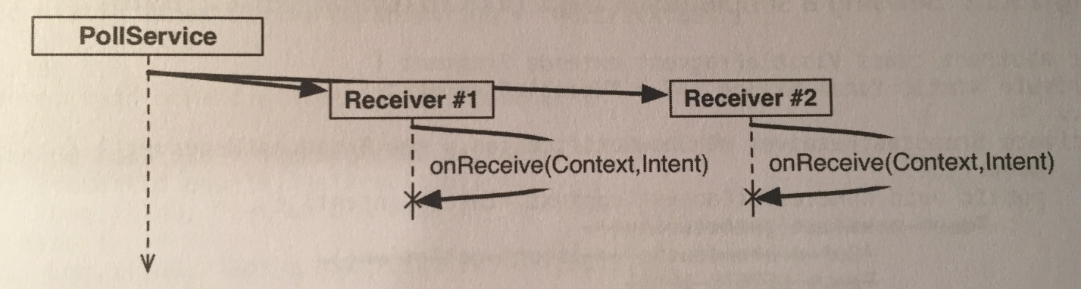

This is because a regular broadcast intent is conceptually received by everyone at the same time. In reality, because onReceive(…) is called on the main thread, our receivers are not actually executed concurrently.

However, it’s not possible to rely on their being executed in any particular order or to know when they have all completed execution. As a result, it’s a hassle for the broadcast receivers to communicate with each other or for the sender of the intent to receive info from the receivers in a certain order.

We can implement two-way communication using an *ordered broadcast intent*. Ordered broadcasts allow a sequence of broadcast receivers to process a broadcast intent in order. They also allow the sender of a broadcast to receive results from the broadcast’s recipients by passing in a special broadcast receiver, called the *result receiver*.

This looks like so:

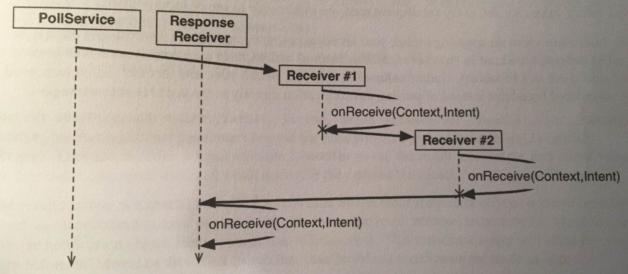

On the receiving side, this looks mostly the same as a regular broadcast. But we get an additional tool: a set of methods used to change the return value of our receiver. Here, we want to cancel the notification. This can be communicated by use of a simple integer result code. We will use the setResultCode(int) method to set the result code to Activity.RESULT_CANCELED.

To implement this, we modify our BroadcastReceiver in VisibleFragment’s class to tell the sender of ACTION_SHOW_NOTIFICATION whether the notification should be posted. This information will also be sent to any other broadcast receivers along the chain:

private BroadcastReceiver mOnShowNotification =

new BroadcastReceiver() {

@Override

public void onReceive(Context context,

Intent intent) {

**//if we receive this, we're visible, so**

**//cancel the notification**

**Log.i(TAG, "canceling notification");**

**setResultCode(Activity.RESULT_CANCELED);**

}

};

Because all we need to do is signal yes or no, we only need the result code. If we need to return more complicated data, we can use setResultData(String) or setResultExtras(Bundle). And if we want to set all three values, we can call setResult(int, String, Bundle). Once our return values are set here, every subsequent receiver will be able to see or modify them.

For those methods to do anything useful, our broadcast needs to be ordered. We write a new method to send an ordered broadcast in the PollService class. This method will package up a Notification invocation and send it out as part of the broadcast. Update onHandleIntent(…) to call our new method and, in turn, send out an ordered broadcast instead of posting the notification directly to the NotificationManager:

public static final String REQUEST_CODE = "REQUEST_CODE";

public static final String NOTIFICATION = "NOTIFICATION";

…

protected void onHandleIntent(Intent intent){

…

else{

…

**showBackgroundNotification(0, notification);**

}

…

}

**private void showBackgroundNotification(**

**int requestCode, Notification notification){**

**Intent i = new Intent(ACTION_SHOW_NOTIFICATION);**

**i.putExtra(REQUEST_CODE, requestCode);**

**i.putExtra(NOTIFICATION, notification);**

**sendOrderedBroadcast(i, PERM_PRIVATE, null, null,**

**Activity.RESULT_OK, null, null);**

**}**

Context.sendOrderedBroadcast(Intent, String, BroadcastReceiver, Handler, int, String, Bundle) has five additional parameters beyond the ones we used in sendBroadcast(Intent, String). They are, in order: a *result receiver*, a Handler to run the result receiver on, and then initial values for the result code, result data, and result extras for the ordered broadcast.

The result receiver is a special receiver that runs after all the other recipients of our ordered broadcast intent. In other circumstances, we would be able to use the result receiver to receive the broadcast and post the notification object. Here, though, that won’t work. This broadcast intent will often be sent right before PollService dies, which means that our broadcast result receiver might be dead too.

Thus, our final broadcast receiver will need to be a standalone receiver, and we’ll need to enforce that it runs after the dynamically registered receiver by different means.

**This final broadcast receiver will post our notification if our dynamically registered receiver in our VisibleFragment class didn’t cancel it first. This means that our app isn’t open and we should post the notification.**

First, we create a new BroadcastReceiver subclass called NotificationReceiver:

public class NotificationReceiver

extends BroadcastReceiver {

private static final String TAG =

"NotificationReceiver";

@Override

public void onReceive(Context c, Intent i){

Log.i(TAG, "received result: " +

getResultCode());

if(getResultCode() != Activity.RESULT_OK){

//a foreground activity cancelled the

//broadcast

return;

}

int requestCode =

i.getIntExtra(PollService.REQUEST_CODE, 0);

Notification notification = (Notification)

i.getParcelableExtra(

PollService.NOTIFICATION);

NotificationManagerCompat notificationManager

= NotificationManagerCompat.from(c);

notificationManager.notify(requestCode,

notification);

}

}

Next, we register our new receiver in the manifest and assign it a priority. To ensure our NotificationReceiver class defined above receives the broadcast after our dynamically registered receiver (so it can check to see whether it should post the notification or not), we need to set a low priority for NotificationReceiver. We give it a priority of -999 so that it runs last. This is the lowest-defined priority possible (-1000 and below are reserved).

Also, since this receiver is only used by our application, we don’t need it to be externally visible. We set android:exported=”false” to keep this receiver to ourselves:

<receiver android:name=".NotificationReceiver"

android:exported="false">

<intent-filter android:priority="-999">

<action

android:name=

"com.bignerdranch.android.photogallery

.SHOW_NOTIFICATION"/>

</intent-filter>

</receiver>

Now our notifications will no longer appear when we have an app in the foreground.

So what do you do if you want a broadcast intent to kick off a longer-running task than the restrictions of the main run loop allow?

You have two options. The first is to put that work into a service instead, and start the service in your broadcast receiver’s small window of opportunity. This is the method the book recommends. A service can take as long as it needs to service a request. It can queue up multiple requests and service them in order or otherwise manage requests as it sees fit.

The second option is to use the BroadcastReceiver.goAsync() method. This method returns a BroadcastReceiver.PendingResult object, which can be used to provide a result at a later time. So you could give that PendingResult to an AsyncTask to perform some longer running work, and then respond to the broadcast by calling methods on PendingResult.

There is one downside to using the goAsync() method: it’s less flexible. You still have to service the broadcast within 10 seconds or so, and you have fewer architectural options that you do with a service.

Of course, goAsync() has one huge advantage: you can set results for ordered broadcasts with it. If you really need that, nothing else will do. Just make sure you don’t take too long.

The book then talks about a way to broadcast intents in a local fashion, within your app’s process only, instead of the global fashion we did in this chapter. You can do this local broadcast with an *event bus*.

An *event bus* operates on the idea of having a standard bus, or stream of data, that components within your app can subscribe to. When an event is posted to the bus, subscribed components will be activated and have their callback code executed.

The book recommends using third-party libraries to implement an event bus, and gives links to a few of them along with some explanations of them on pages 578-579. One of these libraries is RxJava.

**Chapter 30 - Browsing the Web and WebView:**

This chapter goes over displaying web content from your app.

The first thing we need to do is update our GalleryItem model class to create a URL from our model data so we can access the web page of the photo we want.

This is done on page 583.

Then we change parseItems(…) in our FlickrFetchr class to read in the owner attribute we need to make the URL of the photo:

item.setOwner(photoJsonObject.getString("owner"));

The first way that we’ll display a photo page is to open the browser app already on our phone. To do this we simply fire an implicit intent. This intent will start up the browser with our photo URL.

The first step is to make our app listen to presses on an item in the RecyclerView. We update PhotoGalleryFragment’s PhotoHolder to implement a click listener that will fire an implicit intent, as well as a way to bind a gallery item to this view holder so we can get the URL from it:

private class PhotoHolder

extends RecyclerView.ViewHolder

**implements View.OnClickListener**{

private ImageView mItemImageView;

**private GalleryItem mGalleryItem;**

public PhotoHolder(View itemView){

super(itemView);

mItemImageView = (ImageView) itemView

.findViewById(

R.id.fragment_photo_gallery_image_view);

**itemView.setOnClickListener(this);**

}

public void bindDrawable(Drawable drawable){

mItemImageView.setImageDrawable(drawable);

}

**public void bindGalleryItem(**

**GalleryItem galleryItem){**

**mGalleryItem = galleryItem;**

**}**

**@Override**

**public void onClick(View v){**

**Intent i = new Intent(Intent.ACTION_VIEW,**

**mGalleryItem.getPhotoPageUri());**

**startActivity(i);**

**}**

}

Next, we bind the PhotoHolder to a GalleryItem in PhotoAdapter.onBindViewHolder(…):

public void onBindViewHolder(PhotoHolder photoHolder,

int position){

GalleryItem galleryItem =

mGalleryItems.get(position);

**photoHolder.bindGalleryItem(galleryItem);**

…

}

That’s it. The implicit intent will bring up the web browser app with the web page URL we gave it.

Just opening the web browser is very unprofessional. It would be better to show web pages within your app. When you want to present web content within your own UI, you use the WebView class.

The first thing we need to do is create a new activity and fragment to display the WebView. We define a layout file that defines a WebView component first. We will be filling in the contents of the WebView later.

Next, we create a new fragment class called PhotoPageFragment that extends VisibleFragment. This new class will inflate the layout file, extract our WebView from it, and forward along the URL to display as a fragment argument.

The code for this fragment class is very simple and is on the top of page 587.

Next, we create the activity class called PhotoPageActivity that will hold this fragment, and have this new activity class extend SingleFragmentActivity:

public class PhotoPageActivity

extends SingleFragmentActivity {

public static Intent newIntent(Context context,

Uri photoPageUri){

Intent i = new Intent(context,

PhotoPageActivity.class);

i.setData(photoPageUri);

return i;

}

@Override

protected Fragment createFragment(){

return PhotoPageFragment.newInstance(

getIntent().getData());

}

}

Here you can see we set the data this intent is operating on to point to the uri of the photo page in newIntent(…), and we create our fragment by getting this data from our intent in createFragment().

Next, we switch up our code in PhotoGalleryFragment to launch our new activity instead of the implicit intent to open the web browser:

private class PhotoHolder

extends RecyclerView.ViewHolder

implements View.OnClickListener{

…

@Override

public void onClick(View v){

**Intent i = PhotoPageActivity**

**.newIntent(getActivity(),**

**mGalleryItem.getPhotoPageUri());**

…

}

}

Finally, we add our new activity to the manifest:

<activity android:name=".PhotoPageActivity"/>

Now, when we run our project and press a pic, a blank WebView appears.

Ok, now we can get to the important shit. We need to do three things to make our WebView successfully display a page. The first one is to tell it what URL to load.

The second thing we need to do is enable JavaScript. By default, JavaScript is off. You don’t have to turn it on but every web-page uses it so it’s a good idea.

Finally, we need to provide a default implementation of a class called WebViewClient. WebViewClient is used to respond to rendering events on a WebView (we’ll discuss it more shortly).

Let’s first take a look at the code to do all this (it’s in PhotoPageFragment’s class):

@Override

public View onCreateView(LayoutInflater inflater,

ViewGroup container, Bundle savedInstanceState){

View v =

inflater.inflate(R.layout.fragment_photo_page,

container, false);

mWebView = (WebView)v.findViewById(

R.id.web_view);

**mWebView.getSettings().setJavaScriptEnabled(true);**

**mWebView.setWebViewClient(new WebViewClient());**

**mWebView.loadUrl(mUri.toString());**

return v;

}

Loading a URL has to be done after configuring the WebView, so we do that last. Before that, we turn JavaScript on by calling getSettings() to get an instance of WebSettings and calling WebSettings.setJavaScriptEnabled(true).

WebSettings is the first of three ways you can modify your WebView. It has various properties you can set, like the user agent string and text size.

After that, we add a WebViewClient to our WebView. To understand why we do that, let’s look at what happens without a WebViewClient.

A new URL can be loaded in a couple of different ways. The page can tell you to go to another URL on its own (a redirect), or you can click on a link. Without a WebViewClient, WebView will ask the activity manager to find an appropriate activity to load the new URL.

This is **not** what you want to have happen, because many sites (like Flickr) redirect to a mobile version of the site, which destroys the purpose of using a WebView to display the content, if it’s going to be redirected to open the mobile version of the web page.

If, on the other hand, you provide your own WebViewClient to your WebView, the process works differently. Instead of asking the activity manager what to do, it asks your WebViewClient, and in the default WebViewClient implementation, it says, “Go to the URL yourself!” Therefore, the page will appear in your WebView.

So, if you press an item now, you should see the item’s photo page displayed in youe WebView!

Let’s now spruce shit up a bit by adding a progress bar and updating the toolbar’s subtitle with the title of the loaded page. The first thing we do is modify the our constraints and design to have a ProgressBar and fix the WebView to use it. The design instructions to do this are defined on page 590.

To hook up the ProgressBar, we will use the second callback on WebView: WebChromeClient. WebViewClient is an interface for responding to rendering events. WebChromeClient is an event interface for reacting to events that should change elements of *chrome* around the browser. This includes JavaScript alerts, favicons, and of course updates for loading progress and the title of the current page.

We hook shit up in onCreateView(…) in the PhotoPageFragment class:

public class PhotoPageFragment extends VisibleFragment{

…

**private ProgressBar mProgressBar;**

…

@Override

public View onCreateView(LayoutInflater inflater,

ViewGroup container,

Bundle savedInstanceState){

…

**mProgressBar = (ProgressBar)v.findViewById(**

**R.id.progress_bar);**

**//WebChromeClient reports in range 0-100**

**mProgressBar.setMax(100);**

…

**mWebView.setWebChromeClient(**

**new WebChromeClient() {**

**public void onProgressChanged(**

**WebView webView, int newProgress) {**

**if (newProgress == 100) {**

**mProgressBar**

**.setVisibility(View.GONE);**

**}**

**else { mProgressBar**

**.setVisibility(View.VISIBLE);**

**mProgressBar**

**.setProgress(newProgress);**

**}**

**}**

**public void onReceivedTitle(**

**WebView webView, String title){**

**AppCompatActivity activity =**

**(AppCompatActivity)getActivity();**

**activity.getSupportActionBar()**

**.setSubtitle(title);**

**}**

**});**

…

}

Progress updates and title updates each have their own callback method, onProgressChanged(WebView, int) and onReceivedTitle(WebView, String). The progress you receive from onProgressChanged(WebView, int) is an integer from 0 to 100. If it’s 100, you know that the page is done loading, so you hide the ProgressBar by setting its visibility to View.GONE.

Now we should have a progress bar and subtitle on our web view!

If we try rotating the screen, shit works correctly but WebView has to completely reload the web page. This is because WebView has too much data to save it all out inside onSaveInstanceState(…). It has to start from scratch each time it’s re-created on rotation.

You may think that the fix for this is to retain PhotoPageFragment. However, this would not work, because WebView is part of the view hierarchy and is thus still destroyed and re-created on rotation.

For some classes like this (VideoView is another one), the Android docs recommend that you allow the activity to handle the configuration change itself. This means that instead of the activity being destroyed on rotation, it simply moves its views around to fit the new screen size. As a result, WebView does’t have to reload all of its data.

To tell PhotoPageFragment to handle its own configuration changes, make the following tweak to the manifest file:

<activity android:name=".PhotoPageActivity" **android:configChanges=**

**"keyboardHidden|orientation|screenSize"**/>

This attribute says that if the configuration changes because the keyboard was opened or closed, due to an orientation change, or due to the screen size changing (which also happens when switching between portrait and landscape after Android 3.2), then the activity should handle the change itself.

Why don’t we do this all the time? First off, because resource qualifiers (like a different layout XML with smallest width met on orientation change) no longer work automatically. We instead have to manually reload our view, which is very complicated.

Second, and more important, allowing an activity to handle configuration changes will likely cause you to not bother with overriding Activity.onSavedInstanceState(…) to stash transient UI states. Doing so is still necessary, even if the activity is handling configuration changes on its own, because we still have to worry about death and re-creation in low-memory situations.

One more important note, if we’re supporting pre-KitKat (API 19) devices and rely on WebView, we need to be aware that things will work differently between devices before and devices after API 19, and we need to support compatibility between the two.

**Chapter 31 - Custom Views and Touch Events:**

Android provides many excellent standard views and widgets, but sometimes you need a custom view that presents visuals that are unique to your app.

While there are all kinds of custom views, you can shoehorn them into two broad categories:

* *simple*: A simple view may be complicated inside; what makes it “simple” is that it has no child views. A simple view will almost always perform custom rendering.
* *composite*: Composite views are composed of other view objects. Composite views typically manage child views but do not perform custom rendering. Instead, rendering is delegated to each child view.

There are three steps to follow when creating a custom view:

1. Pick a superclass. For a simple custom view, View is a blank canvas, so it’s the most common choice. For a composite custom view, chose an appropriate layout class, such as FrameLayout.
2. Subclass this class and override the constructors from the superclass.
3. Override other key methods to customize behavior.

We create a new class called BoxDrawingView that extends View, and add two constructors for it:

public class BoxDrawingView extends View {

//used when creating the view in code

public BoxDrawingView(Context context){

this(context, null);

}

//used when inflating the view from XML

public BoxDrawingView(Context context,

AttributeSet attrs){

super(context, attrs);

}

}

We write two constructors because our view could be instantiated in code or from a layout file. Views instantiated from a layout file receive an instance of AttributeSet containing the XML attributes that were specified in XML. Even if we don’t plan on using both constructors, it’s good practice to include them.

Next, we update our fragment XML to use our new view:

<com.bignerdranch.android.draganddraw.BoxDrawingView

xmlns:android=

"http://schemas.android.com/apk/res/android"

android:layout_width="match_parent"

android:layout_height="match_parent" />

You must use BoxDrawingView’s fully qualified class name so that the layout inflater can find it. The inflater works through a layout file creating View instances. If the element name is an unqualified class name, then the inflater looks for a class with that name in the android.view and android.widget packages. If the class lives somewhere else, then the layout inflater will not find it, and your app will crash.

So, for custom classes and other classes that live outside of android.view and android.widget, you must always specify the fully qualified class name.

Now we need a way to listen for and respond to touch events on our custom view.

One way to listen for touch events is to set a touch event listener using the following View method:

public void setOnTouchListener(View.OnTouchListener l);

This method works the same way as setOnClickListener(View.OnClickListener). You provide an implementation of View.OnTouchListener, and your listener will be called every time a touch event happens.

However, because you are subclassing View, you can take a shortcut and override this View method:

public boolean onTouchEvent(MotionEvent event);

This method receives an instance of MotionEvent, a class that describes the touch event, including its location and its *action*. The action describes the stage of the event:

* ACTION_DOWN: user’s finger touches the screen
* ACTION_MOVE: user moves finger on the screen
* ACTION_UP: user lifts finger off the screen
* ACTION_CANCEL: a parent view has intercepted the touch event

In our implementation of onTouchEvent(…), we can check the value of the action by calling the MotionEvent method:

public final int getAction();

Here’s how we do it (this code is in our BoxDrawingView class):

@Override

public boolean onTouchEvent(MotionEvent event){

PointF current =

new PointF(event.getX(), event.getY());

String action = "";

switch(event.getAction()){

case MotionEvent.ACTION_DOWN:

action = "ACTION_DOWN";

break;

case MotionEvent.ACTION_MOVE:

action = "ACTION_MOVE";

break;

case MotionEvent.ACTION_UP:

action = "ACTION_UP";

break;

case MotionEvent.ACTION_CANCEL:

action = "ACTION_CANCEL";

break;

}

Log.i(TAG, action + " at x=" + current.x +

", y=" + current.y);

return true;

}

Notice that you package your X and Y coordinates in a PointF object. You want to pass these two values together. PointF is a container class provided by Android that does this for you.

Now that we’ve got our points being tracked, it’s time to use them to draw boxes. First, we need to define a box, and to do this we need two points: the origin point (where the finger was initially placed) and the current point (where the finger currently is).

To define a box, then, requires keeping track of data from more than one MotionEvent. We will store this data in a Box object, which we create. Code for this is simple and is on page 604.

When the user touches BoxDrawingView, our custom view, a new Box will be created and added to a list of existing boxes:

public class BoxDrawingView extends View {

…

**private Box mCurrentBox;**

**private List<Box> mBoxen = new ArrayList<>();**

…

@Override

public boolean onTouchEvent(MotionEvent event){

PointF current =

new PointF(event.getX(), event.getY());

String action = "";

switch(event.getAction()){

case MotionEvent.ACTION_DOWN:

action = "ACTION_DOWN";

**//reset drawing state**

**mCurrentBox = new Box(current);**

**mBoxen.add(mCurrentBox);**

break;

case MotionEvent.ACTION_MOVE:

action = "ACTION_MOVE";

**if(mCurrentBox != null){**

**mCurrentBox.setCurrent(current);**

**invalidate();**

**}**

break;

case MotionEvent.ACTION_UP:

action = "ACTION_UP";

**mCurrentBox = null;**

break;

case MotionEvent.ACTION_CANCEL:

action = "ACTION_CANCEL";

**mCurrentBox = null;**

break;

}

Log.i(TAG, action + " at x=" + current.x +

", y=" + current.y);

return true;

}

}

Any time an ACTION_DOWN motion event is received, we set mCurrentBox to be a new Box with its origin as the event’s location. This new Box is added to the list of boxes.

As the user’s finger moves around the screen, we update mCurrentBox.mCurrent. Then, when the touch is canceled or when the user’s finger leaves the screen, we null out mCurrentBox to end our draw motion. The Box is complete, and it’s stored safely in the list but will no longer be updated about motion events.

We call invalidate() in the case of ACTION_MOVE. This forces BoxDrawingView to redraw itself so that the user can see the box while dragging across the screen. This brings us to our next step: drawing the boxes on the screen.

When an application is launched, all of its views are *invalid*. This means that they have not drawn anything to the screen. To fix this situation, Android calls the top-level View’s draw() method. This causes that view to draw itself, which causes its children to draw themselves, and those children’s children to draw themselves. etc. down the hierarchy. When all the views in the hierarchy have drawn themselves, the top-level View is no longer invalid.

To hook into this drawing, we override the following View method:

protected void onDraw(Canvas canvas);

The call to invalidate() that we made in response to ACTION_MOVE in onTouchEvent(MotionEvent) makes the BoxDrawingView invalid again. This causes it to redraw itself and will cause

onDraw(Canvas canvas) to be called again.

Now, let’s consider the Canvas parameter. Canvas and Paint are the two main drawing classes in Android:

* The Canvas class has all the drawing operations we perform. The methods we call on Canvas determine where and what we draw - a line, a circle, a word, a rectangle.
* The Paint class determines how these operations are done. The methods we call on Paint specify characteristics - whether the shape is filled, which font text is drawn in, and what color lines are.

In our custom view class, we create two Paint objects in our XML constructor:

…

**private Paint mBoxPaint;**

**private Paint mBackgroundPaint;**

…

public BoxDrawingView(Context context,

AttributeSet attrs){

super(context, attrs);

**//paint the boxes a nice semitransparent red (ARGB)**

**mBoxPaint = new Paint();**

**mBoxPaint.setColor(0x22ff0000);**

**//paint the background off-white**

**mBackgroundPaint = new Paint();**

**mBackgroundPaint.setColor(0xfff8efe0);**

}

Armed with paint, we can now draw our boxes on the screen. We override onDraw(Canvas) in our custom view class:

@Override

protected void onDraw(Canvas canvas){

//fill the background

canvas.drawPaint(mBackgroundPaint);

for(Box box : mBoxen){

float left = Math.min(box.getOrigin().x,

box.getCurrent().x);

float right = Math.max(box.getOrigin().x,

box.getCurrent().x);

float top = Math.min(box.getOrigin().y,

box.getCurrent().y);

float bottom = Math.max(box.getOrigin().y,

box.getCurrent().y);

canvas.drawRect(left, top, right, bottom,

mBoxPaint);

}

}

The first part of the code fills the canvas with a backdrop to draw our boxes with off-white paint in their background.

Then, for each box in our list of boxes we determine what the left, right, bottom, and top of the box should be by looking at the two points we have for the box. After calculating these values, we call Canvas.drawRect(…) to draw a red rectangle onto the screen.

That’s it! We should be able to draw rectangles on screen now.

**Chapter 32 - Property Animation:**

This chapter looks into making our interface move, by animating its elements into new positions.

First we get our scene set up. We create colors and an oval shape for the sun by adding the colors to the colors.xml file and the oval shape to a new res/drawable/sun.xml file. We also build our layout file combining all the elements in our scene together. This layout file is big but simple and is shown on page 610.

Now that our scene is set up, we can make parts of it move around.

To do this, we first pull a couple of its views into fields of the fragment where the animation will be done. For example:

**private View mSceneView;**

**private View mSunView;**

**private View mSkyView;**

@Override

public View onCreateView(…){

…

**mSceneView = view;**

**mSunView = view.findViewById(R.id.sun);**

**mSkyView = view.findViewById(R.id.sky);**

…

}

Now that we have those, we can write code to animate them. We translate the location of a view from one place to another. We write this first step in a new method called startAnimation():

private void startAnimation(){

float sunYStart = mSunView.getTop();

float sunYEnd = mSkyView.getHeight();

}

The getTop() method is one of four methods on View that return the *local layout rect* for that view: getTop(), getBottom(), getRight(), and getLeft(). A view’s local layout rect is the position and size of that view in relation to its parent, as determined when the view was laid out.

It’s possible to change the location of the view on screen by modifying these values, but it’s not recommended. They are reset every time a layout pass occurs, so they tend to not hold their value.

getHeight() is the same as getBottom() - getTop().

Now that we have where the animation will start and end, we can create and run an ObjectAnimator to perform it:

private void startAnimation(){

float sunYStart = mSunView.getTop();

float sunYEnd = mSkyView.getHeight();

**ObjectAnimator heightAnimator = ObjectAnimator**

**.ofFloat(mSunView, "y", sunYStart, sunYEnd)**

**.setDuration(3000);**

**heightAnimator.start();**

}

Then we hook up startAnimation() so that it’s called every time the user presses anywhere in the scene:

public View onCreateView(LayoutInflater inflater,

ViewGroup container, Bundle savedInstanceState){

…

**mSceneView.setOnClickListener(**

**new View.OnClickListener(){**

**@Override**

**public void onClick(View v){**

**startAnimation();**

**}**

**});**

return view;

}

Now everything should animate correctly.

Here’s how it works: ObjectAnimator is a *property animator*. Instead of knowing specifically about how to move a view around the screen, a property animator repeatedly calls property setter methods with different values.

The following method call creates an ObjectAnimator:

ObjectAnimator.ofFloat(mSunView, “y”, 0, 1);

When that ObjectAnimator is started, it’ll repeatedly call mSunView.setY(float) with values starting at 0 and moving up to 1.

This process of finding values in between a starting and ending point is called *interpolation*. Between each interpolated value, a little time will pass, which makes it look like the view is moving.

Now, property animators are great, but with them alone it wouldn’t be possible to animate a view easily. Modern Android property animation works in concert with *transformation properties*.

Our view has a local layout rect, which is the position and size it’s assigned from the layout process. We can move the view around after that by setting additional properties on the view, called transformation properties.

We have three properties to rotate the view (rotation, pivotX, and pivotY):

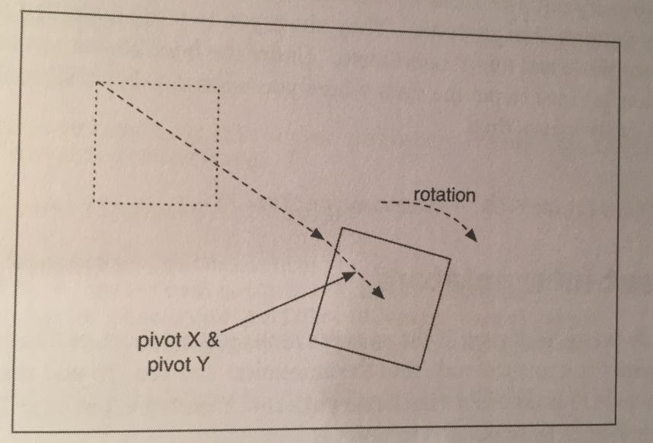

two properties to scale the view vertically and horizontally (scaleX and scaleY):

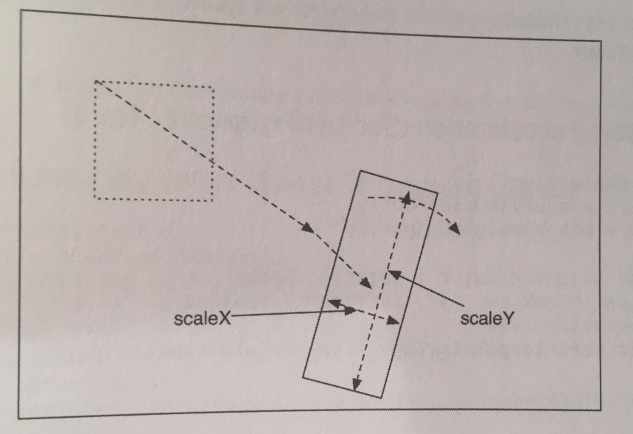

and two to move the view around the sreen (translateX and translateY):

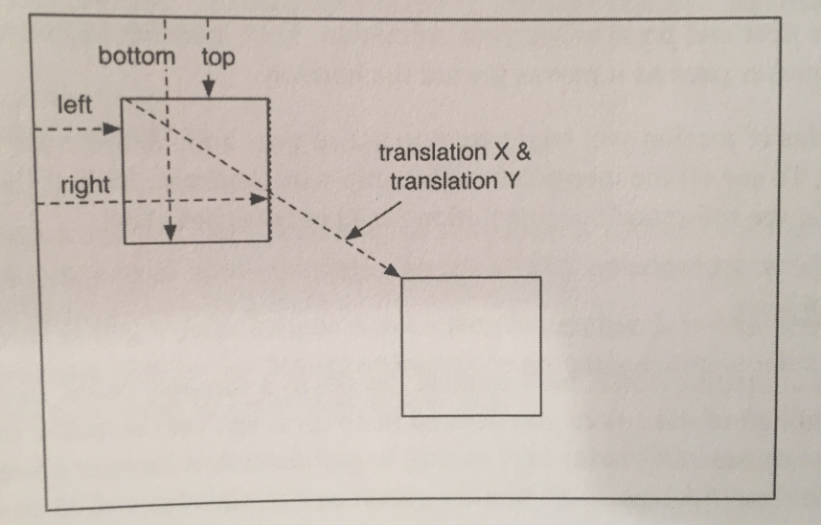

All of these properties have getters and setters.

Animations need to be smoothly done. They need a sensation of acceleration. To add this sensation, all we need to do is use a TimeInterpolator. TimeInterpolator has one role: to change the way your animation goes from point A to point B. Here’s an example of using one:

ObjectAnimator heightAnimator = ObjectAnimator

.ofFloat(mSunView, "y", sunYStart, sunYEnd)

.setDuration(3000);

**heightAnimator.setInterpolator(**

**new AccelerateInterpolator());**

There are a lot of styles of motion you might want to use in your app, so there are a lot of different TimeInterpolators. Check the docs for them.

Sometimes when we animate something, like color, ObjectAnimator doesn’t know how to properly interpolate between the values we give it. It needs help. To provide this help, we can provide a subclass of TypeEvaluator to fix things. A TypeEvaluator is an object that tells ObjectAnimator what value is, say, a quarter of the way between a start value and end value. Android provides a subclass of TypeEvaluator called ArgbEvaluator that is great for interpolating colors:

ObjectAnimator sunsetSkyAnimator =

ObjectAnimator.ofInt(mSkyView,

"backgroundColor", mBlueSkyColor,

mSunsetSkyColor)

.setDuration(3000);

sunsetSkyAnimator.setEvaluator(new ArgbEvaluator());

Let’s now talk about playing animations together. If all we need to do is kick off a few animations at the same time, then we can just call start() on them all at the same time. They will animate in sync with one another.

For more sophisticated shit, this won’t work. We could use AnimatorListener, which tells you when an animation completes. So we could write a listener that waits until the end of the first animation, at which time we can start the second animation. This is a huge hassle, though, and requires a lot of listeners.

It’s much easier to use an AnimatorSet. To use an AnimatorSet, delete any animations you call with start(), and then build and run an AnimatorSet:

AnimatorSet animatorSet = new AnimatorSet();

animatorSet

.play(heightAnimator)

.with(sunsetSkyAnimator)

.before(nightSkyAnimator);

animatorSet.start();

An AnimatorSet is nothing more than a set of animations that can be played together. There are a few ways to build one, but the easiest way is to use the play(Animator) method we used above.

When you call play(Animator), you get an AnimatorSet.Builder, which allows you to build a chain of instructions. The Animator passed into play(Animator) is the “subject” of the chain. So the chain of calls we wrote above could be described as: “Play heightAnimator with sunsetSkyAnimator; also, play heightAnimator before nightSkyAnimator.”

For complicated AnimatorSets, you may find it necessary to call play(Animator) a few times, which is perfectly cool.

Android 4.4 introduced a new transitions framework, which enables fancy transitions between view hierarchies. We could define a transition that explodes a small view in one activity into a zoomed-in version of that view in another activity.

The basic idea of the transitions framework is that we can define scenes, which represent the state of a view hierarchy at some point, and transitions between those scenes. Scenes can be described in XML layout files, and transitions can be described in animation XML files.

This beats the property animation framework when animating a layout as it’s coming onto the screen, as the property animation framework can’t do that without a lot of work.

**Javid if you need this look into it.**

**Chapter 33 - Locations and Play Services:**

In this chapter we’ll look at finding out your current location in your app. This simple job is more interesting that you might expect. It requires integrating with Google’s set of libraries that live outside the standard library set, called Google Play Services.

The book does a ton of setup code on pages 623-629. After that, we’re ready to really start our app.

In order to use Google Play Services you must have the Play Store App installed and must ship your product through the Google Play Store.

Google’s locations service is called Fused Location Provider. To get our location using Fused Location Provider, we need to use Google Play Services. To get those up and running, we will need to add a few standard bits of boilerplate code.

First, we need to add the Google Play Services library as a dependency. The services themselves live in the Play app, but the Play Services library contains all the code to interface with them.

The book shows you how to make this dependency on page 629.

Next, we need to verify that Play services is available. Since the working parts live in another app on our device, the Play Services library is not always guaranteed to be working. The library makes it easy to verify this. Here’s the code to do so, placed in our main activity class (LocatrActivity):

private static final int REQUEST_ERROR = 0;

…

@Override

protected void onResume(){

super.onResume();

GoogleApiAvailability apiAvailability =

GoogleApiAvailability.getInstance();

int errorCode =

apiAvailability

.isGooglePlayServicesAvailable(this);

if(errorCode != ConnectionResult.SUCCESS){

Dialog errorDialog = apiAvailability

.getErrorDialog(this,

errorCode, REQUEST_ERROR,

new DialogInterface.OnCancelListener(){

@Override

public void onCancel(

DialogInterface dialog){

//leave if services are unavailable

finish();

}

});

errorDialog.show();

}

}

Normally we would not use a bare Dialog like this. However, in this case there’s no need to defend against startup and rotation issues. The errorCode value will be the same if the user starts up again and/or rotates, so the Dialog will be displayed again correctly.

Now, we will also need some permissions for our app to work. There are two relevant permissions: android.permission.ACCESS_FINE_LOCATION, and android.permission.ACCESS_COARSE_LOCATION. Fine location is the GPS radio; coarse location is derived from cell towers or WiFi access points.

It’s a good idea to put in both permissions, use the fine one, and have the coarse one as a backup.

Add these permissions to our manifest, along with an Internet permission because we’re going to query Flickr in this project:

<uses-permission android:name="android.permission.ACCESS_FINE_LOCATION"

/>

<uses-permission android:name="android.permission.ACCESS_COARSE_LOCATION"/>

<uses-permission android:name="android.permission.INTERNET"/>

Both FINE_LOCATION and COARSE_LOCATION are dangerous permissions. That means that, unlike INTERNET, this manifest code is not enough. You must also make a runtime request to use these locations. To handle that, we’re gonna write some more permissions code later. For now, let’s continue and keep that in mind.

To use Play Services, you need to create a client. That client is an instance of GoogleApiClient. To create a client, create a GoogleApiClient.Builder and configure it. At a minimum, you want to configure the instance with the specific APIs you will be using. Then call build() to create an instance.

We will do this inside our onCreate(Bundle) function in LocatrFragment:

**private GoogleApiClient mClient;**

…

public void onCreate(Bundle savedInstanceState){

…

**mClient =**

**new GoogleApiClient.Builder(getActivity())**

**.addApi(LocationServices.API)**

**.build();**

}

Once we do that, we need to connect to the client. Google recommends always connecting to the client in onStart() and disconnecting in onStop(). Calling connect() on our client will change what our menu button can do, so call invalidateOptionsMenu() to update its visible state (we will call it one more time later: after we’ve been told that we’ve been connected):

@Override

public void onStart(){

super.onStart();

getActivity().invalidateOptionsMenu();

mClient.connect();

}

@Override

public void onStop(){

super.onStop();

mClient.disconnect();

}

If our client is not connected, our app will not be able to do anything. So for the next step, enable or disable the button depending on whether the client is connected:

public void onCreateOptionsMenu(Menu menu,

MenuInflater inflater){

…

**MenuItem searchItem =**

**menu.findItem(R.id.action_locate);**

**searchItem.setEnabled(mClient.isConnected());**

}

Now we add another call to getActivity().invalidateOptionsMenu() to update our menu item when we find out that we’re connected. Connection state info is passed thru two callback functions: ConnectionCallbacks and OnConnectionFailedListener. Hook up a ConnectionCallback listener in onCreate(Bundle) to invalidate our toolbar when we’re connected:

mClient = new GoogleApiClient.Builder(getActivity())

.addApi(LocationServices.API)

**.addConnectionCallbacks(**

**new GoogleApiClient.ConnectionCallbacks(){**

**@Override**

**public void onConnected(**

**Bundle bundle){**

**getActivity()**

**.invalidateOptionsMenu();**

**}**

**@Override**

**public void onConnectionSuspended(**

**int i){}**

**})**

.build();

If you’re curious, you can hook up an OnConnectionFailedListener and see what it reports, but that’s not necessary.

With that, your Google Play Services hookup is ready.

Now we need to add the ability to search for geographic locations. To do this, we perform a regular search, but also provide a latitude and longitude.

In Android, the location APIs pass around these location fixes in Location objects. So we write a new buildUrl(…) override that takes in one of these Location objects and builds an appropriate search query.

We do this in the FlickrFetchr class file because that’s where the search occurs:

private String buildUrl(Location location){

return ENDPOINT.buildUpon()

.appendQueryParameter("method", SEARCH_METHOD)

.appendQueryParameter("lat",

""+ location.getLatitude())

.appendQueryParameter("lon",

"" + location.getLongitude())

.build().toString();

}

Then, we write a matching searchPhotos(Location) method:

public List<GalleryItem> searchPhotos(

Location location) {

String url = buildUrl(location);

return downloadGalleryItems(url);

}

Now that we have everything set up, we’re ready to get a location fix. Our window to the Fused Location Provider API is a class named FusedLocationProviderApi. There is one instance of this class. It’s a singleton object that lives in LocationServices called FusedLocationApi.

To get a location fix from this API, we need to build a location request. Fused location requests are represented by LocationRequest objects. We create one and configure it in a new method called findImage() in the LocatrFragment class:

private void findImage(){

LocationRequest request = LocationRequest.create();

request.setPriority(

LocationRequest.PRIORITY_HIGH_ACCURACY);

request.setNumUpdates(1);

request.setInterval(0);

}

LocationRequest objects configure a variety of parameters for your request:

* *interval* - how frequently the location should be updated
* *number of updates* - how many times the location should be updated
* *priority* - how Android should prioritize battery life against accuracy to satisfy your request
* *expiration* - whether the request should expire and, if so, when
* *smallest displacement* - the smallest amount the device must move (in meters) to trigger a location update

When we first create a LocationRequest, it’ll be configured for accuracy within a city block, with repeated slow updates until the end of time. In our code above, we change this to get a single, high-accuracy location fix by changing the priority and number of updates. We also set the interval to 0, to signify that we would like to get a location fix as soon as possible.

The next thing to do is to send off this request and listen for the Locations that come back. We do this by adding a LocationListener to findImage():

private void findImage(){

…

**LocationServices.FusedLocationApi**

**.requestLocationUpdates(mClient, request,**

**new LocationListener() {**

**@Override**

**public void onLocationChanged(**

**Location location) {**

**Log.i(TAG, "Got a fix: " +**

**location);**

**}**

**});**

}

If this were a longer-lived request, we would need to hold on to our listener and call removeLocationUpdates(…) later to cancel the request. However, since we called setNumUpdates(1), all we need to do is send this request off and forget about it.

Finally, to send this request off we need to hook up our search button. Let’s override onOptionsItemSelected(…) to call findImage():

@Override

public boolean onOptionsItemSelected(MenuItem item){

switch(item.getItemId()){

case R.id.action_locate:

findImage();

return true;

default:

return super.onOptionsItemSelected(item);

}

}

However, all of this code fails, because we must first ask permission to use these location services. We’ll address this next.

Handling permissions at runtime requires you to do three things:

* Check to see whether you have permission before performing the operation.
* Request permission if you do not already have it.
* Listen for the response to your permission request.

Requesting permission means displaying the system-standard permissions request UI. If this dialog pops up in a place in your app where it’s clear why you’re asking your user for this permission, then this is all you need to do.

Sometimes, though, the reason is not obvious. Users often deny requests that don’t make sense to them, so in those cases you’ll need to display a rationale. So those apps require a fourth step:

* Check to see whether you need to display a rationale to the user.

We won’t do the fourth step in our app.

Our first step will be to pull our permissions information into our Java code. We can do this by adding a constant array to the top of LocatrFragment that lists all the permissions we need:

private static final String[] LOCATION_PERMISSIONS = new String[]{

Manifest.permission.ACCESS_FINE_LOCATION,

Manifest.permission.ACCESS_COARSE_LOCATION

};

All standard Android permissions are declared in the Manifest.permission class for us to use programmatically. So these two constants refer to the same string values we used in our AndroidManifest.xml. With our permissions array declared, our next step is to ask for the permissions we need.

Permission is granted for dangerous permissions on the basis of *permission groups*, **not** individual permissions. A permission group contains several permissions that deal with the same kinds of access. For example, ACCESS_FINE_LOCATION and ACCESS_COARSE_LOCATION are both in the LOCATION permission group.

Here’s a table of the permission groups:

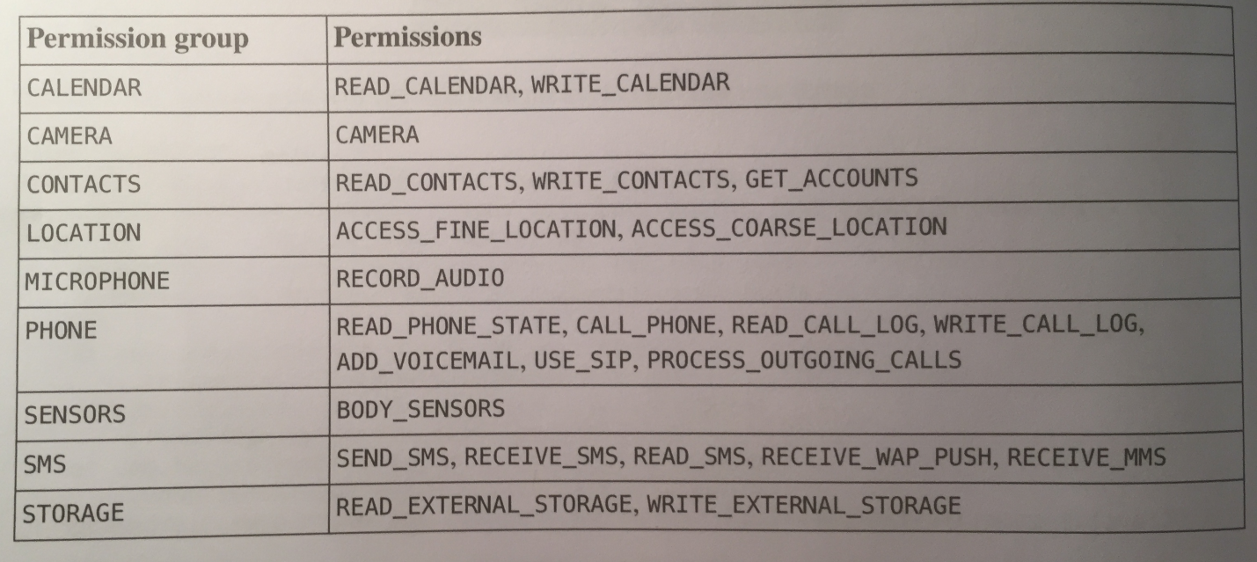

Once a permission is granted for any permission within the group, permission is granted for *all* permissions in the group. Since both of our permissions are in the LOCATION group, we only need to check whether we have one of those permissions.

We write a method to check whether we have access to the first permission in our LOCATION_PERMISSIONS array:

private boolean hasLocationPermission(){

int result =

ContextCompat.checkSelfPermission(

getActivity(), LOCATION_PERMISSIONS[0]);

return result == PackageManager.PERMISSION_GRANTED;

}

Because checkSelfPermission(…) is a relatively new method on Activity, introduced in Marshmallow, we use ContextCompat’s checkSelfPermission(…) instead to avoid ugly conditional code. It’ll take care of the compatibility behavior for us.

Next, we add a check before calling findImage() to make sure we have the permission:

public boolean onOptionsItemSelected(MenuItem item){

switch(item.getItemId()) {

case R.id.action_locate:

**if (hasLocationPermission()){**

findImage();

**}**

…

}

Now we write what should happen when we **do not** have location permission. In this case, we wanna call the requestPermissions(…) method:

private static final int

REQUEST_LOCATION_PERMISSIONS = 0;

…

public boolean onOptionsItemSelected(MenuItem item){

switch(item.getItemId()) {

case R.id.action_locate:

if (hasLocationPermission()){

findImage();

}

**else{**

**requestPermissions(**

**LOCATION_PERMISSIONS,**

**REQUEST_LOCATION_PERMISSIONS);**

**}**

…

}

The requestPermissions(…) method is an asynchronous request. When we call it, Android will display the systems permissions dialog with a message appropriate to the permission we’re requesting.

To respond to the system dialog, we write a corresponding implementation of onRequestPermissionResult(…). Android will call this callback when the user presses ALLOW or DENY. We write an implementation that checks the permission again and calls findImage() if the permission was granted:

@Override

public void onRequestPermissionsResult(int requestCode, String[] permissions, int[] grantResults){

switch(requestCode){

case REQUEST_LOCATION_PERMISSIONS:

if(hasLocationPermission()){

findImage();

}

default:

super.onRequestPermissionsResult(

requestCode, permissions,

grantResults);

}

}

The callback to onRequestPermissionResult(int, String[]. int[]) includes a parameter called grantResults. If you like, you can check this parameter to see whether your permission was granted. Here, we take a simpler approach: when we call hasLocationPermission(), its call to checkSelfPermission(…) will also tell us whether we have acquired the permission. So we can call hasLocationPermission() one more time and accomplish the same thing with less code than it takes to look into the contents of grantResults.

Now permissions and everything else should work correctly!

The last thing we need to do, now that we have a location, is to use it to search for pictures in Flickr. We write an AsyncTask to find a GalleryItem near our location fix, download its associated image, and display it:

private void findImage(){

…

LocationServices.FusedLocationApi

.requestLocationUpdates(mClient, request,

new LocationListener() {

@Override

public void onLocationChanged(

Location location) {

Log.i(TAG, "Got a fix: " +

location);

**new SearchTask()**

**.execute(location);**

}

});

}

**private class SearchTask**

**extends AsyncTask<Location,Void,Void> {**

**private GalleryItem mGalleryItem;**

**@Override**

**protected Void doInBackground(Location... params){**

**FlickrFetchr fetchr = new FlickrFetchr();**

**List<GalleryItem> items =**

**fetchr.searchPhotos(params[0]);**

**if(items.size() == 0){**

**return null;**

**}**

**mGalleryItem = items.get(0);**

**return null;**

**}**

**}**

Saving out the GalleryItem here accomplishes nothing for now, but will be used next chapter.

Now, we download that GalleryItem’s associated image data and decode it. Then display it on mImageView inside onPostExecute(Void):

**private Bitmap mBitmap;**

…

protected Void doInBackground(Location... params){

…

mGalleryItem = items.get(0);

**try{**

**byte[] bytes =**

**fetchr.getUrlBytes(mGalleryItem.getUrl());**

**mBitmap = BitmapFactory.decodeByteArray(**

**bytes, 0, bytes.length);**

**}**

**catch(IOException ioe){**

**Log.i("TAG", "Unable to download bitmap",**

**ioe);**

**}**

…

}

**@Override**

**protected void onPostExecute(Void result){**

**mImageView.setImageBitmap(mBitmap);**

**}**

mImageView is from our layout file and we inflate it in onCreateView(…) in LocatrFragmet. With that, we should be able to find a nearby image and see it in our app.

**Chapter 34 - Maps:**

To get started, you first need to import the mapping library as a dependency. There is also the task of setting up your maps API key, and that is all covered on pages 648-649.

Now that we have the Maps API set up, we need to create a map. Maps are displayed, appropriately enough, in a MapView. MapView is like other views, mostly, except in one way: for it to work correctly, you have to forward all of your lifecycle events, like this:

@Override

public void onCreate(Bundle savedInstanceState){ super.onCreate(savedInstanceState);

mMapView.onCreate(savedInstanceState);

}

This is a huge pain in the ass. It’s far easier to let the SDK do that work for you instead by using a MapFragment or, if you’re using support library fragments, SupportMapFragment. The MapFragment will create and host a MapView for you, including the proper lifecycle callback hookups.

Our first step then is to wipe out our old UI entirely and replace it with a SupportMapFragment. This is easier than it sounds. All we need to do is switch to using a SupportMapFragment, delete our onCreateView(…) method, and delete everything that uses our ImageView.

The code to do this is simple and is shown on page 650.

SupportMapFragment has its own override of onCreateView(…), so we should be all set. Now we should be able to see a map displayed.

To actually plot our image on this map, we need to know where it is. We add an additional “extra” parameter to our Flickr API query to fetch a lat-lon pair back for our GalleryItem:

private static final Uri ENDPOINT = Uri .parse("https://api.flickr.com/services/rest/")

.buildUpon()

.appendQueryParameter("api_key", API_KEY)

.appendQueryParameter("format", "json")

.appendQueryParameter("nojsoncallback", "1")

.appendQueryParameter("extras", "url_s, **geo**")

.build();

Now we add latitude and longitude to GalleryItem. The code is simple and is shown on page 652.

Next, we pull that data out of our Flickr JSON response:

private void parseItems(List<GalleryItem> items, JSONObject jsonBody)

throws IOException, JSONException{

…

**item.setLat(photoJsonObject**

**.getDouble("latitude")); item.setLon(photoJsonObject**

**.getDouble("longitude"));**

items.add(item);

}

}

Now that we’re getting our location data, lets add some fields to our main fragment to store the current state of our search. We add a field to stash the Bitmap we’ll display, a field to stash the GalleryItem it’s associated with, and a field for our current Location:

public class LocatrFragment extends SupportMapFragment {

…

**private Bitmap mMapImage;**

**private GalleryItem mMapItem;**

**private Location mCurrentLocation;**

…

Next, we save those bits of info out from within our AsyncTask, SearchTask:

private class SearchTask

extends AsyncTask<Location,Void,Void> {

private GalleryItem mGalleryItem;

private Bitmap mBitmap;

**private Location mLocation;**

@Override

protected Void doInBackground(Location... params){

**mLocation = params[0];**

…

}

@Override

protected void onPostExecute(Void result){

**mMapImage = mBitmap;**

**mMapItem = mGalleryItem;**

**mCurrentLocation = mLocation;**

}

}

With this, we have all the data we need. Now we need to make our map show it.

Our SupportMapFragment creates a MapView, which is, in turn, a host for the object that does the real work: GoogleMap. So our first step is to acquire a reference to this master object. We do this by calling getMapAsync(OnMapReadyCallback) in our LocatrFragment class’s onCreate(…) method:

**private GoogleMap mMap;**

…

public void onCreate(Bundle savedInstanceState){

…

**getMapAsync(new OnMapReadyCallback() {**

**@Override**

**public void onMapReady(GoogleMap googleMap) {**

**mMap = googleMap;**

**}**

**});**

}

The getMapAsync(…) method gets a map object asynchronously. If we call this from within our onCreate(Bundle), we will get a reference to a GoogleMap object once it’s created and initializd.

Now that we have a GoogleMap, we can update the look of that map according to the current state of LocatrFragment. The first thing we will do is zoom in on an area of interest.

We will want a margin around that area of interest, so we add a dimension value in res/values/dimens.xml for that margin:

<dimen name="map_inset_margin">100dp</dimen>

Then we add a method called updateUI() to LocatrFragment’s class that performs our zoom:

private void updateUI(){

if(mMap == null || mMapImage == null){

return;

}

LatLng itemPoint = new LatLng(mMapItem.getLat(),

mMapItem.getLon());

LatLng myPoint =

new LatLng(mCurrentLocation.getLatitude(),

mCurrentLocation.getLongitude());

LatLngBounds bounds = new LatLngBounds.Builder()

.include(itemPoint)

.include(myPoint)

.build();

int margin =

getResources().getDimensionPixelSize(

R.dimen.map_inset_margin);

CameraUpdate update =

CameraUpdateFactory

.newLatLngBounds(bounds, margin);

mMap.animateCamera(update);

}

Here is what we’re doing. To move our GoogleMap around, we built a CameraUpdate. CameraUpdateFactory has a variety of static methods to build different kinds of CameraUpdate objects that adjust the position, zoom level, and other properties around what our map is displaying.

Here, we created an update that points the camera at a specific LatLngBounds. We can think of a LatLngBounds as a rectangle around a set of points. We can make one explicitly by saying what the southwest and northeast corners of it should be.

More often, it’s easier to provide a list of points that we would like this rectangle to encompass. LatLngBounds.Builder makes it easy to do that: simply create a LatLngBounds.Builder and call .include(LatLng) for each point our LatLngBounds should encompass (represented by LatLng objects). The points we put in are the location of our current position and the location of the nearest photo taken relative to our position. When we’re done, call build(), and we get an appropriately configured LatLngBounds.

With that done, we can update our map in two ways: with moveCamera(CameraUpdate) or animateCamera(CameraUpdate). We chose to animate because that’s more fun.

Next, we need to hook up our updateUI() method in two places: when the map is first received, and when our search is finished:

public void onCreate(Bundle savedInstanceState){

…

getMapAsync(new OnMapReadyCallback() {

@Override

public void onMapReady(GoogleMap googleMap) {

mMap = googleMap;

**updateUI();**

}

});

}

…

private class SearchTask extends

AsyncTask<Location,Void,Void> {

…

@Override

protected void onPostExecute(Void result){

mMapImage = mBitmap;

mMapItem = mGalleryItem;

mCurrentLocation = mLocation;

**updateUI();**

}

}

Now when we run our project and press the search button, we should see our map zoom in on an area of interest that includes our current location.

Our map is still not done though. We have zoomed in on the general area where we are and where the picture is, but we don’t see specifically where anything is.

Let’s add specificity with some markers.

Drawing on a map is not the same as drawing on a regular view. It’s easier. Instead of drawing pixels on the screen, we draw features to a geographic area. And by “drawing” we mean, “build little objects and add them to our GoogleMap so that it can draw them for us.”

Actually, what we REALLY mean is that we create objects that describe what we want the GoogleMap to draw. The GoogleMap object makes these objects, not us. We just give it *options objects* so it can do its job.

We need to add two markers to our map by creating MarkerOptions objects and then calling mMap.addMarker(MarkerOptions):

private void updateUI(){

…

**BitmapDescriptor itemBitmap =**

**BitmapDescriptorFactory.fromBitmap(mMapImage);**

**MarkerOptions itemMarker = new MarkerOptions()**

**.position(itemPoint)**

**.icon(itemBitmap);**

**MarkerOptions myMarker = new MarkerOptions()**

**.position(myPoint);**

**mMap.clear();**

**mMap.addMarker(itemMarker);**

**mMap.addMarker(myMarker);**

…

}

When we call addMarker(MarkerOptions), the GoogleMap builds a Marker instance and adds it to the map. If we need to remove or modify the marker in the future, we can hold onto this instance. In this case, we will be clearing the map every time we update it, so we don’t need to hold onto the Markers.

Now we should have markers showing up when we run our project.

When we have more than one person working on an app with an API key, debug builds start to be a pain. Your signing credentials are stored in a keystore file, which is unique to you. On a team, everyone will have their *own* keystore file, and their own credentials. In order for anyone new to work on the app, you have to ask them for their SHA1, and then go and update your API key’s credentials.

If we want a lot of explicit control over who is doing what, this may be the right solution.

But there is another option: create a debug keystore specifically for the project. We first create a brand new keystore with Java’s keytool program. The book shows you how on pages 659.

Once we have that debug.keystore file, we need to move it into our app module’s folder. Then, we open up our project structure, select our app module, and navigate to the Signing tab. We add our debug.keystore file as a new signing config. The book shows you how to do this on page 660.

If we configure our API key to use this new keystore, instead of a personal keystore file, then anyone else can use the same API key by using the same keystore. Much easier.

**Chapter 35 - Material Design:**

The biggest change in Android 5.0 Lollipop was the introduction of a new design style: material design. This new visual language is the shit.

Material design introduces some new interface concepts in addition to design sensibilities. We need to familiarize ourselves with them in order to properly do Material Design.

For designers, material design emphasizes three big ideas:

* *Material is the metaphor*: The pieces of the app should act like physical, material objects.
* *Bold, graphic, and intentional*: App designs should jump off the page like they would in a well-designed magazine or book.
* *Motion provides meaning*: The app should animate in response to actions taken by the user.

The only one of these we won’t get into is the second one. This is a designer’s responsibility. If you’re designing your own app, check out the material guidelines to see what they mean by that.

For the first part, designers need your help to build out the material surfaces. You will need to know how to position them in three dimensions using z-axis properties, and you’ll need to know how to use two new material widgets: floating action buttons and snackbars.

Finally, for the third point, we can learn about a set of animation tools: state list animators, animated state list drawables (different from state list animators), circular reveals, and shared element transitions. These can be used to add to the visual interest that bold designers crave.

Now, as a developer, the single most important idea you should be familiar with in material design is the idea of material surfaces. Designers think of these as very thin bits of paper. These bits of paper act like magically changeable bits of paper and ink: they can grow, they can show animated pictures, they can show changing text.

However, they still behave like pieces of paper. For example, one sheet of paper cannot move right through another. The same logic applies when you animate material surfaces: they cannot animate through one another.

Instead, surfaces exist and maneuver around one another in a three-dimensional space. They can move up towards your finger, or down and away:

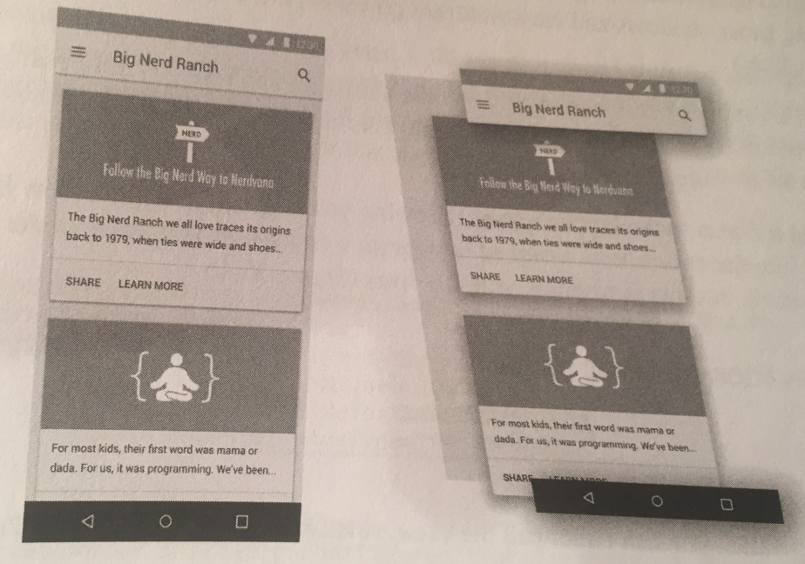

To animate one surface across another, you move it up and across the other surface:

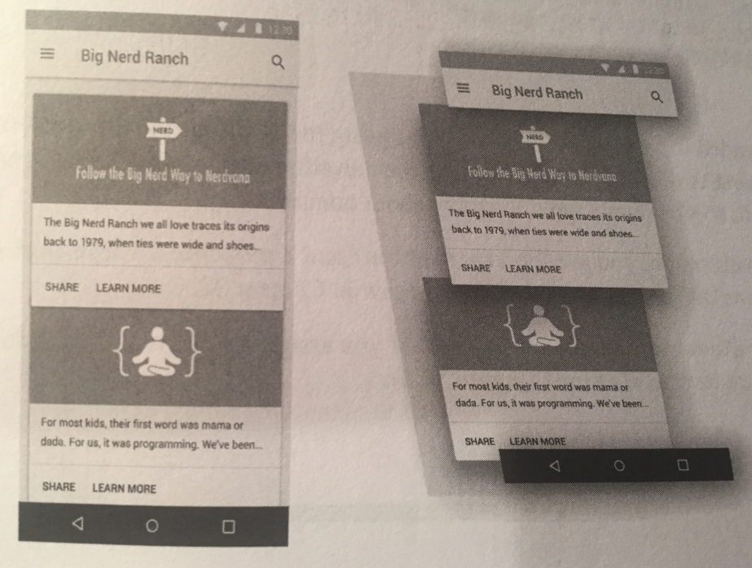

The most apparent way users will see the depth in your interface is by seing how elements of your app cast shadows on one another. Designers can’t take care of this themselves. Instead, we let Android take care of drawing the shadows by giving each of our Views an *elevation*.

Lollipop introduced a z-axis to the layout system, allowing us to specify where a view lives in 3-D space. Elevation is like the coordinates assigned to your view in a layout: you can animate your view away from this position, but this is where it naturally lives:



To set the elevation value, you can either call the View.setElevation(float) method or set the value in your layout file, like so:

<Button …

android:elevation=”2dp” />

Because this is intended to be your baseline Z value, using the XML attribute is preferred. It’s also easier to use than setElevation(float), because the elevation attribute is silently ignored on older versions of Android, so you don’t need to worry about compatibility.

To change a View’s elevation, you use the translationZ and Z properties. These work exactly like translationX, translationY, X, and Y. Z’s value is always elevation plus transitionZ. If we assign a value to Z, it will do the math to assign the right value to translationZ:

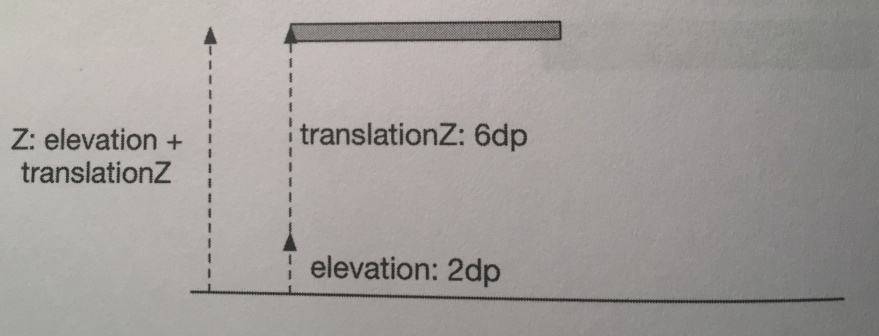

Material applications are often designed with many animated user interactions. To make implementing these animations easier, Lollipop introduced *state list animators*. State list animators are the animation counterpart of state list drawables: instead of switching out one drawable for another, they animate the view into a particular state. To implement an animation that raises the button up when you press it, you can define a state list animator that looks like this in res/animator:

<selector xmlns:android= “http://schemas.android.com/apk/res/android”>

<item android:state_pressed=”true”>

<objectAnimator

android:propertyName=”translationZ”

android:duration=”100”

android:valueTo=”6dp”

android:valueType=”floatType”

/>

</item>

<item android:state_pressed=”false”>

<objectAnimator

android:propertyName=”translationZ”

android:duration=”100”

android:valueTo=”0dp”

android:valueType=”floatType”

/>

</item>

</selector>

This is great if you need to use a property animation. If you want to perform a framed animation, you need to use another tool: the *animated state list drawable*.

This is different from “state list animator”. Animated state list drawables allow you to define images for each state, like a normal state list drawable, but they also allow you to define frame animation transitions between those states.

If we wanted to have a multiframe animation each time a button is pressed, for example, we could modify our XML to look like this:

<animated-selector xmlns:android=

“http://schemas.android.com/apk/res/android”>

<item android:id=”@+id/pressed

android:drawable=

”@drawable/button_beat_box_pressed”

android:state_pressed=”true”/>

<item android:id=”@+id/released”

android:drawable=

”@drawable/button_beat_box_normal” />

<transition

android:fromId=”@id/released”

android:toId=”@id/pressed”

<animation-list>

<item android:duration=”10”

android:drawable=

”@drawable/button_frame_1” />

<item android:duration=”10”

android:drawable=

”@drawable/button_frame_2” />

<item android:duration=”10”

android:drawable=

”@drawable/button_frame_3” />

…

</animation-list>

</transition>

</animated-selector>

This XML would need to live inside res/drawable-21 because this feature is not supported prior to Lollipop.

Here, each item in the selector gets an ID. You can then define a transition between different IDs to play a multiframe animation. If you wanted to provide an animation when you release the button, too, that requires an additional transition tag.

Material design has many new nifty animations. Some of them can be achieved quickly. Others require more work, but Android provides some tools to help you out.

The first one we’ll look at is the circular reveal. The circular reveal animation is used in material design to look like an ink flood-fill. A view or piece of content is progressively revealed outward from a point of interaction, usually a point pressd by the user.

To create a circular reveal animation, you call the createCircularReveal(…) method on ViewAnimationUtils:

static Animator createCircularReveal(View view,

int centerX, int centerY, float startRadius,

float endRadius);

The View passed in is the View you would expect to reveal. If we animate from a startRadius of 0 to a large endRadius, this view will start out being completely transparent, and then slowly be revealed as the circle expands. The circle’s origin (**in terms of the View’s coordinates, the view we pass in**) will be centerX and centerY. This method returns an Animator, which we need to start.

The material guidelines say that these animations should originate from the point where the user touched the screen. So, our first step is to find the screen coordinates of the view that the user touched:

@Override

public void onClick(View clickSource){

int clickCoords = new int[2];

//find the location of clickSource on the screen

clickSource.getLocationOnScreen(clickCoords);

//tweak that location so that it points at the

//center of the view, not the corner

clickCoords[0] += clickSource.getWidth() / 2;

clickCoords[1] += clickSource.getHeight() / 2;

performRevealAnimation(mViewToReveal,

clickCoords[0], clickCoords[1]);

}

Then we perform our reveal animation:

private void performRevealAnimation(View view,

int screenCenterX, int screenCenterY){

//find the center relative to the view that will be

//animated

int[] animatingViewCoords = new int[2];

view.getLocationOnScreen(animatingViewCoords);

int centerX = screenCenterX -

animatingViewCoords[0];

int centerY = screenCenterY -

animatingViewCoords[1];

//find the maximum radius

//(we can do different shit)

Point size = new Point();

getActivity().getWindowManager()

.getDefaultDisplay()

.getSize(size);

int maxRadius = size.y;

if(Build.VERSION.SDK_INT >=

Build.VERSION_CODES.LOLLIPOP){

ViewAnimationUtils.createCircularReveal(

view, centerX, centerY, 0,

maxRadius)

.start();

}

}

Important note: **the View must already be in the layout for this method to work.**

Another kind of animation that is new to material design is the *shared element transition*, or *hero transition*. This transition is meant for a specific situation: where two screens display some of the same things.

For example, if we have a project where we have a thumbnail view of an image and when we press it it expands to a full size view of it, we can use shared element transitions here to animate that.

A shared element transition is an animation for any situation where we are transitioning between two screens that are displaying some of the same elements. In the case of the thumbnail picture getting blown up, the picture is a *shared element*.

In Lollipop, Android provides techniques for accomplishing a transition between activities or between fragments. The book shows us how it works with activities.

For activities, the basic implementation is a three-step process:

1. Turn on activity transitions.
2. Set transition name values for each shared element view.
3. Start your next activity with an ActivityOptions that will trigger the transition.

First, we have to turn on activity transitions. If our activity uses the AppCompat theme, then we can skip this step because AppCompat inherits from the Material theme, which turns on activity transitions for us.

To turn on activity transitions manually, you can do one of two things. One option is to add a line of code to the activity, like so:

public void onCreate(Bundle savedInstanceState){

**getWindow().requestFeature(**

**Window.FEATURE_ACTIVITY_TRANSITIONS);**

…

The other way is to tweak the style the activity uses and set the android:windowActivityTransitions to true:

<style name=”TransparentTheme”

…

**<item name=”android:windowActivityTransitions”>**

**true**

**</item>**

</style>

The next step in the shared element transition is to tag each shared element view with a transition name. This is done in a property on View introduced in API 21: transitionName. You can set it in either XML or in code; depending on the circumstance, one or the other might be appropriate.

In our case, we set the transition name for the zoomed-in image by setting android:transitionName to image in our layout XML:

<ImageView

…

**android:transitionName=”image”**

… />

Then we define a static method to set the same transition name on a view to animate from:

public static void startWithTransition(

Activity activity, Intent intent, View sourceView){

ViewCompat.setTransitionName(sourceView, “image”);

ActivityOptionsCompat options =

ActivityOptionsCompat

.makeSceneTransitionAnimation(activity,

sourceView, “image”);

activity.startActivity(intent, options.toBundle());

}

ViewCompat.setTransitionName(View, String) is there to help out on older versions of Android, where View will not have a setTransitionName(String) implementation.

The code above shows the final step too: making an ActivityOptions object. The ActivityOptions object tells the OS what the shared elements are and what transitionName value to use. The activity is the activity we’re going to. The intent tells us where we are transitioning to, and contains our target activity with the shared view.

To learn more about transitions and shared element transitions, including how they are used for fragment transitions, check the docs given by the book on page 672.

Lollipop’s new material design guidelines specify a few new kinds of view components. The Android team provides implementations of many of these components. Let’s take a look at a few of them.

The first new widget is a frame for other widgets: *cards*.

A card is a container for other kinds of content. It’s elevated slightly, with a shadow behind it, and its corners are slightly rounded.

You create a card by using a CardView. CardView is a class provided in its own v7 support library, much like RecyclerView. You can include it in your project by adding a dependency on com.android.support:cardview-v7 to your module.

Once you do that, you can use CardView like any other ViewGroup in a layout. It’s a FrameLayout subclass, so you can use any of FrameLayout’s layout params for CardView’s children.

For example:

<android.support.v7.widget.CardView

android:id=”@+id/item”

android:layout_width=”match_parent”

android:layout_height=”200dp”

android:layout_margin=”16dp”>

…

</android.support.v7.widget.CardView>

Because CardView is a support library class, it gives you some nice compatibility features on older devices. Unlike other widgets, it will always project a shadow. On older versions, it will simply draw its own - not a perfect shadow, but close enough.

Another component we’ll go over is the *floating action button*, or FAB. An implementation of the FAB is available in Google’s design support library, which can be included by including com.android.support:design:24.2.1.

FABs are little more than a solid-color circle with a custom circular shadow, provided by an OutlineProvider. The FloatingActionButton class, a subclass of ImageView, takes care of the circle and shadow for you. Simply place a FloatingActionButton in your layout file and set its src attribute to the image that you want to display in your button.

While we could place our floating action button in a FrameLayout, the design support library also includes the clever CoordinatorLayout. This layout is a subclass of FrameLayout that changes your floating action button’s position based on the movement of other components. For example, if we display a SnackBar (discussed next), our FAB will move up so that the SnackBar does not cover it.

For example:

<android.support.design.widget.CoordinatorLayout

…>

[…main content here…]

<android.support.design.widget.FloatingActionButton

android:id=”@+id/floating_action_button”

android:layout_width=”wrap_content”

android:layout_height=”wrap_content”

android:layout_gravity=”bottom|right”

android:layout_margin=”16dp”

android:src=”@drawable/play”/>

</android.support.design.widget.CoordinatorLayout>

This code will place the button over the rest of the content in the bottom right, without interfering with any of it.

Snackbars are a bit more involved than floating action buttons. They are little interaction components that appear at the bottom of the screen.

Snackbars animate up from the bottom of the screen. After a certain period of time, or after another interaction on the screen, they automatically animate back down. They are similar in purpose to Toasts, but unlike Toasts they are a part of your app’s own interface. A Toast appears above your app and will stick around even if you navigate away. Also, snackbars let you provide a button so that the user can take immediate action.

Like floating action buttons, Android provides an implementation of snackbars in the design support library.

Snackbars are constructed and displayed in a similar way to Toasts:

Snackbar.make(container, R.string.munch,

Snackbar.LENGTH_SHORT).show();

When constructing a SnackBar, pass in the view where the snackbar will be displayed, the text to display, and the length of time that the snackbar should be visible for. Finally, call show() to display the snackbar.

Snackbars can optionally provide an action on the right side. This is handy if the user performs a destructive action, like deleting a crime, and you want to provide a way for the user to undo that action.

The full documentation for the Material Design spec is given in the middle of page 677.